Supplemental Table S1. Summary of primer sequence
Name of primer | Sequence
qACTIN-F | TGTCCCTATTTACGAGGGTTATGC
qACTIN-R | AGTTAAATCACGACCAGCAAGAT
qSlSWEET7a-F | TGATGCCTACATTCTCGCACC
qSlSWEET7a-R | TCCTTTAGCCTCTCTTGCTGCC
qSlZIP11-F | GCATCTTATTGATCGTTGCACT
qSlZIP11-R | ACTTACAGTCCAAAGAGCTCTC
STE-SlSWEET7a-F | ATTAACAAGGCCATTACGGCCACTTTTAATAGGGACAATGCTAGGTTTG
STE-SlSWEET7a-R | AACTGATTGGCCGAGGCGGCCCCAACTCTAAAATCACTTCTCGGGTTTTG
GFP-SlZIP11-F | CGGGGGACGAGCTCGGTACCATGGCACGTTTACACTTGTTTCTTG
GFP-SlZIP11-R | CTAGAGGATCCCCGGGTACCAGTGTCCCATATCATCACCACAGC
GWSlZIP11-F | GGGGACAAGTTTGTACAAAAAAGCAGGCTTCGGTACCATGGCACGTTTACACTTGTTTCTTG
GWSZIP11-R | GGGGACCACTTTGTACAAGAAAGCTGGGTGACTAGTAGTGTCCCATATCATCACCACAGC
OESlZIP11-F | GCTCTAGAATGGCACGTTTACACTTGTTTCTTG
OESlZIP11-R | CCCCCGGGAGTGTCCCATATCATCACCACAGC
TRV-SlZIP11-F | CCTCCATGGGGATCCGGTACCATGGCACGTTTACACTTGTTTCTTG
TRV-SlZIP11-R | GAGACGCGTGAGCTCGGTACCCGCAGTTCCCAAGAAAACCC

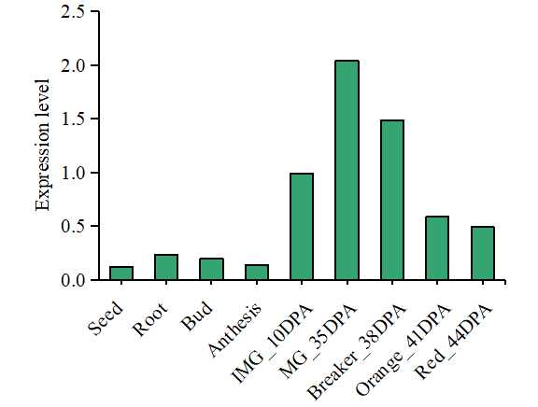
Supplemental Figure S1. Expression level of SlZIP11 in ‘Heinz 1706’.
IMG_10DPA, immature green fruits (10 day post-anthesis); MG_35DPA, mature green fruits (35DPA); Breaker_38DPA, breaker fruits (38DPA); Orange_41DPA, orange fruits (41DPA); Red_44DPA, red ripen fruits (44DPA). The data was obtained in the tomato database (https://solgenomics.net/).

