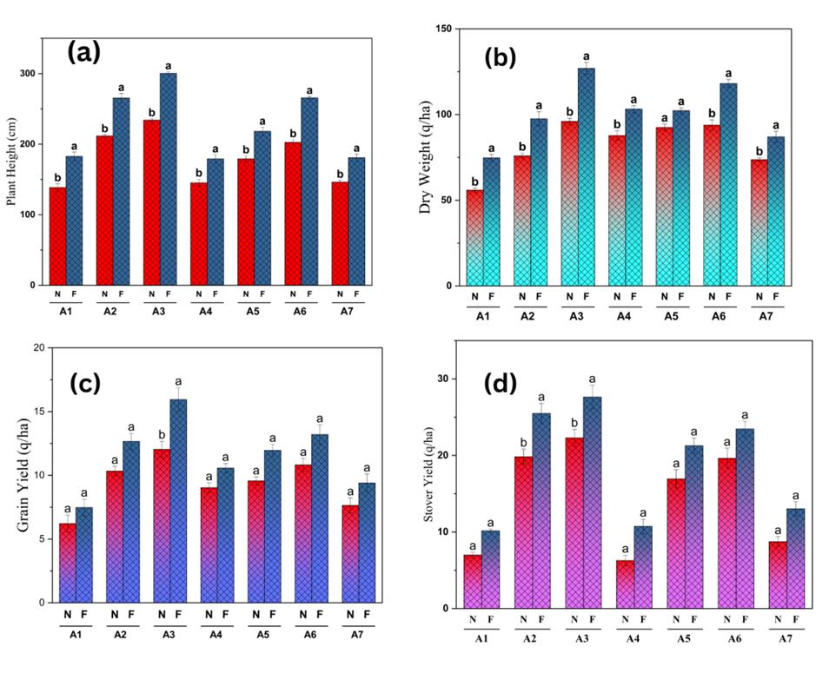

**Supp Figure 1 Maize growth and productivity as affected by amendment type and fertilizer regimes.**

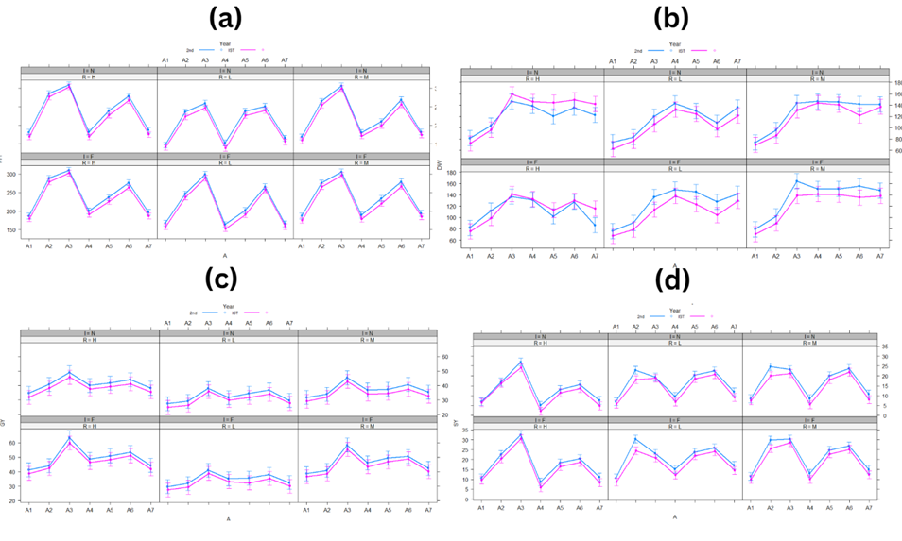

**Suppl Figure 2** **Interactive effect of maize growth and productivity on amendment, year, rate of application, and fertilizer regimes.**

**Suppl Table 1 Treatment details**

|  |  |  |
| --- | --- | --- |
| **Factor 1 (Amendments)** | **Factor 2 (Rate)** | **Factor 3 (Inorganic fertilizer)** |
| 1. No material - (A1) | Low - (L) | No fertilizer - (N) |
| 1. Apple biochar (400℃) - (A2) | Medium - (M) | RDF (recommended dose of fertilizer) - (F) |
| 1. Apple biochar (600℃) - (A3) | High - (H) |
| 1. Apple residue biomass - (A4) |
| 1. Dal weed biochar (400℃) - (A5) |
| 1. Dal weed biochar (600℃) - (A6) |
| 1. Dal weed residue biomass - (A7) |