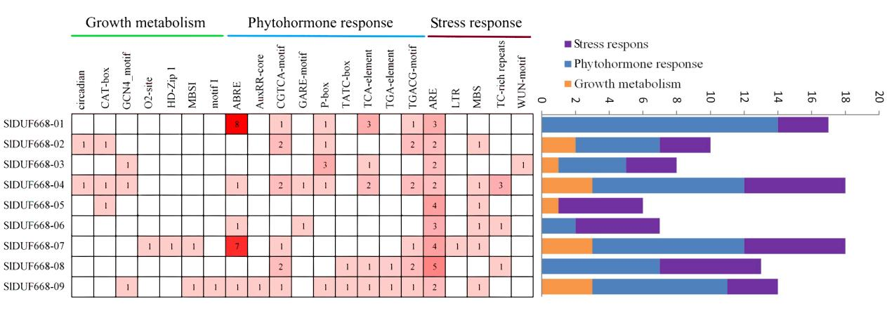

**Supplementary Fig. S1** Cis-acting elements analysis of theSlDUF668gene family in tomato. Numbers in the box are the number of cis-elements indicated by different intensity colors and numbers. The stacked graph on the right side represents the total number of promoter elements in each category.