Supplemental Information for: A quantitative test of the “Ecomorphotype Hypothesis” for fossil true seals (Family Phocidae)
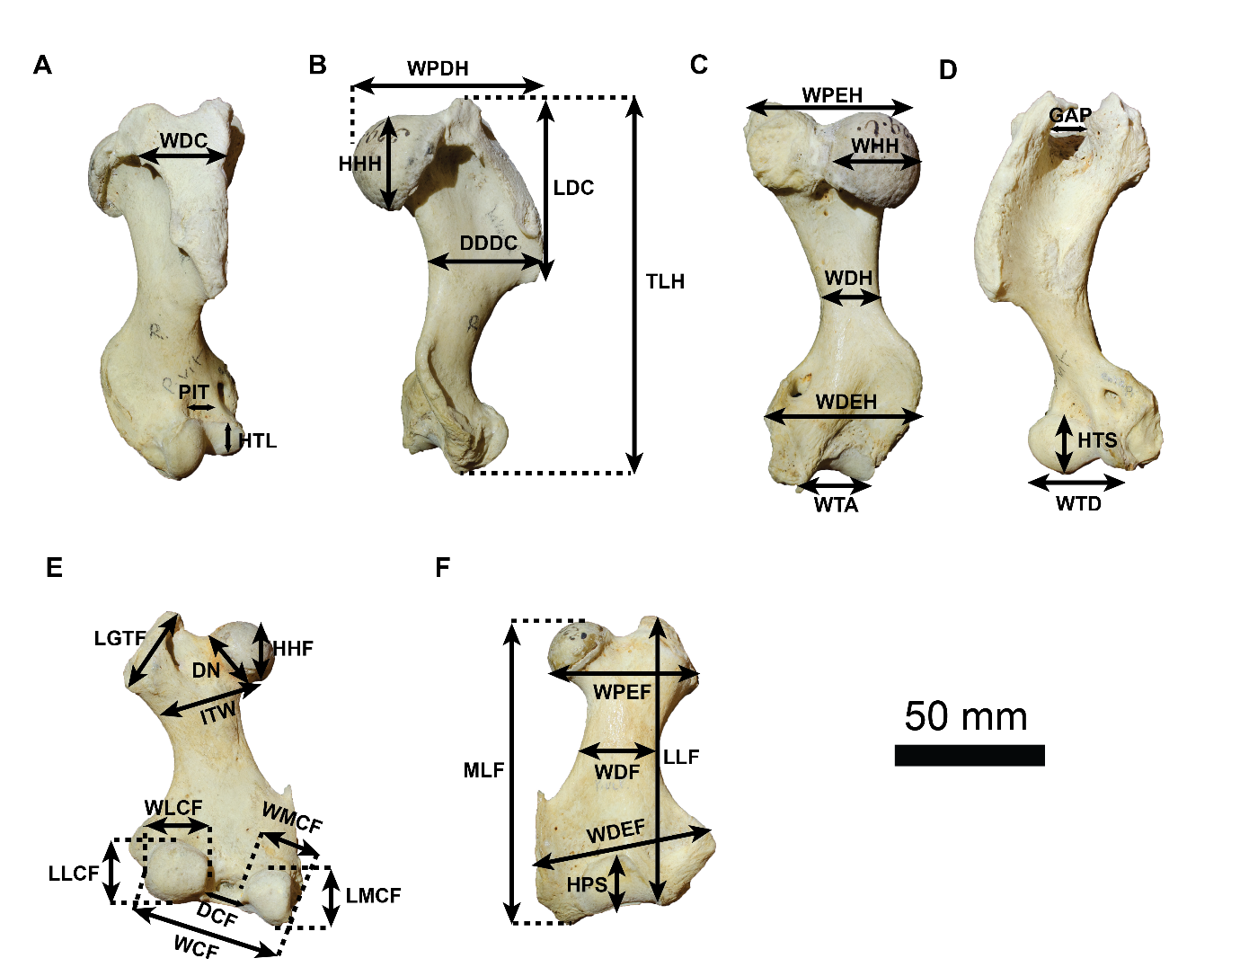
Supplementary Figure 1. Measurement protocol from Churchill and Uhen (2019). Right humerus (A, B, C, D) and left femur (E, F) of Phoca vitulina (NHMUK 329i) in oblique lateral (A), lateral (B), posterior (C, E), and anterior (D, F) views. Definitions of Humerus measurements: DDDC – diaphysis diameter at deltopectoral crest; HHH – proximo-distal height of humeral head; HTL – proximo-distal height of capitulum; HTS – proximo-distal height of trochlea; LDC – proximo-distal deltopectoral crest length; TLH – total proximo-distal length of humerus; WDC – medio-lateral width of deltopectoral crest; WDEH – medio-lateral width of distal epiphysis; WDH – minimum medio-lateral width of diaphysis; WHH – maximum width of humeral head; WPDH - width of proximal epiphysis head to deltopectoral crest; WPEH – width of humeral head to lesser tubercle; WTA – medio-lateral width of trochlea in anterior view; WTD – medio-lateral width of trochlea in posterior view; GAP – width of inter-tubercle space; PIT – anterior-posterior depth of coronoid fossa. Definitions of Femur measurements: DCF – medio-lateral distance between condyles; DN – proximo-distal diameter of the femur neck; HHF – proximo-distal height of femoral head; HPS – proximo-distal height of patellar surface; ITW – medio-lateral intertrochlear width of femur; LGTF – maximum length of the greater trochanter; LLF – maximum proximo-distal length of the lateral femur; MLF – maximum proximo-distal length of the medial femur; LMCF – proximo-distal length of the medial condyle; LLCF – proximo-distal length of the lateral condyle; WCF – medio-lateral width across condyles; WDEF – maximum medio-lateral width across distal diaphysis; WDF – minimum medio-lateral width of diaphysis; WPEF – maximum medio-lateral width across proximal diaphysis; WLCF – medio-lateral width of lateral condyle; WMCF – medio-lateral width of medial condyle.

Supplemental Table 1. List of new specimens measured for this study and Churchill & Uhen 2019. Except where indicated, both humeri and femora were measured for each specimen, and both left and right sides (except for Churchill & Uhen 2019). NHMUK: Natural History Museum, London. NMNS: National Museum of Nature and Science, Tokyo. IRSNB: Royal Belgian Institute of Natural Sciences, Brussels.
Species | Specimen number | Notes | Ecomorphotype
Phoca vitulina | NHMUK 1868.3.21.1 | Sex unknown. | 2
Phoca vitulina | NHMUK 329.i | Left humerus missing. Sex unknown. | 2
Pusa hispida | NHMUK ZD 1997.585 | Right femur missing. Sex unknown. | 2
Pusa hispida | NHMUK 1938.12.10.5 | Female. | 2
Pusa sibirica | NHMUK 1965.9.6.2 | Male. | 2
Pusa sibirica | NHMUK 1960.12.21.1 | Female. | 2
Pusa sibirica | NHMUK 1965.9.6.1 | Female. | 2
Histriophoca fasciata | NHMUK 1966.12.7.2 | Male. | 3
Pagophilus groenlandicus | NHMUK 1846.6.18.3 | Sex unknown. | 2
Pagophilus groenlandicus | NHMUK 1938.12.10.1 | Female. | 2
Pagophilus groenlandicus | NHMUK 1951.11.28.2 | Male. | 2
Halichoerus grypus | NHMUK ZD 2003.361 | Right side only. Sex unknown. | 4
Halichoerus grypus | NHMUK 1938.3.12.1 | Left side only. Female. | 4
Halichoerus grypus | NHMUK 1956.9.26.1 | Left side only. Female. | 4
Halichoerus grypus | NHMUK 1956.9.26.4 | Right side only. Male. | 4
Halichoerus grypus | NHMUK 1962.3.6.1 | Left side only. Male. | 4
Halichoerus grypus | NHMUK 1951.11.28.1 | Female. | 4
Halichoerus grypus | NHMUK 1956.9.26.2 | Right side only. Male. | 4
Erignathus barbatus | NHMUK 1887.9.28.1 | Sex unknown. | 1
Phoca largha | NMNS M62796 | Right side only. Sex unknown. | 4
Phocanella pumila | Cast: NHMUK PV M1199, original: IRSNB 1080-M227 | Right humerus only. Fossil specimen. | Treated as unknown
Phocanella minor | Cast: NHMUK PV M1206, original: IRSNB 1101-M234 | Right humerus only. Fossil specimen. | Treated as unknown
Nanophoca vitulinoides | Cast: NHMUK PV M1212, original: IRSNB 1063-M242 | Left humerus only. Fossil specimen. | Treated as unknown
Nanophoca vitulinoides | Cast: NHMUK PV M1216, original: IRSNB 1049-M247 | Left femur only. Fossil specimen. | Treated as unknown
Erignathus barbatus | USNM 16116 | Side and sex unknown. Churchill & Uhen 2019. | 1
Erignathus barbatus | USNM 269126 | Side and sex unknown. Churchill & Uhen 2019. | 1
Erignathus barbatus | USNM 500250 | Side and sex unknown. Churchill & Uhen 2019. | 1
Erignathus barbatus | AMNH 19347 | Side unknown. Male. Churchill & Uhen 2019. | 1
Erignathus barbatus | AMNH 28 | Side and sex unknown. Churchill & Uhen 2019. | 1
Histriophoca fasciata | USNM 504959 | Side and sex unknown. Churchill & Uhen 2019. | 3
Histriophoca fasciata | USNM 504960 | Side and sex unknown. Churchill & Uhen 2019. | 3
Histriophoca fasciata | USNM 571367 | Side and sex unknown. Churchill & Uhen 2019. | 3
Histriophoca fasciata | AMNH 130246 | Side and sex unknown. Churchill & Uhen 2019. | 3
Histriophoca fasciata | AMNH130245 | Side unknown. Male. Churchill & Uhen 2019. | 3
Pagophilus groenlandica | USNM 3517 | Side and sex unknown. Churchill & Uhen 2019. | 2
Pagophilus groenlandica | USNM 21535 | Side and sex unknown. Churchill & Uhen 2019. | 2
Pagophilus groenlandica | USNM 188766 | Side unknown. Male. Churchill & Uhen 2019. | 2
Pagophilus groenlandica | AMNH 180016 | Side and sex unknown. Churchill & Uhen 2019. | 2
Phoca vitulina | USNM 49911 | Side and sex unknown. Churchill & Uhen 2019. | 2
Phoca vitulina | USNM 21056 | Side and sex unknown. Churchill & Uhen 2019. | 2
Phoca vitulina | USNM 15276 | Side and sex unknown. Churchill & Uhen 2019. | 2
Phoca vitulina | USNM 504298 | Side and sex unknown. Churchill & Uhen 2019. | 2
Phoca vitulina | USNM 504299 | Side and sex unknown. Churchill & Uhen 2019. | 2
Phoca vitulina | AMNH 15900 | Side and sex unknown. Churchill & Uhen 2019. | 2
Phoca vitulina | AMNH 232416 | Side unknown. Male. Churchill & Uhen 2019. | 2
Phoca vitulina | AMNH 232402 | Side and sex unknown. Churchill & Uhen 2019. | 2
Phoca vitulina | USNM 250712 | Side and sex unknown. Churchill & Uhen 2019. | 2
Phoca vitulina | USNM 283568 | Side and sex unknown. Churchill & Uhen 2019. | 2
Halichoerus grypus | USNM 218323 | Side and sex unknown. Churchill & Uhen 2019. | 4
Halichoerus grypus | USNM 446405 | Side and sex unknown. Churchill & Uhen 2019. | 4
Halichoerus grypus | USNM 446406 | Side and sex unknown. Churchill & Uhen 2019. | 4
Pusa hispida | USNM 16106 | Side and sex unknown. Churchill & Uhen 2019. | 2
Pusa hispida | USNM 7102 | Side and sex unknown. Churchill & Uhen 2019. | 2
Pusa hispida | USNM 504208 | Side and sex unknown. Churchill & Uhen 2019. | 2
Pusa sibirica | AMNH 185595 | Side and sex unknown. Churchill & Uhen 2019. | 2
Pusa caspica | USNM 341615 | Side unknown. Male. Churchill & Uhen 2019. | 2
Phocanella pumila | USNM 329059 | Humerus only, side unknown. Churchill & Uhen 2019. | Treated as unknown
Phocanella pumila | USNM 171151 | Humerus only, side unknown. Churchill & Uhen 2019. | Treated as unknown
Phocanella pumila | USNM 305283 | Femur only, side unknown. Churchill & Uhen 2019. | Treated as unknown
Phocanella pumila | USNM 329060 | Femur only, side unknown. Churchill & Uhen 2019. | Treated as unknown
Phocanella pumila | USNM 175217 | Femur only, side unknown. Churchill & Uhen 2019. | Treated as unknown
Phocanella pumila | USNM 181649 | Femur only, side unknown. Churchill & Uhen 2019. | Treated as unknown
Phocanella pumila | USNM 481569 | Femur only, side unknown. Churchill & Uhen 2019. | Treated as unknown
Cryptophoca maeotica | USNM 214979, cast of LPB 259 | Femur only, side unknown. Churchill & Uhen 2019. | Treated as unknown
Leptophoca "amphiatlantica" | USNM 321926 | Femur only, side unknown. Churchill & Uhen 2019. | Treated as unknown
Leptophoca proxima | USNM 559330 | Femur only, side unknown. Churchill & Uhen 2019. | Treated as unknown
Monachopsis pontica | USNM 214967, cast of LPB 21 | Femur only, side unknown. Churchill & Uhen 2019. | Treated as unknown
Praepusa vindobonensis | USNM 214993, cast of LPB 158? | Femur only, side unknown. Churchill & Uhen 2019. | Treated as unknown
Praepusa? pannonica | USNM 214978, cast of LPB 5? | Femur only, side unknown. Churchill & Uhen 2019. | Treated as unknown

