SUPPLEMENTARY FIGURES

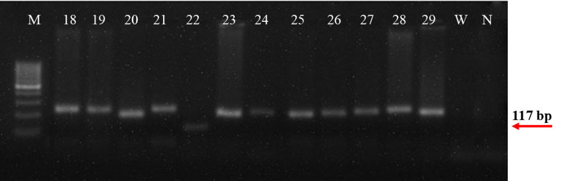
Figure S1. Gel electrophoretogram of wheat varieties amplified in PCR using WMC633 marker to the linked with the Sr22 resistance gene. The red arrow shows the band size of Sr22-carrying (117 bp) and not carrying (171, 191 and 211 bp). W: Water, N: Negative control (Morocco), M: 100 bp DNA Ladder (Thermo Fisher Scientific, USA).

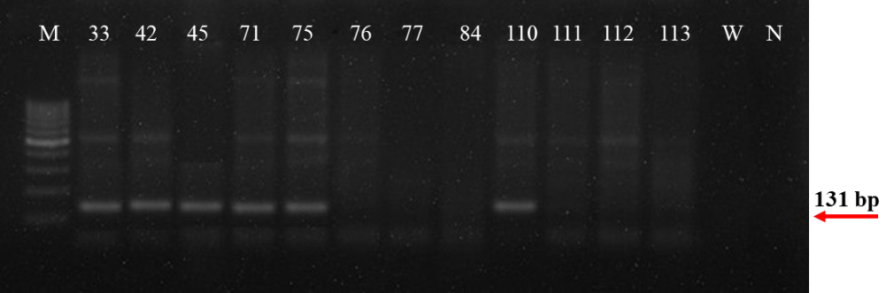
Figure S2. Gel electrophoretogram of wheat varieties amplified in PCR using GB marker to the linked with the Sr25 resistance gene. The red arrow shows the band size of Sr25-carrying (131 bp). W: Water, N: Negative control (Morocco), M: 100 bp DNA Ladder (Thermo Fisher Scientific, USA).

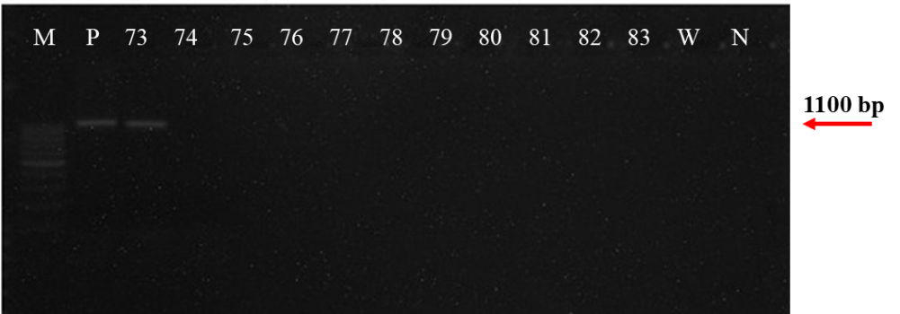
Figure S3. Gel electrophoretogram of wheat varieties amplified in PCR using Iag95 marker to the linked with the Sr31 resistance gene. The red arrow shows the band size of Sr31-carrying (1100 bp). P: Positive control, W: Water, N: Negative control (Morocco), M: 100 bp DNA Ladder (Thermo Fisher Scientific, USA).

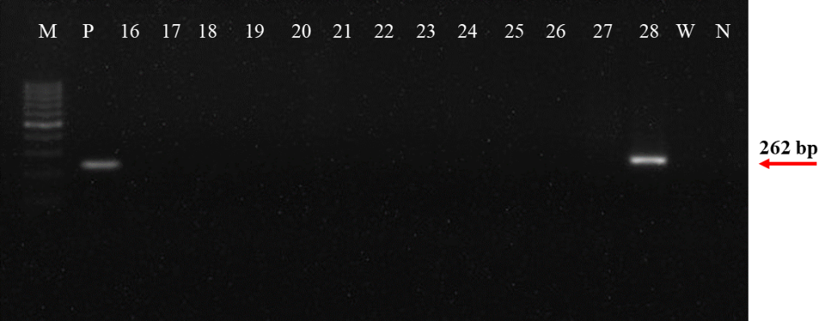
Figure S4. Gel electrophoretogram of wheat varieties amplified in PCR using primers to the Ventriup/LN2 locus linked with the Sr38 resistance gene. The red arrow shows the band size of Sr38-carrying (262 bp). P: Positive control, W: Water, N: Negative control (Morocco), M: 100 bp DNA Ladder (Thermo Fisher Scientific, USA).

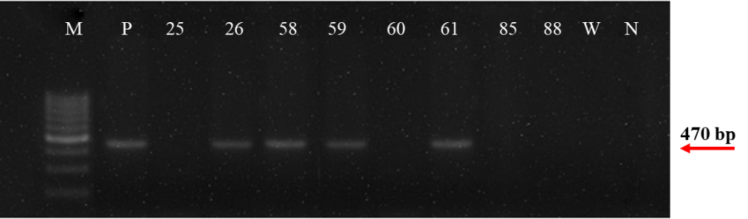
Figure S5. Gel electrophoretogram of wheat varieties amplified in PCR using Sr50-5p marker to the linked with the Sr50 resistance gene. The red arrow shows the band size of Sr50-carrying (470 bp). P: Positive control, W: Water, N: Negative control (Morocco), M: 100 bp DNA Ladder (Thermo Fisher Scientific, USA).
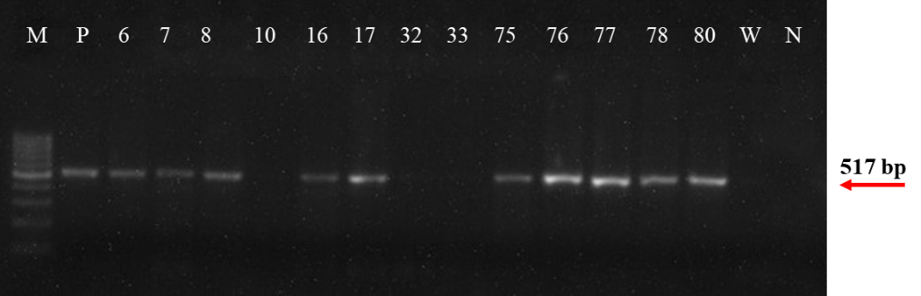
Figure S6. Gel electrophoretogram of wheat varieties amplified in PCR using L34DINT9F marker to the linked with the Sr57 resistance gene. The red arrow shows the band size of Sr57-carrying (517 bp). P: Positive control, W: Water, N: Negative control (Morocco), M: 100 bp DNA Ladder (Thermo Fisher Scientific, USA).

SUPPLEMENTARY TABLES

Table S1. Name, release year and pedigree information associated with the 150 bread wheat varieties used in this study.
No | Cultivar name | Release year | Pedigree | No | Cultivar name | Release year | Pedigree
1 | Sivas 111/33 | 1937 | Pure-line selected from a landrace | 76 | Hanlı | 2007 | OK-82282//BOBWHITE/NEELKANT/3/F-4105-W
2 | İkizce 96 | 1996 | ARTHUR*2/SIETE-CERROS-66//BRILL | 77 | Sakin | 2002 | PITIC-62(PI)/2*FUNO//VALDIVIA/3/CO-723595
3 | Mızrak | 1998 | POLYCROSS//C-126-15/C-47-6/3/YESILKOY-1978-79-7 | 78 | Özcan | 2004 | K-8/MM-2
4 | Uzunyayla | 1998 | HYSLOP/SIETE-CERROS-66//YAYLA-305/6/NADADORES-63/CO-652643/4/NAINARI-60/MAYO-54//NAINARI-60/KADAS/3/NS-220/5/HYSLOP/SIETE-CERROS-66 | 79 | Cumhuriyet 75 | 1976 | SONORA-64*2//TEZANOS-PINTOS-PRECOZ/YAQUI-54/3/ANDES-64-A/4/2*FROCOR//YAQUI/KENTANA
5 | Bayraktar 2000 | 2000 | CHISHOLM(CSM)/GEREK-79 | 80 | Marmara 86 | 1986 | AVRORA//KALYANSONA/BLUEBIRD/3/(SIB)WOODPECKER
6 | Atlı-2002 | 2002 | HYSLOP/SIETE-CERROS-66//SADOVO-1 | 81 | Kaklıç 88 | 1988 | KAVKAZ/(SIB)BUHO//KALYANSONA/BLUEBIRD
7 | Zencirci-2002 | 2002 | STURDY/KIRAC-66 | 82 | Basri Bey 95 | 1995 | JUPATECO-73/(SIB)BLUEJAY//URES-81
8 | Eser | 2003 | AGRI/NACOZARI-76//LIRA | 83 | Kaşif Bey 95 | 1995 | HORK(SIB)/YAMHILL//KALYANSONA/BLUEBIRD”
9 | Seval | 2004 | BOLAL-2973/NO64/3/ARTHUR*2/SIETE-CERROS-66//BOLAL-2973 | 84 | Gönen 98 | 1998 | II-8156-R/MARA//BLUEBIRD
10 | Tosunbey | 2004 | ECVD-12/KIRAC-66//(SIB) CROW | 85 | Ziyabey 98 | 1998 | NORD-DESPREZ/VG-9144// KALYANSONA/BLUEBIRD/3/YACO/4/VEERY-5
11 | Kenanbey | 2009 | GEREK-79//CO-652643/KIRAC-66 | 86 | Meta 2002 | 2002 | NORD-DESPREZ/VG-9144//KALYANSONA/BLUEBIRD/3/YACO/4/VEERY-5
12 | Nis.22 | 1966 | Composite variety | 87 | Alibey | 2004 | KAUZ,MEX*2//SAPSUCKER/MONCHO/3/KAUZ,MEX
13 | P 8-6 | 1966 | Ak702/Sertak52//Yayla305/Melez13 | 88 | Menemen | 2004 | JUPATECO-73/BLUEJAY//URES-81
14 | Melez 13 | 1944 | Composite variety | 89 | Çukurova 86 | 1986 | BLUEBIRD/KALYANSONA
15 | Ak 702 | 1931 | Composite variety | 90 | Doğankent 1 | 1991 | FLICKER/HORK
16 | Sertak 52 | 1936 | Composite variety | 91 | Seri 82 | 1991 | KAVKAZ/(SIB)BUHO//KALYANSONA/BLUEBIRD
17 | Yayla 305 | 1939 | Composite variety | 92 | Seyhan 95 | 1995 | JUPATECO-73/(SIB)BLUEJAY//URES-81
18 | Porsuk-2800 | 1976 | N10B/3/27-15/RIO//REX-53/4/ BURT | 93 | Adana-99 | 1999 | PFAU/SERI-82//(SIB)BOBWHITE”
19 | Gerek 79 | 1979 | MENTANA/MAYO-48//4-11/3/YAYLA-305 | 94 | Ceyhan-99 | 1999 | BLUEJAY(SIB)/COCORAQUE-75
20 | Atay-85 | 1985 | HYSLOP/SIETE-CERROS-66 | 95 | Pandas | 2001 | ORSO//BEZOSTAYA-1/S-1/3/ GENEROSO-7/CONTO-MARZOTTO
21 | Kutluk 94 | 1994 | KRASNODARSKAYA//INIA/LILIFEN/3/CALIBASAN | 96 | Yüreğir-89 | 2002 | HD-1220/3*KALYANSONA// NACOZARI-76
22 | Kırgız 95 | 1995 | DOMANIC/AVRORA | 97 | Karatopak | 2006 | TESIA-79/VEERY(SIB)// SERI-82
23 | Sultan 95 | 1995 | AGRI/NACOZARI-76 | 98 | Osmaniyem | 2006 | TUJ/ONELTO
24 | Süzen 97 | 1997 | C-126-15/COLLAFEN/3/NORIN-10-BREVOR/P-14//P-101/4/(KRC)KIRAC-66 | 99 | Altın Başak | 2013 | CHEN/TR.TA//BACANORA-88/3/2*KAUZ
25 | Yıldız 98 | 1998 | SEL.55-1744/P-101//MAYA-74/3/MUSALA/(PRM)PRIMO//MAYA-74/(SIB)ALONDRA | 100 | Gökkan | 2013 | KRICHAUFF/FINSI
26 | Harmankaya-99 | 1999 | FUNDULEA-29/2*LOVRIN-32 | 101 | Seri 2013 | 2013 | WEAVER/4/NACOZARI- 76/THATCHER/AC//3*PAVON-  76/3/MIRLO/BUCKBUCK
27 | Altay 2000 | 2000 | ES-14//YEKTAY/BLUEBOY-2 | 102 | Yakamoz | 2014 | BL-1496/MILAN/3/CROC-1/(205)TR.TA//KAUZ
28 | Çetinel 2000 | 2000 | MALCOLM/4/VPM 1/MOISSON 951//HILL 81/3/STEPHENS | 103 | Gemini | 1987 | AUTONOMIA//AUTONOMIA/AQUILA
29 | Alpu 2001 | 2001 | ID800994.W/VEE | 104 | Köksal-2000 | 2001 | Unknown
30 | Sönmez 2001 | 2001 | BEZ//BEZ/TVR/3/KREMENA/LOV29/4/KATIA1 | 105 | Genç 88 | 1988 | CIANO-67(SIB)/ NACOZARI-76// CORRECAMINOS(CC)/ INIA-66/3/BLUEBIRD/ NARINO-59
31 | Soyer02 | 2002 | ATAY-85/GALVEZ-S-87 | 106 | Özkan | 2011 | VORONA/CIANO-79//KAUZ
32 | Müfitbey | 2006 | NGDA146/4/YMH/TOB//MCD/ 3/LIRA/5/F130L1.12 | 107 | Carisma | 2011 | D-29/F-65
33 | Nacibey | 2008 | F900K/3/EGL//BUC/PVN | 108 | Esperia | 2011 | B-16-3/LINEA-RUSSA
34 | ES 26 | 2010 | LLKOFEN/GEREK79*4 | 109 | Sagittario | 2001 | ADAM/Z-282
35 | Yunus | 2012 | SG-S1915/FANDANGO | 110 | Bone de | 2013 | Unknown
36 | Mesut | 2013 | MV-8/5/BEZOSTAYA-1//BEZOSTAYA-1/TEVERE/3/KREMENA/LOVRIN-29/4/KATYA-1 | 111 | Bora | 2014 | H-31/TRAP-1-F-2//ENESCO
37 | Kınacı-97 | 1997 | YAMHILL/TOBARI-66//MCDERMID/3/LIRA | 112 | Genesi | 2014 | COLFIORITO/HEREWARD
38 | Karahan-99 | 1999 | C-126-15/COLLAFEN/3/NORIN-10-BREVOR/P-14//(P101)PULLMAN-101/4/KIRAC-66 | 113 | Syrena odes'ka | 2008 | Unknown
39 | Bağcı-2002 | 2002 | HN7/OROFEN//BEIJING 8/3/SERI M82/4/74CB462/TRAPPER//VONA | 114 | Nota | 2013 | LUTESCENS-2618-G-26465/LUTESCENS-5056-h-44-3//LUTESCENS-5056-h-44-3
40 | Konya-2002 | 2002 | KANRED/ TENMARQ//P-211-6/3/2183/ CO-652643/LANCER | 115 | Yubileynaya | 2013 | Unknown
41 | Ahmetağa | 2004 | Unknown | 116 | Galil | 2002 | HORK/YAMHILL//KALYANSONA/BLUEBIRD/3/BOBWHİTE ‘S’
42 | Ekiz | 2004 | F-885-K-1-1/SIOUXLAND | 117 | Özdemirbey-97 | 2003 | JUPATECO-73/(SIB)BLUEJAY//URES-81
43 | Eraybey | 2012 | F-10-S-1/CHISHOLM | 118 | Pinzon | 2011 | Unknown
44 | Kırkpınar 79 | 1979 | HYSLOP/SIETE-CERROS-66 | 119 | Flamura 85 | 1999 | RANNYAYA-12/NADADORES-63//LOVRIN-12
45 | Murat-1 | 1991 | Unknown | 120 | Alka | 2011 | HANA/MERCIA
46 | Kate A-1 | 1988 | KHEBROS/BEZOSTAJA-1 | 121 | Guadalupe | 2007 | 165613/RECITAL
47 | Pehlivan | 1998 | BEZOSTAYA-1/TEVERE/5/CENTRIFEN/BEZOSTAYA-1//SUWEON-92/CI-13645/3/NAINARI-60/4/(SIB)EMU | 122 | Tina | 2005 | SANA/GALA
48 | Prostor | 1999 | RUSALKA-PODOBRENA/NADADORES-63 | 123 | Tosun 144 | 1975 | BEZOSTAYA-1/54-T-72
49 | Saroz 95 | 1999 | COR-71-11460/3/PKG/LOVRIN-13//JINGSWON-3 | 124 | Krasunia odes'ka | 2008 | Unknown
50 | Atilla-12 | 2001 | MIRONOVSKAYA-808/BEZOSTAYA-1//BEZOSTAYA- 1/3/BEZOSTAYA-1/PRODUTTORE//BEZOSTAYA-1 | 125 | Tanya | 2012 | GRADO(TR.CE)/2*SKIFYANKA
51 | Saraybosna | 2001 | OSJECKA-20/OSK-4.216-2-76 | 126 | Dariel | 2002 | HORK/YAMHILL//KALYANSONA/BLUEBIRD
52 | Gelibolu | 2005 | 506/88-113 | 127 | Bancal | 2006 | Unknown
53 | Tekirdağ | 2005 | Unknown | 128 | Nina | 2005 | SANA(ZG-213-82)/GALA
54 | Aldane | 2009 | BUL-2477-2/3/093-44/AVRORA//BEZOSTAYA-1 | 129 | Mihelca | 2014 | ZG-1325-78/SO-1065
55 | Selimiye | 2009 | LAU/AGD/3/ODESSKAYA-95//OLVIYA/B16 | 130 | Prima | 2014 | SANA/GALA
56 | Bereket | 2010 | KIRAC-66/BEZOSTAYA-1//SUP/3/WEIQUE-RED-MACE(WRM)/2*HUACAMAYO/4/DONS/5/KATE/MVM/6/PRES | 131 | Segor | 2013 | Unknown
57 | Saban | 2014 | TRAKIYA/3/MV-C-410-90/GK-KALAKA//MV-C-410-90/FTM-11 | 132 | Colfiorito | 2010 | IRNERIO/IS-237-T//ARGELATO
58 | Lancer | 1977 | BEZOSTAYA-1/4/II-50-72//YAQUI-54/N10B/3/MARNE- DESPREZ(MD)/IGA-BORDEAUX | 133 | Mane Nick | 2012 | Unknown
59 | Doğu 88 | 1990 | BEZOSTAYA-1/DANNE// CO-725052 | 134 | Vittorio | 2011 | LANCOTA/KALYANSONA//JE-4-B
60 | Karasu 90 | 1990 | LOVRIN-11/BOLAL-2973//MIRONOVSKAYA-264 | 135 | Quality | 2012 | Unknown
61 | Palandöken 97 | 1997 | AVRORA//YAKTANA-54*2/NORIN-10-BREVOR/3/II-8260/5/PONCA(PNC)/CM//NB- 6977/3/CC/LNIA//BLUEBIRD/4/MEXIPAK/IKR/FUNO | 136 | Adagio | 2013 | Unknown
62 | Alparslan | 2001 | TX-69-A-509-2//BBY2/FOX | 137 | Iridium | 2012 | ORATORIO/SHANGO
63 | Nenehatun | 2001 | NORD DEPREZ/PULLMAN SELECTION 101//BLUEBOY | 138 | Geya I | 2011 | Unknown
64 | Daphan | 2002 | JUPATECO-73/4/COLLAFEN/3/II-14.53/ODIN,SWE//VOGEL-1(CI-14431)/WA-00477 | 139 | Anapo | 2011 | EG-52/BEL-118
65 | Ayyıldız | 2011 | NONGDA-146/4/YAMHILL/TOBARI-66//MCDERMID/3/LIRA/5/F-130-L-1-12 | 140 | Rumeli | 2012 | Unknown
66 | Kırik | 2010 | Unknown | 141 | Turkuaz | 2012 | Unknown
67 | Karacadağ 98 | 1998 | RED-RIVER-68/WW-15/3/ BAJIO/2*OLESEN// BONANZA/4/NACOZARI-76 | 142 | Tekira | 2009 | Unknown
68 | Nurkent | 2001 | HD-1220/3*KALYANSONA// NACOZARI-76 | 143 | Nogal | 2012 | Unknown
69 | Tekin | 2014 | WEEBILL-1*2/TUKURU | 144 | Adelaide | 2013 | Unknown
70 | İnia 66 | 1970 | LERMA-ROJO-64/SONORA-64 | 145 | Antille | 2013 | Unknown
71 | Bezostaja-1 | 1968 | LUTESCENS-17,UKR/ SKOROSPELKA-2 | 146 | Avorio | 2013 | Unknown
72 | Bandırma 97 | 1997 | BOBWHITE/PARULA | 147 | MV Suba | 2012 | ERYTHROSPERMUM-1778-87/2*MV-MAGDALENA
73 | Karacabey 97 | 1997 | VEERY-5/PAVON-76/3/ GOLDEN-VALLEY/ AZTECA-67//MUSALA | 148 | Aglika | 2012 | GP-2558-128/PLISKA
74 | Momtchill | 2000 | NS-11-33/AVRORA | 149 | İnci20 | 2012 | Unknown
75 | Beşköprü | 2007 | 362-K-2-111/6/NEELKANT/5/TOBARI-66/CIANO-67//TOBARI-66/8156/3/CALIDAD//BLUEBIRD/CIANO-67/4/TORIM-73 | 150 | Hawk (Şahin) | - | -

Table S2. Host reactions (HR) and coefficient of infection (CI) value of 150 bread wheat varieties at adult-plant stages in natural infection in 2020 and 2021 growing seasons and molecular screening results of eight stem rust resistance genes.

 |  | Resistance genes |  |  |  |  |  |  |  | Resistance at adult plant
 |  |  |  |  |  |  |  |  |  | 2020 |  | 2021
No | Variety | Sr22 | Sr24 | Sr25 | Sr26 | Sr31 | Sr38 | Sr50 | Sr57 | HR | CI | HR | CI
1 | Sivas 111/33 | - | - | - | - | - | - | - | + | 10R | 2 | 20R | 4
2 | İkizce 96 | - | - | - | - | - | - | - | - | 10MR | 4 | 30MR | 12
3 | Mızrak | - | - | - | - | - | - | - | - | 10R | 2 | 20MR | 8
4 | Uzunyayla | - | - | - | - | - | - | - | - | 70S | 70 | 70S | 70
5 | Bayraktar 2000 | - | - | - | - | - | - | - | - | 90S | 90 | 70S | 60
6 | Atlı-2002 | - | - | - | - | - | - | - | + | 5R | 1 | 10R | 2
7 | Zencirci-2002 | - | - | - | - | - | - | - | + | 10R | 2 | 20R | 4
8 | Eser | - | - | - | - | - | - | - | + | 40MS | 32 | 30MS | 24
9 | Seval | - | - | - | - | - | - | - | + | 10R | 2 | 20MR | 8
10 | Tosunbey | - | - | - | - | - | - | - | - | 5R | 1 | 20MR | 8
11 | Kenanbey | - | - | - | - | - | - | - | + | 5R | 1 | 10MR | 4
12 | 4-22 | - | - | - | - | - | - | - | - | 80S | 80 | 70S | 70
13 | P 8-6 | - | - | - | - | - | - | - | - | 100S | 100 | 90S | 90
14 | Melez | - | - | - | - | - | - | - | - | 20MR | 8 | 50MS | 40
15 | Ak 702 | - | - | - | - | - | - | - | + | 40MS | 32 | 30MS | 24
16 | Sertak | - | - | - | - | - | - | - | + | 30MS | 24 | 30MS | 24
17 | Yayla 305 | - | - | - | - | - | - | - | + | 10MR | 4 | 20MR | 8
18 | Porsuk-2800 | - | - | - | - | - | - | - | - | 30MS | 24 | 50MS | 40
19 | Gerek 79 | - | - | - | - | - | - | - | - | 40MS | 32 | 50MS | 40
20 | Atay-85 | - | - | - | - | - | - | - | - | 10MR | 4 | 30MR | 12
21 | Kutluk 94 | - | - | - | - | - | - | - | - | 10MR | 4 | 20MR | 8
22 | Kırgız 95 | + | - | - | - | - | - | - | - | 5R | 1 | 10R | 2
23 | Sultan 95 | - | - | - | - | - | - | - | + | 5R | 1 | 20R | 4
24 | Süzen 97 | - | - | - | - | - | - | - | - | 70S | 70 | 60S | 60
25 | Yıldız 98 | - | - | - | - | - | - | - | + | 20MS | 16 | 30MS | 24
26 | Harmankaya-99 | - | - | - | - | - | - | + | - | 10MR | 4 | 10MR | 4
27 | Altay 2000 | - | - | - | - | - | - | - | - | 20MR | 8 | 30MS | 24
28 | Çetinel 2000 | - | - | - | - | - | + | - | + | 20MR | 8 | 10MR | 4
29 | Alpu 2001 | - | - | - | - | - | - | - | + | 20MS | 16 | 20MS | 16
30 | Sönmez 2001 | - | - | - | - | - | - | - | + | 5R | 1 | 20R | 4
31 | Soyer02 | - | - | - | - | - | - | - | + | 10MR | 4 | 20MR | 8
32 | Müfitbey | - | - | - | - | - | - | - | - | 10MR | 4 | 20MR | 8
33 | Nacibey | - | - | + | - | - | - | - | - | 5R | 1 | 10R | 2
34 | ES 26 | - | - | - | - | - | - | - | - | 10MR | 4 | 30MR | 12
35 | Yunus | - | - | - | - | - | - | - | + | 40MS | 32 | 50MS | 40
36 | Mesut | - | - | - | - | - | - | - | + | 5R | 1 | 20MR | 8
37 | Kınacı-97 | - | - | - | - | - | - | - | - | 10R | 2 | 40MR | 16
38 | Karahan-99 | - | - | - | - | - | - | - | + | 60S | 60 | 50MS | 40
39 | Bağcı-2002 | - | - | - | - | - | - | - | - | 60S | 60 | 70S | 70
40 | Konya-2002 | - | - | - | - | - | - | - | - | 30MS | 24 | 60MS | 48
41 | Ahmetağa | - | - | - | - | - | - | - | - | 60MS | 48 | 70S | 70
42 | Ekiz | - | - | + | - | - | - | - | + | 20R | 4 | 10R | 2
43 | Eraybey | - | - | - | - | - | - | - | + | 5R | 1 | 20R | 4
44 | Kırkpınar 79 | - | - | - | - | - | - | - | + | 20MR | 8 | 10MR | 4
45 | Murat-1 | - | - | + | - | - | - | - | - | 5R | 1 | 10R | 2
46 | Kate A-1 | - | - | - | - | - | - | - | + | 50MS | 40 | 60MS | 48
47 | Pehlivan | - | - | - | - | - | - | - | + | 30MS | 24 | 50MS | 40
48 | Prostor | - | - | - | - | - | - | - | + | 10R | 2 | 20R | 4
49 | Saroz 95 | - | - | - | - | - | - | - | + | 90S | 90 | 80S | 80
50 | Atilla-12 | - | - | - | - | - | - | - | + | 90S | 90 | 70S | 70
51 | Saraybosna | - | - | - | - | - | - | - | + | 90S | 90 | 70S | 70
52 | Gelibolu | - | - | - | - | - | - | - | + | 10R | 2 | 20R | 4
53 | Tekirdağ | - | - | - | - | - | - | - | - | 10R | 2 | 20MR | 8
54 | Aldane | - | - | - | - | - | - | - | - | 10R | 2 | 10MR | 4
55 | Selimiye | - | - | - | - | - | - | - | + | 5MR | 2 | 10MR | 4
56 | Bereket | - | - | - | - | - | - | - | - | 50S | 50 | 70S | 70
57 | Saban | - | - | - | - | - | - | - | + | 10R | 2 | 20R | 4
58 | Lancer | - | - | - | - | - | - | + | - | 10R | 2 | 10R | 2
59 | Doğu 88 | - | - | - | - | - | - | + | + | 70S | 70 | 70S | 70
60 | Karasu 90 | - | - | - | - | - | - | - | + | 80S | 80 | 70S | 70
61 | Palandöken 97 | - | - | - | - | - | - | + | - | 80S | 80 | 70S | 70
62 | Alparslan | - | - | - | - | - | - | - | - | 70S | 70 | 70S | 70
63 | Nenehatun | - | - | - | - | - | - | - | - | 80S | 80 | 70S | 70
64 | Daphan | - | - | - | - | - | - | - | + | 10MS | 8 | 20MS | 16
65 | Ayyıldız | - | - | - | - | - | - | - | + | 5R | 1 | 10R | 2
66 | Kırik | - | - | - | - | - | - | - | - | 100S | 100 | 80S | 80
67 | Karacadağ 98 | - | - | - | - | - | - | - | - | 70S | 70 | 70S | 70
68 | Nurkent | - | - | - | - | - | - | - | + | 20MS | 16 | 20MS | 16
69 | Tekin | - | - | - | - | - | - | - | + | 5R | 1 | 10R | 2
70 | İnia 66 | - | - | - | - | - | - | - | + | 10MR | 4 | 20MR | 8
71 | Bezostaja-1 | - | - | + | - | - | - | - | + | 5R | 1 | 10R | 2
72 | Bandırma 97 | - | - | - | - | - | - | - | + | 0 | 0 | 0 | 0
73 | Karacabey 97 | - | - | - | - | + | - | - | + | 10MR | 4 | 10MR | 4
74 | Momtchill | - | - | - | - | - | - | - | + | 5R | 1 | 10MR | 4
75 | Beşköprü | - | - | + | - | - | - | - | + | 10MR | 4 | 20MR | 8
76 | Hanlı | - | - | - | - | - | - | - | + | 10R | 2 | 20R | 4
77 | Sakin | - | - | - | - | - | - | - | + | 10MR | 4 | 20MR | 8
78 | Özcan | - | - | - | - | - | - | - | + | 5R | 1 | 10MR | 4
79 | Cumhuriyet 75 | - | - | - | - | - | - | - | - | 30MR | 12 | 50MS | 40
80 | Marmara 86 | - | - | - | - | - | - | - | + | 0 | 0 | 0 | 0
81 | Kaklıç 88 | - | - | - | - | - | - | - | + | 10MS | 8 | 30MS | 24
82 | Basri Bey 95 | - | - | - | - | - | - | - | + | 10MR | 4 | 20MR | 8
83 | Kaşif Bey 95 | - | - | - | - | - | - | - | + | 10MR | 4 | 5R | 1
84 | Gönen 98 | - | - | - | - | - | - | - | + | 5R | 1 | 20MR | 8
85 | Ziyabey 98 | - | - | - | - | - | - | - | - | 60MS | 48 | 50MS | 40
86 | Meta 2002 | - | - | - | - | - | - | + | + | 0 | 0 | 0 | 0
87 | Alibey | - | - | - | - | - | - | - | + | 10MS | 8 | 30MS | 24
88 | Menemen | - | - | - | - | - | - | - | + | 10MS | 8 | 40MS | 32
89 | Çukurova 86 | - | - | - | - | - | - | - | + | 20MS | 16 | 20MS | 16
90 | Doğankent 1 | - | - | - | - | - | - | - | + | 70S | 70 | 60S | 60
91 | Seri 82 | - | - | - | - | - | - | - | + | 20MS | 16 | 60S | 60
92 | Seyhan 95 | - | - | - | - | - | - | - | - | 70S | 70 | 70S | 70
93 | Adana-99 | - | - | - | - | - | - | - | + | 80MS | 64 | 50MS | 40
94 | Ceyhan-99 | - | - | - | - | - | - | - | + | 80MS | 64 | 50MS | 40
95 | Pandas (Panda) | - | - | - | - | - | - | - | - | 80S | 80 | 70S | 70
96 | Yüreğir-89 | - | - | - | - | - | - | + | - | 50MS | 40 | 40MS | 32
97 | Karatopak | - | - | - | - | - | - | - | + | 10R | 2 | 20R | 4
98 | Osmaniyem | - | - | - | - | - | - | - | + | 10MR | 4 | 20MR | 8
99 | Altın Başak | - | - | - | - | - | - | - | + | 5R | 1 | 10MR | 4
100 | Gökkan | - | - | - | - | - | - | - | + | 5R | 1 | 20MR | 8
101 | Seri 2013 | - | - | - | - | - | - | - | + | 10R | 2 | 10MR | 4
102 | Yakamoz | - | - | - | - | - | - | - | - | 50S | 50 | 60S | 60
103 | Gemini | - | - | - | - | - | - | - | + | 5R | 1 | 10R | 2
104 | Köksal-2000 | - | - | - | - | - | - | - | + | 20MR | 8 | 30MS | 24
105 | Genç 88 | - | - | - | - | - | - | - | + | 0 | 0 | 0 | 0
106 | Özkan | - | - | - | - | - | - | + | + | 30MR | 12 | 20MS | 16
107 | Carisma | - | - | - | - | - | - | - | + | 5R | 1 | 20R | 4
108 | Esperia | - | - | - | - | - | - | - | - | 30MS | 24 | 50MS | 40
109 | Sagittario | - | - | - | - | - | - | - | - | 40MS | 32 | 50S | 50
110 | Bone de | - | - | + | - | - | - | - | - | 10R | 2 | 10R | 2
111 | Bora | - | - | - | - | - | - | - | + | 0 | 0 | 0 | 0
112 | Genesi | - | - | - | - | - | - | - | + | 20MR | 8 | 20MR | 8
113 | Syrena odes'ka | - | - | - | - | - | - | - | + | 10R | 2 | 20MR | 8
114 | Nota | - | - | - | - | - | - | - | + | 5R | 1 | 10MR | 4
115 | Yubileynaya | - | - | - | - | - | - | - | + | 10MR | 4 | 20MR | 8
116 | Galil | - | - | - | - | - | - | - | + | 0 | 0 | 0 | 0
117 | Özdemirbey-97 | - | - | - | - | - | - | - | + | 10MR | 4 | 10MR | 4
118 | Pinzon | - | - | - | - | - | - | - | + | 0 | 0 | 0 | 0
119 | Flamura 85 | - | - | - | - | - | - | - | + | 0 | 0 | 0 | 0
120 | Alka | - | - | - | - | - | - | + | - | 0 | 0 | 0 | 0
121 | Guadalupe | - | - | - | - | - | - | - | + | 20MR | 8 | 10MR | 4
122 | Tina | - | - | - | - | - | - | - | + | 30MS | 24 | 20MR | 8
123 | Tosun 144 | - | - | - | - | - | - | - | + | 5R | 1 | 10MR | 4
124 | Krasunia odes'ka | - | - | - | - | - | - | - | + | 20MR | 8 | 30MR | 12
125 | Tanya | - | - | - | - | - | - | - | + | 5MR | 2 | 20MR | 8
126 | Dariel | - | - | - | - | - | - | - | + | 10MR | 4 | 20MS | 16
127 | Bancal | - | - | - | - | - | - | - | + | 0 | 0 | 0 | 0
128 | Nina | - | - | - | - | - | - | - | + | 20MR | 8 | 20MS | 16
129 | Mihelca | - | - | - | - | - | - | - | + | 10MR | 4 | 20MR | 8
130 | Prima | - | - | - | - | - | - | - | + | 40MR | 16 | 30MS | 24
131 | Segor | - | - | - | - | - | - | - | + | 20MR | 8 | 20MR | 8
132 | Colfiorito | - | - | - | - | - | - | - | + | 10MR | 4 | 30MR | 12
133 | Mane Nick | - | - | - | - | - | - | - | + | 5R | 1 | 5R | 1
134 | Vittorio | - | - | - | - | - | - | - | + | 30MS | 24 | 40MR | 16
135 | Quality | - | - | - | - | - | - | - | + | 30MR | 12 | 40MS | 32
136 | Adagio | - | - | - | - | - | - | - | + | 20MR | 8 | 20MR | 8
137 | Iridium | - | - | - | - | - | - | + | + | 10MR | 4 | 10MR | 4
138 | Geya I | - | - | - | - | - | - | - | + | 10MR | 4 | 20MR | 8
139 | Anapo | - | - | - | - | - | - | - | + | 0 | 0 | 0 | 0
140 | Rumeli | - | - | - | - | - | - | - | + | 5MR | 2 | 10MR | 4
141 | Turkuaz | - | - | - | - | - | - | - | + | 10MR | 4 | 20MR | 8
142 | Tekira | - | - | - | - | - | - | - | + | 0 | 0 | 0 | 0
143 | Nogal | - | - | - | - | - | - | - | + | 10MR | 4 | 10MR | 4
144 | Adelaide | - | - | - | - | - | - | - | - | 60S | 60 | 60S | 60
145 | Antille | - | - | - | - | - | - | - | - | 60S | 60 | 60S | 60
146 | Avorio | - | - | - | - | - | - | - | + | 10MR | 4 | 20MR | 8
147 | MV Suba | - | - | - | - | - | - | - | + | 5MR | 2 | 20MR | 8
148 | Aglika | - | - | - | - | - | - | - | + | 10MR | 4 | 20MS | 16
149 | İnci20 | - | - | - | - | - | - | - | - | 60S | 60 | 70S | 70
150 | Hawk (Şahin) | - | - | - | - | - | - | - | - | 50MS | 40 | 60S | 60
151 | Morocco | - | - | - | - | - | - | - | - | 80S | 80 | 80S | 80

