Supplementary Table 3: Forest plots for abundance levels of the dysregulated proteins identified in MADvC among groups of AD patient vs normal controls.
Protein/ Study | Alzheimer's Disease |  |  | Control |  |  | Weight (%) | Std. Mean Difference (Random) [95% CI]
 | Mean | SD | No. sample | Mean | SD | No. sample
Apolipoprotein A-IV (APOA4) |  |  |  |  |  |  |  |  | 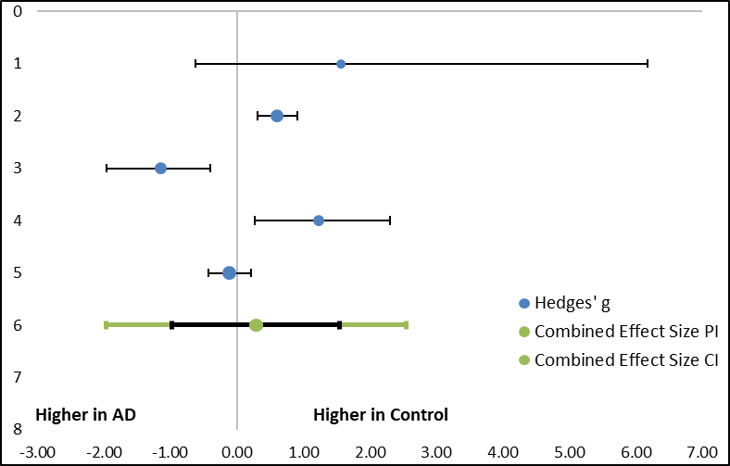
Current study | 89.55 | 21.85 | 2 | 179.2 | 40.16 | 2 | 11.3 | 1.56[-.0.63, 6.17]
Kononikhin et al. (2022) | 750.81 | 207.58 | 96 | 878.63 | 215.13 | 86 | 25.47 | 0.6[0.31, 0.9]
Nielsen et al. (2021) | 11235145 | 6276581.3 | 20 | 5130950 | 2298780.6 | 12 | 20.22 | -1.15[-1.96, -0.39]
Kitamura et al. (2017) | 0.93 | 0.23 | 9 | 1.27 | 0.29 | 10 | 17.72 | 1.23[0.27, 2.31]
Llano et al. (2013) | 19.06 | 9.31 | 109 | 17.9 | 12.12 | 58 | 25.29 | -0.11[-0.43, 0.21]
Total (95% CI) |  |  | 236 |  |  | 168 | 100 | 0.29[-0.97,1.55]
Heterogeneity: Q= 30.58, T2= 0.46, I2= 86.92%, df=1(P=0.33)
Pearson Correlation (r)= 0.14
Test for overall effect: Z= 0.64(P<0.001)
Fibrinogen alpha chain (FGA)
Current study | 5442.55 | 2457.27 | 2 | 2137.55 | 192.55 | 2 | 12.63 | -1.07[-4.82, 1.03]
Eldem et al. (2022) | 11033333.33 | 10807559.08 | 3 | 94520000 | 115475760.2 | 3 | 12.26 | 0.81[-0.9, 2.94]
Kononikhin et al. (2022) | 8838.22 | 9495.83 | 96 | 7171.53 | 2865.56 | 86 | 47.45 | -0.23[-0.53, -0.06]
Nielsen et al. (2021) | 585574850 | 580103821.2 | 20 | 202492583.3 | 240616706.5 | 12 | 27.66 | -0.77[-1.54, -0.04]
 |  |  |  |  |  |  |  |  | 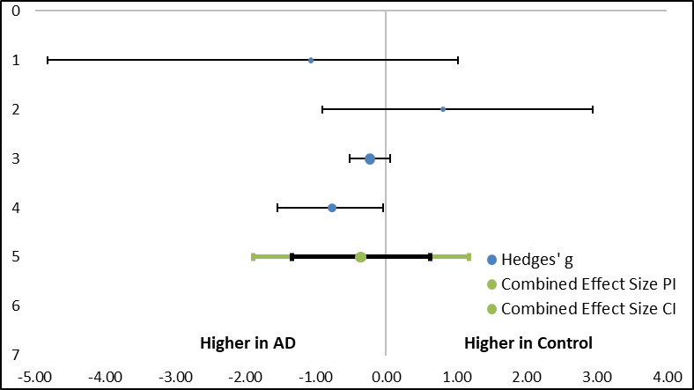
Total (95% CI) |  |  | 121 |  |  | 103 | 100 | -0.36[-1.34, 0.63]
Heterogeneity: Q= 5.71, T2= 0.14, I2= 47.47%, df=1(P=0.42)
Pearson Correlation (r)= 0.19
Test for overall effect: Z= -1.16(P=0.13)
Complement C2 (C2)
Current study | 787.6 | 212.21 | 2 | 1357.45 | 34.01 | 2 | 10.09 | 2.12[-0.28, 7.78]
Kononikhin et al. (2022) | 90.36 | 17.85 | 96 | 92.09 | 16.1 | 86 | 54.49 | -0.1[-0.19, 0.39]
Nielsen et al. (2021) | 38268.42 | 81625.73 | 20 | 1990.58 | 6895.58 | 21 | 35.42 | 0.00[-0.73, 0.73]
Total (95% CI) |  |  | 118 |  |  | 109 | 100 | 0.27[-1.62, 2.16] | 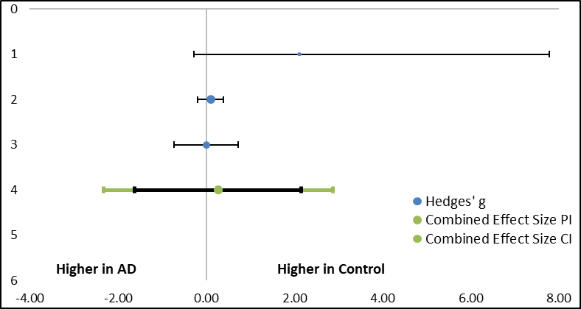
Heterogeneity: Q= 4.66, T2= 0.17, I2= 57.11%, df=1(P=0.83)
Pearson Correlation (r)= 0.13
Test for overall effect: Z= 0.61(P=0.1)

Complement C4-A (C4A)
Current study | 6097.25 | 1013.21 | 2 | 11385.55 | 1878.57 | 2 | 46.97 | 1.97[-0.36, 7.37]
Nielsen et al. (2021) | 25536405 | 11532222.58 | 20 | 12670816.67 | 4609442.93 | 12 | 53.03 | 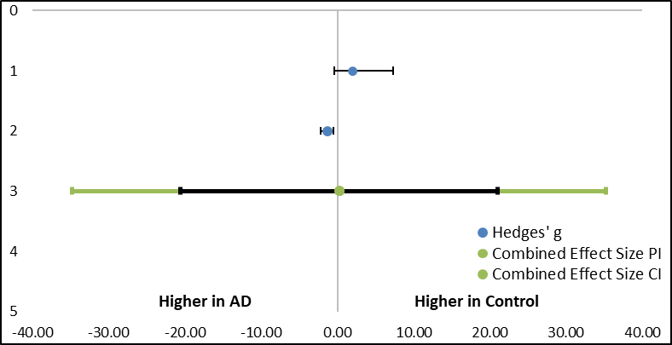  -1.31[-2.14, -0.54]
Total (95% CI) |  |  | 22 |  |  | 14 | 100 | 0.24[-20.59, 21.06]
Heterogeneity: Q= 11.23, T2= 4.91, I2= 91.1%, df=1(P=0.001)
Pearson Correlation (r)= 0.39
Test for overall effect: Z= 0.14(P<0.001)
Inter-alpha-trypsin inhibitor heavy chain H4 (ITIH4)
Current study | 1849.9 | 298.23 | 2 | 2904.7 | 426.1 | 2 | 21.93 | 1.62[-0.59, 6.33]
Eldem et al. (2022) | 7258000 | 12163037.94 | 3 | 50573333.33 | 84394467.43 | 3 | 27.78 | 0.57[-1.15, 2.58]
Nielsen et al. (2021) | 2084939 | 782155.85 | 20 | 1314530 | 1025188.88 | 12 | 50.29 | 0.00[-0.73, 0.73]
 |  |  |  |  |  |  |  |  | 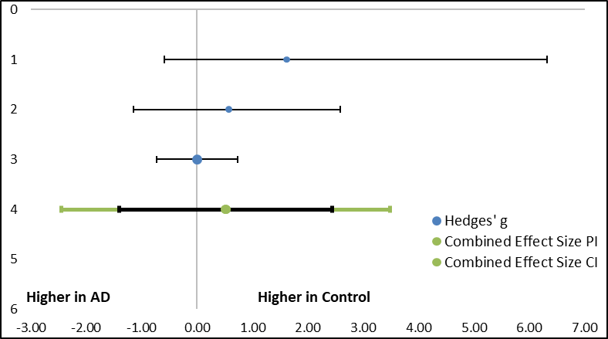
Total (95% CI) |  |  | 25 |  |  | 17 | 100 | 0.51[-1.41, 2.44]
Heterogeneity: Q= 3.56, T2= 0.27, I2= 43.83%, df=1(P=0.44)
Pearson Correlation (r)= 0.32
Test for overall effect: Z= 1.15(P=0.17)
Note: Blue dot (Hedges’ g) represents the SMD for each individual study where the positive value indicates higher levels of proteins in AD compared to normal controls. Green dot indicates the total SMD controlled by the combined effects of prediction interval (PI) and confidence interval (CI). Total SMD with positive value indicates upregulation of the proteins in AD group.

