Supplementary Table S1: List of 20 medicinal weeds species used in the study for screening of pigments, phytochemical properties and free radical scavenging potential
Scientific Name | Common/English name | Family | Pictures
Acalypha indica L. | Indian nettle | Euphorbiaceae | 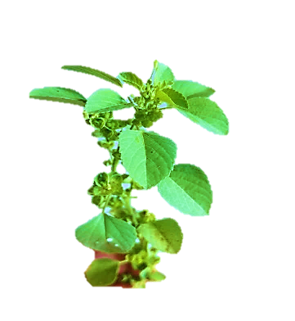
Ageratum conyzoides L. | Billygoat Weed | Asteraceae | 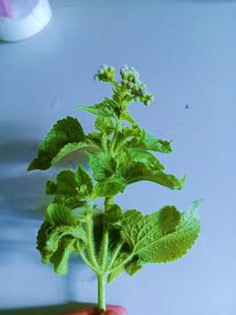
Alternanthera sessilis L. | Sessile joyweed | Amaranthacea | 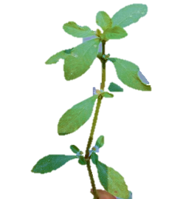
Bryophyllum calycinum S. | Mother of thousands | Crassulaceae | 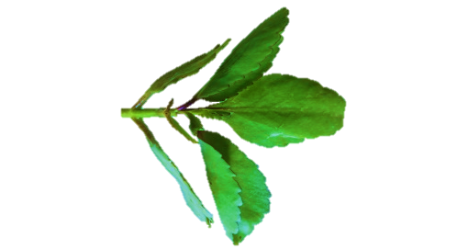
Centella verticillata T. | Whorled pennywort | Araliaceae | 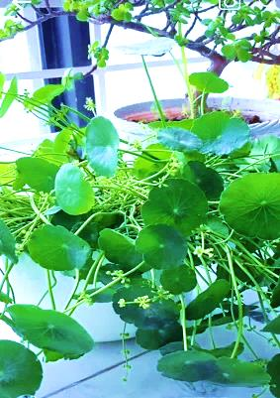
Coccinia grandis L. | Ivy gourd | Cucurbitaceae | 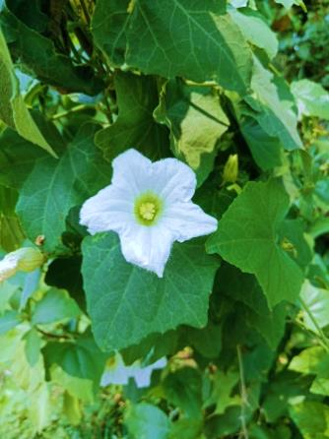
Eclipta postrata L. | False daisy | Asteraceae | 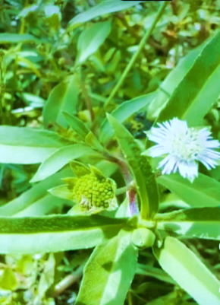
Enhydra fluctuans Lour. | Water spinach | Asteraceae | 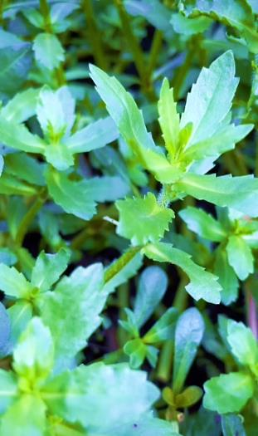
Euphorbia hirta L. | Asthma plant | Euphorbiaceae | 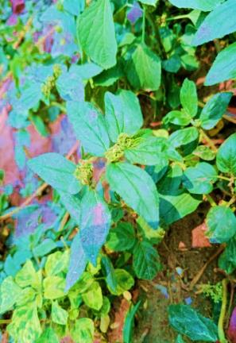
Heliotropium indicum L. | Indian turnsole | Boraginaceae | 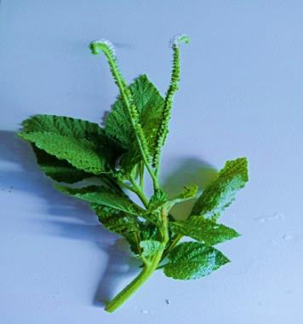
Oxalis corniculata L. | Creeping wood sorrel | Oxalidaceae | 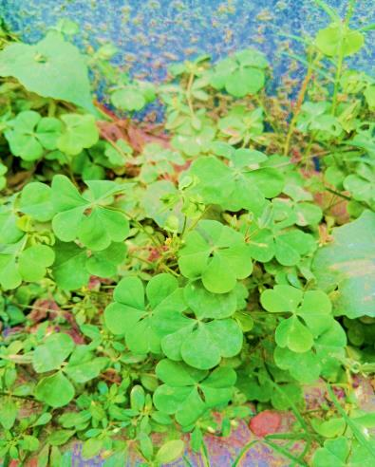
Parthenium hysterophorus L. | Famine weed | Asteraceae | 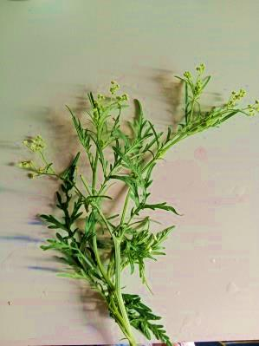
Persicaria lapathifolia L. | Pale smartweed L. | Polygonaceae | 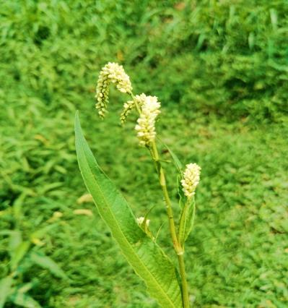
Portulaca oleracea L. | Common purslane | Portulacaceae | 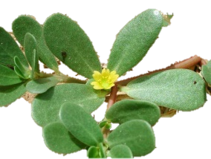
Ruellia tuberosa L. | Minnieroot | Acanthaceae | 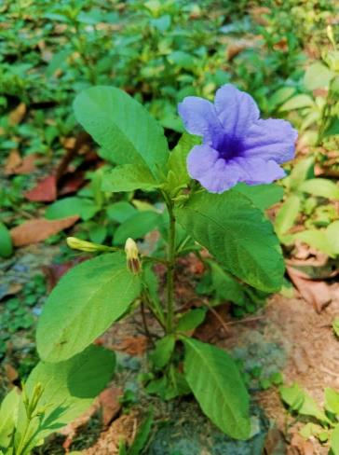
Scoparia dulcis L. | Sweet broom weed | Scrophulariaceae | 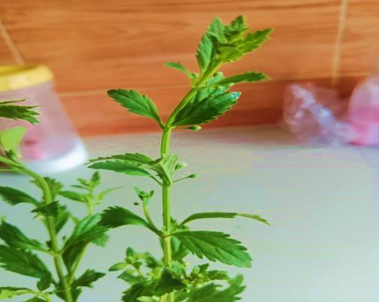
Senna occidentalis L. | Coffee senna | Fabaceae | 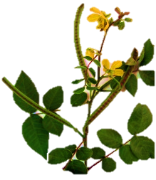
Synedrella nodiflora L. | Node weed | Asteraceae | 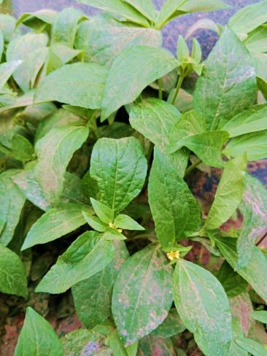
Trema orientalis L. | Charcoal tree | Cannabaceae | 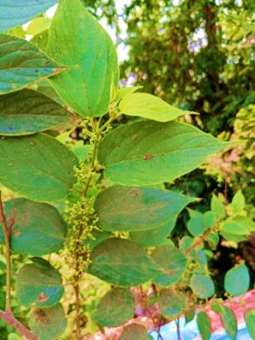
Tridax procumbens L. | Coat buttons | Asteraceae | 