Supplemental file 1

**Figure 1S**

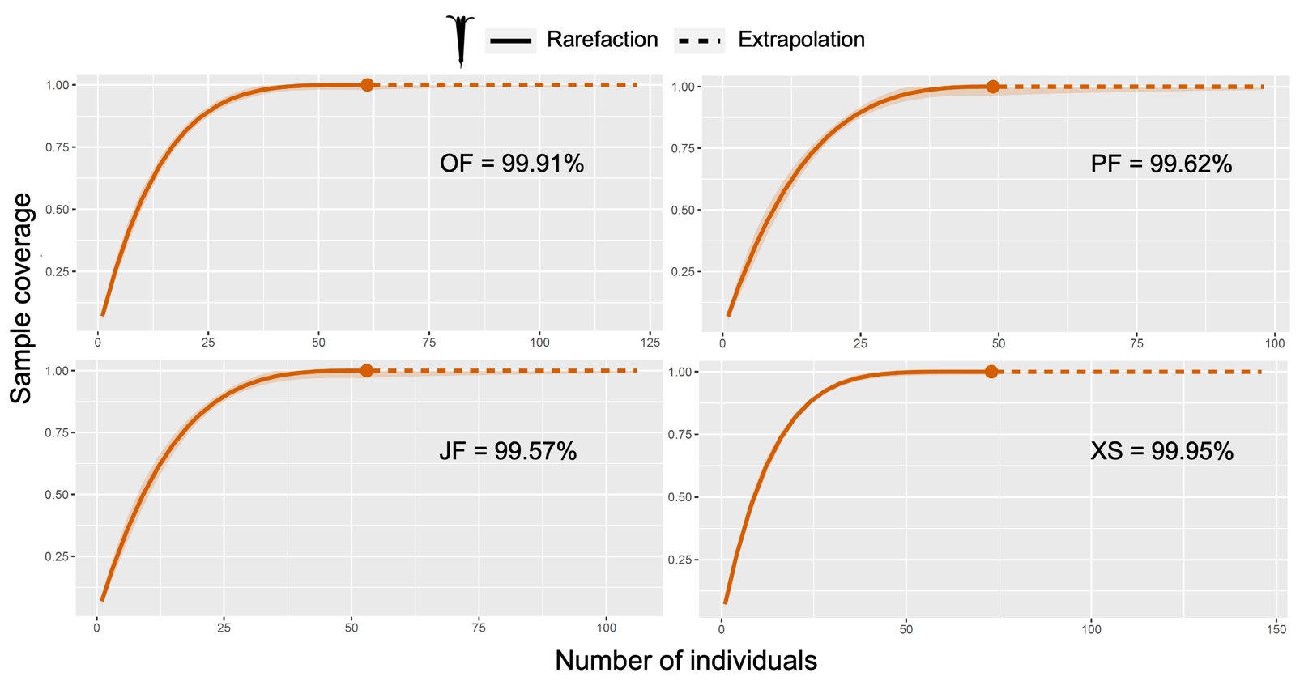

**Fig. 1S.** Sample coverage for the four habitat types studied: oak forest (OF), pine forest (PF), juniper forest (JF) and xerophytic shrubland (XS), including the percent of estimated plant diversity recorded. In all habitat types, we collect more than 99% of the expected plant species richness.

.

**Figure 2S**

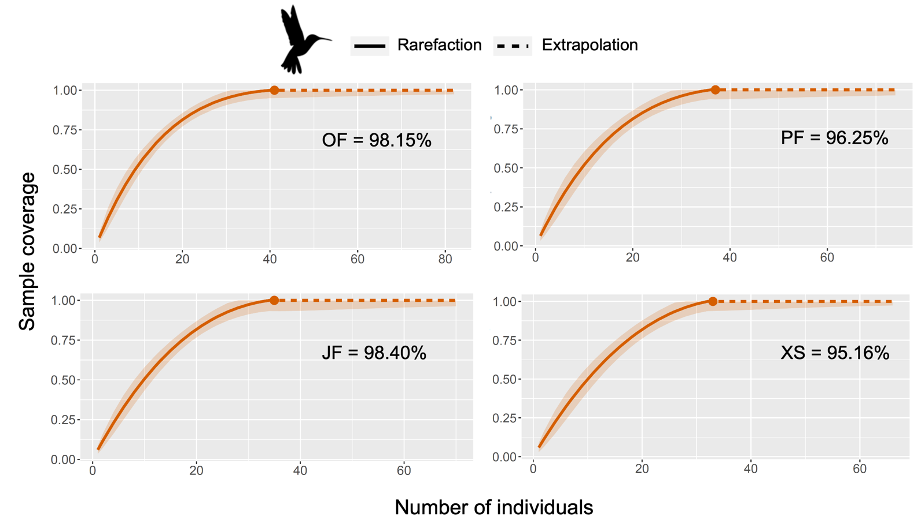

**Fig. 1S.** Sample coverage for the four habitat types studied: oak forest (OF), pine forest (PF), juniper forest (JF) and xerophytic shrubland (XS), including the percent of estimated hummingbird diversity captured. In all habitat types, we collect either a little over 95% or even more than 98% of the expected hummingbird species richness