SD-TLH+50 mM 3AT CHI

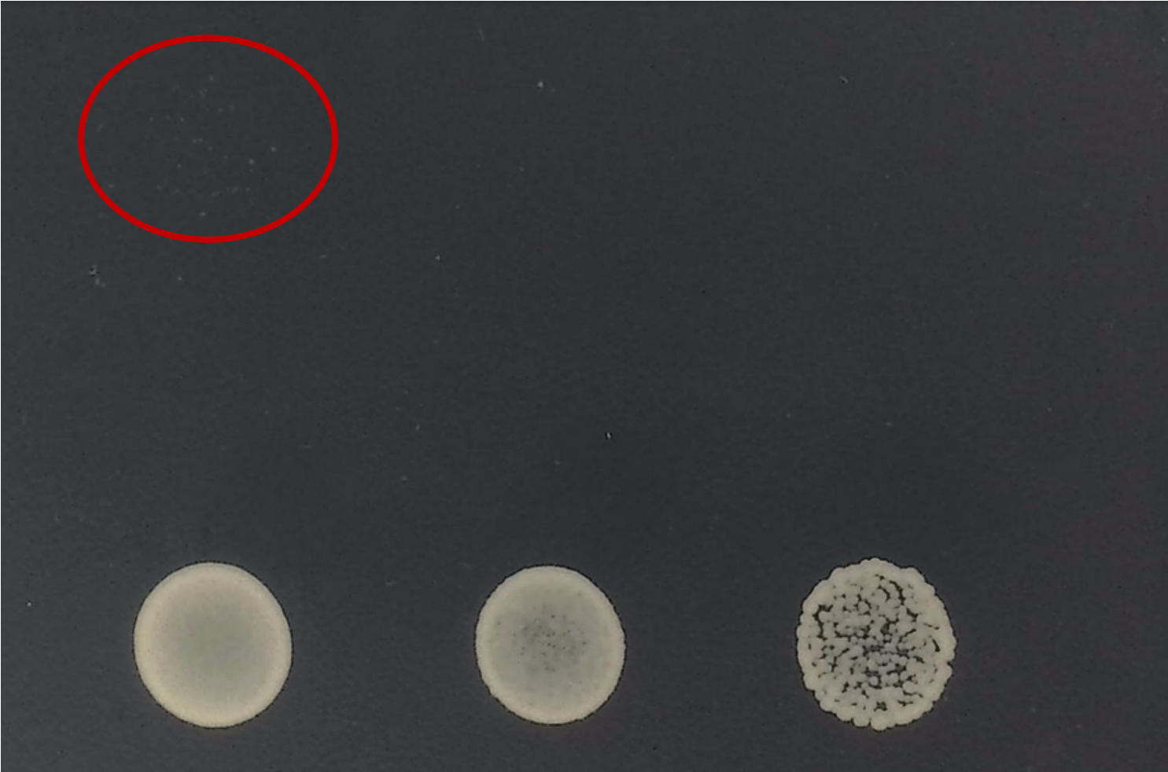

SD-TLH+50 mM 3AT GT