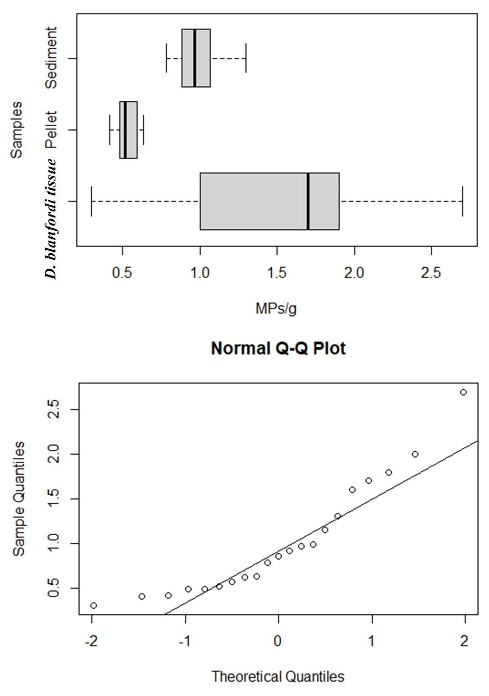

**Supplementary figure 1s:**

Abundance of microplastic contamination in the burrow sediment, feeding pellet and crab’ tissue collected from study site Asharmata, showing not a normal distribution (Shapiro-Wilk test, W = 0.88, p = 0.01).