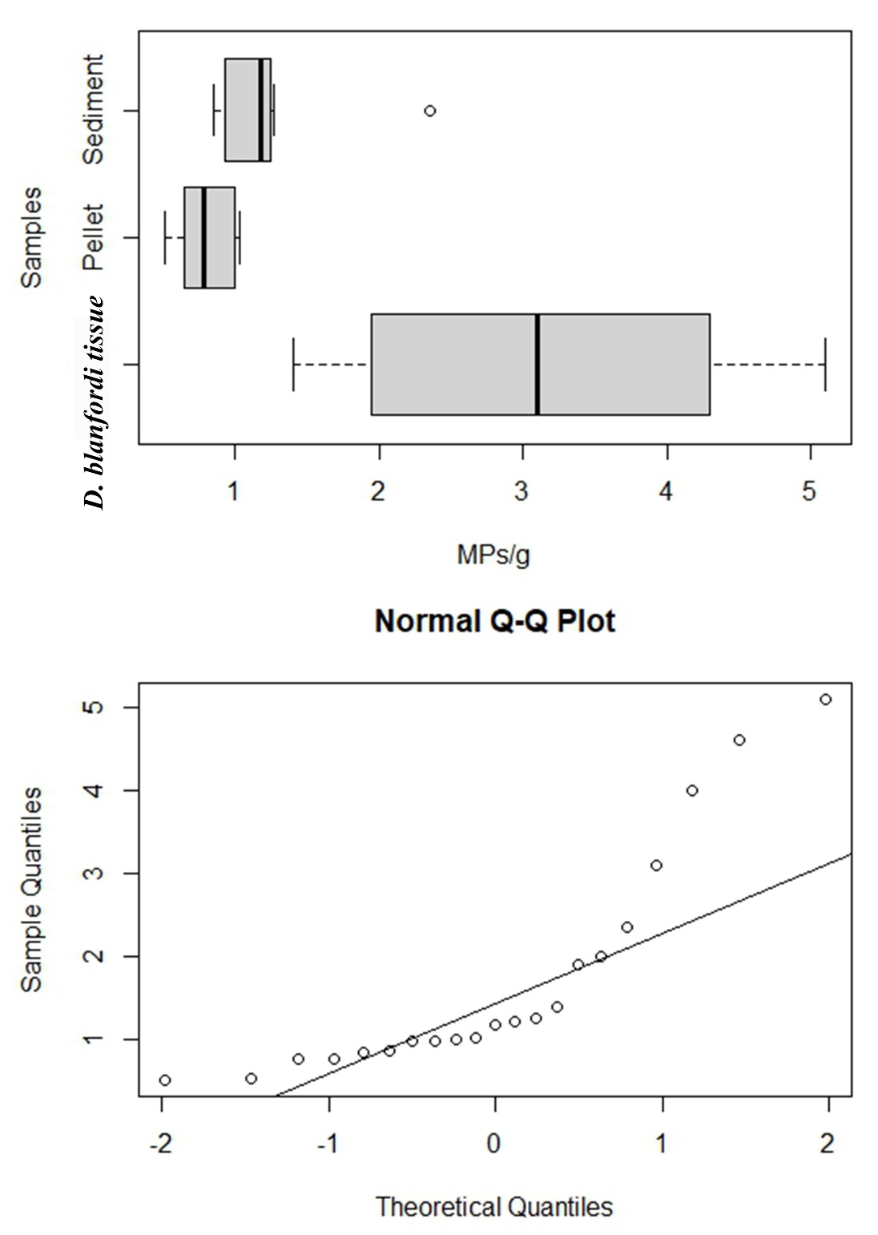

**Supplementary figure 2s:**

Abundance of microplastic contamination in the burrow sediment, feeding pellet and crab’ tissue collected from study site Mandvi, showing not a normal distribution (Shapiro-Wilk test, W = 0.77, p = 0.0003).