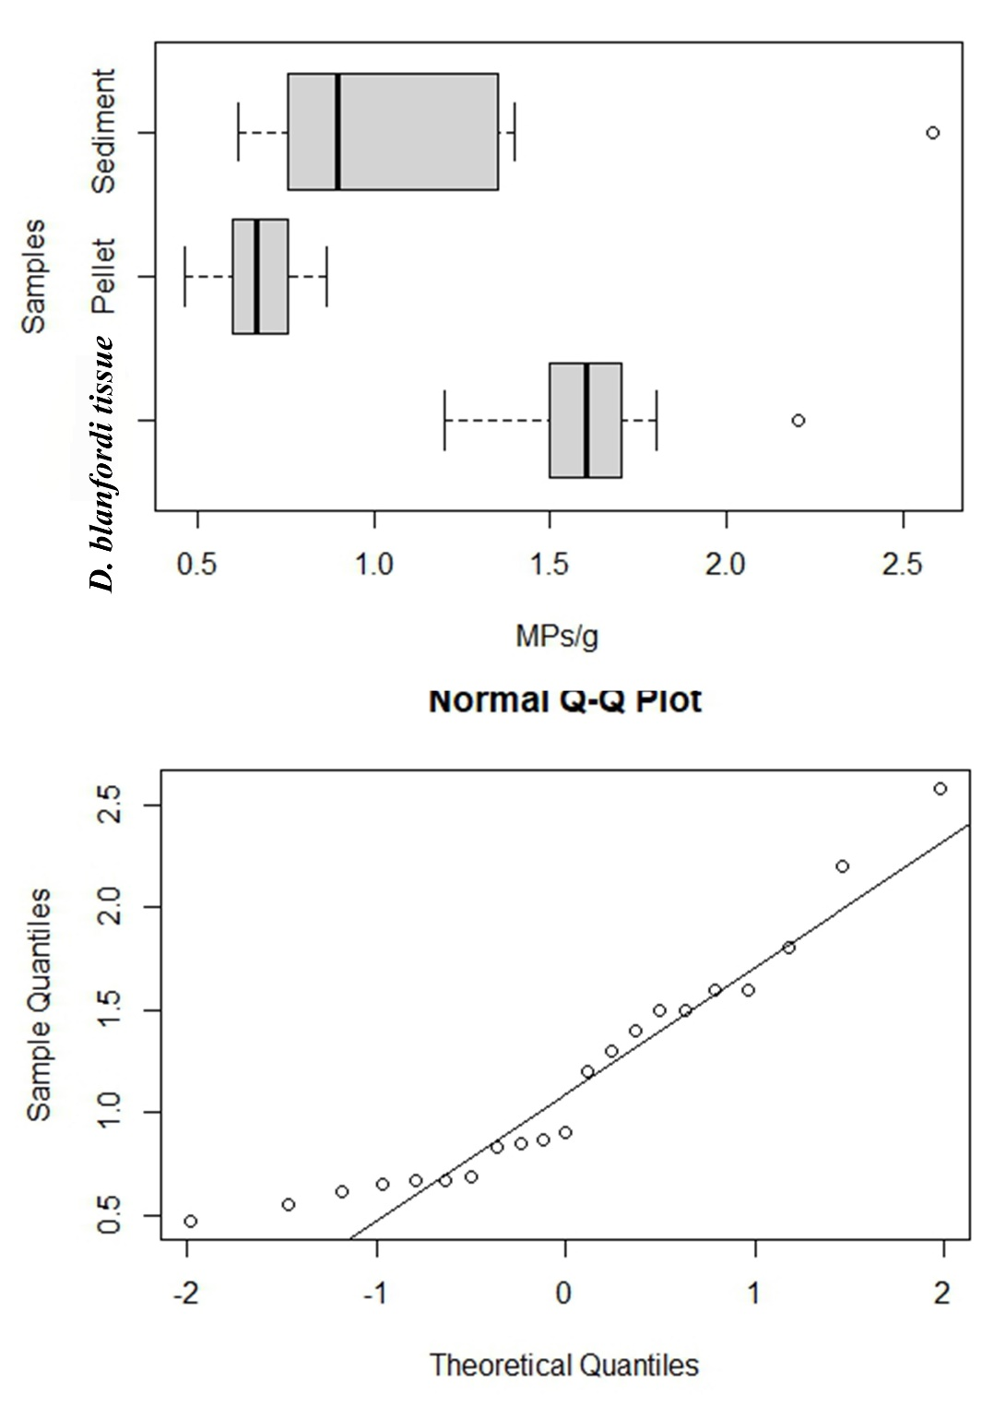

**Supplementary figure 3s:**

Abundance of microplastic contamination in the burrow sediment, feeding pellet and crab’ tissue collected from study site Serena, showing not a normal distribution (Shapiro-Wilk test, W = 0.90, p = 0.04).