Supplemental information

Figure 1 Determination of allicin in the in vitro BBB model by HPLC analysis

Chromatogram of Hank’s Balanced Salt Solution (HBSS) or baseline
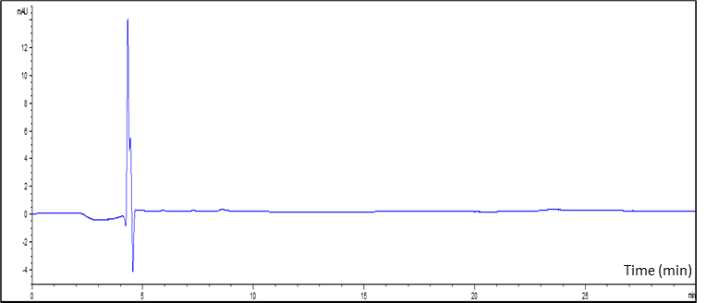

Chromatogram of allicin standard curve at 0.5 µg/ml
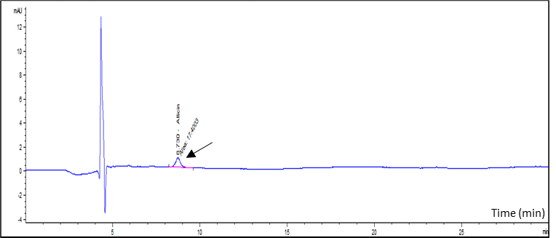

Chromatogram of allicin standard curve at 1 µg/ml
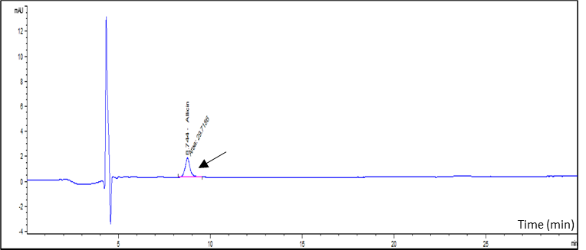

Chromatogram of allicin standard curve at 1.5 µg/ml
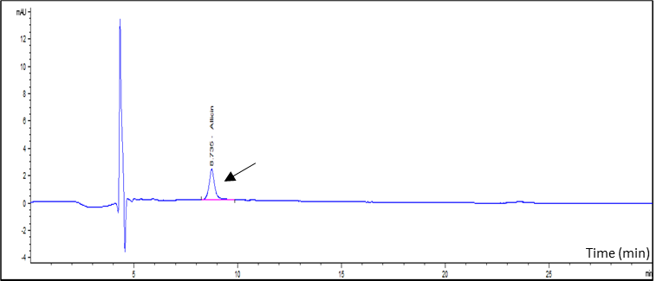

Chromatogram of allicin standard curve at 2 µg/ml
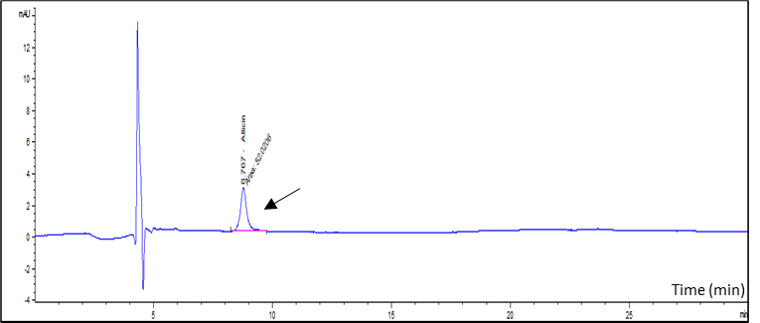

Chromatogram of allicin standard curve at 3 µg/ml
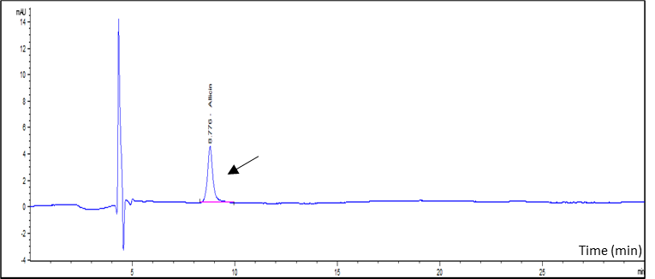

Chromatogram of allicin standard curve at 4 µg/ml
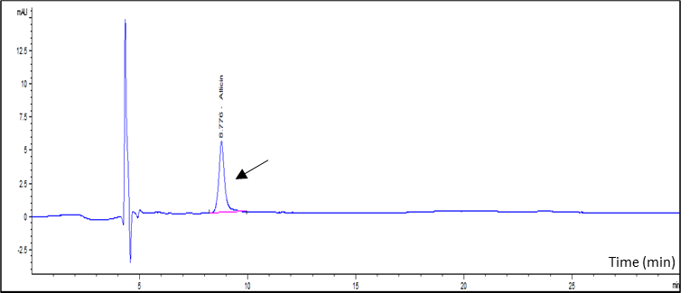

Chromatogram of allicin standard curve at 5 µg/ml
