Development and Clinical Application of a Rapid and Visual Detection of tcdA gene in Clostridioides difficile by a Specific and Sensitive Loop-Mediated Isothermal Amplification Assay

Minyi Lin^{1,#}, Pu Wang^{3,#}, Bingyun Lu², Ming Jin² , Jiasheng Tan⁴, Wei Liu⁵ , Jing Yuan⁵, Xiaomou Peng^{1,*} and Ye Chen^{2,*}

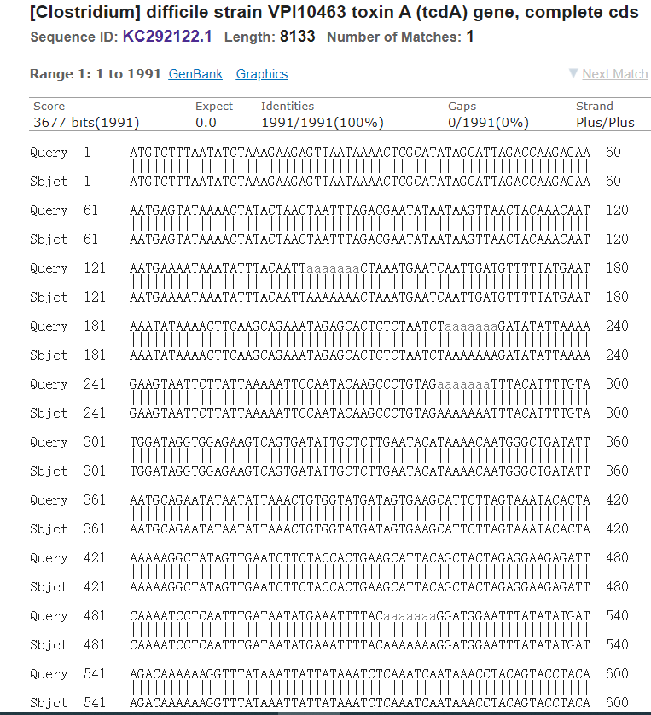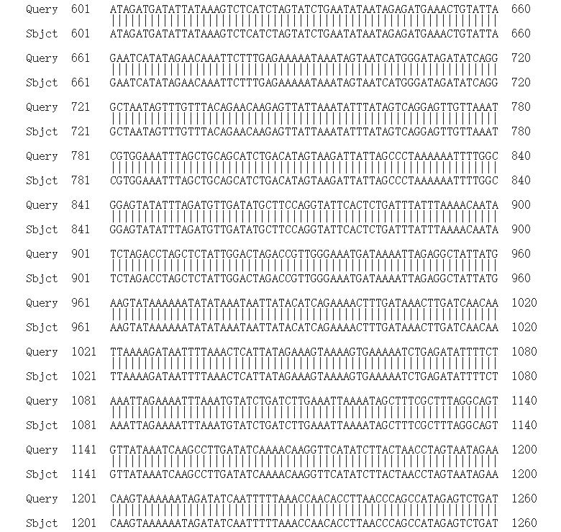

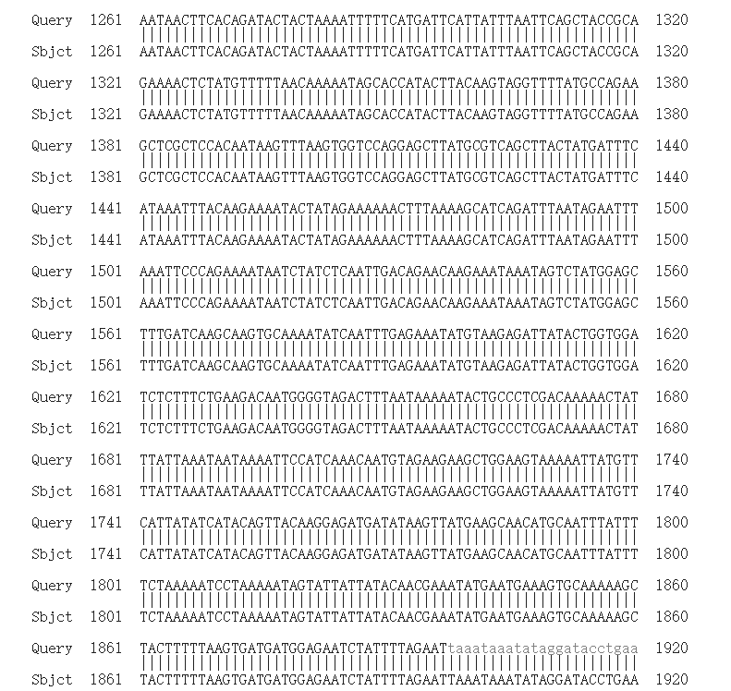
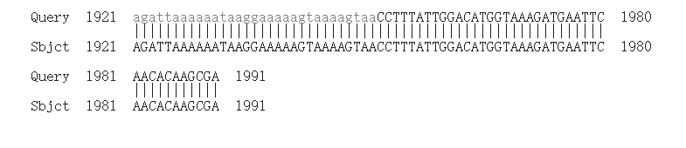

Figure S1: Sequence comparison of tcdA gene carried by Clostridioides difficile VPI10463 with the reported tcdA gene in GenBank.

