The QPCR experiment report

1 Reagent
PCR-related reagents | vender
absolute ethyl alcohol | Chengdu Cologne Chemicals Co., LTD
TRlzol | Ambion
primer | Engine biology
chloroform | Chengdu Gulda Rubber Industry Co., LTD
No RNase water was available | Sevier
isopropanol | Chengdu Gulda Rubber Industry Co., LTD

2 Instruments
PCR-related instruments | vender
S1000 ™ Thermal Cycler, ordinary PCR instrument | BIO-RAD
CFX Connect Real-time quantitative fluorescence PCR instrument | BIO-RAD
And 96-well quantitative PCR plates | Sevier
PCR plate sealing membrane | LABSELECT
Chemiluminescence, and the imaging system, ChemiScope 6100 | Shanghai Qinxiang Scientific Instrument Co., LTD
H1 16KR Desktop freezing high-speed centrifuge | Can become an instrument
The SC-3610 low-speed centrifuge | Anhui Zhongke Zhongjian Scientific Instrument Co., LTD
Palm instantaneous centrifuge (with reagent or mix) | SCLLOGEX
Vortex oscillator SCL-VS | SCLLOGEX
Electrophoresis meter (164-5050) | BIO-RAD
10 μ l, 20 μ l, 200ul, 1000ul gun head | Beijing Ranjke Technology Co., LTD
Trace sampler | thermo scientific
Handheld instantaneous centrifuge CF2800M | LABGIC
beveller | Sevier
Seal plate instrument | Sevier

3 Methods

3.1 The extraction of the total RNA
Five pairs of frozen whole blood samples, 1-5 for Control group, 6-10 for AML group, each sample took 600ul of whole blood, add 1ml of TRIzol reagent, fully homogenate, let on ice for 10 minutes to fully lysis cells, add 300ul chloroform, shake vigorously for 30 seconds, stand at room temperature for 10 minutes, make liquid layered, centrifugation at 12000g and 4℃ for 15 minutes, visible liquid was divided into three layers, and RNA was retained in the colorless upper aqueous phase. Carefully absorb the upper water phase into another EP tube, be careful not to suck to the middle layer and lower layer (if not carefully, must be gently squeezed), then add the volume of ice isopropyl alcohol, reverse, stand for 10 minutes (when the sample size is less in-20 degrees refrigerator overnight, to improve the RNA extraction rate), centrifugation for 10 minutes 12000g, 4℃, visible bottom of the white RNA sediment generation (sample size less precipitation is invisible to the naked eye, also does not affect the normal operation). Gently tilt the tube mouth to discard the supernatant, be careful not to pour out the precipitation, absorbent paper to dry the tube mouth, add 1 ml of 75% ethanol to the precipitation, reverse the precipitate down a few times to let the precipitate float, stand for 2 minutes, centrifuge 7500g, 4℃ for 5 minutes, make the precipitation adhere to the bottom of the tube again, repeat this step twice. Remove the cleaning, pour the centrifuge tube on the absorbent paper, carefully absorb the remaining liquid with 10ul of the gun head, pay attention not to suck away the precipitation, and dry naturally for 20 minutes or put into the ultra-clean working table to blow dry, make the ethanol and water evaporate as far as possible, the RNA precipitation becomes transparent, but not too dry, otherwise it will affect the subsequent dissolution of RNA. 20-50ul of RNase-free water was added to the dried RNA precipitate, allowed for 15 minutes to dissolve the RNA thoroughly, and took 1ul of Nano drop for concentration to calculate the subsequent reverse transcription step, and the remaining RNA was immediately reverse transcribed or frozen in a-80℃ refrigerator.

3.1.1 It was used for RNA detection
RNA concentration detection:
1 ul of RNA was detected by N anoPhotometer N 50.
Concentration test results:
number | Sample name | divide into groups | Concentration (ng / uL) | A260/A280 | A260/A230
1 | 6 | Control | 1737.2 | 1.852 | 1.384
2 | 7 | Control | 462.60 | 1.778 | 1.297
3 | 8 | Control | 379.4 | 1.571 | 0.649
4 | 9 | Control | 1110.7 | 1.865 | 1.561
5 | 10 | Control | 242.8 | 1.560 | 0.645
6 | 1 | AML | 1107.50 | 1.652 | 0.885
7 | 2 | AML | 549.6 | 1.856 | 1.594
8 | 3 | AML | 616.16 | 1.852 | 1.69
9 | 4 | AML | 2358.6 | 1.775 | 1.144
10 | 5 | AML | 2035.8 | 1.186 | 1.318

3.2 Reverse transcription
Reverse transcription of mRNA, using, SureScript-First-strand-cDNA-synthesis-kit kit, specifically: remove the components of the kit, melt at room temperature, centrifuge briefly, put on ice, and add the following reagents and solutions on ice in the following order:

Component | Volume
5x Reaction Buffer | 4ul
P rimer | 1ul
S weScript RT I Enzyme Mix | 1ul
T otal RNA | 0.1ng-5ug
N u clease-Free Water | A dd to 20ul

After brief centrifugation, reverse record on an ordinary PCR instrument using the following conditions:
temperature | time
25℃ | 5min
50℃ | 15min
85℃ | 5s
4℃ | hold

3.3 Computer detection
The cDNA was added with ddH₂O (RNase / DNase free) was diluted 5-20 times. Then perform the qPCR reaction according to the following reaction system:
Component | Volume
cDNA | 3ul
2xUniversal Blue SYBR Green qPCR Master Mix | 5ul
Forward primer (10µM ) | 1ul
Reverse primer (10µM) | 1ul

On the operation, each draw liquid should check whether there are bubbles in the gun, the liquid into the hole also check whether there is liquid residue in the gun, if there is residual, should be the residual liquid instrument into the corresponding hole, and the sample operation must be one, not other experimental operation or do irrelevant things, in order to ensure the consistency of repeated hole.
After brief centrifugation, the reactions were performed for 40 cycles in a CFX 96 quantitative real-time fluorescence PCR instrument under the following conditions, making amplification and dissolution curves and read Ct values.
The amplification conditions are listed below:
 | temperature | time
Predenaturation | 95℃ | 1min
denaturation | 95℃ | 20s
anneal | 55℃ | 20s
extend | 72℃ | 30s

Related primer sequences are as follows:
primer | order
CCL4 F | AAGTCTGTGCTGATCCCAGTG
CCL4 R | GAGAAGGGACAGGAACTGCG
CCL20 F | GGGTTGGAGGTTTCACTTGC
CCL20 R | ATTGGACAAGTCCAGTGAGGC
CCR2 F | AGAGGCATAGGGCAGTGAGA
CCR2 R | TGAAAAAGGCTTCTGAACTTCTCC
CXCR2 F | TTCCTGGGTACAGTGCTATTC
CXCR2 R | TAAATCCTGACTGGGTCGCTG
CXCR3 F | CTTTTCGCCCTCCCAGACTT
CXCR3 R | ATGTGGGCATAGCAGTAGGC
CXCR6 F | GTCAGGACTCAAAGTCAGCG
CXCR6 R | GAACACATCCGTCAGGCTCT
Internal reference-GAPDH F | CGAAGGTGGAGTCAACGGATTT
Internal reference-GAPDH R | ATGGGTGGAATCATATTGGAAC

.4 3 Results analysis
First look at the dissolution curve, if it is a smooth single peak, the primer specificity is good. If the curve is not smooth but only a large single peak, it shows that the primer specificity is general and the data is ok. If the curve is bimodal or multimodal, the primer specificity is too poor, and the primer needs to be redesigned to repeat the experiment.
The relative expression level of genes was calculated by the 2 △△ Ct method, specifically as follows:
In the first step, △ Ct = Ct (target gene) -Ct (reference gene);
△△ CT= △ Ct (experimental group) - △ Ct (control group);
Finally calculation 2^{-△△CT}Values, and the P-values were calculated using the Graphpad Prism 5 plot.

bear fruit

Primer specificity

CCL4
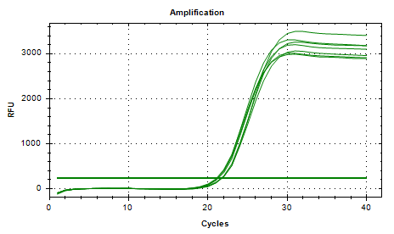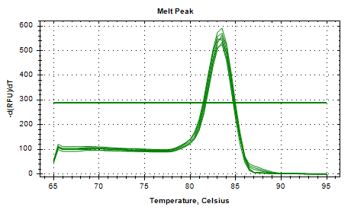
CCL20
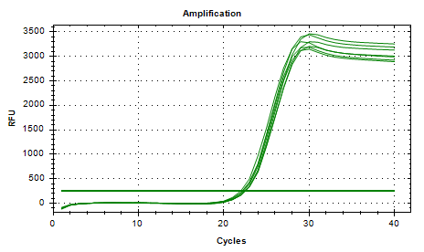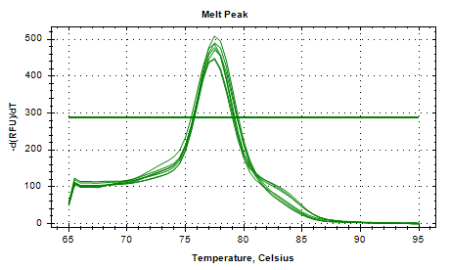
CCR2
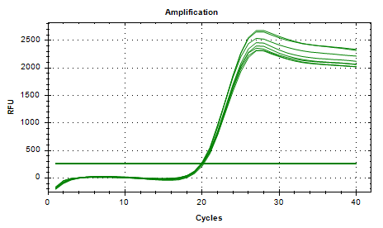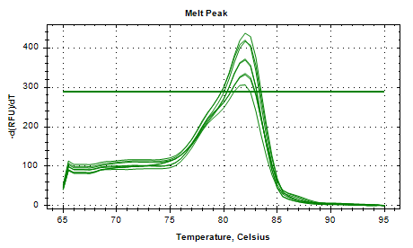
CXCR2
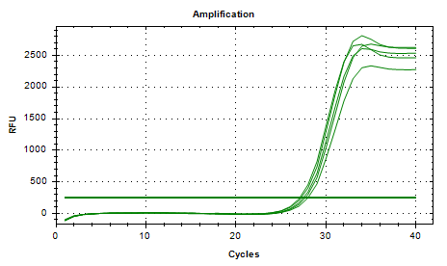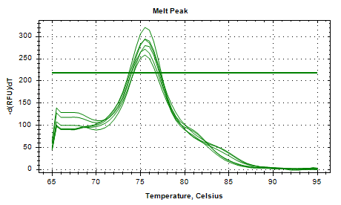
CXCR3
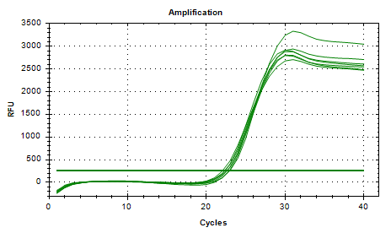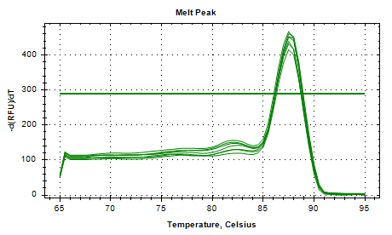
CXCR6
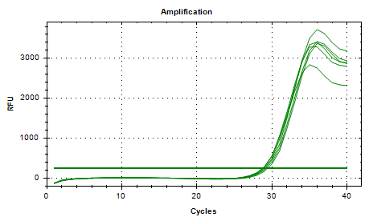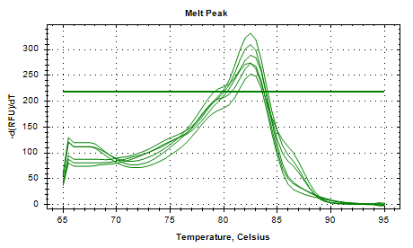
GAPDH
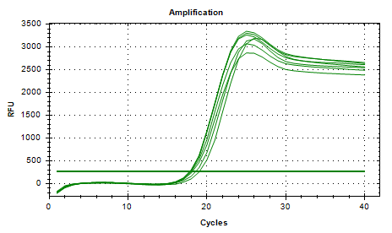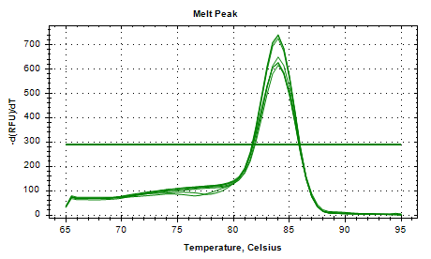
Figure 1 A dissolution amplification curve
First look at the dissolution curve, if it is a smooth single peak, the primer specificity is good. If the curve is not smooth but only a large single peak, it shows that the primer specificity is general and the data is ok. If the curve is bimodal or multimodal, the primer specificity is too poor, and the primer needs to be redesigned to repeat the experiment.

detection result

Table 1 Statistical three-line tables of the results
 | Control | AML | p price
CCL4 | 1±0.3289 | 0.5126±0.1959 | 0.0216
CCL20 | 1±0.1924 | 0.5999±0.0852 | 0.0028
CCR2 | 1±0.4812 | 0.3851±0.1995 | 0.0298
CXCR2 | 1±0.6218 | 0.7185±0.3733 | 0.4108
CXCR3 | 1±0.5533 | 0.3565±0.1124 | 0.0343
CXCR6 | 1±0.7427 | 0.7524±0.3013 | 0.5092

Figure 2. Comparison of the expression differences

