**SUPPORTING INFORMATION**

**Genetic investigation of population structure in Atlantic chub mackerel, *Scomber colias* Gmelin, 1789 along the West African coast**

**FIGURES**

**Fig S1.** Percentage of missing data per locus and sample.

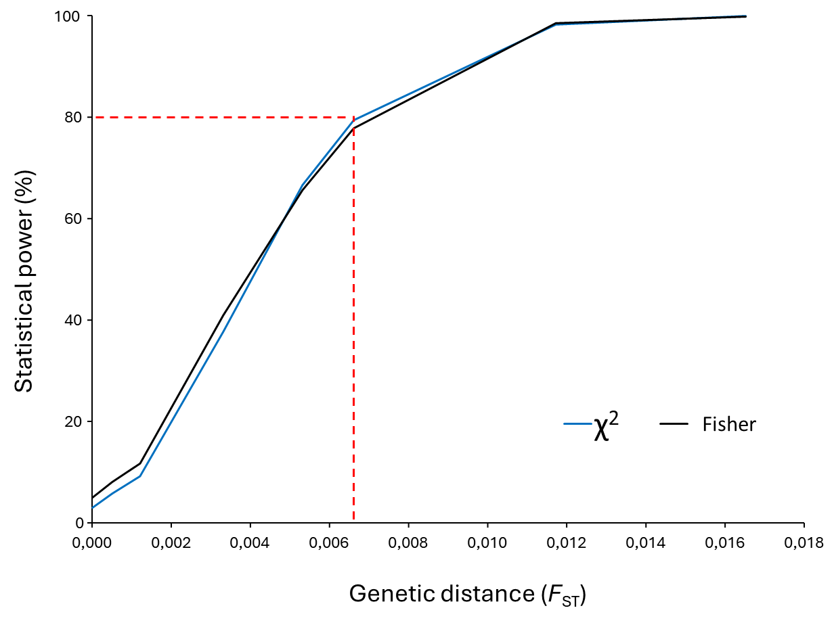

**Fig S2.** Statistical assessment of power to detect significant differentiation between two populations conducted with POWSIM. The red line depicts the power threshold of 80% following the recommendations by Ryman and Palm (2006); *i.e.* our data set carries enough statistical power to detect significant differentiation at *F*ST≥0.0065 some 80% of the times.

**Fig S3.** Genotype accumulation curve calculated for the set of 8 microsatellites using the total 1169 individuals.

|  |
| --- |
| a) |

|  |
| --- |
| b) |

**Fig S4.** Output of STRUCTURE with (a) and without (b) using LOC PRIORS using both Puechmaille and Evanno Methods.

|  |
| --- |
|  |

**Fig S5.** Barplot of STRUCTURE at K=2 without using LOCPRIORS.

**TABLES**

**Table S1.** Microsatellite loci used in the present study: distribution into multiplex reactions. References correspond to:

(1) Chen FF, Ma CY, Yan LP, et al. (2017) Isolation and characterization of polymorphic microsatellite markers for the chub mackerel (*Scomber japonicus*) and cross-species amplification in the blue mackerel (*S. australasicus*). Genetics and Molecular Research: GMR 16 (3), gmr16039712.

(2) Zeng L, Cheng Q (2012) Thirty novel microsatellite markers for the coastal pelagic fish, *Scomber japonicus* (Scombridae). Journal of Genetics 91, e64-68

(3) Catanese G, Funes V, Perez L, Infante C (2010) Microsatelites for *Scomber colias* (https://www.researchgate.net/publication/281005067).

|  |  |  |  |  |  |  |  |  |  |
| --- | --- | --- | --- | --- | --- | --- | --- | --- | --- |
| **Locus** | **Size range (bp)** | **No alleles** | **Motif** | **Primer sequences (F, forward and R, reverse)** | **Ta (°C)** | **[MgCl2]** | **Multiplex** | **Accession no.** | **Reference** |
| SJT5 | 74_130 | 28 | (CT)17 | F: CCAGTGGGAATCAAATCA  R: TGGGCATCCATACTACCT | 55 | 2mM | 1 | JN656631 | 2 |
| SJNT19 | 158_224 | 33 | (GA)26 | F: ACAGATCGGTCCAATCAAG  R: TTGTCAACTCCAGCAAATG | 56 | 2mM | 1 | JN656651 | 2 |
| SJT199 | 228_310 | 31 | (TC)5-(GA)5-(AG)5-(AG)15 | F: CCTCACTTCCACTCCTCTA  R: CTGCCATCCTCCTCTCAT | 58 | 2mM | 2 | JN656647 | 2 |
| Sco2_1 | 129_205 | 21 | (CCCT)6(CCTT)11(CCTC)2 | F: GAGGAACCAGATTACAGGTAGTCAGGTATTGGTG  R: TGTGGAGCAACAACGAGTTTAACAACGTC | 60 | 2mM | 2 | AB354595 | 3 |
| SJ78 | 196_232 | 18 | (TC)5…(CT)7 | F: GCATTGAGATGATTTTGGTA  R: GCAGAATTGGGATGGAAATA | 53 | 3mM | 3 | KY042115 | 1 |
| SJT122 | 78_124 | 24 | (AG)29 | F: GCACACAAGTCTTCTTCG  R: GGATCGTGACGGTTCTATT | 52 | 3mM | 3 | JN656641 | 2 |
| SJT182 | 123_189 | 27 | (CT)5-(CT)20-(TC)8 | F: GCTCCCTGAATGAATCACT  R: ATCAGCAAGTCAGCAGAG | 52 | 3mM | 3 | JN656646 | 2 |
| SJT53 | 167_221 | 28 | (AG)5-(AG)7-(AG)8-(AG)5 | F: ACAGTAAGCGAGACAGACA  R: ATAATCAACAAACCCACAG | 52 | 3mM | 3 | JN656639 | 2 |

**Table S2.** Frequency of null allele(s) estimated with maximum likelihood method using the EM algorithm of Dempster et al. (1977). According to MICROCHECKER evaluation, the first two rows of loci were suggestive of harbouring null alleles in contrast with the last six ones.

|  |  |  |  |  |  |  |  |  |
| --- | --- | --- | --- | --- | --- | --- | --- | --- |
| **Sample** | **SJT5** | **Sco2-1** | **SJNT19** | **SJT199** | **SJ78** | **SJT122** | **SJT182** | **SJT53** |
| MOR_1 | 0.080 | 0.112 | 0.033 | 0.000 | 0.057 | 0.043 | 0.017 | 0.006 |
| MOR_2 | 0.117 | 0.038 | 0.023 | 0.006 | 0.070 | 0.030 | 0.000 | 0.000 |
| MOR_3 | 0.149 | 0.091 | 0.043 | 0.000 | 0.025 | 0.109 | 0.000 | 0.015 |
| MOR_4 | 0.063 | 0.100 | 0.000 | 0.004 | 0.004 | 0.021 | 0.000 | 0.000 |
| MOR_5 | 0.101 | 0.052 | 0.083 | 0.046 | 0.160 | 0.042 | 0.000 | 0.000 |
| MOR_6 | 0.119 | 0.073 | 0.000 | 0.065 | 0.028 | 0.002 | 0.000 | 0.000 |
| MOR_7 | 0.166 | 0.000 | 0.000 | 0.027 | 0.014 | 0.016 | 0.002 | 0.011 |
| MOR_8 | 0.110 | 0.021 | 0.000 | 0.031 | 0.047 | 0.006 | 0.000 | 0.012 |
| MOR_9 | 0.171 | 0.024 | 0.000 | 0.000 | 0.041 | 0.099 | 0.000 | 0.026 |
| MAU_1 | 0.149 | 0.010 | 0.043 | 0.037 | 0.047 | 0.036 | 0.000 | 0.000 |
| MAU_2 | 0.128 | 0.000 | 0.028 | 0.000 | 0.079 | 0.000 | 0.000 | 0.000 |
| MAU_3 | 0.200 | 0.080 | 0.000 | 0.023 | 0.000 | 0.085 | 0.017 | 0.000 |
| MAU_4 | 0.067 | 0.000 | 0.000 | 0.000 | 0.088 | 0.004 | 0.036 | 0.000 |
| MAU_5 | 0.034 | 0.046 | 0.017 | 0.000 | 0.116 | 0.028 | 0.000 | 0.000 |
| MAU_6 | 0.133 | 0.013 | 0.000 | 0.000 | 0.054 | 0.103 | 0.000 | 0.033 |
| SEN_1 | 0.122 | 0.083 | 0.000 | 0.053 | 0.049 | 0.004 | 0.000 | 0.037 |
| SEN_2 | 0.081 | 0.048 | 0.000 | 0.016 | 0.003 | 0.000 | 0.000 | 0.000 |
| GAM | 0.175 | 0.050 | 0.000 | 0.026 | 0.047 | 0.000 | 0.000 | 0.000 |
| GUIBIS | 0.000 | 0.086 | 0.000 | 0.000 | 0.000 | 0.067 | 0.105 | 0.000 |
| GUI_1 | 0.105 | 0.055 | 0.040 | 0.054 | 0.074 | 0.076 | 0.000 | 0.000 |
| GUI_2 | 0.102 | 0.000 | 0.074 | 0.025 | 0.000 | 0.072 | 0.000 | 0.000 |
| SIER | 0.127 | 0.000 | 0.000 | 0.000 | 0.000 | 0.000 | 0.032 | 0.000 |
| LIB | 0.186 | 0.000 | 0.000 | 0.009 | 0.050 | 0.074 | 0.002 | 0.000 |
| IVCO | 0.044 | 0.055 | 0.024 | 0.000 | 0.049 | 0.015 | 0.009 | 0.000 |
| GHA_1 | 0.057 | 0.063 | 0.024 | 0.005 | 0.066 | 0.018 | 0.002 | 0.000 |
| GHA_2 | 0.067 | 0.083 | 0.010 | 0.000 | 0.090 | 0.047 | 0.000 | 0.000 |
| GHA_3 | 0.039 | 0.069 | 0.041 | 0.053 | 0.058 | 0.070 | 0.000 | 0.000 |
| GHA_4 | 0.166 | 0.000 | 0.057 | 0.000 | 0.040 | 0.024 | 0.000 | 0.000 |
| GAB_1 | 0.026 | 0.040 | 0.008 | 0.054 | 0.024 | 0.048 | 0.000 | 0.000 |
| GAB_2 | 0.148 | 0.064 | 0.000 | 0.000 | 0.000 | 0.012 | 0.000 | 0.023 |
| ANG_1 | 0.160 | 0.018 | 0.045 | 0.000 | 0.014 | 0.000 | 0.069 | 0.001 |
| ANG_2 | 0.216 | 0.100 | 0.065 | 0.000 | 0.046 | 0.000 | 0.018 | 0.000 |
| NAM | 0.142 | 0.133 | 0.043 | 0.041 | 0.059 | 0.000 | 0.000 | 0.000 |

**Table S3.** Summary statistics of outlier detection procedures. No locus was flagged as a candidate to positive selection but all of them were flagged as candidate outliers to balancing selection by BayeScan.

|  |  |  |  |  |  |  |
| --- | --- | --- | --- | --- | --- | --- |
|  | **Arlequin** | | | **BayeScan** | | |
| **Locus** | **Het** | ***F*ST** | ***F*ST *P*-value** | **log10(PO)** | **qval** | ***F*ST** |
| SJT5 | 0.8690 | 0.0005 | 0.4787 | 1000 | 0.0000 | 0.0033 |
| SJNT19 | 0.9477 | 0.0002 | 0.4702 | 1000 | 0.0000 | 0.0019 |
| SJT199 | 0.8382 | 0.0011 | 0.4977 | 1000 | 0.0000 | 0.0036 |
| Sco2-1 | 0.9003 | 0.0020 | 0.4743 | 1000 | 0.0000 | 0.0049 |
| SJ78 | 0.8655 | 0.0034 | 0.4303 | 1000 | 0.0000 | 0.0038 |
| SJT122 | 0.9025 | 0.0034 | 0.4288 | 1000 | 0.0000 | 0.0043 |
| SJT182 | 0.8560 | -0.0016 | 0.4107 | 1000 | 0.0000 | 0.0018 |
| SJT53 | 0.9024 | 0.0021 | 0.4705 | 1000 | 0.0000 | 0.0027 |