**Supplementary File Caption**

**Seasonal Mouse Cadaver Microbial Study: Rupture Time and Postmortem Interval Estimation Model Construction**

Figure S

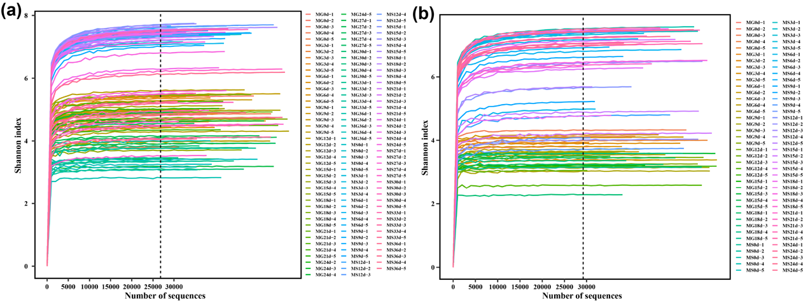

**Figure S1** Rarefaction curve of samples. (a) Winter samples. (b) Summer samples. MG, microorganism of gut; MS, microorganism of gravesoil.

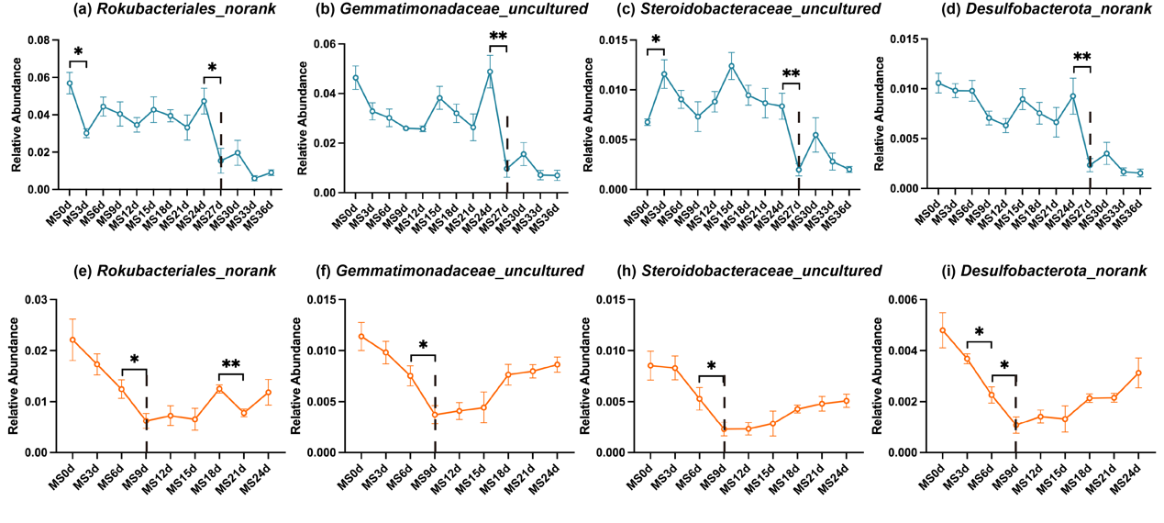

**Figure S2** Potential indicator bacteria for rupture points (at the genus level). Blue (top row) represents the winter season, while orange (bottom row) represents the summer season. Statistical analysis was performed using the Wilcoxon test; "**" denotes P ≤ 0.01; "*" denotes P ≤ 0.05.

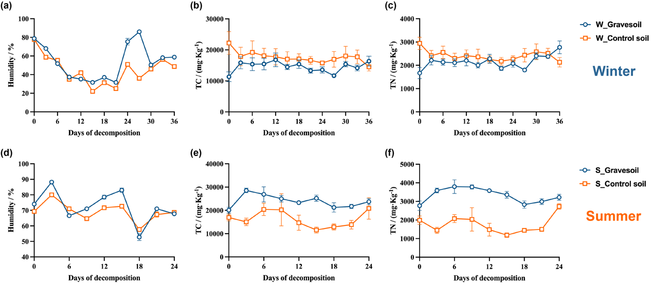

**Figure S3** Changes in physicochemical properties of gravesoil. The first row **(a-c)** shows the winter experiment and the second row **(d-f)** shows the summer experiment. Blue circles represent gravesoil samples, and orange squares represent control soil samples. The statistical method was ordinary one-way ANOVA, "****": P ≤ 0.0001; "****": P ≤ 0.001; "**": P ≤ 0.01; "*": P ≤ 0.05.

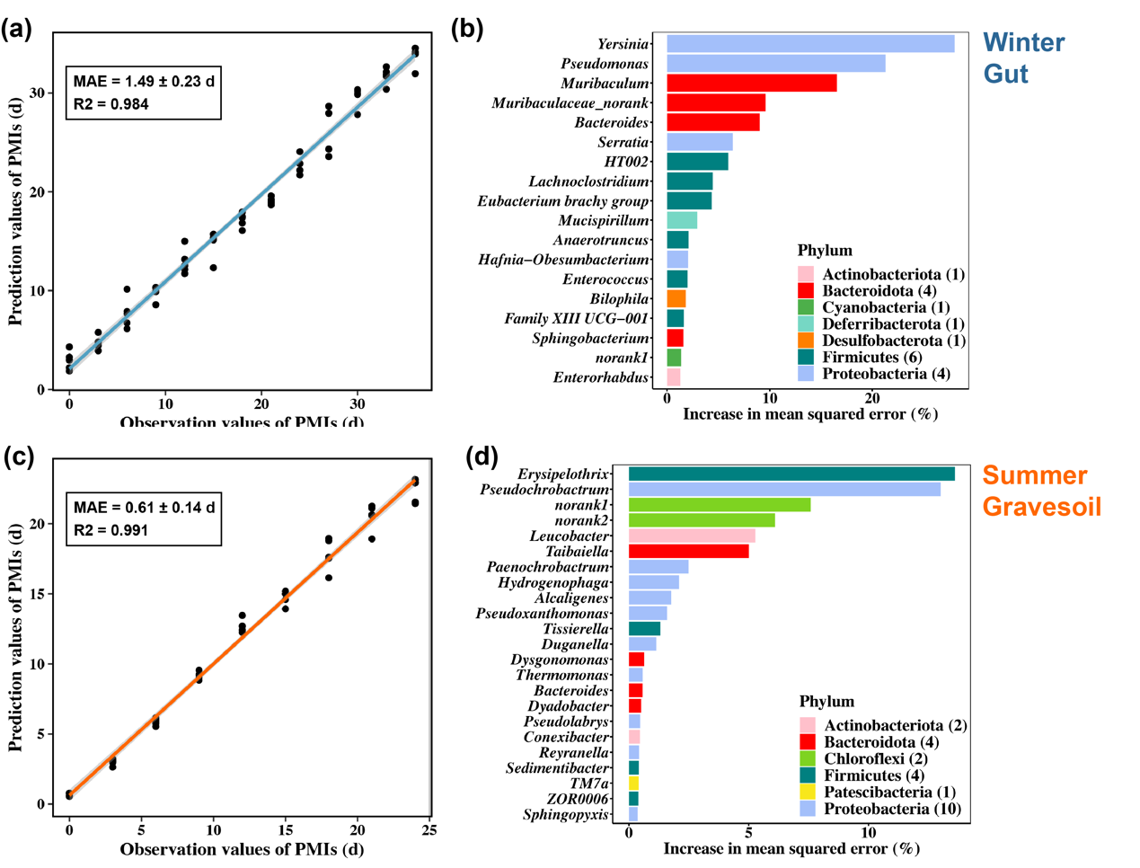

**Figure S4** PMI estimation model and corresponding marker microbial taxa. The first row represents the winter sample and the second row represents the summer sample. **(a)** and **(c)** are constructed using gut microbes in winter and gravesoil microbes in summer, respectively. **(b)** and **(d)** are the marker bacteria selected by each model, with 18 genera in winter and 23 genera in summer.

Table S

|  |  |  |  |  |  |
| --- | --- | --- | --- | --- | --- |
| **Table S1.** Sequencing results of samples after quality control | | | | | |
|  | **Sample counts** | **Statistics** | **Sequence counts** | **Sequence length (bp)** | **Average length (bp)** |
| Winter | All samples（n=128） | MAX | 59,781 | 25,320,397 | 428 |
| MIN | 27,918 | 11,785,731 | 413 |
| MEAN | 43,118 | 18,201,575 | 422 |
| SUM | 5,519,073 | 2,329,801,663 | / |
| Gravesoil（n=64） | MAX | 59,781 | 25,320,397 | 428 |
| MIN | 27,918 | 11,785,731 | 413 |
| MEAN | 41,523 | 17,470,035 | 421 |
| SUM | 2,657,472 | 1,118,082,261 | / |
| Gut（n=64） | MAX | 59,457 | 25,197,502 | 428 |
| MIN | 30,104 | 12,845,220 | 417 |
| MEAN | 44,713 | 18,933,116 | 424 |
| SUM | 2,861,601 | 1,211,719,402 | / |
|  | | | | | |
| Summer | All samples（n=80） | MAX | 59,763 | 25,475,142 | 428 |
| MIN | 30,222 | 12,836,970 | 416 |
| MEAN | 46,621 | 19,725,753 | 423 |
| SUM | 3,729,699 | 1,578,060,204 | / |
| Gravesoil（n=45） | MAX | 59,763 | 25,438,192 | 426 |
| MIN | 30,518 | 12,836,970 | 419 |
| MEAN | 46,192 | 19,496,836 | 422 |
| SUM | 2,078,652 | 877,357,618 | / |
| Gut（n=35） | MAX | 59,713 | 25,475,142 | 428 |
| MIN | 30,222 | 12,895,654 | 416 |
| MEAN | 47,173 | 20,020,074 | 424 |
| SUM | 1,651,047 | 700,702,586 | / |

|  |  |  |  |  |  |  |  |
| --- | --- | --- | --- | --- | --- | --- | --- |
| **Table S2.** The values of alpha diversity indexes. | | | | | | | |
| Season | Sample | SampleID | richness | chao1 | ACE | shannon | simpson |
| Winter | MG0d | MG0d-1 | 879 | 1294.672566 | 1245.512197 | 4.704365781 | 0.975326148 |
| MG0d-2 | 1784 | 2678.802676 | 2719.979331 | 5.394650713 | 0.984585232 |
| MG0d-3 | 1587 | 2287.633452 | 2358.926105 | 4.948232519 | 0.97113211 |
| MG0d-4 | 960 | 1548.284768 | 1611.710062 | 3.811404832 | 0.912198555 |
| MG0d-5 | 1583 | 2371.356322 | 2383.842226 | 4.835834706 | 0.970220792 |
| MG3d | MG03d-1 | 1912 | 2883.316456 | 2942.154047 | 5.236880515 | 0.97657474 |
| MG03d-2 | 1383 | 2111.124464 | 2176.404301 | 4.604579085 | 0.963126652 |
| MG03d-3 | 1801 | 2548.720798 | 2680.294347 | 4.945059985 | 0.954252218 |
| MG03d-4 | 1904 | 2746.333333 | 2731.50061 | 5.360579005 | 0.984169192 |
| MG03d-5 | 1729 | 2595.448795 | 2832.484805 | 4.838880509 | 0.963283692 |
| MG6d | MG06d-1 | 1577 | 2407.772894 | 2465.507999 | 4.421542331 | 0.924035413 |
| MG06d-2 | 1786 | 2604.493711 | 2695.918852 | 4.99314462 | 0.969290243 |
| MG06d-3 | 1989 | 2835.854599 | 2825.301433 | 5.416769092 | 0.981535701 |
| MG06d-4 | 1392 | 2217.346154 | 2309.665414 | 4.618085386 | 0.962350648 |
| MG06d-5 | 1932 | 2747.480769 | 2861.455827 | 5.408380145 | 0.986521668 |
| MG9d | MG09d-1 | 1550 | 2269.841155 | 2362.988585 | 4.696221003 | 0.960554797 |
| MG09d-2 | 1353 | 2057.480519 | 2136.396548 | 4.491126337 | 0.952644401 |
| MG09d-3 | 1614 | 2417.958333 | 2489.749173 | 4.880456892 | 0.973031637 |
| MG09d-4 | 1977 | 2946.508475 | 3068.289715 | 5.28283113 | 0.979612457 |
| MG09d-5 | 1982 | 2889.728614 | 2941.332455 | 5.457571522 | 0.985923231 |
| MG12d | MG12d-1 | 1160 | 1742.552632 | 1774.598444 | 3.989749199 | 0.931087747 |
| MG12d-2 | 2088 | 3016.405995 | 3105.433469 | 5.614157592 | 0.987038667 |
| MG12d-3 | 1247 | 2095.14486 | 2223.577503 | 3.968049865 | 0.918257501 |
| MG12d-4 | 1406 | 2184.555556 | 2301.198159 | 4.281199843 | 0.934313365 |
| MG12d-5 | 1667 | 2774.733591 | 2812.493354 | 4.943238772 | 0.969721332 |
| MG15d | MG15d-1 | 1608 | 2260.083333 | 2344.106706 | 5.102372859 | 0.978697883 |
| MG15d-2 | 1277 | 1836.194444 | 1880.094574 | 4.913341569 | 0.97984874 |
| MG15d-3 | 1585 | 2292.90681 | 2378.139453 | 5.001147931 | 0.975263809 |
| MG15d-4 | 1196 | 1912.135266 | 1992.88323 | 4.445198084 | 0.961291333 |
| MG15d-5 | 1007 | 1625.543956 | 1728.854173 | 3.717529816 | 0.914313956 |
| MG18d | MG18d-1 | 1343 | 2113.4689 | 2125.998267 | 4.684780641 | 0.965978696 |
| MG18d-2 | 1342 | 2038.416667 | 2074.977991 | 4.714070216 | 0.967830444 |
| MG18d-3 | 1723 | 2407.203822 | 2547.829296 | 5.455915346 | 0.987527056 |
| MG18d-4 | 1419 | 2172.838983 | 2221.185384 | 4.853810246 | 0.976362043 |
| MG18d-5 | 1491 | 2214.811538 | 2328.078451 | 4.888494174 | 0.974807888 |
| MG21d | MG21d-1 | 1149 | 1761.57377 | 1797.737755 | 4.472608889 | 0.960673907 |
| MG21d-2 | 1077 | 1644.580645 | 1729.130973 | 3.903815954 | 0.933509893 |
| MG21d-3 | 1622 | 2341.719298 | 2417.06651 | 5.258265477 | 0.985420932 |
| MG21d-4 | 1049 | 1621.090909 | 1662.227226 | 4.357050379 | 0.962304943 |
| MG21d-5 | 1609 | 2474.021898 | 2595.61123 | 5.018513043 | 0.974670384 |
| MG24d | MG24d-2 | 1248 | 1928.452632 | 1901.704078 | 4.695155873 | 0.97078358 |
| MG24d-3 | 1254 | 2001.554348 | 1955.577015 | 4.616361026 | 0.969510041 |
| MG24d-4 | 755 | 1221.827869 | 1314.384294 | 3.415369064 | 0.885639844 |
| MG24d-5 | 1494 | 2251.046809 | 2258.865669 | 4.90944362 | 0.97708974 |
| MG27d | MG27d-1 | 376 | 501.2631579 | 508.6560294 | 3.179041791 | 0.914615921 |
| MG27d-2 | 1013 | 1642.235669 | 1635.992139 | 4.158183377 | 0.959526681 |
| MG27d-3 | 1095 | 1643.4 | 1715.146471 | 4.100562438 | 0.941787917 |
| MG27d-4 | 1149 | 1849.109375 | 1921.954442 | 3.901022306 | 0.920968652 |
| MG27d-5 | 1448 | 2340.034043 | 2400.1821 | 4.540865519 | 0.959623327 |
| MG30d | MG30d-1 | 1086 | 1785.389535 | 1799.33948 | 3.825134564 | 0.903013442 |
| MG30d-2 | 592 | 931.1340206 | 961.3540318 | 3.075405678 | 0.880129849 |
| MG30d-3 | 900 | 1356.993377 | 1376.829123 | 3.447932846 | 0.886901104 |
| MG30d-4 | 919 | 1390.256579 | 1415.836974 | 3.763754444 | 0.911540132 |
| MG30d-5 | 775 | 1223.636364 | 1246.970602 | 3.353866631 | 0.844015149 |
| MG33d | MG33d-1 | 495 | 739.1388889 | 747.688138 | 3.463207257 | 0.934438765 |
| MG33d-2 | 964 | 1484.776398 | 1541.408046 | 3.767652062 | 0.923153562 |
| MG33d-3 | 379 | 517.6545455 | 518.4708232 | 3.349914909 | 0.924443932 |
| MG33d-4 | 805 | 1237.285714 | 1360.408597 | 3.335697622 | 0.870869052 |
| MG33d-5 | 685 | 1075.675676 | 1112.180131 | 3.092942401 | 0.795838486 |
| MG36d | MG36d-1 | 857 | 1282.751773 | 1383.576364 | 4.008022175 | 0.933906127 |
| MG36d-2 | 531 | 904.8970588 | 873.0944095 | 2.817542241 | 0.808890691 |
| MG36d-3 | 545 | 711.2244898 | 751.7540341 | 3.169630684 | 0.818742497 |
| MG36d-4 | 741 | 1102.375 | 1149.710193 | 3.241275767 | 0.849388587 |
| MG36d-5 | 602 | 885.1460674 | 893.0026729 | 3.395830074 | 0.887984252 |
| MS0d | MS0d-1 | 3781 | 5326.222892 | 5476.088716 | 7.148157041 | 0.997924631 |
| MS0d-2 | 4481 | 6114.356718 | 6313.941845 | 7.429315613 | 0.998320058 |
| MS0d-3 | 4370 | 6162.46375 | 6353.592123 | 7.327192256 | 0.997936067 |
| MS0d-4 | 3998 | 5363.008746 | 5398.109625 | 7.357894541 | 0.998460969 |
| MS0d-5 | 4489 | 6040.333333 | 6205.272279 | 7.44694016 | 0.998378495 |
| MS3d | MS03d-1 | 4993 | 6733.515963 | 6970.68445 | 7.622319976 | 0.99863812 |
| MS03d-2 | 4894 | 6456.871551 | 6866.074905 | 7.510238669 | 0.998241577 |
| MS03d-3 | 4888 | 6517.041801 | 6697.989822 | 7.615691337 | 0.998675626 |
| MS03d-4 | 4908 | 6697.106583 | 6929.449507 | 7.551018512 | 0.998584617 |
| MS6d | MS06d-1 | 3895 | 5391.101695 | 5558.400631 | 7.074297506 | 0.996205912 |
| MS06d-2 | 4863 | 7107.097863 | 7279.210365 | 7.328726703 | 0.996027327 |
| MS06d-3 | 5202 | 7533.131387 | 7723.420989 | 7.61518564 | 0.998562436 |
| MS06d-4 | 4992 | 6999.745435 | 7228.699551 | 7.620256549 | 0.998701924 |
| MS06d-5 | 4895 | 7123.130337 | 7268.729412 | 7.367881234 | 0.996934573 |
| MS9d | MS09d-1 | 5203 | 7220.476923 | 7614.087955 | 7.645547063 | 0.998749949 |
| MS09d-2 | 4875 | 7171.511732 | 7437.741376 | 7.378907323 | 0.997274836 |
| MS09d-3 | 4816 | 7328.136574 | 7468.303034 | 7.005647884 | 0.988220823 |
| MS09d-4 | 4936 | 7503.529748 | 7573.158323 | 7.208485627 | 0.994477708 |
| MS09d-5 | 4931 | 7188.639871 | 7508.158452 | 7.475233509 | 0.998259949 |
| MS12d | MS12d-1 | 4955 | 7700.011338 | 7903.5237 | 7.197582872 | 0.995812768 |
| MS12d-2 | 5150 | 7789.860991 | 8018.544489 | 7.384116267 | 0.995716409 |
| MS12d-3 | 5353 | 7658.688953 | 7969.206603 | 7.619176131 | 0.998312698 |
| MS12d-4 | 5031 | 7127.582073 | 7301.352973 | 7.634385591 | 0.998772097 |
| MS12d-5 | 5435 | 7916.503597 | 8012.78328 | 7.713967632 | 0.998740624 |
| MS15d | MS15d-1 | 4746 | 7010.001152 | 7248.792676 | 7.356904026 | 0.997727673 |
| MS15d-2 | 4688 | 6907.92883 | 7012.248105 | 7.219549932 | 0.994678667 |
| MS15d-3 | 5271 | 7631.44929 | 7897.359086 | 7.694276983 | 0.998896353 |
| MS15d-4 | 4938 | 7119.864865 | 7264.855192 | 7.552568376 | 0.998439335 |
| MS15d-5 | 5006 | 7188.939394 | 7334.070121 | 7.551084855 | 0.998492162 |
| MS18d | MS18d-1 | 5173 | 7567.217842 | 7825.085305 | 7.494833055 | 0.997256676 |
| MS18d-2 | 5147 | 7144.361111 | 7320.290023 | 7.64079853 | 0.99862368 |
| MS18d-3 | 4958 | 6894.066075 | 7290.104532 | 7.274535088 | 0.996289983 |
| MS18d-4 | 4975 | 6848.684481 | 7115.846046 | 7.507687386 | 0.998017805 |
| MS18d-5 | 4703 | 6421.296582 | 6646.254469 | 7.421186941 | 0.997425421 |
| MS21d | MS21d-1 | 4701 | 6790.820093 | 6943.832235 | 7.299648135 | 0.99721101 |
| MS21d-2 | 4612 | 6271.124408 | 6395.405478 | 7.537728596 | 0.998679991 |
| MS21d-3 | 3491 | 5379.156627 | 5522.466941 | 5.502185651 | 0.957625311 |
| MS21d-4 | 4827 | 6882.081023 | 7153.746555 | 7.213043022 | 0.996359712 |
| MS21d-5 | 4935 | 6828.442266 | 6940.977423 | 7.435368375 | 0.996983982 |
| MS24d | MS24d-1 | 4361 | 5718.449153 | 5867.758258 | 7.406336542 | 0.998107184 |
| MS24d-2 | 4452 | 6197.291829 | 6184.373591 | 7.395455624 | 0.998136404 |
| MS24d-3 | 4507 | 6000.154472 | 6165.002535 | 7.432634905 | 0.998246109 |
| MS24d-4 | 3845 | 5759.643741 | 6060.383123 | 6.298932842 | 0.98253745 |
| MS24d-5 | 4156 | 5927.33871 | 6069.21815 | 7.112227198 | 0.996832063 |
| MS27d | MS27d-1 | 4488 | 6778.954654 | 7038.055936 | 6.800611173 | 0.991724826 |
| MS27d-2 | 3358 | 5509.605565 | 5730.817382 | 5.558356172 | 0.969903748 |
| MS27d-3 | 2474 | 4102.049801 | 4516.350901 | 4.61224847 | 0.955413169 |
| MS27d-4 | 1803 | 3655.688679 | 4002.491081 | 3.517499742 | 0.869548387 |
| MS27d-5 | 2713 | 4856.403194 | 5178.084933 | 4.499652459 | 0.916712942 |
| MS30d | MS30d-1 | 4255 | 6540.609903 | 6868.097875 | 6.188366848 | 0.976589925 |
| MS30d-2 | 5107 | 7660.080472 | 7884.490632 | 7.480836229 | 0.998151667 |
| MS30d-3 | 3003 | 5138.4125 | 5418.434871 | 5.197534834 | 0.967744777 |
| MS30d-4 | 3066 | 5393.978378 | 5662.488598 | 4.95071446 | 0.948480107 |
| MS30d-5 | 5099 | 7429.069182 | 7732.830119 | 7.528278289 | 0.998073192 |
| MS33d | MS33d-1 | 3002 | 5065.446237 | 5303.765908 | 4.454007503 | 0.832990009 |
| MS33d-2 | 3528 | 5981.032609 | 6223.17558 | 5.479892321 | 0.96607746 |
| MS33d-3 | 2321 | 4403.363196 | 4716.616234 | 4.078156568 | 0.889191788 |
| MS33d-4 | 3236 | 5614.707317 | 5826.910474 | 5.240765 | 0.961068787 |
| MS33d-5 | 1511 | 2592.859107 | 2837.820545 | 4.047465418 | 0.938864191 |
| MS36d | MS36d-1 | 2624 | 4748.0587 | 5153.919267 | 4.697516268 | 0.933459926 |
| MS36d-2 | 2703 | 4840.779835 | 5081.007682 | 4.809187419 | 0.952675006 |
| MS36d-3 | 2387 | 4221.968468 | 4574.230963 | 4.872407638 | 0.970223014 |
| MS36d-4 | 3903 | 5926.595506 | 6360.270155 | 6.124970248 | 0.981263481 |
| MS36d-5 | 2960 | 4952.731707 | 5355.297461 | 5.204230296 | 0.968262509 |