Table s1 Grade of evidence

|  |  |
| --- | --- |
| Outcome | Grade |
| Clinical Remission | Moderate |
| Clinical Response | Moderate |
| Endoscopic Remission | Moderate |
| endoscopic improvement | Low |
| Histological remission | Low |
| adverse events | Moderate |

figure S1 Risk of bias graph

figure S2 Risk of bias summary

figure s3 egger test of clinical remission

figure s4 egger test of endoscopic improvement

图形用户界面

figure s5 egger test of adverse events

figure s6 egger test of histological remission

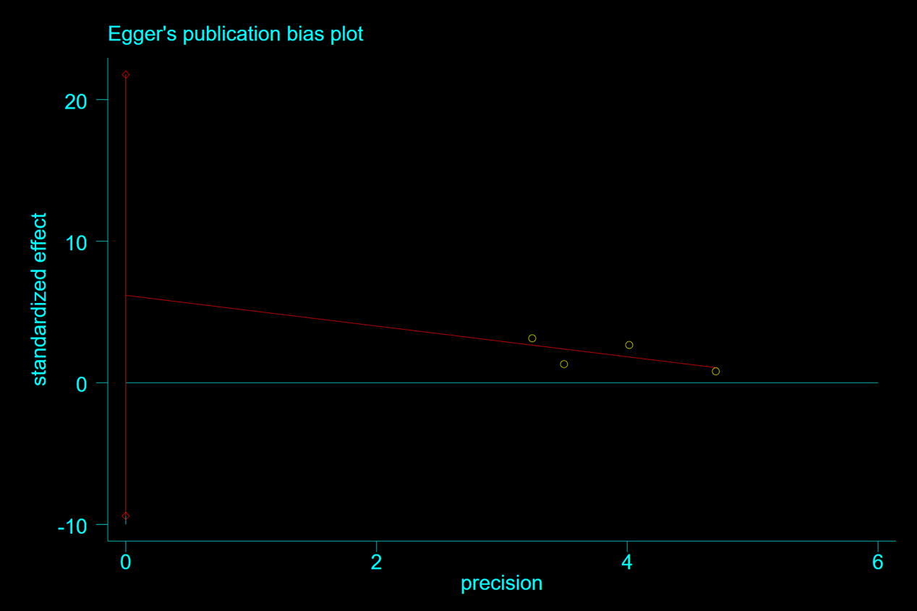

figure s7 egger test of clinical response

figure s8 egger test of clinical remission

