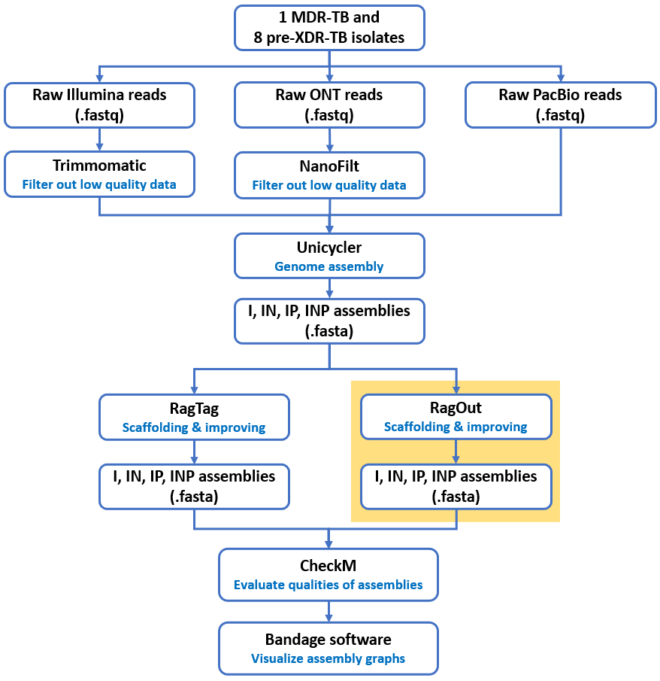**Supplemental** **Fig. S1** An analysis workflow to generate genome assembly of nine DR-TB isolates using Unicycler, RagOut, and RagTag.

**Supplemental 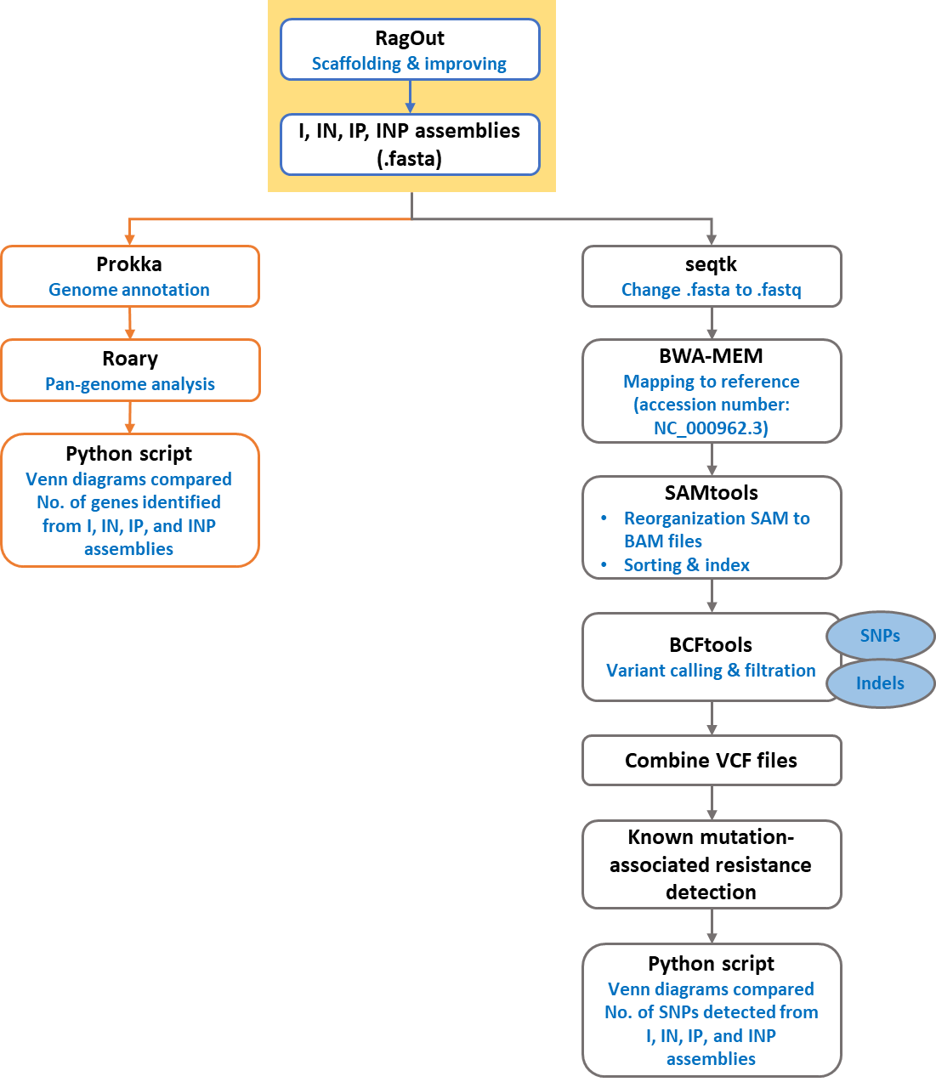Fig. S2** An analysis workflow for pan-genome analysis and mutation-associated drug resistance detection.