Supplementary file 8

The different conserved motifs in cranberry. The letter size of the amino acid represents the frequency of the corresponding nucleotide.

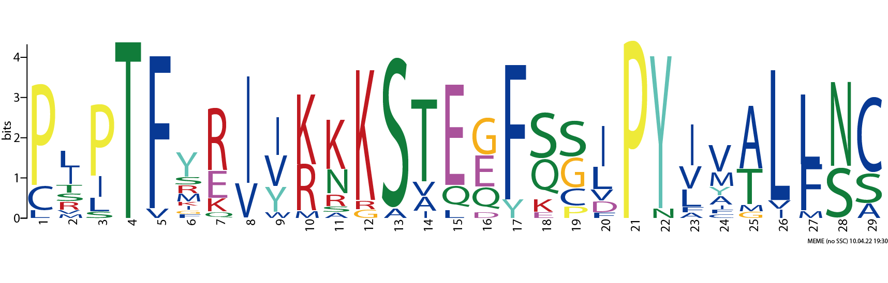

Motif1

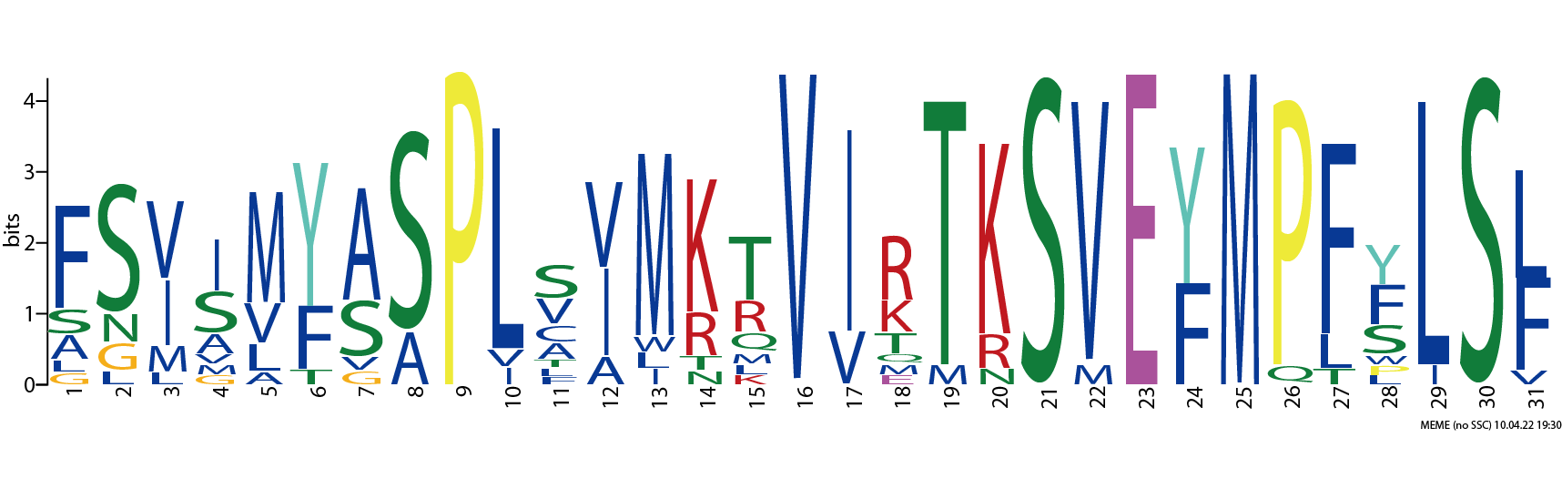

Motif2

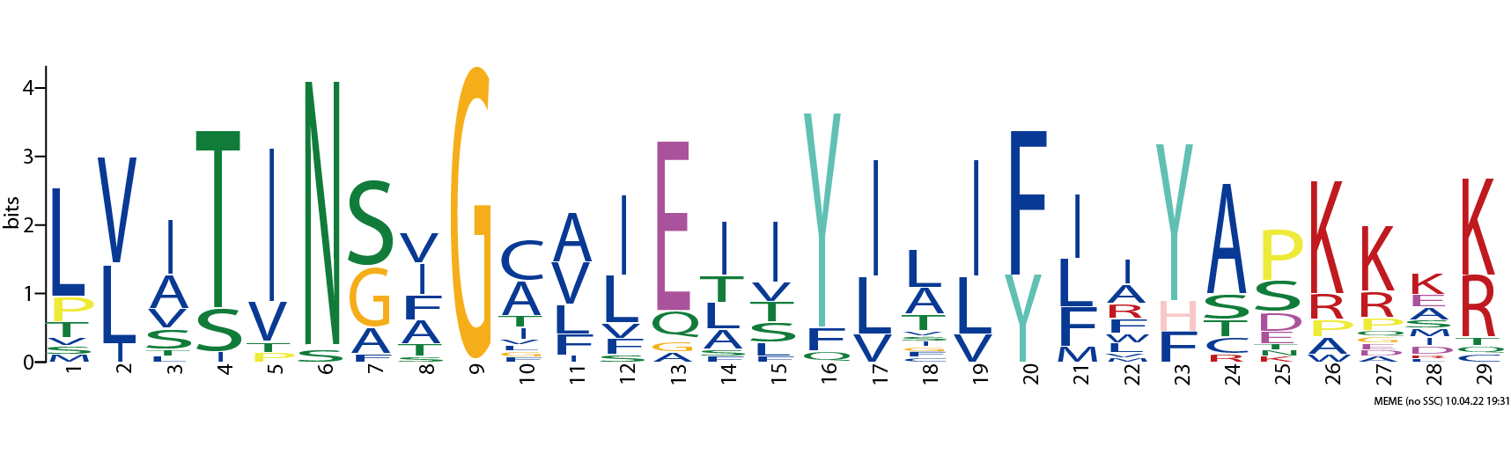

Motif3

Motif4

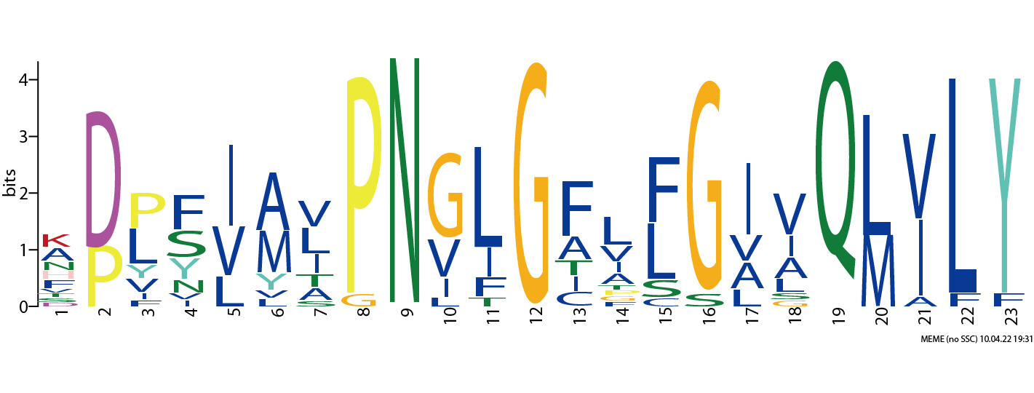

Motif5

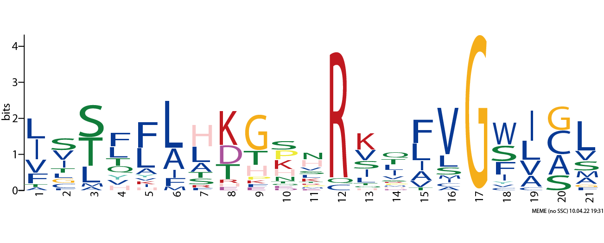

Motif9

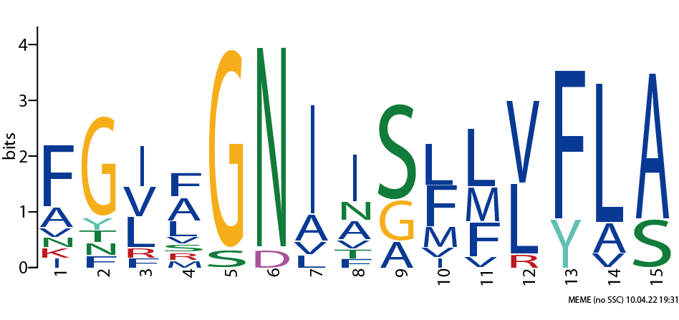

Motif8

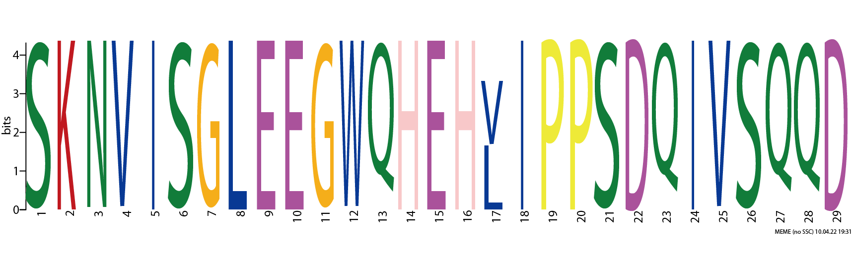

Motif7

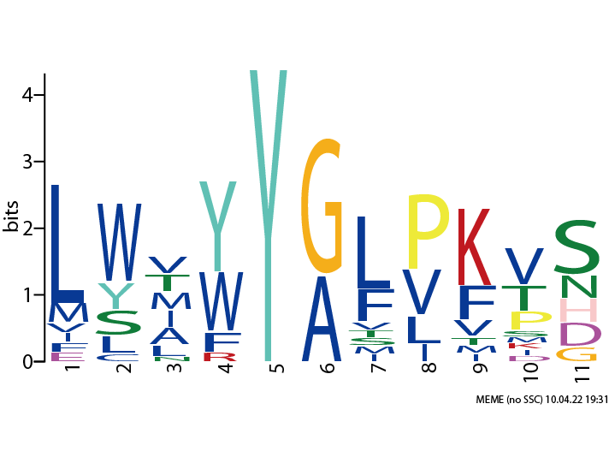

Motif6

