**Figure**

**Distribution of burnout according to health profession**

1. **Personal**

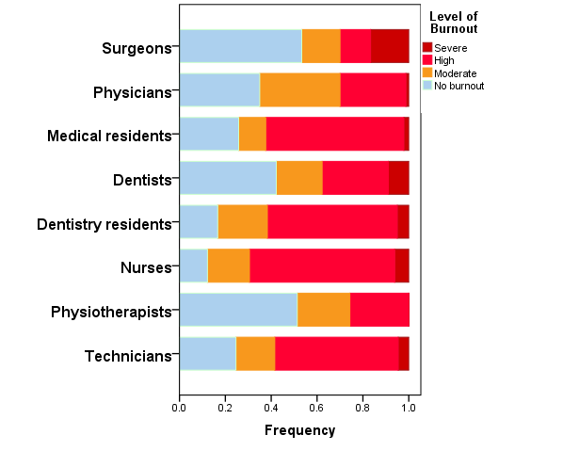

1. **Work related**

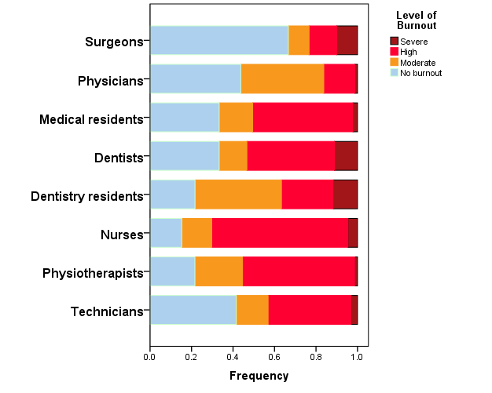

1. **Client related**

