Supplement 1. Effects of direction specific resistance and plyometric training on athletic performance outcomes: a systematic review and meta-analysis

Pubmed：442
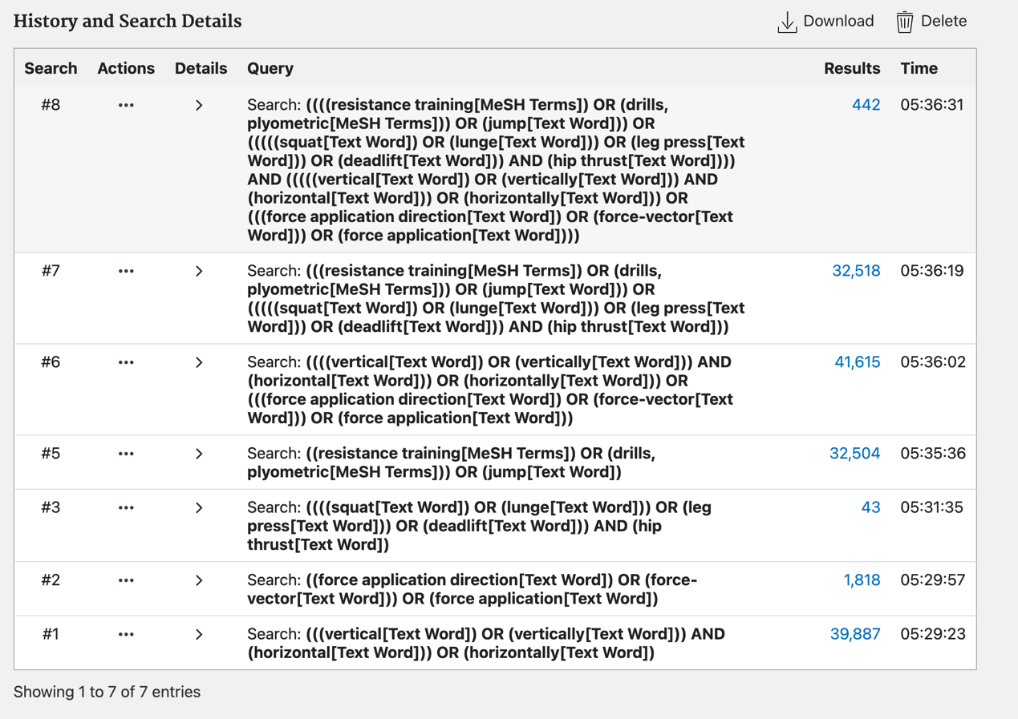

Wos: 1799



Medline：3375

