**Supplementary Material 4:** Publication bias assessment by funnel plot and Egger’s test, sensitivity analyses.



Figure 1: Funnel plot for (A) favourable neurological outcome, Egger’s test P=0.033; (B) favourable neurological outcome after trim-and-fill method (RR: 1.30, 95% CI 1.14 to 1.49); (C) long-term mortality, Egger’s test P=0.011; (D) long-term mortality after trim-and-fill method (RR: 0.75, 95% CI 0.63 to 0.91);



Figure 2: (A) short-term mortality, Egger’s test P=0.144; (B) length of stay in ICU, Egger’s test P=0.919; (C) length of stay in hospital, Egger’s test P=0.896

Figure 3: Sensitivity analysis for favourable neurological outcome



Figure 4: Sensitivity analysis for long-term mortality



Figure 5: Sensitivity analysis for short-term mortality



Figure 6: Sensitivity analysis for length of ICU stay



Figure 7: Sensitivity analysis for length of hospital stay

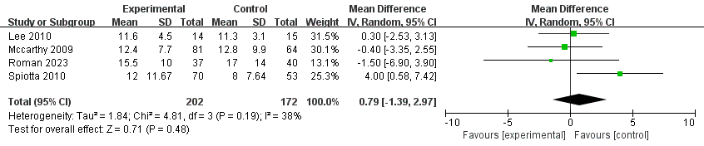

Figure 8: Sensitivity analysis for length of ICU stay by excluding studies reported length of stay data in the form of median and IQR

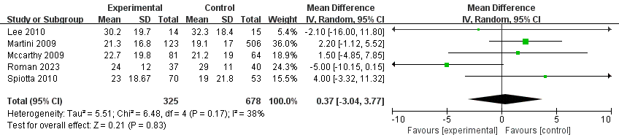 Figure 9: Sensitivity analysis for length of hospital stay by excluding studies reported length of stay data in the form of median and IQR