Supplementary Material
Proteomic Profiling of Oleamide-Mediated Polarization in a Primary Human Monocyte-Derived Tumor-associated Macrophages (TAMs) Model: A Functional Analysis

Prapakorn Wisitpongpun¹, Watunyoo Buakaew^{1,7}, Sutatip Pongcharoen², Napaporn Apiratmateekul³, Pachuen Potup¹, Krai Daowtak¹, Sucheewin Krobthong^{4,5}, Yodying Yingchutrakul⁵, Paul J. Brindley⁶ and Kanchana Usuwanthim¹*

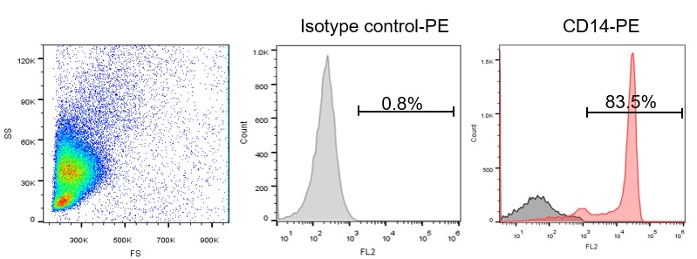
Supplemental Figure S1 Flow cytometry analysis of percent purity of human monocytes isolated by density-gradient centrifugation method. Cells were washed and stained with an anti-CD14 PE-conjugated antibody. The percentage of CD14+ cells was analyzed by flow cytometer.

NC MØ Ctr
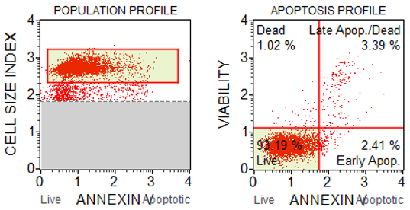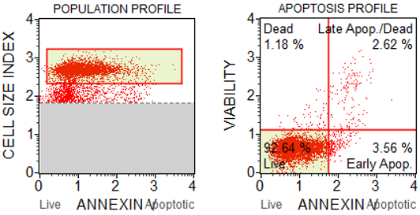

TAMs TAMs + OLA
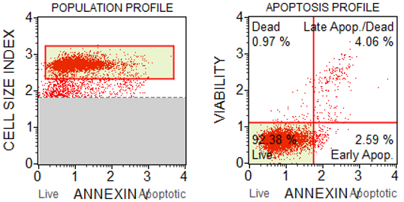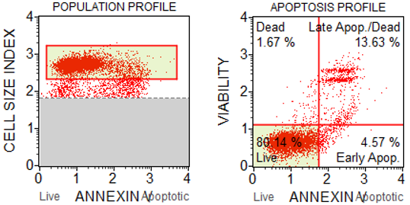

OLA only
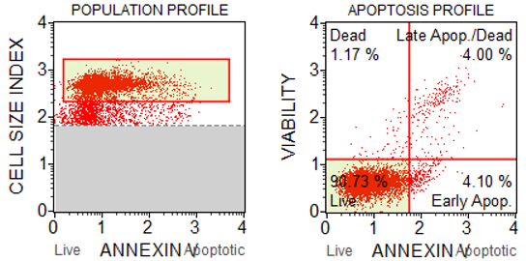
Supplemental Figure S2 Analysis of MDA-MB-231 cell apoptosis using Muse cell analyzer. MDA-MB-231 cells were incubated for 24 h. Cells were incubated in complete medium (NC), complete medium plus 20 µg/ml oleamide (OLA only) or incubated with conditioned medium from untreated TAMs (TAMs), oleamide-treated TAMs (TAMs + OLA), or M0 macrophages (MØ Ctr).

Gene name | Forward primer (5'-3') | Reverse primer (5'-3')
c-Myc | ATGGCCCATTACAAAGCCG | TTTCTGGAGTAGCAGCTCCTAA
MMP-9 | TGTACCGCTATGGTTACACTCG | GGCAGGGACAGTTGCTTCT
VEGFA | AGGGCAGAATCATCACGAAGT | AGGGTCTCGATTGGATGGCA
HLA-DR | ATACTCCGATCACCAATGTACCT | GACTGTCTCTGACACTCCTGT
CD163 | TTTGTCAACTTGAGTCCCTTCAC | TCCCGCTACACTTGTTTTCAC
CD206 | CTACAAGGGATCGGGTTTATGGA | CTACAAGGGATCGGGTTTATGGA
iNOS | TTCAGTATCACAACCTCAGCAAG | TGGACCTGCAAGTTAAAATCCC
IL-10 | GGAGAACCTGAAGACCCTCA | GATGTCAAACTCACTCATGGC
ACTB | AGAAAATCTGGCACCACACC | CCATCTCTTGCTCGAAGTCC
Supplemental Table S1 Sequence of primers for RT-qPCR.

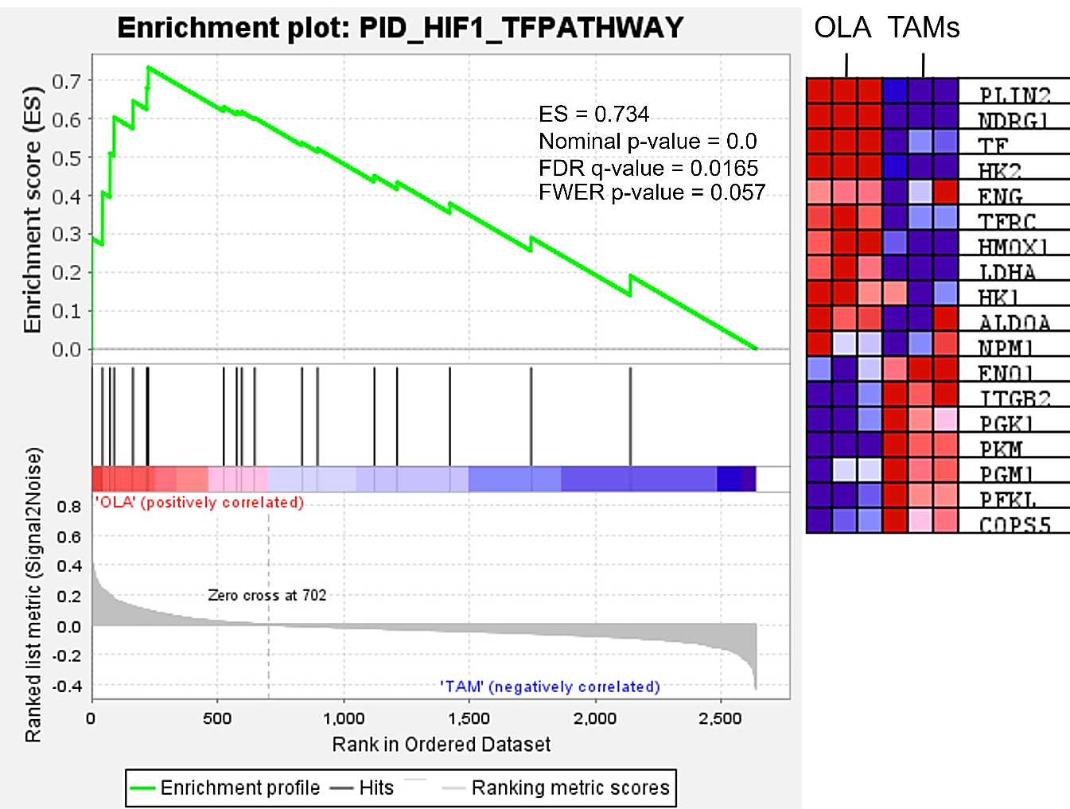

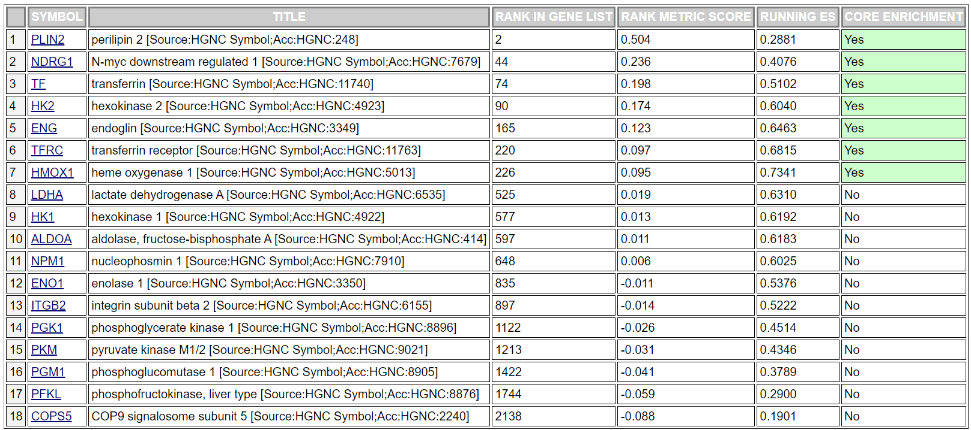
Supplemental Table S2 HIF-1 TF pathway.

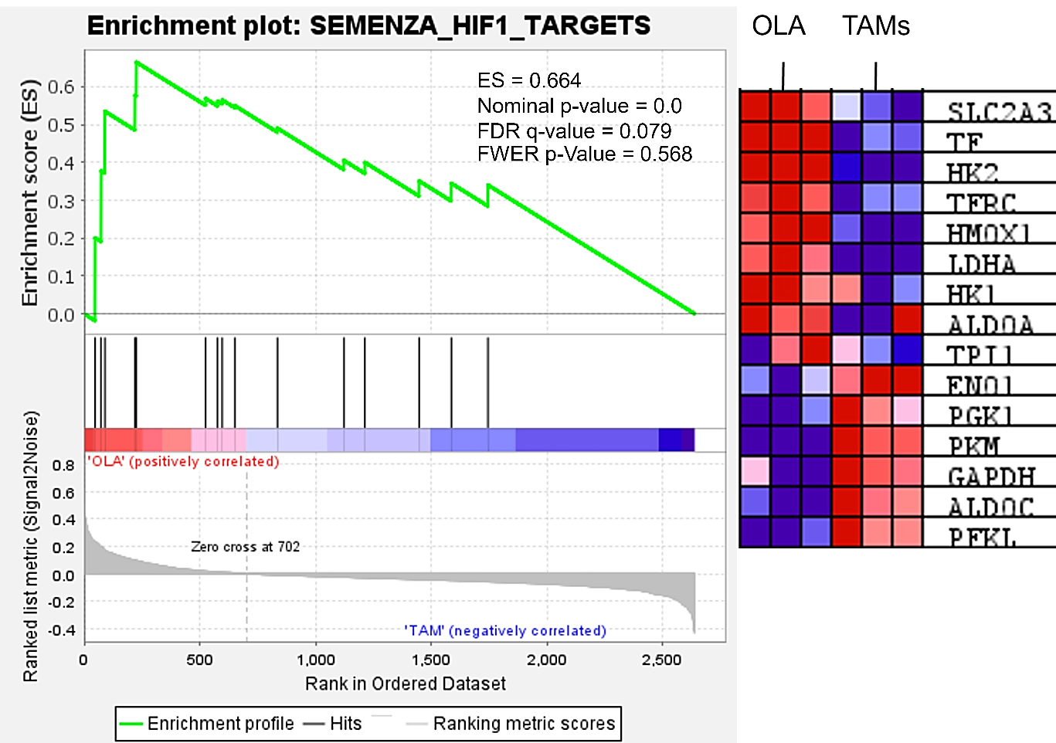

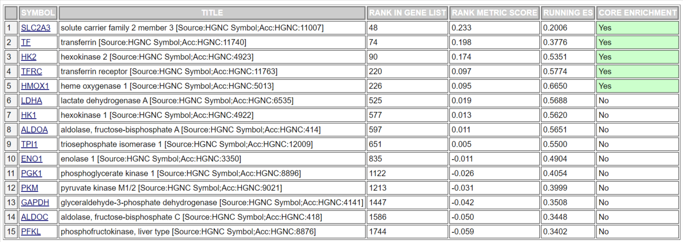
Supplemental Table S3 HIF-1 target.

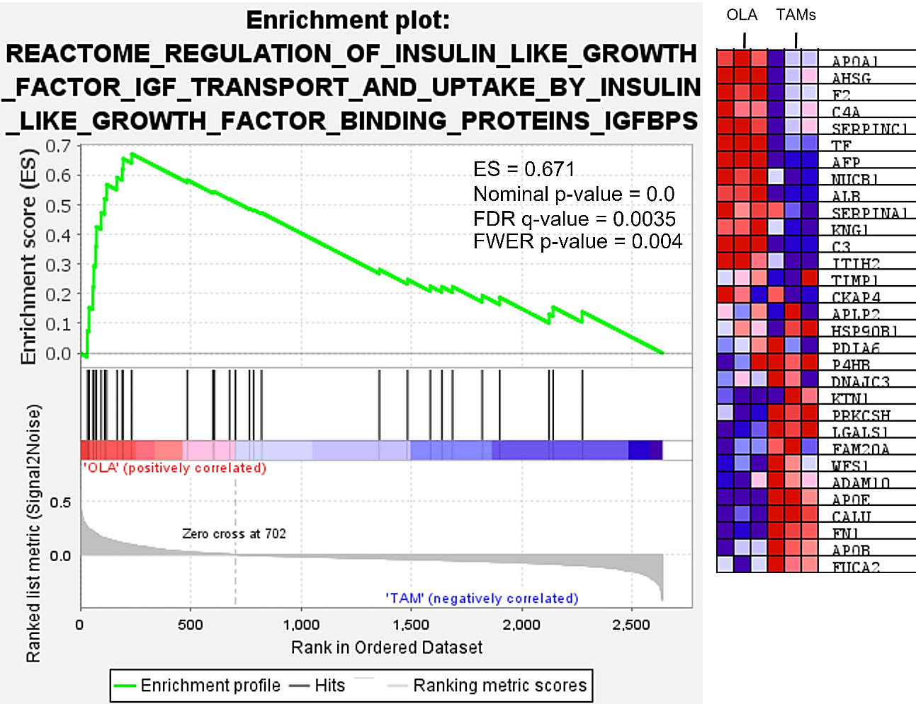

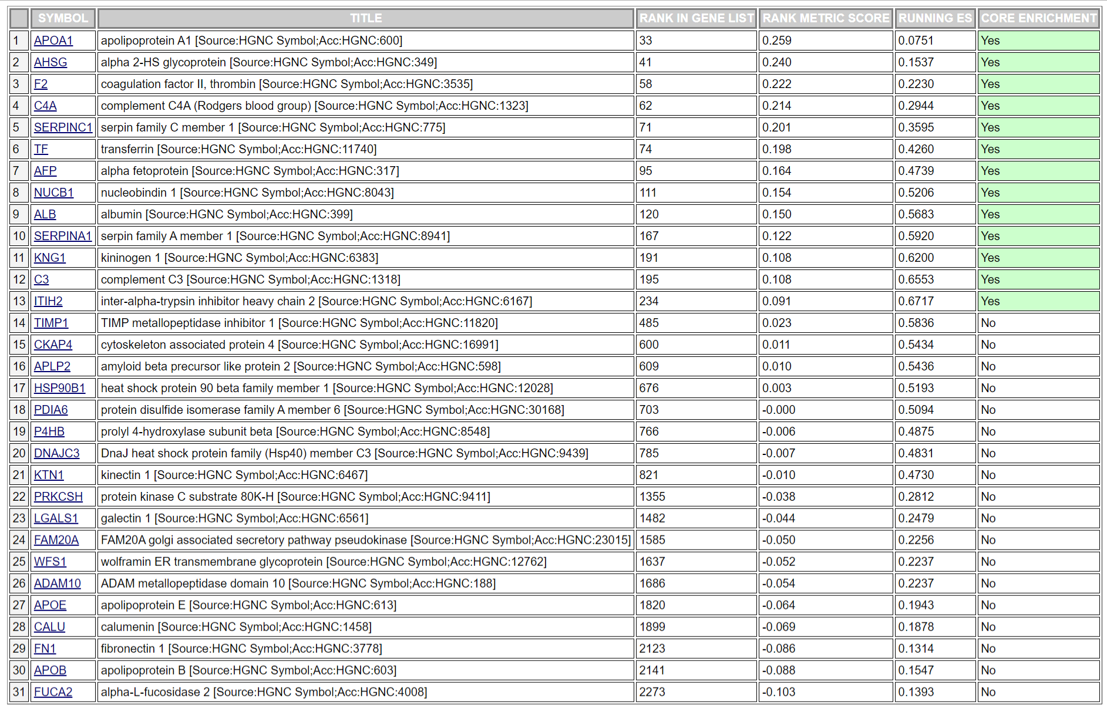
Supplemental Table S4 Regulation of insulin-like growth factor (IGF) transport and uptake by insulin-like growth factor binding proteins (IGFBPs).

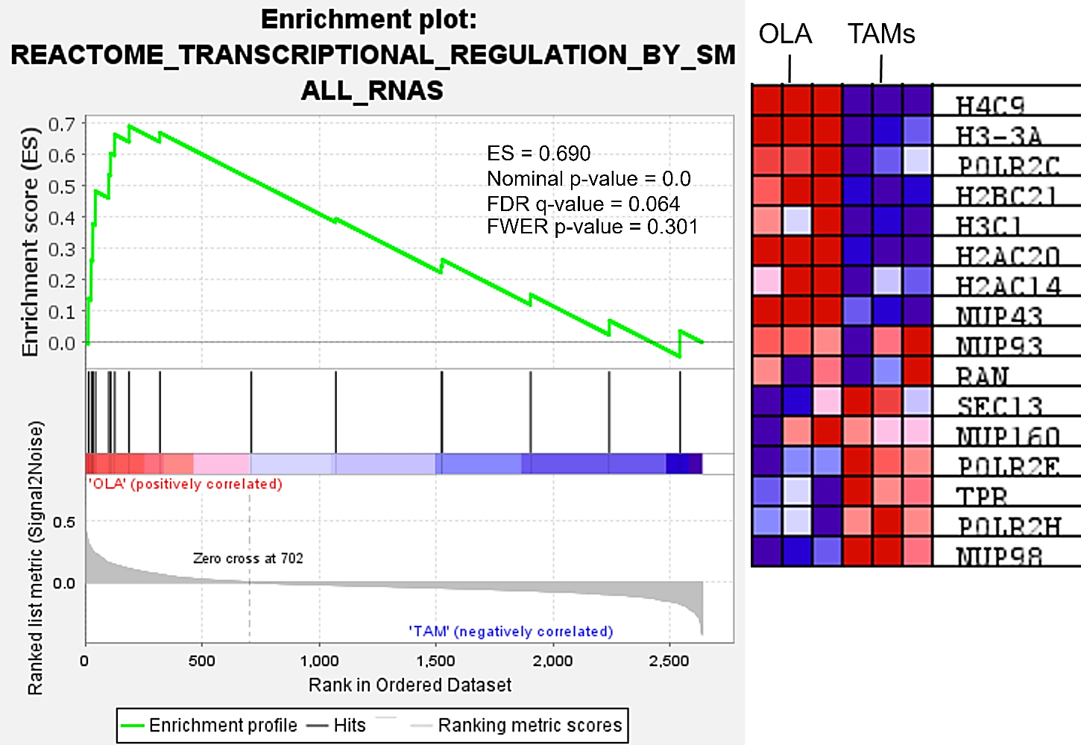

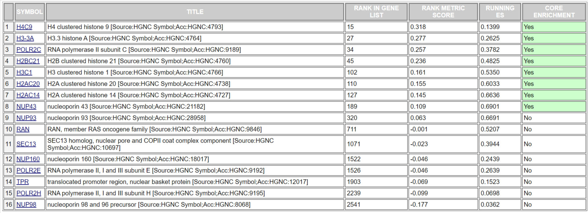
Supplemental Table S5 Transcriptional regulation by small RNAs.

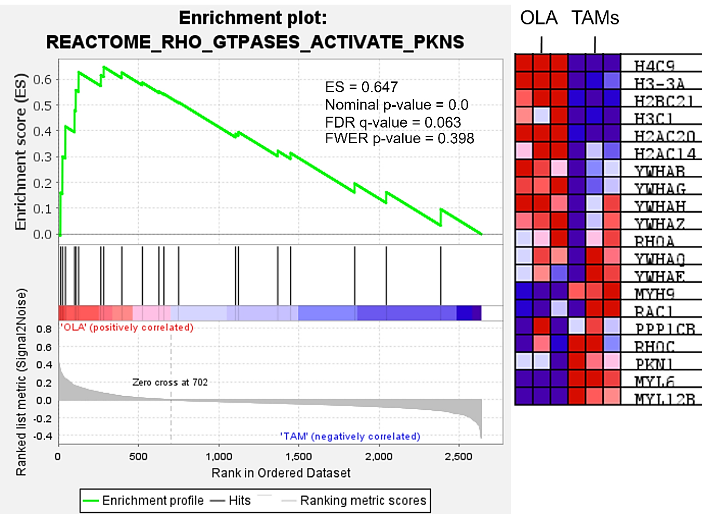

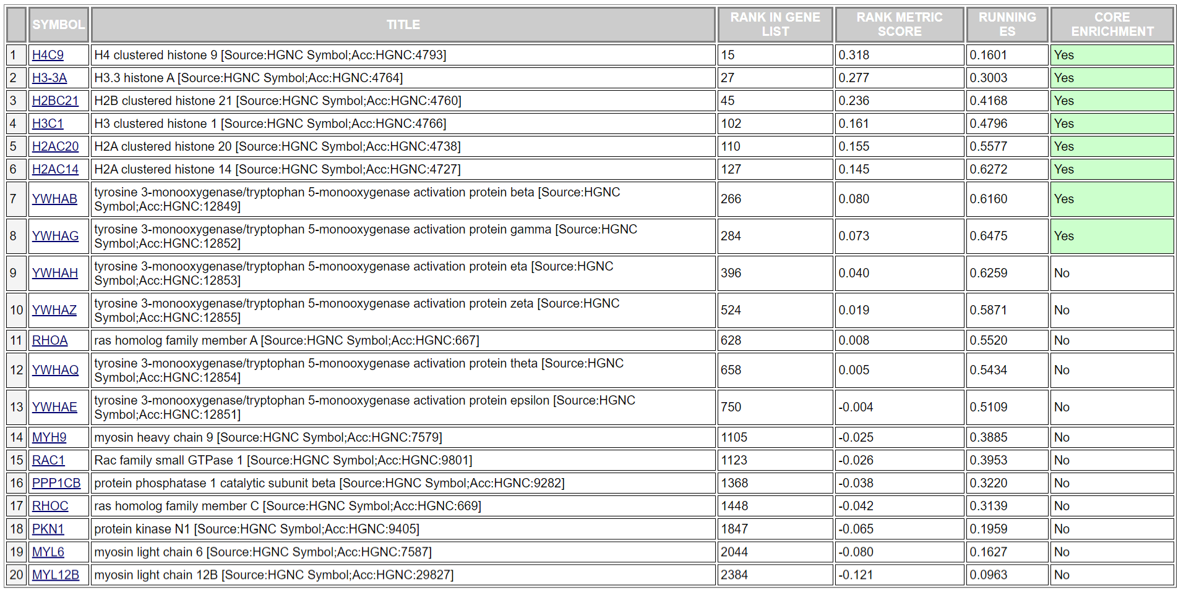
Supplemental Table S6 Rho GTPases activate PNKs.

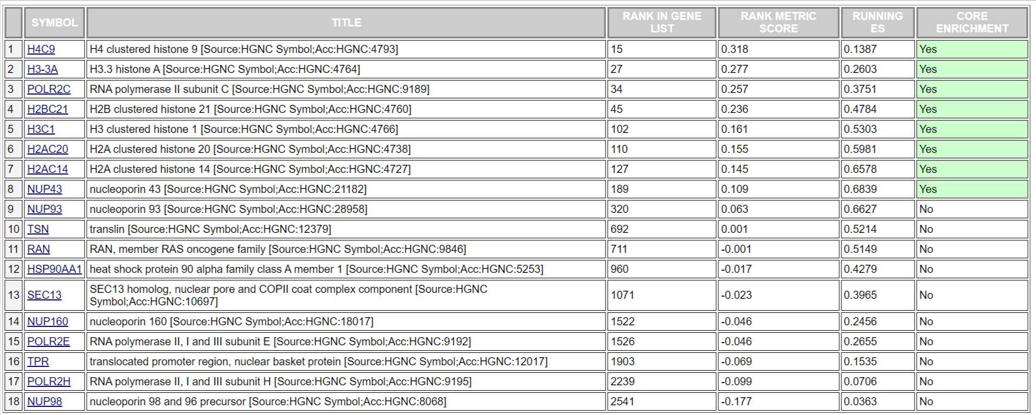
Supplemental Table S7 Gene silencing by RNAs.

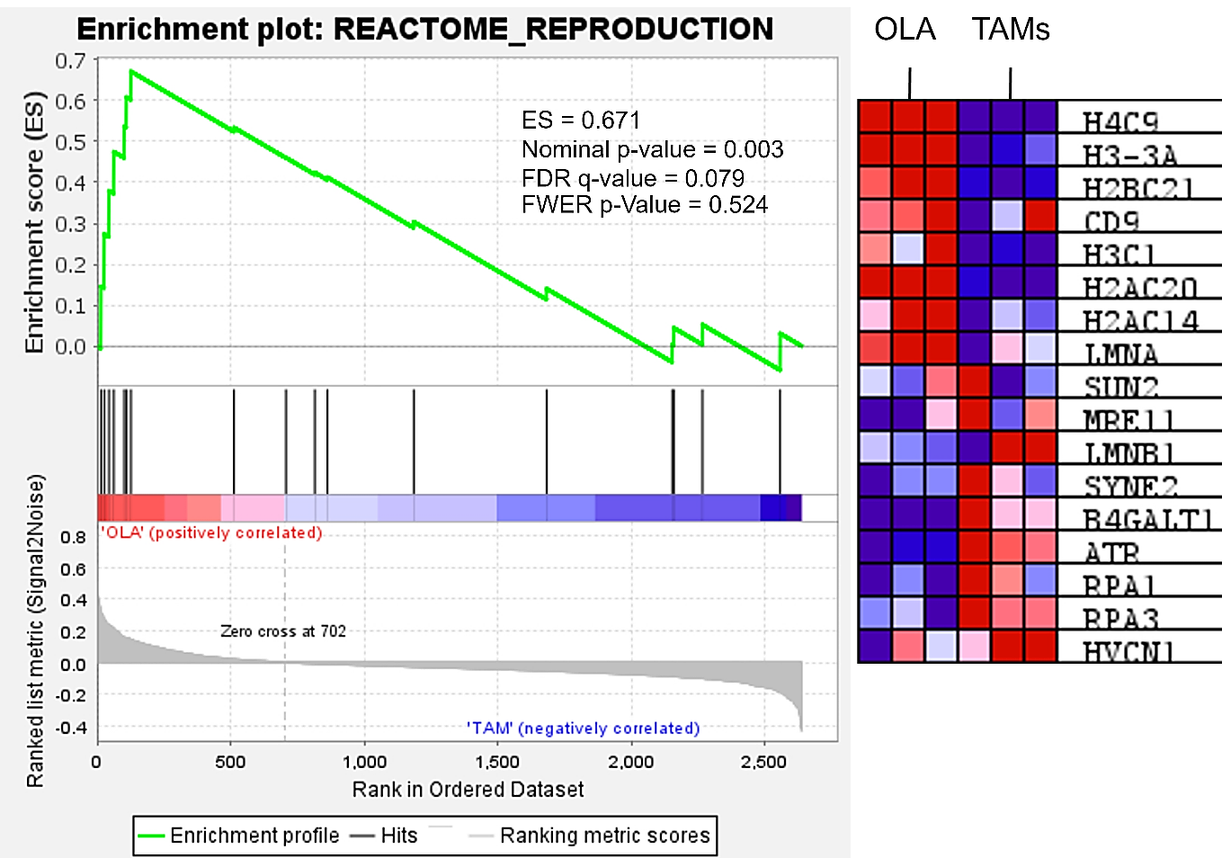

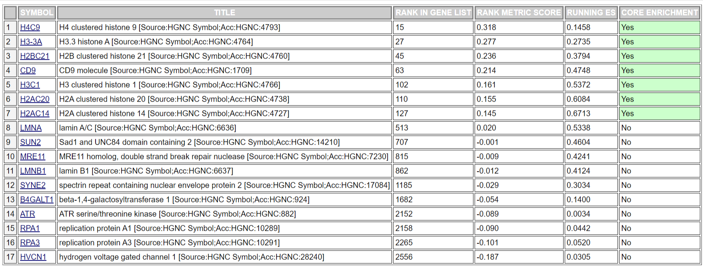
Supplemental Table S8 Reproduction.

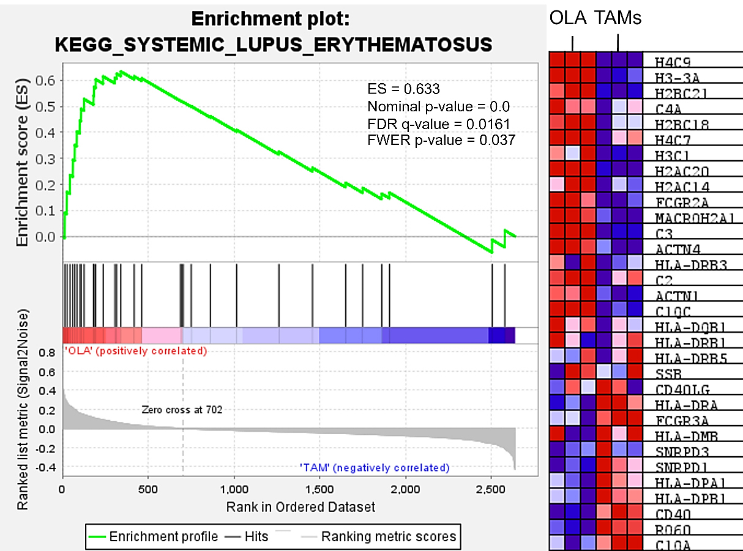

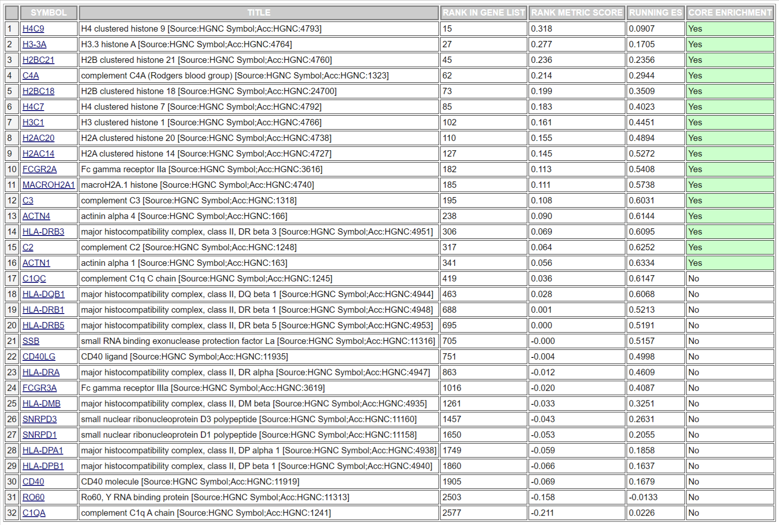
Supplemental Table S9 Systemic lupus erythematosus.

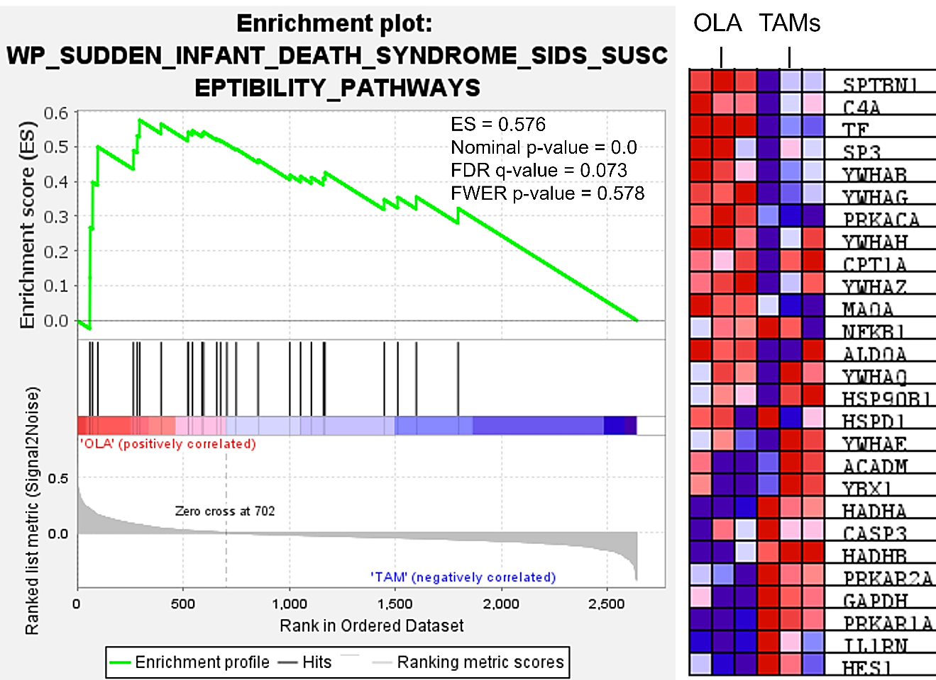

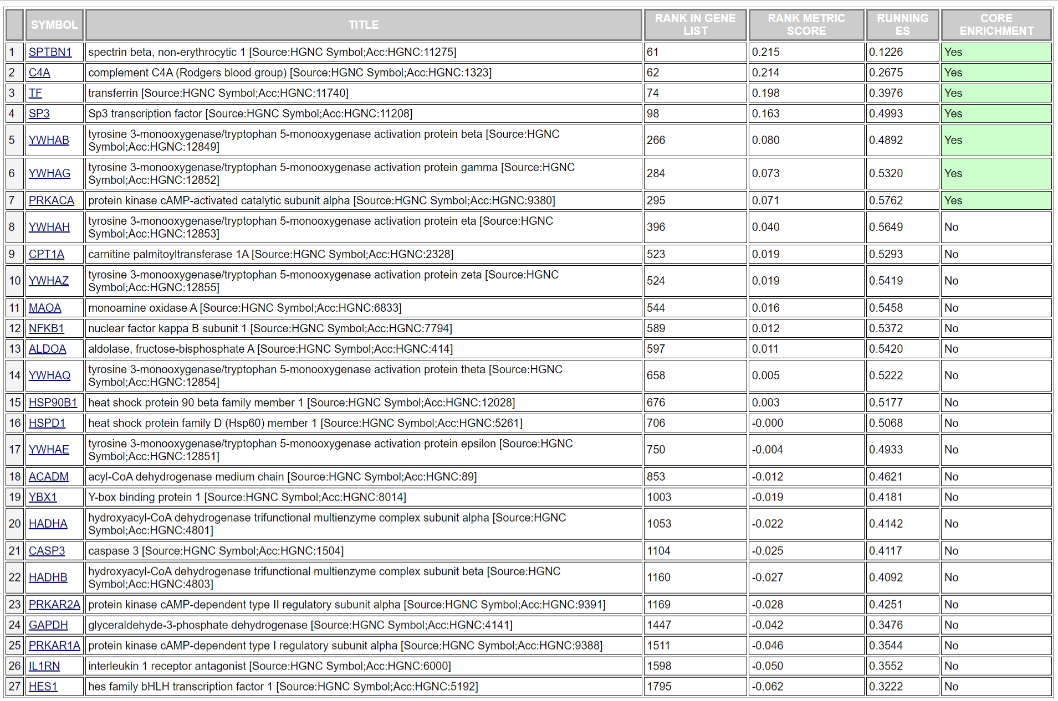
Supplemental Table S10 Sudden infant death syndrome (SIDs) susceptibility pathways.

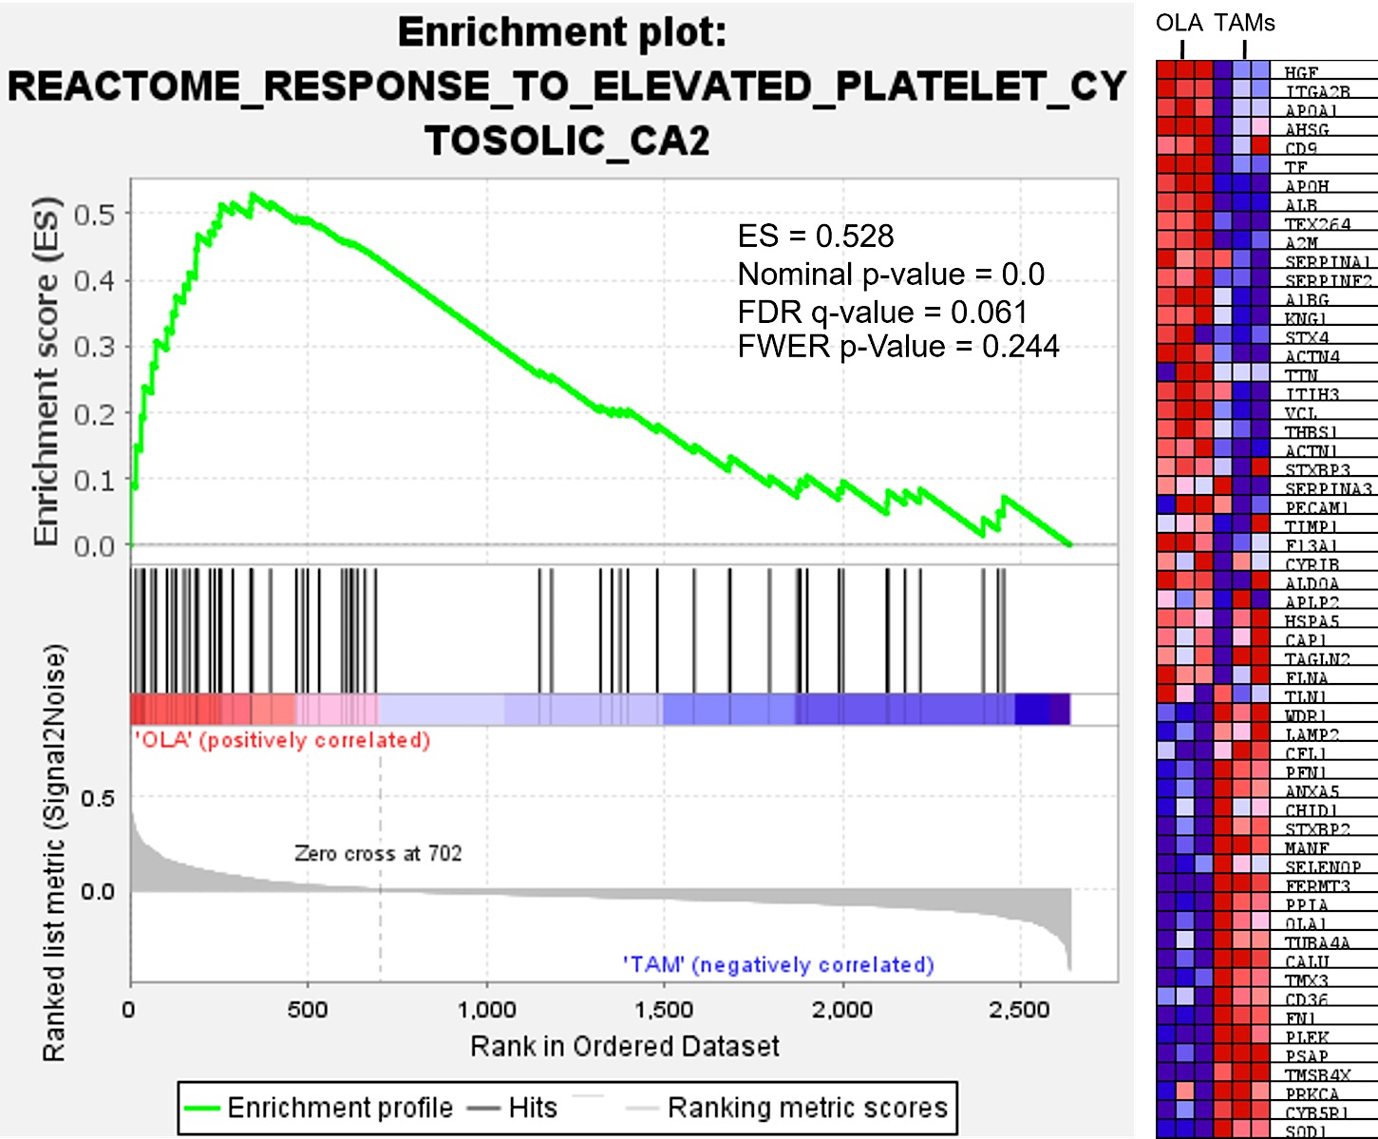

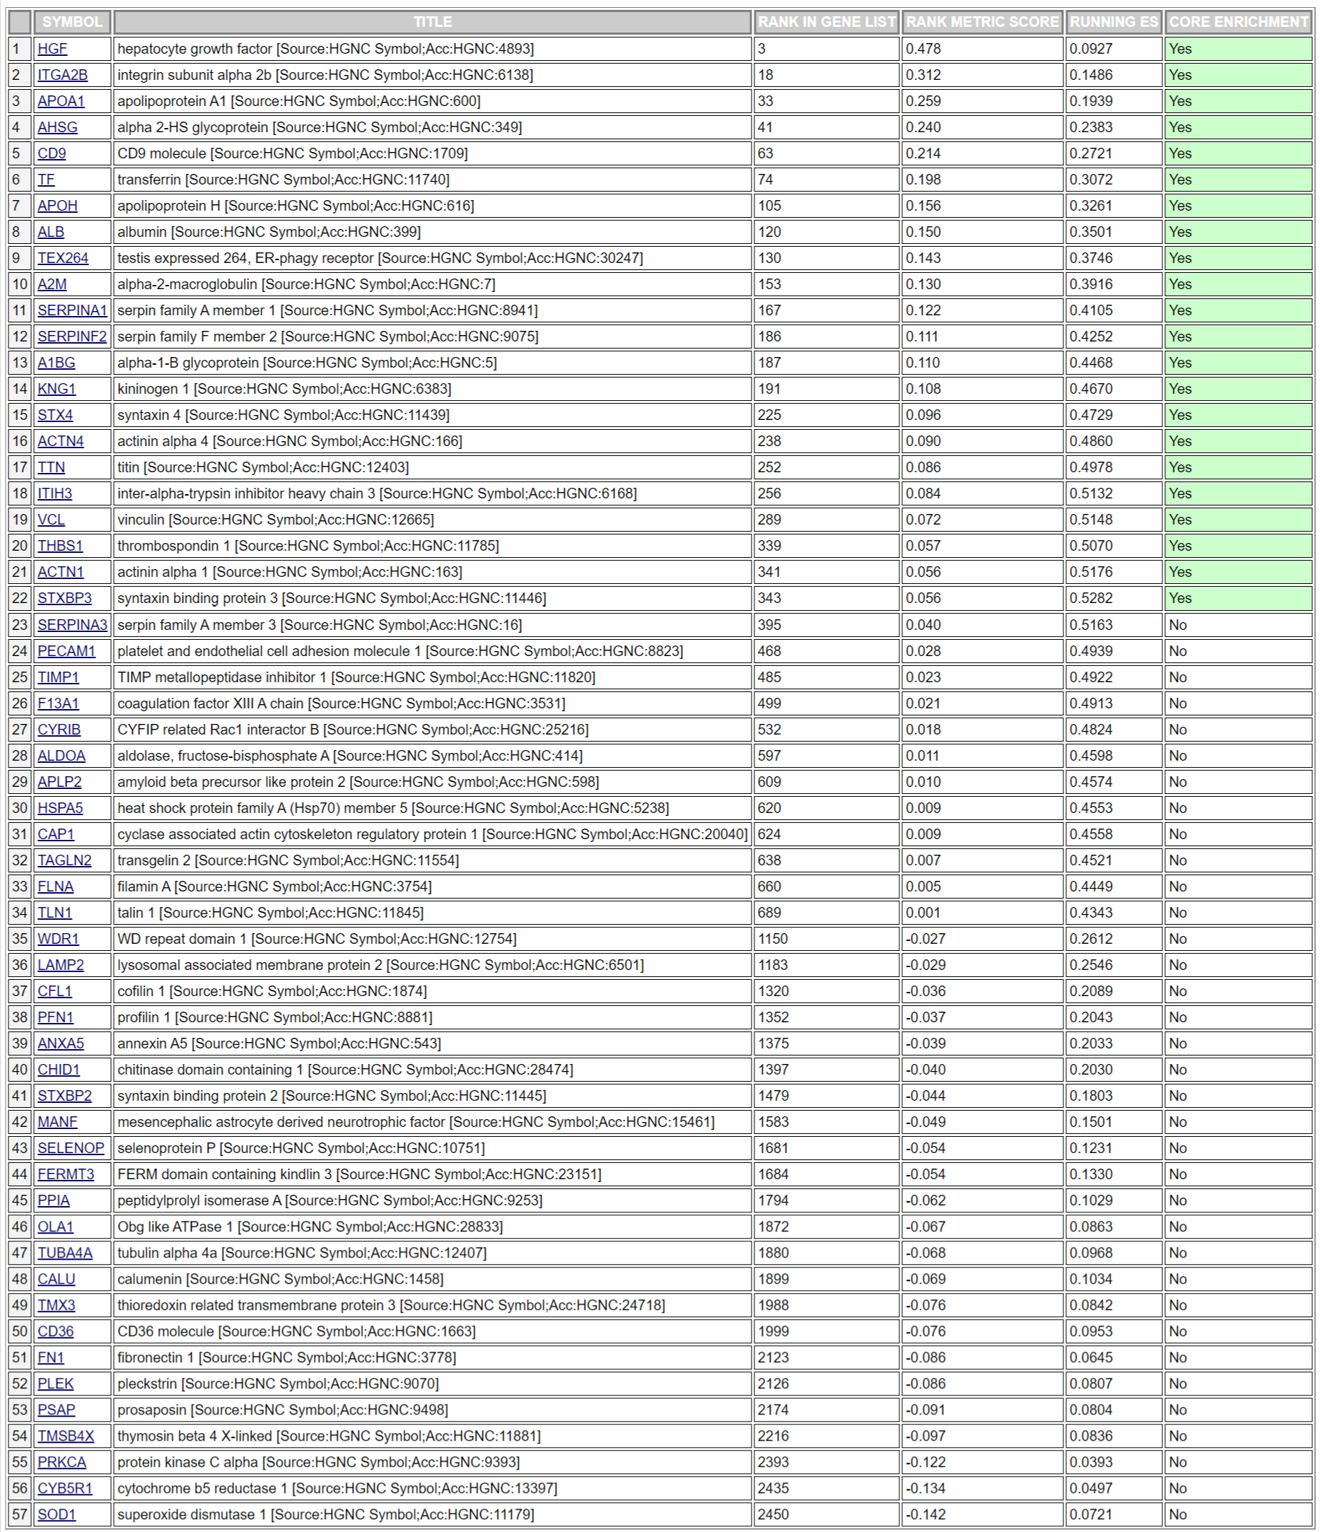
Supplemental Table S11 Response to elevated platelet cytosolic Ca².

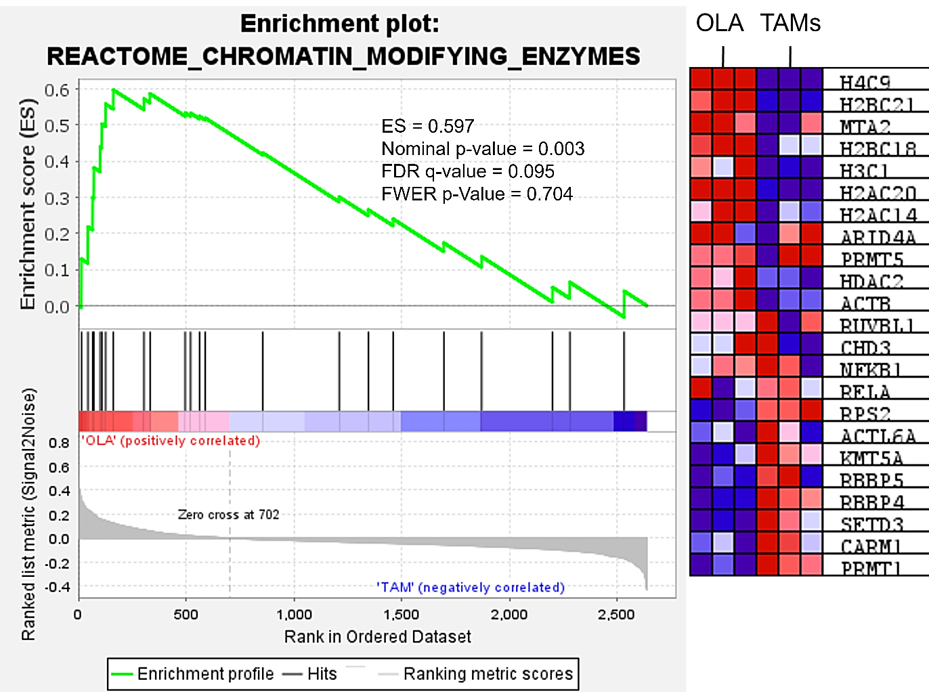

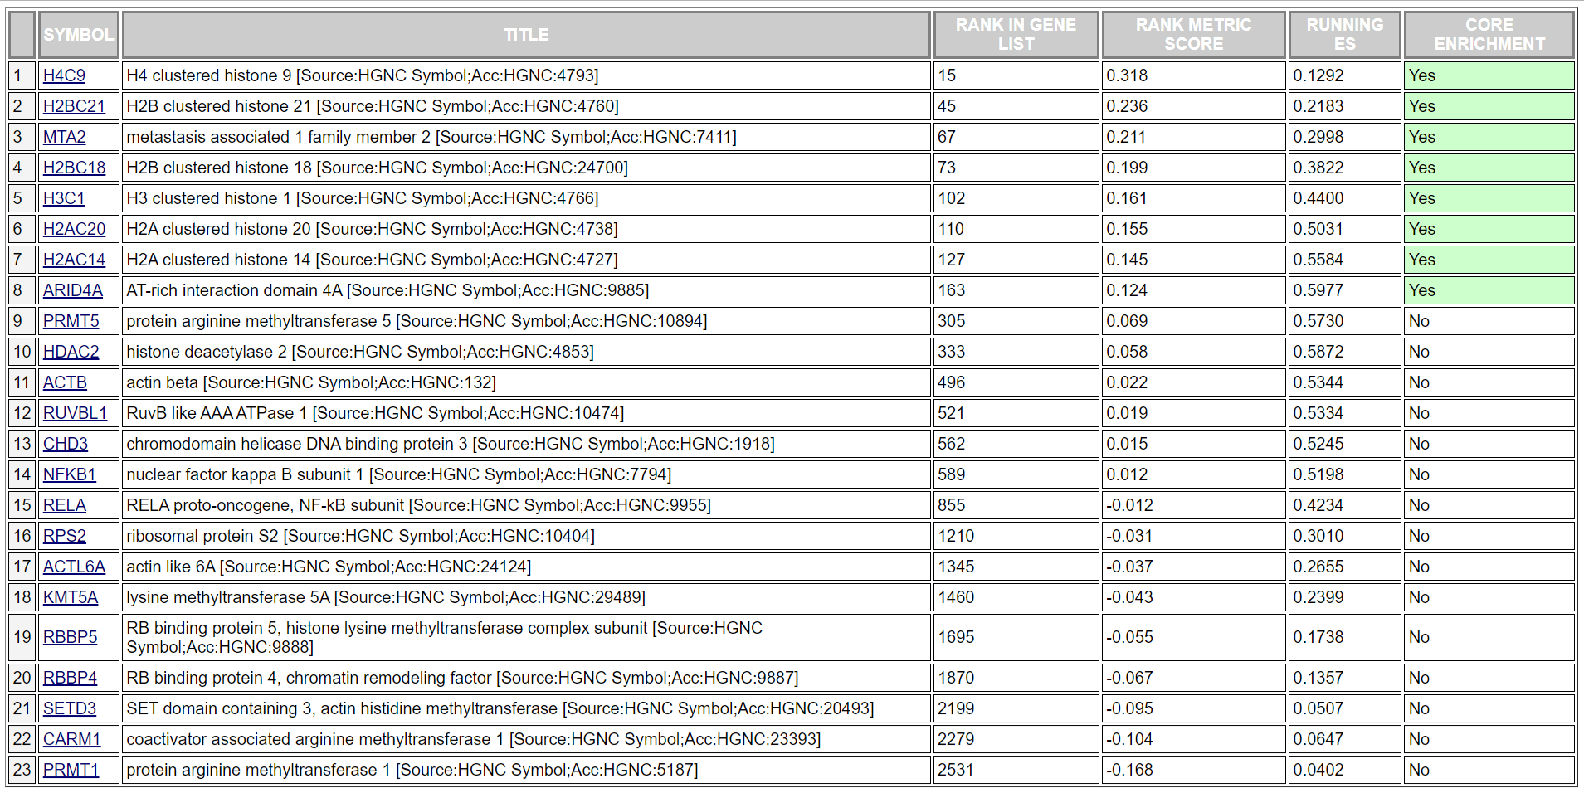
Supplemental Table S12 Chromatin modifying enzymes.

