Supplementary information

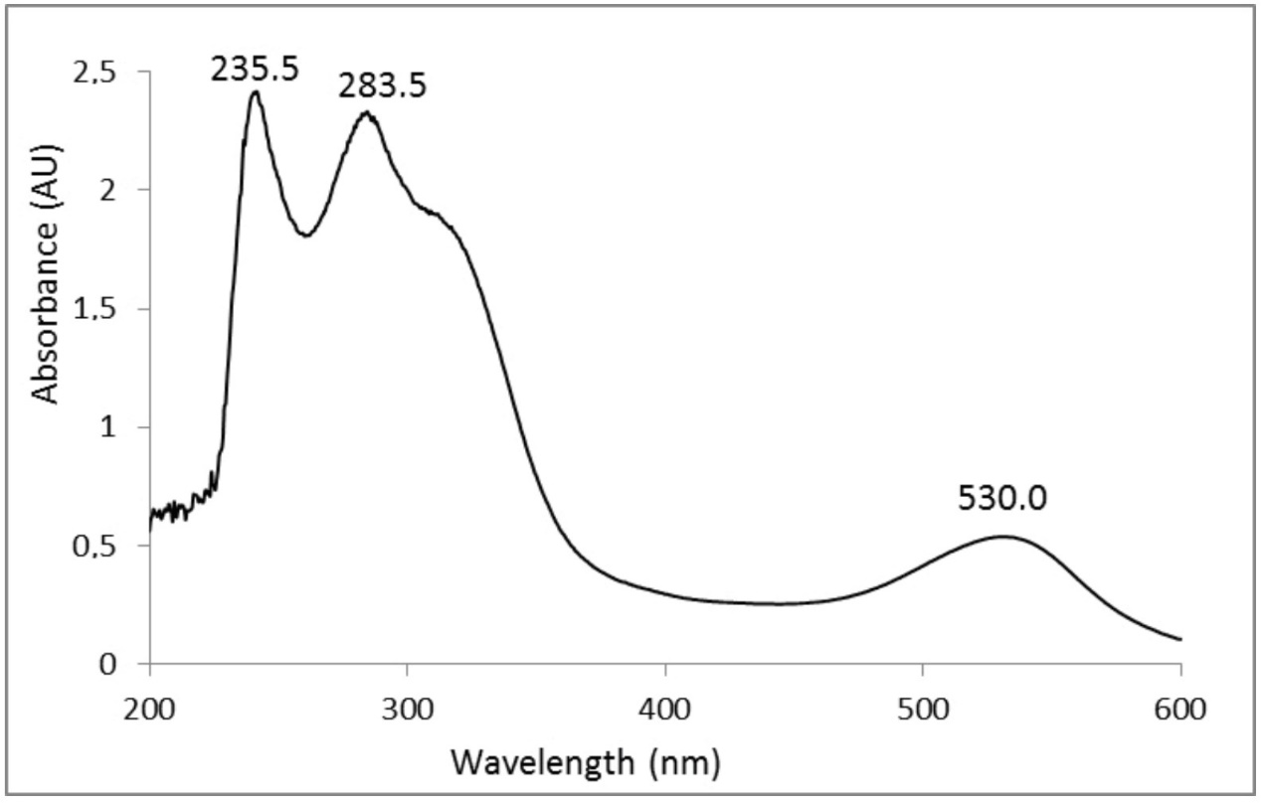

**UV-Vis spectra of the total anthocyanins [1]**

[1]Demir, Taki & Gunesli, Zuhal & Sonmez, Fatih & Bilen, Cigdem & Yavuz, Emre & Gençer, Nahit. (2015). Inhibition of carbonic anhydrase I and II with total anthocyanins extracted from sweet cherry cultivars. Environmental Engineering and Management Journal. 14. 935-941. 10.30638/eemj.2015.104.