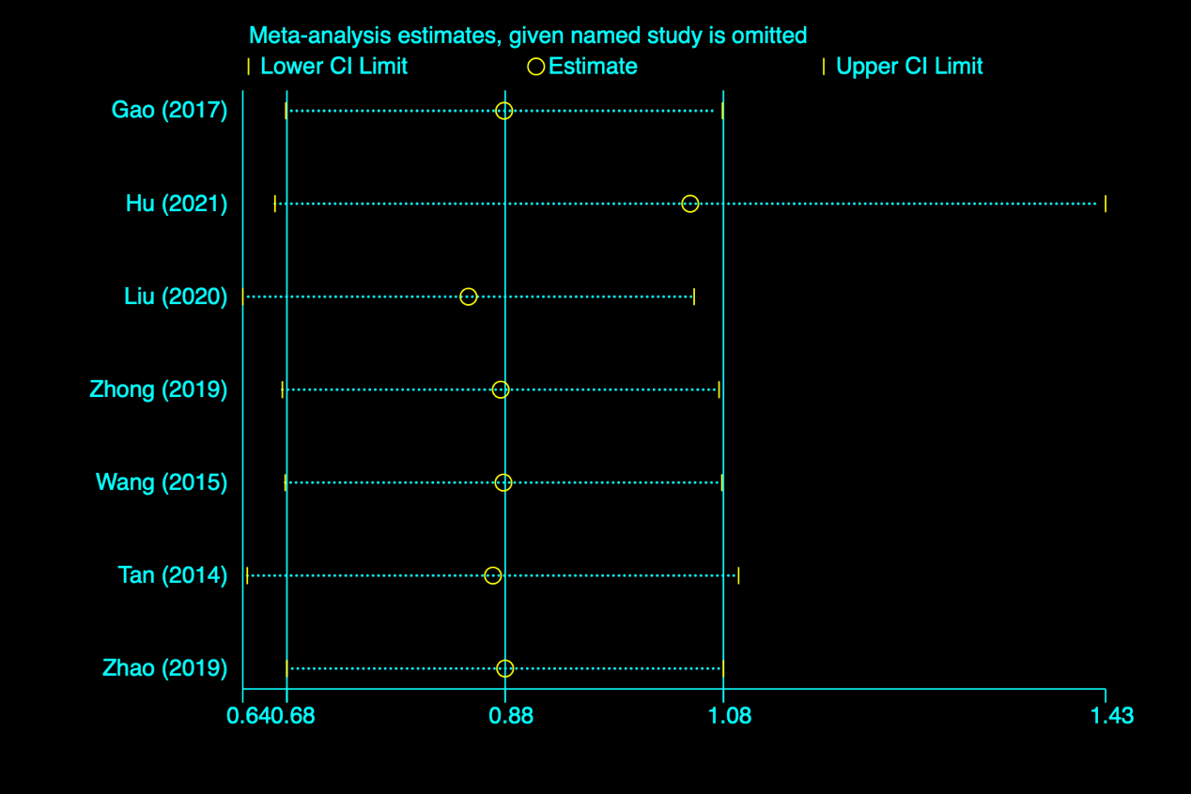

figure s1 Sensitivity analysis of preoperative complete ONP

figure s2 Sensitivity analysis of treatment time

图表

figure s3 Sensitivity analysis of surgery