Appendix 1.
Results of follow-up experiment to verify unexpected non-linear reaction norm in the Temperature Experiment.

Methods the same as for the Temperature Experiment (see main text), using three temperatures.

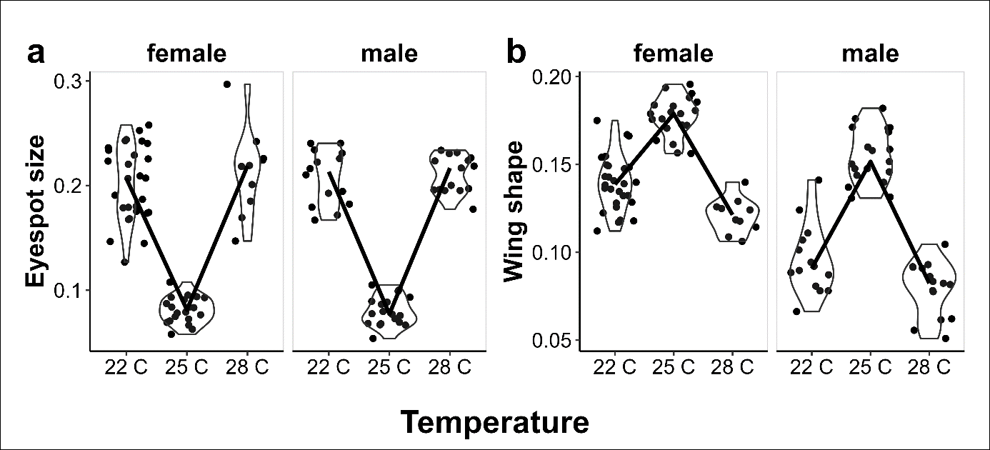

Figure A1.1. Provisional reaction norms of M. leda for a) Eyespot size, and b) wing shape.

The results are qualitatively similar to those of the main experiment (see Figure 3 in main text): a non-linear effect of temperature on adult phenotype.

