**Appendix 2.**

Details on statistical analyses.

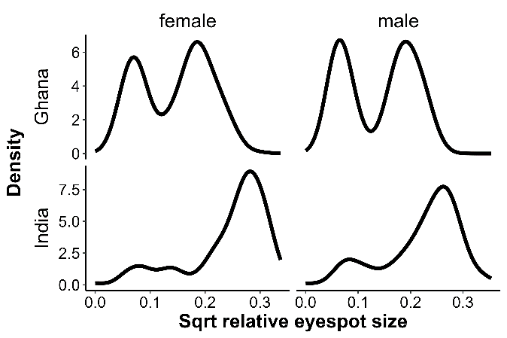

Figure A2.1. Density function of eyespot size combining all data, showing bimodal distributions, especially for Ghanaian population.

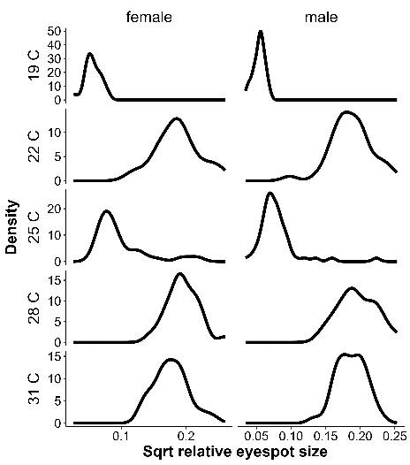

Figure A2.2. Density function of eyespot size per treatment for the Temperature Experiment showing unimodal distributions within treatments.

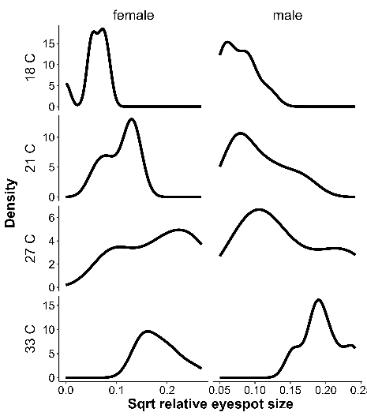

Figure A2.3. Density function of eyespot size per temperature for the Temperature and Humidity Experiment.

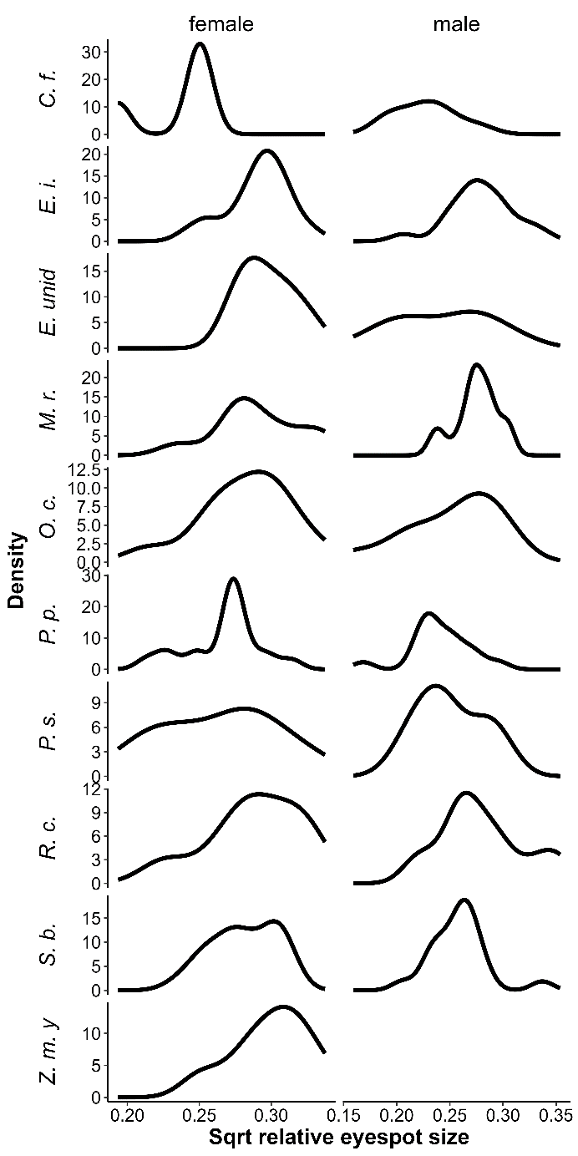

Figure A2.4. Density function of eyespot size per temperature for the Host Plant Experiment for plants with N > 7.

Figure A2.5. Density function of wing shape (square root of relative fore-wing tip area) combining all data, showing bimodal distributions, especially for Ghanaian population.

Figure A2.6 Density function of wing shape (square root of relative fore-wing tip area) per treatment for the Temperature Experiment showing unimodal distributions within treatments.

Figure A2.7 Density function of wing shape (square root of relative fore-wing tip area) per temperature for the Temperature and Humidity Experiment.

Figure A2.8. Density function of wing shape (square root of relative fore-wing tip area) per temperature for the Host Plant Experiment for plants with N > 7.

Table A2.1. Results of simple regressions within treatment and sex combinations as illustrated in Figure 8 of the main text.



Table A2.2. Results of simple regressions within treatment and sex combinations as illustrated in Figure 9 of the main text.



Table A2.3. Results of mixed models sorted by AICc values.

