**Appendix 3.**

Results of analyses on adult body size and larval development time.

Pupal mass is a good predictor of wing area of the adult within a treatment and sex combination (Figure A3.1., Table A3.1).

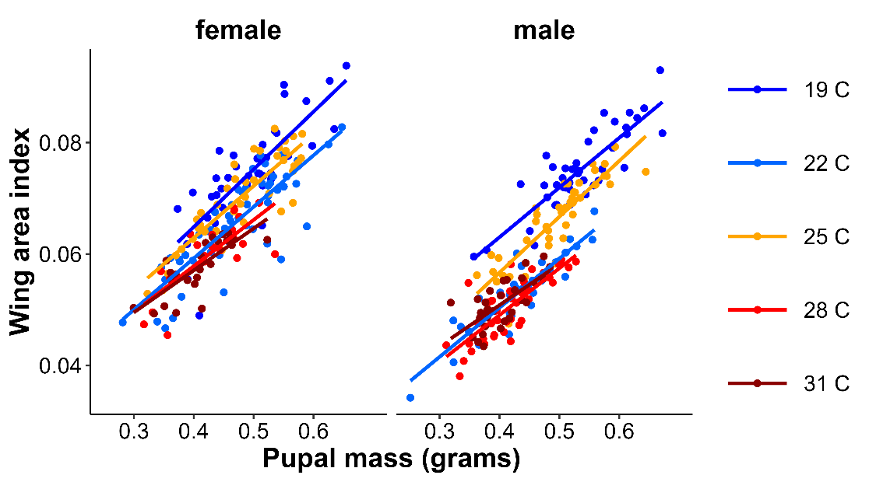

Figure A3.1. Relationship between pupal mass and wing area by temperature treatment for females and male *M. leda* from the Ghanaian population. Statistical results are in Table A3.1.

Table A3.1. Results of mixed model representing Figure A3.1. with as dependent variable wing area index and predictors, pupal mass, rearing temperature and sex.

Type III Analysis of Variance Table with Satterthwaite's method

Sos MS NumDF DenDF F-value P-value

Pupal mass 0.0112 0.0112 1 334.51 797 **< 0.001**

Temperature 0.0027 0.0007 4 35.26 47.5 **< 0.001**

Sex 0.0037 0.0037 1 352.04 260 **< 0.001**

Temp:sex 0.0004 0.0001 4 349.84 7.45 **< 0.001**

Wing area tends to be larger when larvae are reared at lower temperatures and on plants on which they grow faster (Figure A3.2).

Figure A3.2. Provisional reaction norms of *M. leda* wing area for a) the Temperature Experiment, b) the Temperature and Humidity Experiment, and c) the Host-Plant Experiment. Violin plots represent mirrored density functions illustrating the distribution of eyespot size within each treatment. For a, the average of eyespot size within each treatment is connected with a line. For 3c, only plants with N > 7 were included and plants were sorted from low to high larval growth rate. No true dry-season form butterflies were produced in the Host-Plant Experiment so the y-axis was truncated. Plant species are: *C. f. = Cymbopogon flexuosus*(Nees ex St.) Watson, *E. unid =* Unidentified like*Eleusine, P. p. = Pennisetum polystachion*(L.) Schult., *O. c. = Oplismenus compositus*(L.), *P. s.= Paspalum scrobiculatum*L., *M. r.= Melinis repens*(Willd.) Zizka, *Z. m. y = Zea mays*L. seedlings, *S. b. = Setaria barbata*(Lam.) Kunth, *R. c.* *= Rottboellia cochinchinensis*(Lour.) Clayton, *E. i. = Eleusine indica* (L.) Gaertn.

Wings tended to be more falcate in larger butterflies (Figure A3.3).

Figure A3.3. Relationship between wing area and wing shape for a) the Temperature Experiment, b) the Temperature and Humidity Experiment, and c) the Host-Plant Experiment. For A3.3c only plants with N >7 were included and plants were sorted from small to large average eyespot size.

Including wing area as a predictor in the models with as dependent variable relative eyespot size and wing shape may cause problems due to collinearity with temperature. Moreover wing area is closely correlated with pupal mass which is part of the growth rate parameter and both eyespot size and wing shape parameters are calculated with the use of wing area. When wing area is excluded in these models the significance of growth rate is often reduced (Table A3.2).

A3.2. Results of mixed models (Type III Analysis of Variance Table with Satterthwaite's method) of effects of growth rate and other predictors (but not wing area) on the square root of relative eyespot size and the wing shape index with a) full models, and b) models selected based on AICc values. For eyespots in the Temperature experiment, the sleeve random effect explained no variation and was excluded from the model (linear regression). Temp = temperature treatment (categorical), SoS = sum of squares, MS = mean squares, NumDF = degrees of freedom of numerator, DenDF = degrees of freedom of denumerator, Models = number of models in the top five that included the predictor.

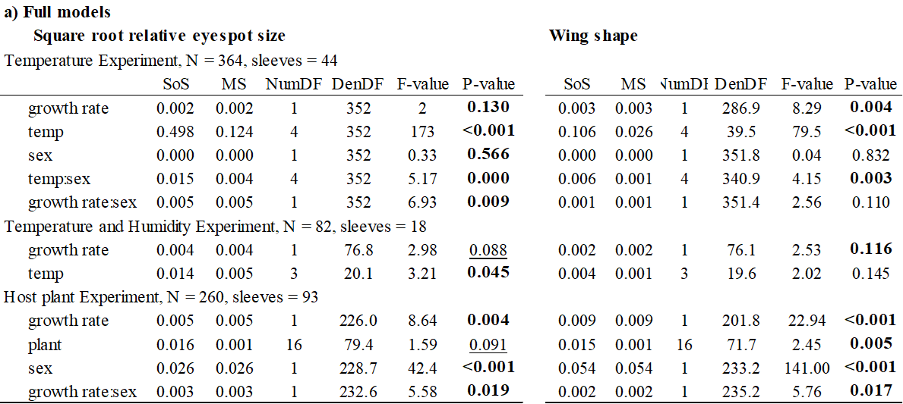



Differences in growth rate between temperature treatments are mainly due to differences in development time, as at low temperature (19 *°*C) the development time is almost three time compared to that at high temperature (31 *°*C), while pupal mass is about one third higher when caterpillars are reared at lower temperatures (Figure A3.4. In contrast, within treatments, most of the variation in growth rate is caused by variation in pupal mass, while development-time variation within treatments is modest compared to among treatment variation, especially at higher temperatures (Figure A3.4.).

Across treatments, higher pupal mass is associated with longer development time, but within treatments, higher pupal mass is generally associated with shorter development time (Figure A3.4.). The relationship across treatments may be interpreted as dry-season-forms having larger body size as well as with the temperature size rule aka ‘hotter is smaller’. The pattern within treatments is somewhat reminiscent of an L-shaped reaction norm where some individuals manage to grow quickly and become large, while others are growing slowly and remain small (aka as ‘stragglers’).

a)

b)

Figure A3.4. Reaction norms for age and size at maturity per treatment in the Temperature Experiment where the shade of points indicates a) eyespot size or b) wing shape indices.

Even though the figures with growth rates within the main text show relationships between growth rate and wing phenotype, this is not obvious when wing phenotype is plotted in relationship to both development time and pupal mass (Figure A3.5). Nevertheless, the statistical results show that both larval development time and pupal mass and their interaction tend to predict wing phenotype in *M. leda* (Table A3.2, with model selection details in Table A3.3).

Figure A3.5. Reaction norms for age and size at maturity per treatment in the Temperature Experiment where the shade of points indicates a) eyespot size or b) wing shape indices and their averages are indicated by the shade of tiles.

Table A3.3. Results of mixed models with as dependent variable square root relative eyespot size or square root relative wing tip size (wing shape) and as predictors, larval development time (devt time), pupal mass (mass), rearing temperature (temp) and sex, with a) full model results, and b) AICc selected model results.

a)



b)

Table A3.4. Results of mixed models sorted by AICc values with larval development time and pupal mass as predictors of eyespot size and wing shape.

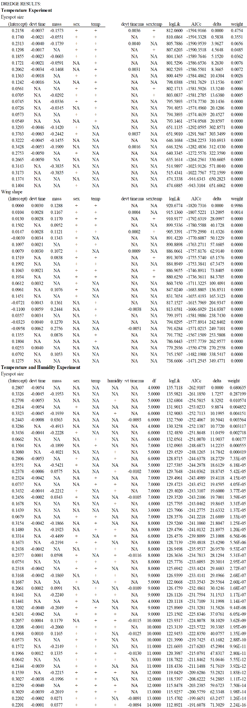

Table A3.4. *continued*