Growth and NO₃⁻ and NO₂⁻ reduction under oxic and anoxic conditions.
Strain JAM1^{T} and GP59 were cultured under three conditions: anoxic with 21.4 mM NO₃⁻ («AN»), oxic with NO₃⁻ («ON»; 21.4 mM NO₃⁻) and oxic without NO₃⁻ («O»). OD_{600nm}, and NO₃⁻ and NO₂⁻ concentrations were measured at different time intervals. Each point is the average with the standard deviation of triplicate cultures.
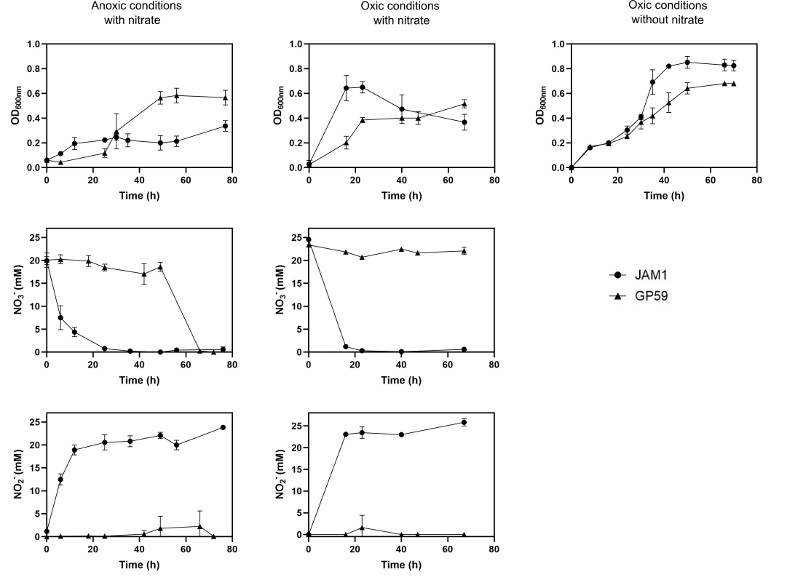
Strain JAM1^{T} grew immediately with no apparent lag phase under the «AN» conditions, and with a growth yield of around 0.2 OD_{600nm}. Under the «ON» and «O» conditions, strain JAM1^{T} reached a growth yield between 0.6 and 0.8 OD_{600nm} after 24h. The complete reduction of NO₃⁻ was observed within 20 h with strain JAM1 cultured under the «ON» or «AN» conditions, with accumulation of NO₂⁻.
Strain GP59 showed a 24-48-h lag phase before growth occurred under the «AN» conditions. Complete reduction of NO₃⁻ and NO₂⁻ was achieved within 70 h. The maximum growth yield was 3 times higher (up to 0.6 OD_{600nm}) than what was found with strain JAM1^{T} cultured under the same conditions. In previous work (Geoffroy et al., 2018), we showed that strain GP59 reached higher level of growth (1.0 OD_{600nm}) under the «AN» conditions with 42.8 mM NO₃⁻, whereas strain JAM1 still reached the same level of growth (0.2 OD_{600nm}). Finally, under the «O» and «ON» conditions, strain GP59 grew with no apparent lag phase, and reach approximately the same level of growth than strain JAM1^{T} cultured under the same conditions No reduction of NO₃⁻ was observed with strain GP59 cultured under the «ON» conditions.

