- The following 17 statements are about how you feel at work. Please read each statement carefully and decide if you ever feel this way about your job.

- At my work, I feel bursting with energy
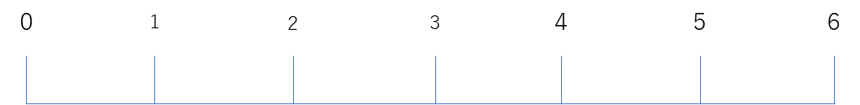
Everyday
Never

- I find the work that I do full of meaning and purpose
Never
Everyday

- Time flies when I'm working
Never
Everyday

- At my job, I feel strong and vigorous
Everyday
Never

- I am enthusiastic about my job
Everyday
Never

- When I am working, I forget everything else around me
Never
Everyday

- My job inspires me
Never
Everyday

- When I get up in the morning, I feel like going to work
Everyday
Never

- I feel happy when I am working intensely
Never
Everyday

- I am proud on the work that I do
Never
Everyday

- I am immersed in my work
Never
Everyday

- I can continue working for very long periods at a time
Everyday
Never

- To me, my job is challenging
Never
Everyday

- I get carried away when I’m working
Never
Everyday

- At my job, I am very resilient, mentally
Everyday
Never

- It is difficult to detach myself from my job
Never
Everyday

- At my work I always persevere, even when things do not go well
Everyday
Never

- Please tell me how you feel about working in the field of radiology.
- How do you feel about the dose on your personal dosimeter?
Very much
Very little

- Is radiation exposure management being carried out appropriately at your workplace?
Not at all
Very much so

- Does your workplace have a system in place for consultation about exposure to radiation?
Very much so
Not at all

- Do you think your radiation protection measures are sufficient?
Not at all
Very much so

- Do you think there is an effect on your health from occupational radiation exposure?
Very much so
Not at all

- Do you think your radiation exposure will affect the health of your children?
Not at all
Very much so

- Please tell me about yourself
- Age: ( ) years old
- Gender: Female, Male
- Marital status: Married, Unmarried
- Spouse: Yes, No
- Presence of children under 18 years of age: Yes, No
- Years of nursing experience: < 5 years, 5-10 years, 11-15 years, 16-20 years, 21-25 years, 26-30 years, 31 years <
- Years of departmental experience: ( ) years
- Position: Staff nurse, Manager nurse
- Post-employment qualifications: Yes, No
- Desire to be assigned to the radiology department: Yes, No
- Current main nursing operations (multiple answers allowed): Assistance in diagnostic imaging, Angiography, Endoscopy/Fluoroscopy, Nuclear medicine, Radiation therapy, Other

