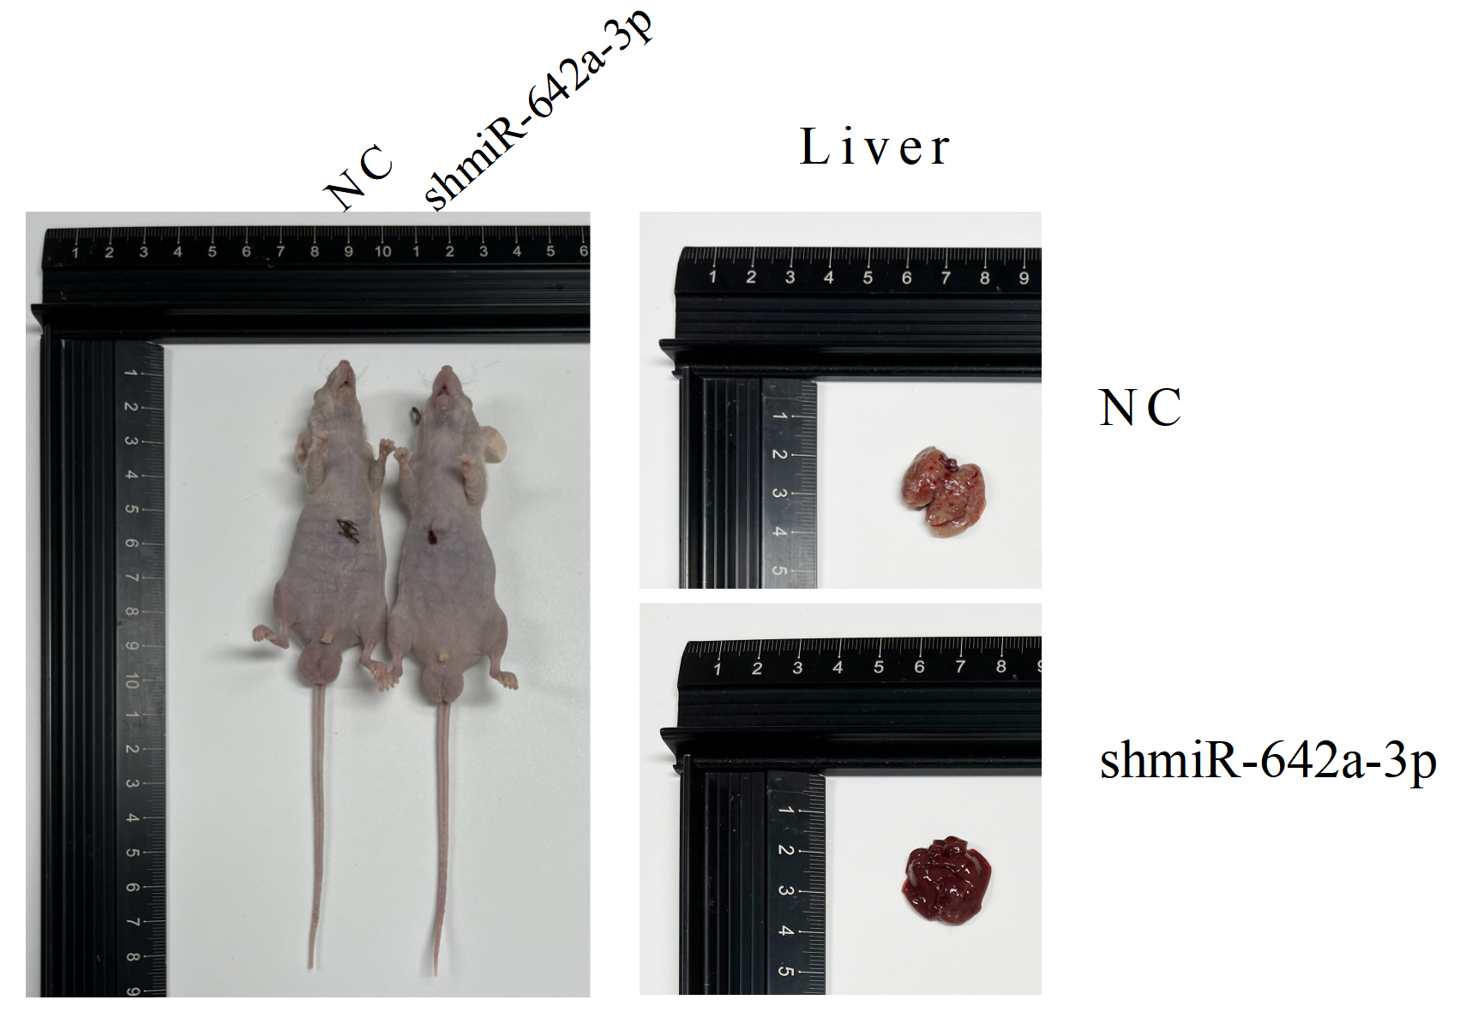

**Supplementary Figure 1** Effect of miR-642a-3p knockdown on growth of orthotopic liver tumors. One animals were shown first in each group (n = 5).