New insights into the impact of wood vinegar on the growth and rhizosphere microorganisms of cherry radish (*Raphanus sativus* L.)

Shiguo Gu 1, Wei Zhu 1, Liying Ren 1, Binbin Sun 2\*, Yuying Ren 3, Yongkang Niu 1, Xiaokang Li 4, Qingshan He 3\*

1 College of Civil and Architecture Engineering, Chuzhou University, Chuzhou, Anhui 239000, P.R. China

2 Institute of Pollution Control and Environmental Health, School of Energy and Environmental Engineering, Hebei University of Technology, Tianjin 300401, P.R. China.

3 School of Environment and Ecology, Jiangnan University, Wuxi, Jiangsu 214122, P.R. China

4 School of Environmental and Material Engineering, Yantai University, Yantai 264005, P.R. China

\* To whom correspondence should be addressed. E-mail: [sunbinnaruto@126.com](mailto:sunbinnaruto@126.com)

Text S1 H/C, O/C, and double bond equivalents (DBE) of molecular compositions H/C, O/C, and double bond equivalents (DBE) of molecular compositions:









where C, H, and O indicate the stoichiometric number of carbons, hydrogen, and oxygen atoms per formula, respectively. The relative magnitude (Mi) was calculated by dividing the signal peak magnitude (Ii) by the summed total magnitude.



Figure 1. Effect of wood vinegar treatment on the shoot biomass of cherry radish fruit. Data with different letters are significantly different (*p* < 0.05).



Figure 2. The effect of different concentrations of WV on cherry radish root morphologies including tips (a), length (b), surface area (c). Different letters represent different statistical groups suggested by the Tukey-HSD multiple comparisons at *p* < 0.05.



Figure 3. Effects of different treatments on chlorophyll content (a) and ratio of chlorophyll a to chlorophyll b (b) of cherry radish fruit. Data with different letters are significantly different (p < 0.05).

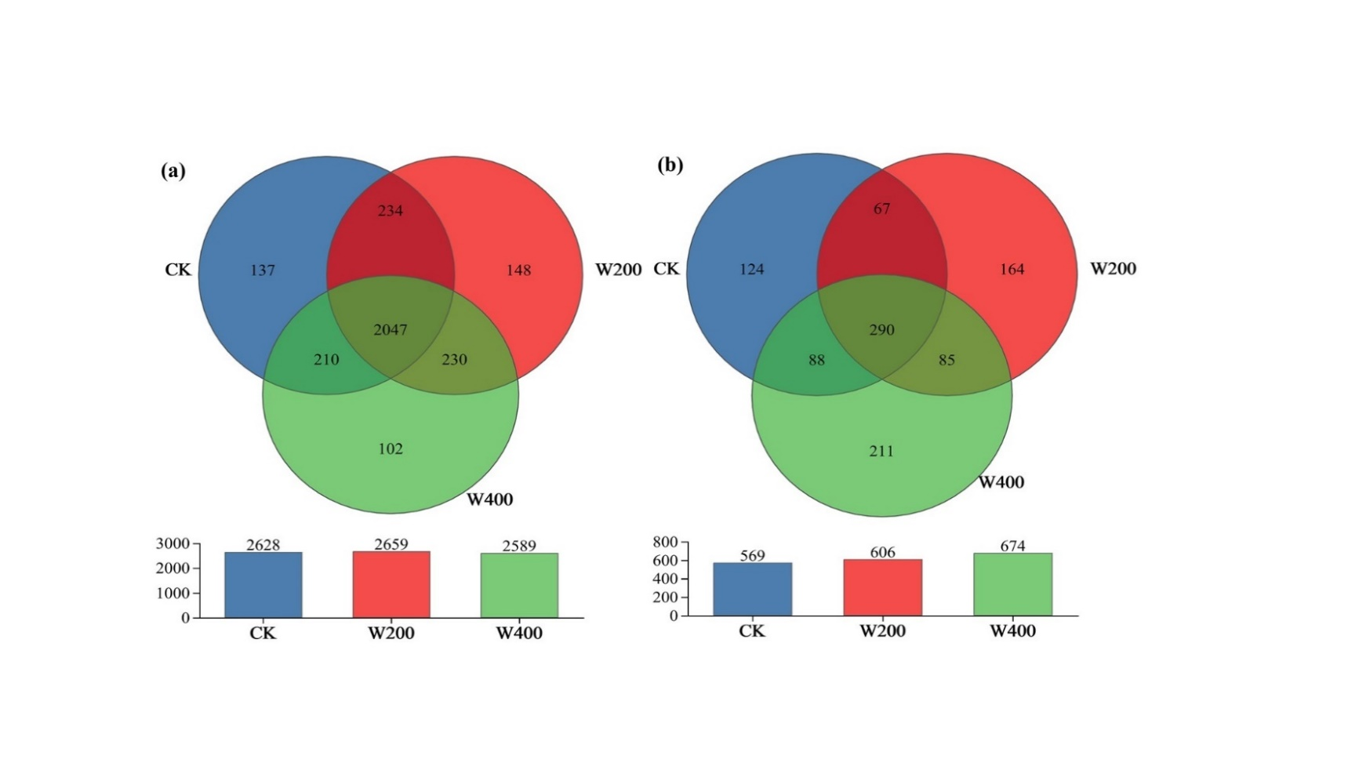

Figure 4. Venn diagram of OTUs of soil bacteria (a) and fungi (b)



Figure 5. Relationship between soil bacteria and physiological indicators of cherry radish revealed by RDA



Figure 6. Relationship between soil fungi and physiological indicators of cherry radish revealed by RDA



Figure 7. Thermogram analysis of the correlation between microbial community and growth factors. Note: \* Significant correlation at 0.05 level, \* \* Very significant correlation at 0.01 level.