Supplementary material

Training program
Table S1: Training program progression plan. Exercises further down the list are increasingly difficult. Progression to more difficult exercises was based on the physical therapist’s observation during the training sessions; if the participant was able to perform the task for 60 seconds, the difficulty would be increased.
Exercises |  | Duration/Frequency
Warm-up: Head rotations, back stretching, trunk rotations
Balancing  - one leg stance  - switch legs  - unstable surfaces |  | 3 x 60 seconds  2 repetitions
Balancing, eyes-closed  - one leg stance (when possible)  - switch legs  - unstable surfaces |  | 3 x 60 seconds  2 repetitions
Displacement of weight  - one leg stance  - switch legs  - unstable surfaces |  | 3 x 60 seconds  2 repetitions
Passing/throwing around a ball in groups of 4 |  | 5 rounds, both directions  3 repetitions
- fitness ball  - one leg  - unstable surface | - 2 kg ball  - one leg  - unstable surface
Alternative approaches for more trunk rotation:
- bigger circle
- backs towards each other
Pass big ball around: stop ball with foot and roll it back |  | 5 rounds, both directions  3 repetitions
- fitness ball  - one leg  - unstable surface | - 2 kg ball  - one leg  - unstable surface

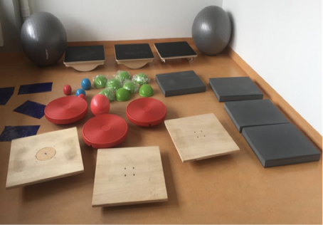
Figure S1: Equipment used during the training sessions.

Experimental setup and model representation
Figure S2.1: The experimental setup of a participant in unipedal stance on the robot-controlled mediolateral rotating platform. | Figure S2.2: Example of the model, constructed from the cluster markers, from which the kinematic parameters are obtained.

Complete overview statistics – Lateral perturbation
A | B
C | D
E | F
G | H
I | J
K | Figure S3: SPM1d statistics of the recovery responses after lateral perturbation for all parameters. Each panel displays the mean response per session (left top), ANOVA F-statistic (left bottom), and post-hoc t-statistic (right) over time for a single parameter. The degrees of freedom for all ANOVAs and dependent sample t-tests were [2,38] and [1,19], respectively. Effects were significant if the test statistic exceeded the critical threshold (red dotted lines). For the t-tests Bonferroni correction was applied. p* represent the test’s omnibus p-value. If more than one cluster was present, their individual p-values are stated after the omnibus value in chronological order.

Complete overview statistics – Medial perturbation
A | B
C | D
E | F
G | H
I | J
K | Figure S4: Statistics of the recovery responses after medial perturbation for all parameters. Each panel displays the mean response per session (left top), ANOVA F-statistic (left bottom), and post-hoc t-statistic (right) over time for a single parameter. The degrees of freedom for all ANOVAs and dependent sample t-tests were [2,38] and [1,19], respectively. Effects were significant if the test statistic exceeded the critical threshold (red dotted lines). For the t-tests Bonferroni correction was applied. p* represent the test’s omnibus p-value. If more than one cluster was present, their individual p-values are stated after the omnibus value in chronological order.

Variability kinematics – Lateral perturbation
Figure S5: Kinematic responses to lateral perturbations. Group mean (solid lines) and standard deviation over subjects (coloured patches) per session.

Variability kinematics – Lateral perturbation
Figure S6: Kinematic responses to medial perturbations. Group mean (solid lines) and standard deviation over subjects (coloured patches) per session.

Variability EMG – Lateral perturbation
Figure S7: EMG responses to lateral perturbations. Group mean (solid lines) and standard deviation over subjects (coloured patches) per session. The letters D & N in the titles indicate muscles on the dominant and non-dominant side, respectively. TA: tibialis anterior, SO: soleus, VL: vastus lateralis, RF: rectus femoris, GM: gluteus medius, ES: erector spinae, AL: adductor longus, PL: peroneus longus, GL: gastrocnemius lateralis, and BF: biceps femoris.

Variability EMG – Lateral perturbation
Figure S8: EMG responses to medial perturbations. Group mean (solid lines) and standard deviation over subjects (coloured patches) per session. The letters D & N in the titles indicate muscles on the dominant and non-dominant side, respectively. TA: tibialis anterior, SO: soleus, VL: vastus lateralis, RF: rectus femoris, GM: gluteus medius, ES: erector spinae, AL: adductor longus, PL: peroneus longus, GL: gastrocnemius lateralis, and BF: biceps femoris.

