Supplementary Materials

Minimum detection densities

To account for the possibility of non-detections, we added a number representing the minimum density that could be detected (1 individual /total volume of mesocosm sampled in a single vertical tow) to densities of all taxa assessed in samples from week 0 and week 3. We added one third of the minimum detection density to each layer to represent the presence of a single undetected individual in that layer, for each species. We also added a minimum detection biomass (0.01 µg/L; representing the measurement resolution of the algae analyzer that we used) to all algal groups as it was unclear if a biomass of 0 represented a true absence, a lack of detection due to sampling, or measurement error (Table S4 provides number of mesocosms where minimum detection density was added for each major taxonomic group assessed). There is support for this protocol because we detected individuals of major taxonomic groups at the end of experiment in many mesocosms without detections in week 0 (Table S4).

Daphnia vertical position

After zooplankton stocking, the vertical position of Daphnia prior to the start of the experiment did not reflect the position in their source lakes. Instead, stocking mesocosms from these uninvaded lakes with different Daphnia vertical positions created a gradient of daphniid vertical position from 0 to 40% hypolimnetic (Figure S1).
Through the course of the experiment, it was possible that Daphnia could change its vertical position in response to individual mesocosm environments. For invaded mesocosms with greater spatial overlap between Daphnia and Bythotrephes (fewer hypolimnetic Daphnia), Daphnia may adopt a deeper depth distribution in response to Bythotrephes kairomone (Bourdeau et al. 2013), although this response is not uniformly observed (Kiehnau and Weider 2019). Additionally, in uninvaded mesocosms with more hypolimnetic Daphnia, metabolic costs associated with residing in deeper, colder waters with potentially lower algal biomass and quality could result in Daphnia migrating to warmer, algae abundant epilimnetic waters (Johnsen and Jakobsen 1987, Leibold 1990, Rautio et al. 2003, Kessler and Lampert 2004).
To determine if total Daphnia and individual Daphnia species shifted their depth distributions during the experiments, either as a result of direct predation or an induced response to Bythotrephes predation, I assessed differences in the proportion of hypolimnetic individuals with experiment week (categorical variables with two levels; Week 0 or Week 3) and Bythotrephes (categorical variables with two levels; Present or Absent) as interacting explanatory variables using either gamma or log-normal distributed generalized linear mixed models (GLMMs) with a log link and mesocosm as a random effect. Minimum adequate models were chosen using log-likelihood ratio tests based on Crawley's (2005) procedure. Any changes in the proportion of hypolimnetic Daphnia between week 0 and week 3 were interpreted as shifts in vertical position during the experiment. AICc values were used to assess model fit between log-normal and gamma distributed models, with the model with the lowest value chosen. The inclusion of mesocosm as a random effect was determined on the basis of log likelihood ratio tests using Crawley’s (2008) procedure. Generalized linear hypothesis tests performed (GLHT) for relevant comparisons when significant interactions between predictor variables were detected. A summary of the results from this analysis is provided in Table S12. Figures S2 and S3 show vertical position for total Daphnia, D. catawba, and D. mendotae at the start of the experiment. Differences in vertical position for D. catawba, and D. mendotae between Week 0 and Week 3 are shown in figure S3.

Zooplankton species categorization
Bythotrephes negatively impacts cladoceran density (Boudreau & Yan, 2003; Strecker et al., 2006) and preferentially feeds on larger bodied cladocerans, especially Daphnia (Schulz & Yurista, 1999). No cladocerans between 0.85-1.0mm were found in our mesocosms. Non-Daphnia cladoceran species were categorized as small or large based on average species body length (Barnett et al. 2007). Small cladocerans included Bosmina freyi/liederi, Eubosmina tubicen, Eubosmina longispina, Chydorus sphaericus, Eubosmina coregoni, Ceriodaphnia lacustris, Simocephalus vetulus, and Scapholeberis mucronata. Large cladocerans included Holopedium glacialis and Sida crystallina. All of these species are impacted by Bythotrephes presence (Azan et al., 2015). Copepod zooplankton were split into calanoid copepods, cyclopoid copepods, nauplii and copepodites, representing different trophic positions and feeding strategies (calanoid and cyclopoid copepods), and juvenile stages (copepodites and nauplii). Calanoid copepods are suspension feeding herbivore-omnivores that could compete with Daphnia and other cladocerans for algal resources while cyclopoid copepods are raptorial feeding omnivore-carnivores (Barnett et al., 2007), that could be indirectly impacted by Bythotrephes predation on small cladocerans.

Structural Equation Models
For the full model, we only fit paths between Bythotrephes presence, proportion of total hypolimnetic Daphnia in week 0, and the per capita change in density for each zooplankton group (Figure 1). Paths for calanoid and cyclopoid copepods also included per capita change in copepodite density as an explanatory variable since copepodites mature into adult calanoid and cyclopoid copepods, directly impacting the per capita change in density for these taxonomic groups. Paths for total algal density included per capita change in density for all herbivorous zooplankton groups, i.e., Daphnia, all cladocerans, copepodites, and calanoid copepods as the density of these groups directly reduce total algal density across time. Collinearity between per capita change in density of all taxonomic groups was accounted for by explicitly treating these as correlated errors (not a directed path). Proportion of total hypolimnetic Daphnia in week 0 and Bythotrephes presence were included as exogenous variables and potential paths were fit with GLMs (normal distribution, log link function). Paths for per capita changes in calanoid and cyclopoid densities included per capita change in copepodite density as an exogenous variable. For total algal density, per capita change in densities for all herbivorous zooplankton groups were also fit as exogenous variables. We fit a nested version containing only the significant links identified in the full model to confirm, using AIC, that the full model is not more likely than the reduced model, given the data.

Density dependent effects of Bythotrephes predation due to differences in starting densities
Due to differences in starting densities (Table S2), it is possible that any significant influence of Daphnia vertical position on Bythotrephes impacts for any zooplankton group could be confounded by density dependent Bythotrephes predation. To ensure that density dependent predation was not confounding Bythotrephes impacts, we examined the correlation between total zooplankton density in week 0 and per capita change in density for taxa where Daphnia vertical position was found to influence per capita density. As per capita density is calculated by dividing densities in week 3 by densities in week 0, we expected per capita density for each taxa assessed to be spuriously correlated with total zooplankton density in week 0. Therefore, we assessed if the Pearson correlation coefficient between taxon per capita change in density and total zooplankton density in week 0 obtained from this analysis was observed within 95% of the distribution of coefficients obtained by bootstrapping (with replacement) (n = 1000). For all zooplankton taxa, correlation coefficients were observed within the 95th percentile of the bootstrapped distribution suggesting that per capita change in density observed in these groups was not influenced by differences in starting densities across my mesocosms (Figure S4).

Influence of vertical position of D. mendotae and D. catawba on per capita change in density for major zooplankton taxonomic groups
Proportion of hypolimnetic D. mendotae and D. catawba in week 0 impacted per capita change in total Daphnia density, with an increase in per capita total Daphnia density observed in mesocosms with a greater proportion of D. mendotae and D. catawba in the hypolimnion (Table S6 & S7). Proportion of hypolimetic D. catawba in week 0 negatively impacted per capita cyclopoid density and positively impacted per capita total algal biomass (Table S7). There was no effect of proportion of hypolimnetic individuals of these two species in week 0 on per capita change for any other zooplankton taxonomic group.
References
Azan, S. S. E., Arnott, S. E. and Yan N. D. (2015) A review of the effects of Bythotrephes longimanus and calcium decline on zooplankton communities can interactive effects be predicted? Environ. Rev., 23, 395–413
Barnett, A. J., Finlay, K. and Beisner, B. E. (2007) Functional diversity of crustacean zooplankton communities: towards a trait-based classification. Freshw. Biol., 52, 796-813
Bourdeau, P. E., Pangle, K. L., Reed, E. M. and Peacor, S. D. (2013) Finely tuned response of native prey to an invasive predator in a freshwater system. Ecology, 94, 1449-1455.
Boudreau, S. A. and Yan, N. D. (2003) The differing crustacean zooplankton communities of Canadian Shield lakes with and without the nonindigenous zooplanktivore Bythotrephes longimanus. Canadian Journal of Fisheries and Aquatic Sciences, 60, 1307-1313.
Crawley, M. J. (2011) Statistics: An introduction using R. John Wiley and Son Ltd
Johnsen, G. H., & Jakobsen, P. J. (1987). The effect of food limitation on vertical migration in Daphnia longispina 1. Limnology and Oceanography, 32, 873-880.
Kiehnau, E. L., and Weider, L. J. (2019). Phototactic behavior of native Daphnia in the presence of chemical cues from a non-native predator Bythotrephes.Oecologia, 190, 799-809.
Kessler, K., & Lampert, W. (2004). Depth distribution of Daphnia in response to a deep‐water algal maximum: the effect of body size and temperature gradient. Freshwater biology, 49(4), 392-401

Leibold, M. A. (1990). Resources and predators can affect the vertical distributions of zooplankton. Limnol. Oceanogr., 35, 938–944
Rautio, M., Korhola, A., & Zellmer, I. D. (2003). Vertical distribution of Daphnia longispina in a shallow subarctic pond: Does the interaction of ultraviolet radiation and Chaoborus predation explain the pattern? Polar Biology, 26, 659-665.
Schulz, K. L. and Yurista, P. M. (1999) Implications of an invertebrate predator’s (Bythotrephes cederstroemi) atypical effects on a pelagic zooplankton community. Hydrobiologia, 380, 179–193.
Strecker, A.L., Arnott, S.E., Yan, N.D. and Girard, R. (2006) Variation in the response of crustacean zooplankton species richness and composition to the invasive predator Bythotrephes longimanus. Can. J. Fish Aquat. Sci., 63, 2126–2136.

Tables
Table S1: Weekly temperature measurements (°C) for Fletcher Lake for 1-14m at 1m intervals through the duration of the experiment

Depth (m) | Week 0 | Week 1 | Week 2 | Week 3
1 | 21.89 | 22.6 | 20.6 | 21.0
2 | 21.82 | 22.6 | 20.5 | 21.0
3 | 21.41 | 22.6 | 20.5 | 21.0
4 | 19.54 | 19.3 | 20.4 | 21.0
5 | 14.89 | 13.6 | 14.8 | 20.2
6 | 9.49 | 9.3 | 10.1 | 15.5
7 | 7.32 | 7.7 | 7.9 | 11.4
8 | 6.31 | 6.8 | 6.5 | 9.6
9 | 5.74 | 5.9 | 5.7 | 8.3
10 | 5.39 | 5.6 | 5.3 | 7.1
11 | 5.08 | 5.3 | 5.1 | 6.5
12 | 4.98 | 5.0 | 4.9 | 6.1
13 | 4.89 | 4.9 | 4.8 | 5.8
14 | 4.79 | 4.8 | 4.7 | 5.4

Table S2: Initial densities (individuals per litre) in each mesocosm for Daphnia, small cladocerans, large cladocerans, calanoids, cyclopoids, copepodids, and nauplii prior to the application of the Bythotrephes treatment (N = absent, Y = present). Mean ± standard error (SE) for each taxonomic group is also provided. Densities for zooplankton taxa are provided in individuals per litre while total algal density is provided in micrograms per litre.

Mesocosm Number | Bythotrephes  Treatment | ‍Stocking Lake | Daphnia | Small Cladocerans | Large Cladocerans | Copepodites | Nauplii | Calanoids | Cyclopoids | Total Algae
1 | N | Mix‍ | 0.009 | 0.009 | 0.009 | 0.345 | 0.028 | 0.009 | 0.028 | 6.530
2 | N | Echo‍ | 0.869 | 0.074 | 0.112 | 2.346 | 0.308 | 0.084 | 0.317 | 6.190
3 | N | Bonnie‍ | 0.009 | 0.018 | 0.046 | 0.906 | 0.074 | 0.028 | 0.074 | 6.410
4 | Y | Bonnie‍ | 0.018 | 0.009 | 0.018 | 0.355 | 0.018 | 0.028 | 0.018 | 6.300
5 | Y | Bonnie‍ | 0.028 | 0.028 | 0.177 | 0.803 | 0.037 | 0.037 | 0.037 | 6.590
6 | Y | ‍Mix | 0.458 | 0.074 | 0.074 | 1.140 | 0.121 | 0.018 | 0.140 | 5.940
7 | N | Bonnie‍ | 0.018 | 0.009 | 0.018 | 0.448 | 0.037 | 0.056 | 0.046 | 5.780
8 | Y | ‍Echo | 0.187 | 0.018 | 0.028 | 0.551 | 0.037 | 0.046 | 0.037 | 6.020
9 | Y | Bonnie‍ | 0.028 | 0.009 | 0.159 | 0.701 | 0.018 | 0.037 | 0.018 | 6.180
10 | N | ‍Bonnie | 0.112 | 0.018 | 0.093 | 0.738 | 0.009 | 0.009 | 0.009 | 5.820
11 | N | ‍Mix | 0.551 | 0.028 | 0.215 | 1.065 | 0.074 | 0.009 | 0.074 | 4.230
12 | N | Echo‍ | 0.495 | 0.046 | 0.065 | 0.981 | 0.074 | 0.074 | 0.074 | 6.980
13 | Y | ‍Echo | 0.205 | 0.009 | 0.018 | 1.102 | 0.168 | 0.046 | 0.168 | 6.410
14 | Y | Echo‍ | 0.850 | 0.037 | 0.187 | 0.944 | 0.187 | 0.018 | 0.187 | 6.640
15 | N | ‍Bonnie | 0.009 | 0.028 | 0.252 | 0.616 | 0.056 | 0.037 | 0.056 | 6.800
16 | Y | ‍Bonnie | 0.018 | 0.018 | 0.130 | 0.551 | 0.065 | 0.018 | 0.065 | 6.600
17 | N | ‍Bonnie | 0.028 | 0.037 | 0.224 | 1.168 | 0.140 | 0.065 | 0.140 | 6.880
18 | Y | ‍Mix | 0.364 | 0.028 | 0.046 | 2.009 | 0.196 | 0.037 | 0.196 | 6.910
19 | N | ‍Mix | 0.159 | 0.056 | 0.102 | 1.897 | 0.243 | 0.037 | 0.243 | 6.390
20 | N | Echo‍ | 0.607 | 0.056 | 0.130 | 3.093 | 0.411 | 0.112 | 0.411 | 7.320
21 | Y | ‍Bonnie | 0.018 | 0.018 | 0.074 | 0.654 | 0.093 | 0.037 | 0.093 | 7.010
22 | N | Echo‍ | 0.803 | 0.018 | 0.028 | 2.383 | 0.205 | 0.187 | 0.205 | 6.240
23 | Y | ‍Bonnie | 0.028 | 0.009 | 0.065 | 0.841 | 0.074 | 0.046 | 0.074 | 6.100
24 | Y | ‍Echo | 0.355 | 0.009 | 0.018 | 1.598 | 0.168 | 0.093 | 0.168 | 6.820
25 | N | Echo‍ | 0.102 | 0.009 | 0.084 | 0.831 | 0.448 | 0.018 | 0.448 | 6.850
26 | N | Echo‍ | 0.355 | 0.046 | 0.046 | 1.710 | 0.121 | 0.149 | 0.121 | 5.180
27 | N | ‍Bonnie | 0.028 | 0.018 | 0.411 | 0.934 | 0.093 | 0.065 | 0.093 | 6.370
28 | Y | Echo‍ | 0.430 | 0.009 | 0.037 | 1.934 | 0.402 | 0.093 | 0.402 | 6.110
29 | Y | Bonnie‍ | 0.046 | 0.028 | 0.168 | 0.841 | 0.261 | 0.121 | 0.261 | 6.630
30 | Y | ‍Echo | 0.504 | 0.028 | 0.009 | 2.131 | 0.504 | 0.112 | 0.504 | 6.250
31 | N | ‍Bonnie | 0.046 | 0.009 | 0.046 | 0.841 | 0.280 | 0.046 | 0.280 | 6.050
32 | Y | Mix‍ | 0.392 | 0.009 | 0.084 | 0.990 | 0.168 | 0.046 | 0.168 | 7.000
33 | Y | Bonnie‍ | 0.018 | 0.009 | 0.028 | 1.953 | 0.168 | 0.009 | 0.168 | 6.870
34 | N | ‍Mix | 0.289 | 0.009 | 0.084 | 1.467 | 0.196 | 0.074 | 0.196 | 6.680
35 | Y | Echo‍ | 0.271 | 0.028 | 0.018 | 1.392 | 0.458 | 0.093 | 0.458 | 6.810
36 | N | ‍Echo | 0.327 | 0.037 | 0.074 | 2.411 | 0.626 | 0.046 | 0.626 | 7.950
37 | N | ‍Echo | 0.467 | 0.102 | 0.037 | 2.327 | 0.504 | 0.159 | 0.504 | 6.660
38 | Y | ‍Echo | 0.121 | 0.046 | 0.009 | 1.280 | 0.514 | 0.037 | 0.514 | 7.650
39 | Y | Mix‍ | 0.514 | 0.046 | 0.280 | 1.701 | 0.336 | 0.056 | 0.336 | 7.010
40 | N | Bonnie‍ | 0.028 | 0.009 | 0.392 | 0.738 | 0.187 | 0.102 | 0.187 | 4.550
Mean ± SE |  | ‍ | 0.254±0.006 | 0.028±0.001 | 0.102±0.002 | 1.268±0.017 | 0.203±0.004 | 0.060±0.001 | 0.204±0.004 | 6.438±0.110
‍
 |  | Echo | 2.492±1.040 |  |  | Bythotrephes Absent | 1.954±1.026
 |  | Bonnie | 1.497±0.974 |  |  | Bythotrephes Present | 2.287±1.126
 |  | Mix | 2.191±0.861

Table S3: Final densities (individuals per litre) in each mesocosm for Daphnia, small cladocerans, large cladocerans, calanoids, cyclopoids, copepodids, and nauplii prior to the application of the Bythotrephes treatment (N = absent, Y = present). Mean ± standard error (SE) for each taxonomic group is also provided. Densities for zooplankton taxa are provided in individuals per litre while total algal density is provided in micrograms per litre.

Mesocosm Number | Bythotrephes  Treatment | ‍Stocking Lake | Daphnia | Small Cladocerans | Large Cladocerans | Copepodites | Nauplii | Calanoids | Cyclopoids | Total Algae
1 | N | Mix‍ | 0.037 | 0.028 | 0.028 | 0.373 | 1.215 | 0.009 | 1.215 | 4.780
2 | N | Echo‍ | 0.317 | 0.074 | 0.018 | 0.420 | 0.439 | 0.009 | 0.439 | 6.750
3 | N | Bonnie‍ | 0.159 | 1.000 | 0.018 | 0.607 | 0.626 | 0.018 | 0.626 | 6.440
4 | Y | Bonnie‍ | 0.056 | 0.467 | 0.056 | 0.635 | 0.663 | 0.009 | 0.663 | 6.650
5 | Y | Bonnie‍ | 0.112 | 0.934 | 0.037 | 0.570 | 0.308 | 0.009 | 0.308 | 5.850
6 | Y | ‍Mix | 0.355 | 0.065 | 0.009 | 0.495 | 0.514 | 0.018 | 0.514 | 6.690
7 | N | Bonnie‍ | 0.289 | 1.495 | 0.037 | 0.327 | 0.607 | 0.009 | 0.607 | 5.330
8 | Y | ‍Echo | 0.972 | 0.233 | 0.018 | 0.383 | 0.542 | 0.037 | 0.542 | 7.100
9 | Y | Bonnie‍ | 0.130 | 0.701 | 0.093 | 0.486 | 0.476 | 0.009 | 0.476 | 5.920
10 | N | ‍Bonnie | 0.402 | 1.308 | 0.037 | 0.383 | 0.888 | 0.028 | 0.888 | 5.140
11 | N | ‍Mix | 1.037 | 0.205 | 0.009 | 0.598 | 0.486 | 0.009 | 0.486 | 7.370
12 | N | Echo‍ | 1.364 | 0.205 | 0.028 | 0.336 | 0.289 | 0.009 | 0.289 | 7.380
13 | Y | ‍Echo | 1.140 | 0.355 | 0.018 | 0.766 | 2.869 | 0.028 | 2.869 | 6.620
14 | Y | Echo‍ | 0.364 | 0.168 | 0.009 | 0.261 | 0.738 | 0.009 | 0.738 | 6.600
15 | N | ‍Bonnie | 0.392 | 1.682 | 0.046 | 0.579 | 0.747 | 0.009 | 0.747 | 5.370
16 | Y | ‍Bonnie | 0.028 | 0.224 | 0.065 | 0.542 | 0.691 | 0.028 | 0.691 | 7.020
17 | N | ‍Bonnie | 0.177 | 0.345 | 0.028 | 0.514 | 0.719 | 0.009 | 0.719 | 5.660
18 | Y | ‍Mix | 0.402 | 0.046 | 0.009 | 0.888 | 0.588 | 0.009 | 0.588 | 8.130
19 | N | ‍Mix | 1.243 | 0.373 | 0.009 | 0.542 | 0.392 | 0.009 | 0.392 | 7.340
20 | N | Echo‍ | 0.906 | 0.187 | 0.018 | 0.486 | 0.532 | 0.009 | 0.532 | 8.060
21 | Y | ‍Bonnie | 0.028 | 0.028 | 0.056 | 0.402 | 0.831 | 0.018 | 0.831 | 8.090
22 | N | Echo‍ | 0.588 | 0.364 | 0.018 | 0.392 | 0.719 | 0.009 | 0.719 | 9.080
23 | Y | ‍Bonnie | 0.065 | 0.037 | 0.233 | 0.532 | 0.766 | 0.028 | 0.766 | 24.030
24 | Y | ‍Echo | 1.430 | 0.495 | 0.037 | 0.271 | 2.822 | 0.018 | 2.822 | 7.800
25 | N | Echo‍ | 2.280 | 0.850 | 0.084 | 0.327 | 1.149 | 0.009 | 1.149 | 7.860
26 | N | Echo‍ | 1.327 | 0.663 | 0.018 | 0.308 | 0.953 | 0.018 | 0.953 | 7.890
27 | N | ‍Bonnie | 0.504 | 1.289 | 0.037 | 0.869 | 0.813 | 0.056 | 0.813 | 7.200
28 | Y | Echo‍ | 0.228 | 0.121 | 0.030 | 0.464 | 3.089 | 0.009 | 3.089 | 8.120
29 | Y | Bonnie‍ | 0.147 | 0.323 | 0.048 | 0.712 | 0.784 | 0.009 | 0.784 | 8.110
30 | Y | ‍Echo | 0.560 | 0.308 | 0.018 | 0.215 | 0.990 | 0.009 | 0.990 | 8.410
31 | N | ‍Bonnie | 0.149 | 1.691 | 0.121 | 0.859 | 1.570 | 0.009 | 1.570 | 6.810
32 | Y | Mix‍ | 1.747 | 0.159 | 0.009 | 0.317 | 0.859 | 0.009 | 0.859 | 8.420
33 | Y | Bonnie‍ | 0.074 | 0.093 | 0.009 | 0.243 | 0.065 | 0.009 | 0.065 | 10.730
34 | N | ‍Mix | 0.944 | 0.383 | 0.009 | 0.523 | 0.850 | 0.009 | 0.850 | 8.570
35 | Y | Echo‍ | 0.588 | 0.159 | 0.009 | 0.430 | 0.691 | 0.009 | 0.691 | 9.430
36 | N | ‍Echo | 2.617 | 0.579 | 0.028 | 0.476 | 2.617 | 0.018 | 2.617 | 9.490
37 | N | ‍Echo | 1.177 | 0.261 | 0.028 | 0.243 | 1.084 | 0.009 | 1.084 | 8.340
38 | Y | ‍Echo | 0.345 | 0.261 | 0.037 | 0.411 | 1.439 | 0.009 | 1.439 | 9.000
39 | Y | Mix‍ | 0.757 | 0.439 | 0.009 | 0.785 | 0.514 | 0.018 | 0.514 | 8.010
40 | N | Bonnie‍ | 0.420 | 0.953 | 0.046 | 1.000 | 0.747 | 0.018 | 0.757 | 7.950
Mean ± SE |  | ‍ | 0.646 ±0.099 | 0.489 ±0.074 | 0.037 ±0.006 | 0.499 ±0.031 | 0.942 ±0.112 | 0.015 ±0.002 | 0.942 ±0.112 | 7.839 ±0.463

Table S4: Number of mesocosms in week 0 and week 3 with non-detections for major six major taxonomic groups and most common zooplankton species. For mesocosms with non-detections, a minimum detection density was added prior to calculation of per capita change in density. There were no non-detections for total algae, green algae, cyanobacteria, cryptophyte, or diatom biomass in either week 0 or week 3.

Taxonomic groups | Week 0 | Week 3
Daphnia | 3 | None
Small cladocerans | 14 | None
Large cladocerans | 3 | 10
Calanoids | 4 | 26
Cyclopoids | 1 | None
Copepodids | None | None
Nauplii | None | None
Most common species | Week 0 | Week 3
Daphnia mendotae | 13 | 3
Daphnia catawba | 4 | 3
Bosmina freyi/leideri | 21 | 5
Eubosmina tubicen | 25 | 5
Eubosmina longispina | 38 | 6
Skistodiaptomus oregonensis | 40 | 10
Cyclops scutifer | 6 | 4

Table S5: Estimates ± standard error (SE), degrees of freedom (df), p-values (p), and standardized estimates for all paths (represented as separate rows of response and predictor variables) assessed in piecewise structural equation model for per capita change in Daphnia, small cladocerans, juvenile copepods, calanoids, cyclopoids, and large cladocerans density, and total algal biomass in week 3 as response variables. Statistically significant paths (p ≤ 0.05) are presented in bold.

Response | Predictor | Estimate(± SE) | df | p | Standardized Estimate
Daphnia | Bythotrephes | -1.76±0.65 | 37 | 0.010 | -0.11
Daphnia | Proportion of total hypolimnetic Daphnia in week 0 | 3.94±1.06 | 37 | 0.0006 | 0.06
Small Cladocerans | Bythotrephes | -1.23±0.56 | 37 | 0.037 | -0.01
Small Cladocerans | Proportion of total hypolimnetic Daphnia in week 0 | 2.52±1.14 | 37 | 0.033 | 0.008
Juvenile Copepods | Bythotrephes | -0.08±0.20 | 37 | 0.686 | -0.05
Juvenile Copepods | Proportion of total hypolimnetic Daphnia in week 0 | 1.38±0.6541 | 37 | 0.0411 | 0.21
Calanoids | Bythotrephes | -2.59±4.14 | 36 | 0.536 | -2.38
Calanoids | Proportion of total hypolimnetic Daphnia in week 0 | -21.74±32.49 | 36 | 0.508 | -5.24
Calanoids | Juvenile Copepods | 2.15±3.11 | 36 | 0.494 | 3.41
Large Cladocerans | Bythotrephes | 0.38±0.41 | 37 | 0.366 | 0.18
Large Cladocerans | Proportion of total hypolimnetic Daphnia in week 0 | 1.10±1.23 | 37 | 0.375 | 0.13
Cyclopoids | Bythotrephes | -3.80±0.61 | 36 | <0.0001 | -0.11
Cyclopoids | Proportion of total hypolimnetic Daphnia in week 0 | -35.48±6.67 | 36 | <0.0001 | -0.28
Cyclopoids | Juvenile Copepods | 3.69±0.73 | 36 | <0.0001 | 0.19
Total Algae | Bythotrephes | -0.05±0.13 | 32 | 0.963 | -0.06
Total Algae | Proportion of total hypolimnetic Daphnia in week 0 | 1.09±0.32 | 32 | 0.0017 | 0.05
Total Algae | Daphnia | -0.04±0.01 | 32 | 0.629 | -0.01
Total Algae | Small Cladocerans | -0.002±0.001 | 32 | 0.128 | -0.03
Total Algae | Large Cladocerans | 0.18±0.04 | 32 | <0.0001 | 0.06
Total Algae | Calanoids | -0.04±0.12 | 32 | 0.747 | -0.007
Total Algae | Juvenile copepods | -0.19±0.08 | 32 | 0.004 | -0.05

Table S6: Estimates ± standard error (SE), degrees of freedom (df), p-values (p), and standardized estimates for all paths (represented as separate rows of response and predictor variables) assessed in piecewise structural equation model with per capita change in Daphnia, small cladocerans, juvenile copepods, calanoids, cyclopoids, and large cladocerans density, and green algal biomass in week 3 as response variables. Statistically significant paths (p ≤ 0.05) are presented in bold.

Response | Explanatory | Estimate(± SE) | df | p | Standardized estimate
Daphnia | Bythotrephes | -1.76±0.65 | 37 | 0.010 | -0.11
Daphnia | Proportion of total hypolimnetic Daphnia in week 0 | 3.94±1.06 | 37 | 0.0006 | 0.06
Small Cladocerans | Bythotrephes | -1.22±0.56 | 37 | 0.037 | -0.01
Small Cladocerans | Proportion of total hypolimnetic Daphnia in week 0 | 2.52±1.14 | 37 | 0.033 | 0.01
Juvenile Copepods | Bythotrephes | -0.08±0.20 | 37 | 0.686 | -0.05
Juvenile Copepods | Proportion of total hypolimnetic Daphnia in week 0 | 1.38±0.65 | 37 | 0.041 | 0.21
Calanoids | Bythotrephes | -2.59±4.14 | 36 | 0.536 | -2.38
Calanoids | Proportion of total hypolimnetic Daphnia in week 0 | -21.74±32.49 | 36 | 0.508 | -5.24
Calanoids | Juvenile Copepods | 2.15±3.11 | 36 | 0.494 | 3.41
Large Cladocerans | Bythotrephes | 0.38±0.41 | 37 | 0.366 | 0.18
Large Cladocerans | Proportion of total hypolimnetic Daphnia in week 0 | 1.10±1.23 | 37 | 0.375 | 0.13
Cyclopoids | Bythotrephes | -3.80±0.61 | 36 | <0.0001 | -0.11
Cyclopoids | Proportion of total hypolimnetic Daphnia in week 0 | -35.48±6.67 | 36 | <0.0001 | -0.28
Cyclopoids | Juvenile Copepods | 3.69±0.72 | 36 | <0.0001 | 0.19
Green Algae | Bythotrephes | 0.30±0.19 | 32 | 0.13 | 0.18
Green Algae | Proportion of total hypolimnetic Daphnia in week 0 | 2.92±0.37 | 32 | <0.0001 | 0.44
Green Algae | Daphnia | -0.02±0.01 | 32 | 0.883 | -0.02
Green Algae | Small Cladocerans | 0.0009±0.001 | 32 | 0.562 | 0.04
Green Algae | Large Cladocerans | 0.36±0.04 | 32 | <0.0001 | 0.43
Green Algae | Calanoids | 0.25±0.15 | 32 | 0.112 | 0.16
Green Algae | Juvenile copepods | -0.14±0.07 | 32 | 0.043 | -0.14

Table S7: Estimates ± standard error (SE), degrees of freedom (df), p-values (p), and standardized estimates for all paths (represented as separate rows of response and predictor variables) assessed in piecewise structural equation model with per capita change in Daphnia, small cladocerans, juvenile copepods, calanoids, cyclopoids, and large cladocerans density, and diatom biomass in week 3 as response variables. Statistically significant paths (p ≤ 0.05) are presented in bold.

Response | Explanatory | Estimate (± SE) | df | p | Standardized estimate
Daphnia | Bythotrephes | -1.76±0.65 | 37 | 0.010 | -0.11
Daphnia | Proportion of total hypolimnetic Daphnia in week 0 | 3.94±1.06 | 37 | 0.0006 | 0.06
Small Cladocerans | Bythotrephes | -1.22±0.56 | 37 | 0.037 | -0.01
Small Cladocerans | Proportion of total hypolimnetic Daphnia in week 0 | 2.52±1.14 | 37 | 0.033 | 0.01
Juvenile Copepods | Bythotrephes | -0.08±0.20 | 37 | 0.686 | -0.05
Juvenile Copepods | Proportion of total hypolimnetic Daphnia in week 0 | 1.38±0.65 | 37 | 0.041 | 0.21
Calanoids | Bythotrephes | -2.59±4.14 | 36 | 0.536 | -2.38
Calanoids | Proportion of total hypolimnetic Daphnia in week 0 | -21.74±32.49 | 36 | 0.508 | -5.24
Calanoids | Juvenile Copepods | 2.15±3.11 | 36 | 0.494 | 3.41
Large Cladocerans | Bythotrephes | 0.38±0.41 | 37 | 0.366 | 0.18
Large Cladocerans | Proportion of total hypolimnetic Daphnia in week 0 | 1.10±1.23 | 37 | 0.375 | 0.13
Cyclopoids | Bythotrephes | -3.80±0.61 | 36 | <0.0001 | -0.11
Cyclopoids | Proportion of total hypolimnetic Daphnia in week 0 | -35.48±6.67 | 36 | <0.0001 | -0.28
Cyclopoids | Juvenile Copepods | 3.69±0.72 | 36 | <0.0001 | 0.19
Diatoms | Bythotrephes | -1.05±0.50 | 32 | 0.04 | -0.44
Diatoms | Proportion of total hypolimnetic Daphnia in week 0 | 1.65±1.89 | 32 | <0.0001 | 1.48
Diatoms | Daphnia | -0.06±0.04 | 32 | 0.186 | -0.41
Diatoms | Small Cladocerans | -0.02±0.005 | 32 | 0.003 | -0.62
Diatoms | Large Cladocerans | 0.73±0.08 | 32 | <0.0001 | 0.65
Diatoms | Calanoids | -3.88±0.76 | 32 | <0.0001 | -1.75
Diatoms | Juvenile copepods | -0.39±0.15 | 32 | 0.0152 | -0.28

Table S8: Estimates ± standard error (SE), degrees of freedom (df), p-values (p), and standardized estimates for all paths (represented as separate rows of response and predictor variables) assessed in piecewise structural equation model with per capita change in Daphnia, small cladocerans, juvenile copepods, calanoids, cyclopoids, and large cladocerans density, and cyanobacteria biomass in week 3 as response variables. Statistically significant paths (p ≤ 0.05) are presented in bold.

Response | Explanatory | Estimate (± SE) | df | p | Standardized estimate
Daphnia | Bythotrephes | -1.76±0.65 | 37 | 0.010 | -0.11
Daphnia | Proportion of total hypolimnetic Daphnia in week 0 | 3.94±1.06 | 37 | 0.0006 | 0.06
Small Cladocerans | Bythotrephes | -1.22±0.56 | 37 | 0.037 | -0.01
Small Cladocerans | Proportion of total hypolimnetic Daphnia in week 0 | 2.52±1.14 | 37 | 0.033 | 0.01
Juvenile Copepods | Bythotrephes | -0.08±0.20 | 37 | 0.686 | -0.05
Juvenile Copepods | Proportion of total hypolimnetic Daphnia in week 0 | 1.38±0.65 | 37 | 0.041 | 0.21
Calanoids | Bythotrephes | -2.59±4.14 | 36 | 0.536 | -2.38
Calanoids | Proportion of total hypolimnetic Daphnia in week 0 | -21.74±32.49 | 36 | 0.507 | -5.24
Calanoids | Juvenile Copepods | 2.15±3.11 | 36 | 0.494 | 3.41
Large Cladocerans | Bythotrephes | 0.38±0.41 | 37 | 0.366 | 0.18
Large Cladocerans | Proportion of total hypolimnetic Daphnia in week 0 | 1.10±1.23 | 37 | 0.375 | 0.13
Cyclopoids | Bythotrephes | -3.80±0.61 | 36 | <0.0001 | -0.11
Cyclopoids | Proportion of total hypolimnetic Daphnia in week 0 | -35.48±6.67 | 36 | <0.0001 | -0.28
Cyclopoids | Juvenile Copepods | 3.69±0.72 | 36 | <0.0001 | 0.19
Cyanobacteria | Bythotrephes | 0.006±0.08 | 32 | 0.963 | 0.0022
Cyanobacteria | Proportion of total hypolimnetic Daphnia in week 0 | -0.258±0.325 | 32 | 0.433 | -0.023
Cyanobacteria | Daphnia | 0.0008±0.007 | 32 | 0.899 | 0.004
Cyanobacteria | Small Cladocerans | -0.001±0.001 | 32 | 0.243 | -0.043
Cyanobacteria | Large Cladocerans | 0.046±0.037 | 32 | 0.216 | 0.033
Cyanobacteria | Calanoids | -0.071±0.084 | 32 | 0.407 | -0.026
Cyanobacteri | Juvenile copepods | -0.122±0.061 | 32 | 0.055 | -0.072
Table S9: Estimates ± standard error (SE), degrees of freedom (df), p-values (p), and standardized estimates for all paths (represented as separate rows of response and predictor variables) assessed in piecewise structural equation model with per capita change in Daphnia, small cladocerans, juvenile copepods, calanoids, cyclopoids, and large cladocerans density, and cryptophyte biomass in week 3 as response variables. Statistically significant paths (p ≤ 0.05) are presented in bold.

Response | Explanatory | Estimate (± SE) | df | p | Standardized estimate
Daphnia | Bythotrephes | -1.76±0.65 | 37 | 0.010 | -0.11
Daphnia | Proportion of total hypolimnetic Daphnia in week 0 | 3.94±1.06 | 37 | 0.0006 | 0.06
Small Cladocerans | Bythotrephes | -1.22±0.56 | 37 | 0.037 | -0.01
Small Cladocerans | Proportion of total hypolimnetic Daphnia in week 0 | 2.52±1.14 | 37 | 0.033 | 0.01
Juvenile Copepods | Bythotrephes | -0.08±0.20 | 37 | 0.686 | -0.05
Juvenile Copepods | Proportion of total hypolimnetic Daphnia in week 0 | 1.38±0.65 | 37 | 0.041 | 0.21
Calanoids | Bythotrephes | -2.59±4.14 | 36 | 0.536 | -2.38
Calanoids | Proportion of total hypolimnetic Daphnia in week 0 | -21.74±32.49 | 36 | 0.508 | -5.24
Calanoids | Juvenile Copepods | 2.15±3.11 | 36 | 0.494 | 3.41
Large Cladocerans | Bythotrephes | 0.38±0.41 | 37 | 0.366 | 0.18
Large Cladocerans | Proportion of total hypolimnetic Daphnia in week 0 | 1.10±1.23 | 37 | 0.375 | 0.13
Cyclopoids | Bythotrephes | -3.80±0.61 | 36 | <0.0001 | -0.11
Cyclopoids | Proportion of total hypolimnetic Daphnia in week 0 | -35.48±6.67 | 36 | <0.0001 | -0.28
Cyclopoids | Juvenile Copepods | 3.69±0.72 | 36 | <0.0001 | 0.19
Cryptophytes | Bythotrephes | 0.210±0.278 | 32 | 0.456 | 0.283
Cryptophytes | Proportion of total hypolimnetic Daphnia in week 0 | 0.509±0.890 | 32 | 0.571 | -0.180
Cryptophytes | Daphnia | 0.106±0.016 | 32 | 0.298 | 0.358
Cryptophytes | Small Cladocerans | 0±0.003 | 32 | 0.993 | -0.042
Cryptophytes | Large Cladocerans | 0.251±0.078 | 32 | 0.003 | 0.723
Cryptophytes | Calanoids | -0.311±0.423 | 32 | 0.468 | -0.556
Cryptophytes | Juvenile copepods | -0.384±0.205 | 32 | 0.070 | -0.893
Table S10: Estimates ± standard error(SE), degrees of freedom (df), p-values (p), and standardized estimates for all paths (represented as separate rows of response and predictor variables) assessed in piecewise structural equation model with per capita change in most common Daphnia, small cladocerans, calanoid, and cyclopoid species as response variables. Statistically significant paths (p ≤ 0.05) are presented in bold.

Response | Explanatory | Estimate (± SE) | df | p | Standardized estimate
Daphnia mendotae | Bythotrephes | -0.97±0.46 | 37 | 0.043 | -0.09
Daphnia mendotae | Proportion of total hypolimnetic Daphnia in week 0 | 1.58±1.09 | 37 | 0.155 | 0.04
Daphnia catawba | Bythotrephes | -0.61±0.46 | 37 | 0.191 | -0.10
Daphnia catawba | Proportion of total hypolimnetic Daphnia in week 0 | -0.70±1.64 | 37 | 0.671 | -0.03
Bosmina freyi/leideri | Bythotrephes | -1.44±0.76 | 37 | 0.068 | -0.02
Bosmina freyi/leideri | Proportion of total hypolimnetic Daphnia in week 0 | 2.72±1.33 | 37 | 0.048 | 0.01
Eubosmina tubicen | Bythotrephes | -0.73±0.50 | 37 | 0.156 | -0.03
Eubosmina tubicen | Proportion of total hypolimnetic Daphnia in week 0 | -0.65±1.66 | 37 | 0.697 | -0.01
Eubosmina longispina | Bythotrephes | -0.49±0.24 | 37 | 0.051 | -0.03
Eubosmina longispina | Proportion of total hypolimnetic Daphnia in week 0 | -3.19±1.39 | 37 | 0.028 | -0.05
Skistodiaptomus oregonensis | Bythotrephes | 0.51±0.37 | 37 | 0.174 | 0.03
Skistodiaptomus oregonensis | Proportion of total hypolimnetic Daphnia in week 0 | -8.03±4.40 | 37 | 0.076 | -0.11
Cyclops scutifer | Bythotrephes | -1.27±0.62 | 37 | 0.046 | -0.18
Cyclops scutifer | Proportion of total hypolimnetic Daphnia in week 0 | 3.55±1.35 | 37 | 0.012 | 0.13

Table S11: Estimates ± standard error(SE), degrees of freedom (df), p-values (p), and standardized estimates for all paths (represented as separate rows of response and predictor variables) assessed in piecewise structural equation model fit with proportion of hypolimnetic Daphnia mendotae in Week 0 as a predictor variable and per capita change in Daphnia, small cladocerans, large cladocerans, calanoids, cyclopoids, juvenile copepods, and total algae density as response variables. Statistically significant paths (p ≤ 0.05) are presented in bold.

Response | Predictor | Estimate(±SE) | df | p | Standardized Estimate
Daphnia | Bythotrephes | -3.51±1.68 | 37 | 0.043 | -0.22
Daphnia | Proportion of hypolimnetic Daphnia mendotae in week 0 | 3.86±1.33 | 37 | 0.006 | 0.09
Small Cladocerans | Bythotrephes | -1.22±0.61 | 37 | 0.052 | -0.01
Small Cladocerans | Proportion of hypolimnetic Daphnia mendotae in week 0 | 1.45±1.01 | 37 | 0.158 | 0.01
Juvenile Copepods | Bythotrephes | -0.03±0.22 | 37 | 0.882 | -0.02
Juvenile Copepods | Proportion of hypolimnetic Daphnia mendotae in week 0 | 0.63±0.48 | 37 | 0.204 | 0.13
Calanoids | Bythotrephes | -0.13±0.37 | 36 | 0.735 | -0.12
Calanoids | Proportion of hypolimnetic Daphnia mendotae in week 0 | -0.04±1.21 | 36 | 0.974 | -0.01
Calanoids | Juvenile Copepods | 0.26±0.17 | 36 | 0.139 | 0.41
Large Cladocerns | Bythotrephes | 0.46±0.44 | 37 | 0.302 | 0.21
Large Cladocerns | Proportion of hypolimnetic Daphnia mendotae in week 0 | 0.06±0.96 | 37 | 0.947 | 0.01
Cyclopoids | Bythotrephes | -0.24±0.39 | 36 | 0.542 | -0.01
Cyclopoids | Proportion of hypolimnetic Daphnia mendotae in week 0 | -1.18±1.71 | 36 | 0.497 | -0.01
Cyclopoids | Juvenile Copepods | 0.57±0.17 | 36 | 0.002 | 0.03
Total Algae | Bythotrephes | -0.03±0.14 | 32 | 0.843 | -0.03
Total Algae | Proportion of hypolimnetic Daphnia mendotae in week 0 | 0.53±0.27 | 32 | 0.062 | 0.20
Total Algae | Daphnia | -0.001±0.01 | 32 | 0.893 | -0.02
Total Algae | Small Cladocerans | -0.001±0.002 | 32 | 0.453 | -0.12
Total Algae | Large Cladocerans | 0.19±0.05 | 32 | 0.0004 | 0.42
Total Algae | Calanoids | 0.10±0.11 | 32 | 0.396 | 0.11
Total Algae | Juvenile Copepods | -0.20±0.09 | 32 | 0.026 | -0.36

Table S12: Estimates ±SE, degrees of freedom (df), p-values (p), and standardized estimates for all paths (represented as separate rows of response and predictor variables) assessed in piecewise structural equation model fit with proportion of hypolimnetic Daphnia catawba in Week 0 as a predictor variable and per capita change in Daphnia, small cladocerans, large cladocerans, calanoids, cyclopoids, juvenile copepods, and total algae density as response variables. Statistically significant paths (p ≤ 0.05) are presented in bold.

Response | Predictor | Estimate (±SE) | df | p | Standardized Estimate
Daphnia | Bythotrephes | -2.41±0.89 | 37 | 0.010 | -0.1506
Daphnia | Proportion of hypolimnetic Daphnia catawba in week 0 | 3.26±0.97 | 37 | 0.002 | 0.0718
Small Cladocerans | Bythotrephes | -0.98±0.55 | 37 | 0.0894 | -0.0113
Small Cladocerans | Proportion of hypolimnetic Daphnia catawba in week 0 | 0.78±1.04 | 37 | 0.460 | 0.0032
Juvenile Copepods | Bythotrephes | -0.01±0.21 | 37 | 0.950 | -0.0079
Juvenile Copepods | Proportion of hypolimnetic Daphnia catawba in week 0 | 0.57±0.50 | 37 | 0.262 | 0.1176
Calanoids | Bythotrephes | -0.33±0.39 | 36 | 0.390 | -0.3093
Calanoids | Proportion of hypolimnetic Daphnia catawba in week 0 | -3.11±2.43 | 36 | 0.208 | -1.0134
Calanoids | Juvenile copepods | 0.52±0.25 | 36 | 0.040 | 0.8317
Large Cladocerans | Bythotrephes | 0.46±0.43 | 37 | 0.302 | 0.2144
Large Cladocerans | Proportion of hypolimnetic Daphnia catawba in week 0 | 0.23±0.96 | 37 | 0.807 | 0.039
Cyclopoids | Bythotrephes | -1.39±0.51 | 36 | 0.00 | -0.0415
Cyclopoids | Proportion of hypolimnetic Daphnia catawba in week 0 | -13.99±4.38 | 36 | 0.003 | -0.1474
Cyclopoids | Juvenile copepods | 1.62±0.47 | 36 | 0.001 | 0.0833
Total Algae | Bythotrephes | -0.02±0.14 | 32 | 0.884 | -0.0208
Total Algae | Proportion of hypolimnetic Daphnia catawba in week 0 | 0.58±0.27 | 32 | 0.044 | 0.2085
Total Algae | Daphnia | -0.005±0.01 | 32 | 0.643 | -0.0857
Total Algae | Small Cladocerans | -0.001±0.002 | 32 | 0.591 | -0.0825
Total Algae | Large Cladocerans | 0.18±0.05 | 32 | 0.0007 | 0.3965
Total Algae | Calanoids | 0.05±0.12 | 32 | 0.695 | 0.0539
Total Algae | Juvenile copepods | -0.17±0.08 | 32 | 0.034 | -0.3089

Table S13: Estimates ± standard error (SE), degrees of freedom (df), p-values (p) for generalized linear models or robust regression fitted with a gamma distribution and a log-link function assessing the interactive effect of Bythotrephes presence and proportion of total hypolimnetic Daphnia in week 0 (Interaction) and stocking lake on the per capita change in density of zooplankton taxonomic groups and species, and biomass of major algal groups with significant paths for one or both of these variables in piecewise structural equation models. P-values were determined from log-likelihood ratio tests with a Chi-squared distribution for GLMs and Wald test for a robust regression.

Response Variable | df | Estimate (±SE) | Interaction  p-value | Stocking Lake  p-value | Analysis
Daphnia | 36 | -4.1575±3.1665 | 0.021 | 0.585 | Gamma GLM with log link
‍Daphnia mendotae | 36 | -3.4512±4.1160 | 0.184 | 0.556 | Gamma GLM with log link
Small Cladocerans | 36 | -7.4558±4.8969 | 0.050 | 0.011 | Gamma GLM with log link
‍Bosmina freyi/leideri | 36 | -16.1305±10.3932 | 0.008 | <0.001 | Gamma GLM with log link
‍Eubosmina longispina | 36 | -3.6154±4.3728 | 0.750 | 0.743 | Gamma GLM with log link
Cyclopoids‍ | 36 | -8.4399±8.1354 | 0.892 | 0.050 | Gamma GLM with log link
‍C. scutifer | 36 | -5.2965±4.8637 | 0.0250 | 0.126 | Gamma GLM with log link
‍Total Algae | 314 | 1.0857±0.2396 | 0.001 | 0.001 | Gamma Robust Regression with log link
‍Green Algae | 314 | 0.8444±0.4162 | 0.780 | 0.024 | Gamma GLM with log link
‍Diatoms | 314 | 1.5438±0.9478 | 0.155 | 0.114 | Gamma Robust Regression with log link

Table S14: Summary of results from Gamma distributed GLMMs assessing the differences in the proportion hypo- (Hypo) Daphnia between invaded and uninvaded mesocosms (Byth; N or Y) across experimental weeks 0 and 3 (Week; 0 or 3). FDR refers to the false discovery rate adjusted p-values with statistical significance denoted in brackets. Generalized linear hypothesis tests performed (GLHT) for relevant comparisons when significant interactions between predictor variables were detected. None refers to no significant predictors detected, with no relevant p values reported (NA). Degrees of freedom (df) are provided in brackets, next to p-values.

Taxa/species | Response variable | Significant Predictor(s) | p-value (df) | Non-significant predictors | GLHT comparisons | p-value
Total Daphnia | Hypo | Byth x Week | 0.03 (76) | None | N0-N3  Y0-Y3  N3-Y3 | 0.07  0.09  0.07
D. catawba | Hypo | None | NA | Byth x Week, Byth, Week | None | NA
D. mendotae | Hypo | Byth x Week | 0.03 (76) | None | N0-N3  Y0-Y3  N3-Y3 | 0.018  0.698  0.09

Figures

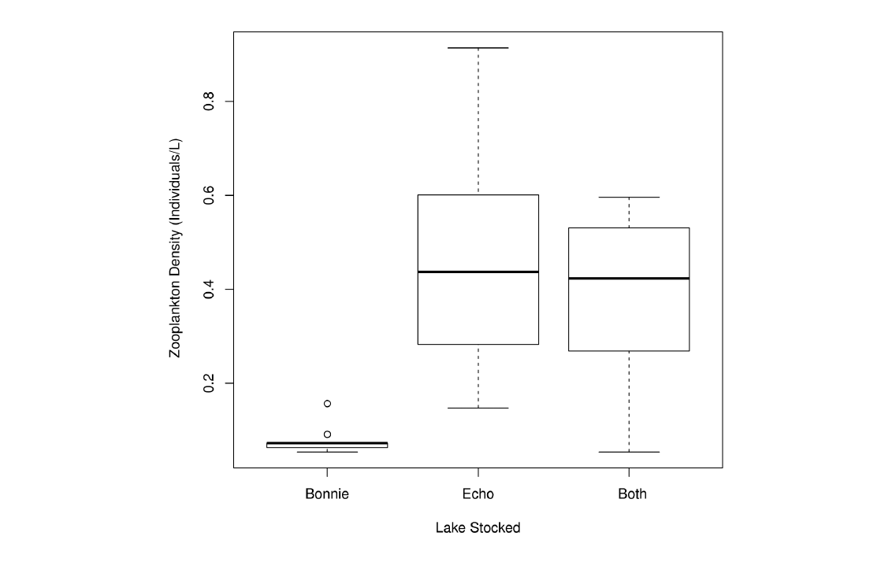

Figure S1: Zooplankton density (individuals/L) in mesocosms stocked from Echo, Bonnie or Both lakes prior to the start
of the experiment.

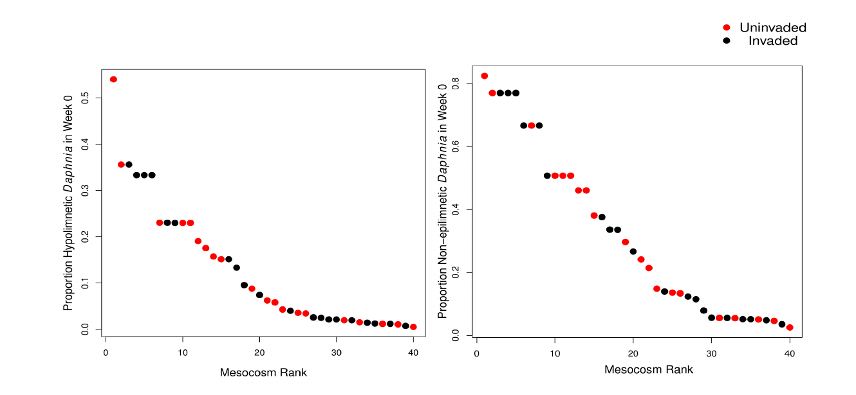

Figure S2: The proportion of hypo- and non-epilimnetic Daphnia across all forty mesocosms prior to the start of the experiment (week 0).
Red dots indicate mesocosms invaded by Bythotrephes in week 1, while black dots indicate mesocosms which remained
uninvaded.

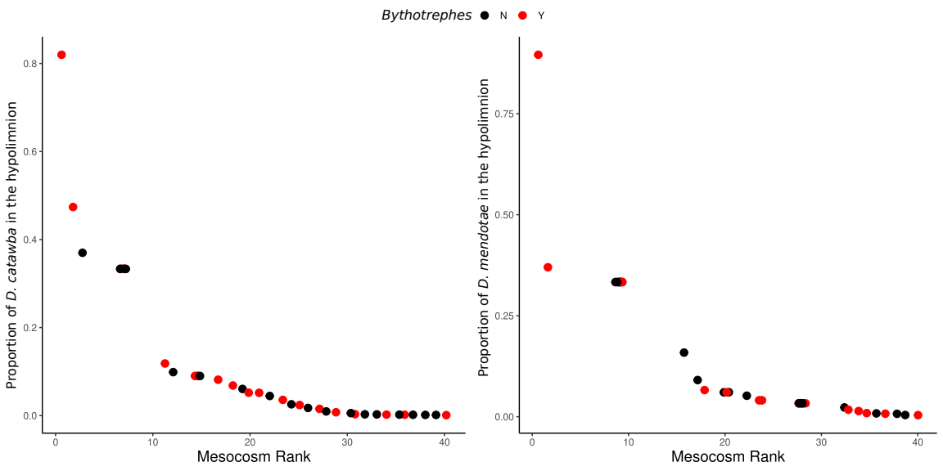

Figure S3: The proportion of hypolimnetic D. catawba and D. mendotae across all forty mesocosms prior to the start of the experiment (week 0).
Red dots indicate mesocosms invaded by Bythotrephes in week 1, while black dots indicate mesocosms which remained uninvaded.

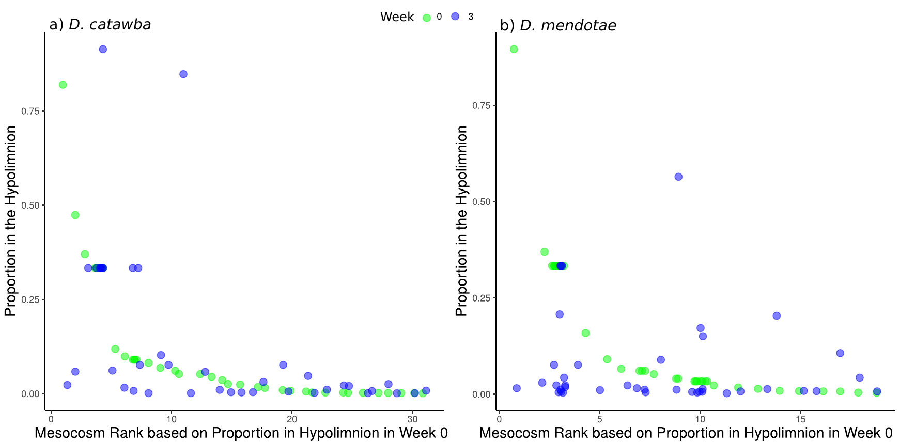
Figure S4: The proportion of hypolimnetic D. catawba and D. mendotae across all forty mesocosms in Week 0 (green) and Week 3 (blue).

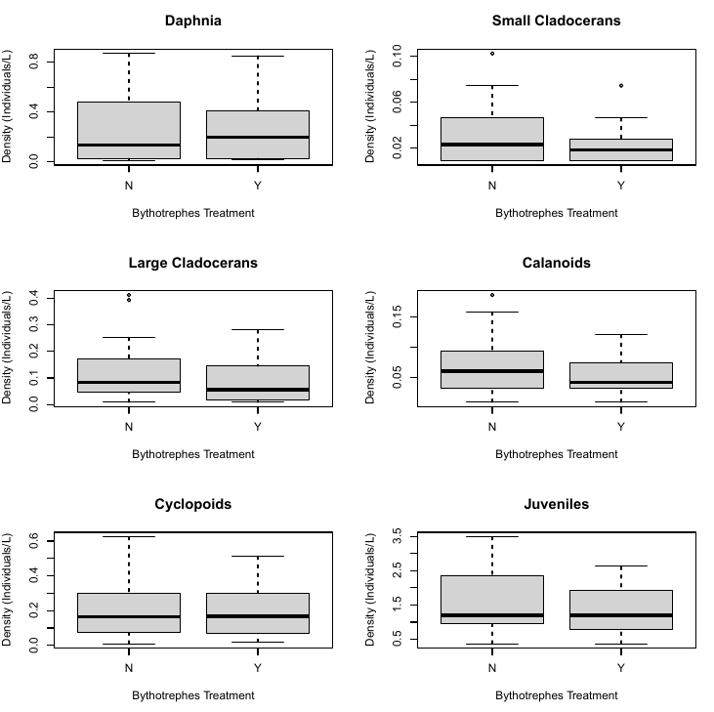

Figure S5: Starting densities (week 0) of total Daphnia, small cladoceran, large cladocerans, calanoids, cyclopoids, and juveniles in mesocosms assigned Bythotrephes invaded (Y) and uninvaded (N) treatments (linear model with Bythotrephes as a predictor variable, Daphnia; p = 0.781, small cladoceran; p = 0.229, large cladocerans; p = 0.186, calanoids; p = 0.224, cyclopoids; p = 0.91, and juveniles; p = 0.448). Week 0 densities were measured prior to the stocking of Bythotrephes in invaded treatments.

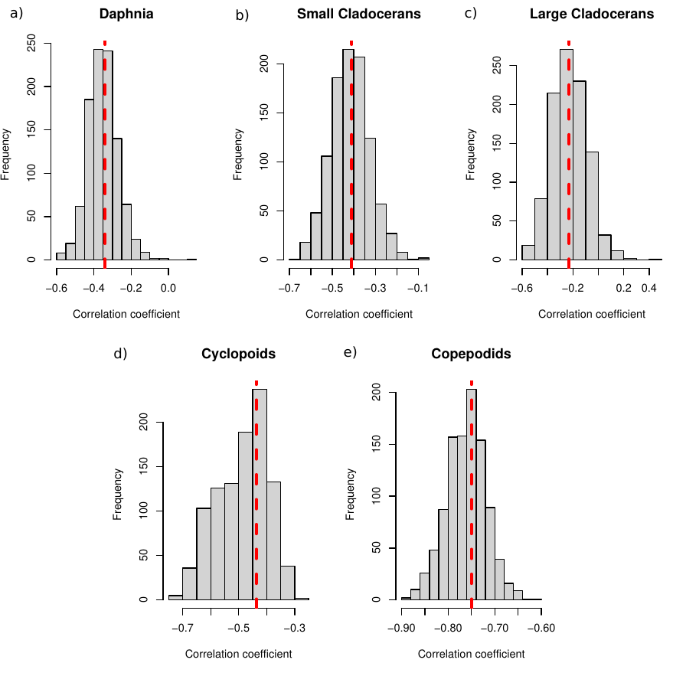

Figure S6: Sampling distributions of bootstrapped correlation coefficients between per capita change in density for a) Daphnia, b) small cladocerans, c)
large cladocerans, d) cyclopoids, and copepodids. Dashed line represents the value of the coefficient obtained from correlation analysis between taxa per capita change in density and total zooplankton density (individuals/L) in week 0.

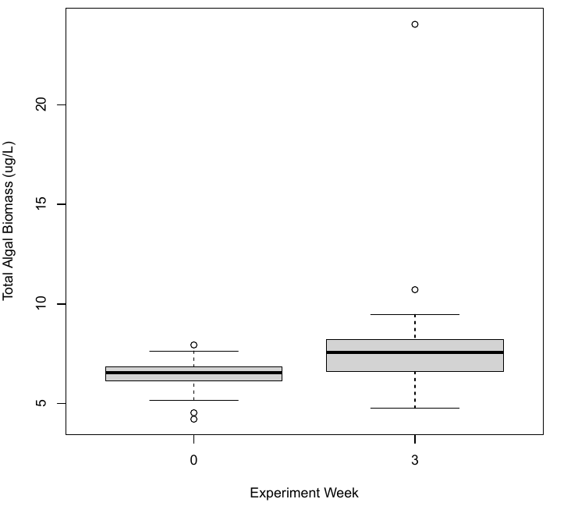

Figure S7: Differences in total algal biomass (µg/L) between the experiment week 0 and week 3 across all mesocosms. Total algal biomass was significantly greater in week 3 as compared to week 0 (two sample t-test, df = 43.4, p = 0.006).

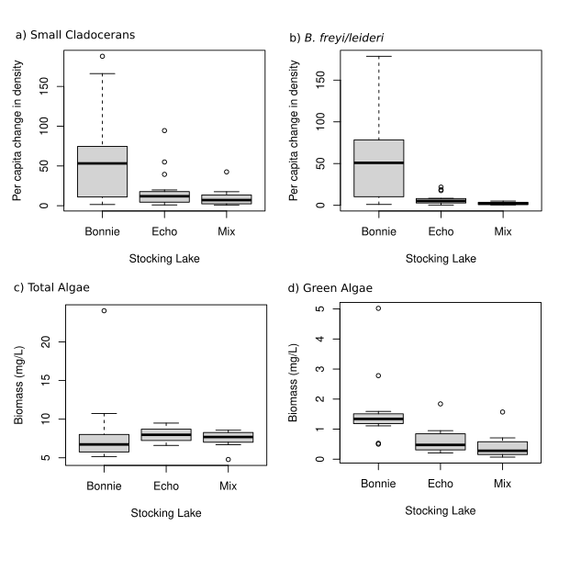

Figure S8: Per capita change in density of a) small cladocerans, b) B. freyi/leideri, and biomass of c) total algae, and d) green algae in final week of the experiment in mesocosms stocked with zooplankton communities from Bonnie Lake, Echo Lake or both lakes (Mix) prior to the start of the experiment.

