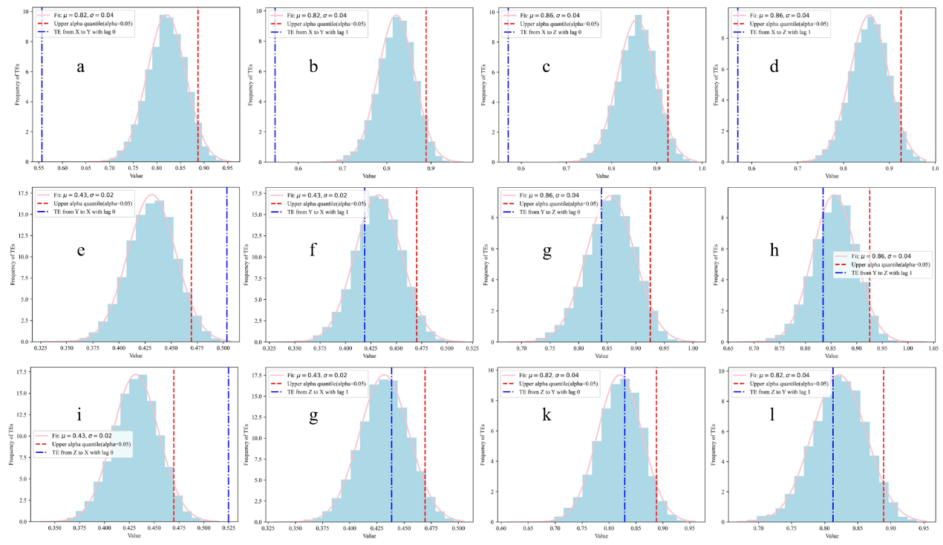

**Figure S1.** TEs from White Gaussian Noise to a specific variable with lag, derived from *N*-trial Monte Carlo simulations, in Case 1. a: ${TE}_{X(t-1)}$ →*Y*(*t*) , b: ${TE}_{X(t-2)}$ →*Y*(*t*), c: ${TE}_{X(t-1)}$ →*Z*(*t*), d: ${TE}_{X(t-2)}$ →*Z*(*t*), e: ${TE}_{Y(t-1)}$ →*X*(*t*), f: ${TE}_{Y(t-2)}$ →*X*(*t*) , g: ${TE}_{Y(t-1)}$ →*Z*(*t*). h: ${TE}_{Y(t-2)}$ →*Z*(*t*), I: ${TE}_{Z(t-1)}$ →*X*(*t*) , j: ${TE}_{Z(t-2)}$ →*X*(*t*) , k: ${TE}_{Z(t-1)}$ →*Y*(*t*), l: ${TE}_{Z(t-2)}$ →*Y*(*t*).

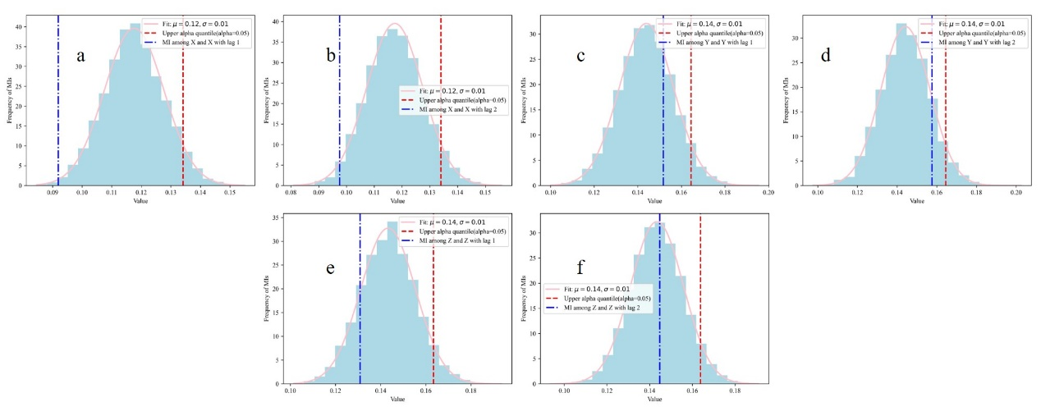

**Figure S2.** MIs between White Gaussian Noise and a specific variable with lag, derived from *N*-trial Monte Carlo simulations, in Case 1. a: *I*(*X*(*t*);*X*(*t* −1)) , b: *I*(*X*(*t*);*X*(*t* −2)), c: *I*(*Y*(*t*);*Y*(*t* −1)), d: *I*(*Y*(*t*);*Y*(*t* −2)), e: *I*(*Z*(*t*);*Z*(*t* −1)), f, *I*(*Z*(*t*);*Z*(*t* −2)).

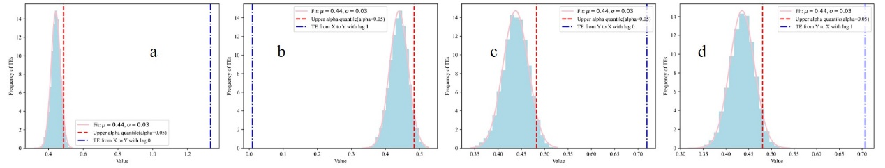

**Figure S3.** TEs from White Gaussian Noise to a specific variable with lag, derived from *N*-trial Monte Carlo simulations, in Case 2. a: ${TE}_{X(t-1)}$ →*Y*(*t*) , b: ${TE}_{X(t-2)}$ →*Y*(*t*), c: ${TE}_{Y(t-1)}$ →*X*(*t*), d: ${TE}_{Y(t-1)}$ →*X*(*t*).

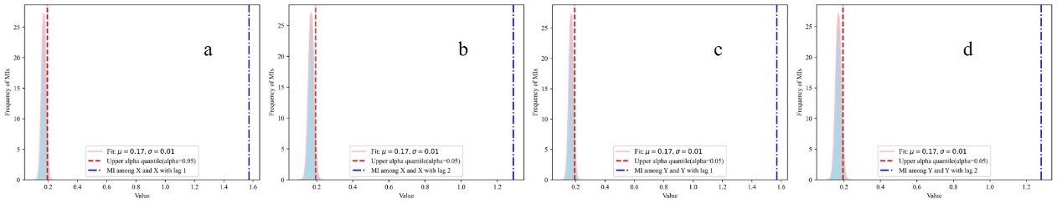

**Figure S4.** MIs between White Gaussian Noise and a specific variable with lag, derived from *N*-trial Monte Carlo simulations, in Case 2. a: *I*(*X*(*t*);*X*(*t* −1)) , b: *I*(*X*(*t*);*X*(*t* −2)), c: *I*(*Y*(*t*);*Y*(*t* −1)), d: *I*(*Y*(*t*);*Y*(*t* −2)).

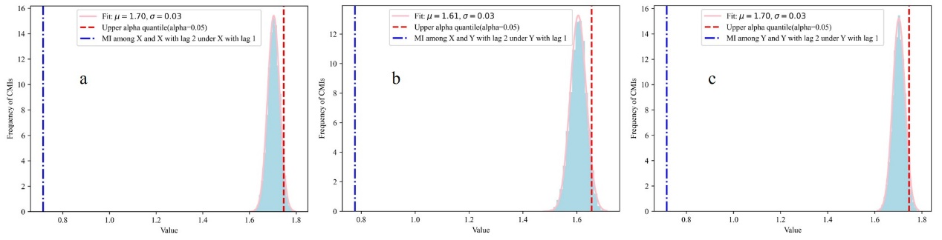

**Figure S5.** CMIs between two specific variables with lag when conditioned on White Gaussian Noise, derived from *N*-trial Monte Carlo simulations, in Case 2. a: *I*(*X*(*t*);*X*(*t* −2)|*X*(*t* −1)), b: *I*(*X*(*t*);*Y*(*t* −2)|*Y*(*t* −1)), c: *I*(*Y*(*t*);*Y*(*t* −2)|*Y*(*t* −1)).