Supplementary information for

**For Catching-by-Polymerization Oligo Purification: Scalable Synthesis of the Precursors to the Polymerizable Tagging Phosphoramidites**

Yipeng Yin, Komal Chillar, Alexander Apostle, Bhaskar Halami, Adikari Eriyagama, Marina Tanasova, and Shiyue Fang*

Department of Chemistry, and Health Research Institute, Michigan Technological University, 1400 Townsend Drive, Houghton, MI 49931, United States

*Email: shifang@mtu.edu

**Content**

General experimental information, and images of compound, TLC, NMR and MS.

**General**. All reactions were performed in oven-dried glassware under nitrogen using standard Schlenk techniques. Reagents and solvents from commercial sources were used as received with the following exceptions. DCM, pyridine, diethyl ether and diisopropylamine were distilled over CaH2 under nitrogen. THF was distilled over CaH2 and then Na/benzophenone under nitrogen. Sigma-Aldrich TLC plates, silica gel 60F-254 over glass support, 0.25 µm thickness, were used for TLC. Selecto Scientific silica gel, particle size 32-63 µm, was used for flash column chromatography. 1H amd 13C NMR spectra were measured on a Bruker spectrometer at 500 and 126 MHz, respectively. Chemical shifts (*δ*) were reported in reference to solvent peaks, residue CHCl3 at 7.24 ppm for 1H, CDCl3 at 77.00 ppm for 13C. MS was obtained on a Thermo Finnigan LCQ Advantage Ion Trap Mass Spectrometer.



Image of compound **6**.

TLC (SiO2, 3:1 hexanes/EtOAc) for compound **6**. Left lane: crude reaction mixture before precipitation and partition (bottom spot is the product, top spot is anisole); middle lane: co-spot of samples on left and right lanes; right lane: compound **6** after precipitation of the deprotonated product with Et2O followed by partition.

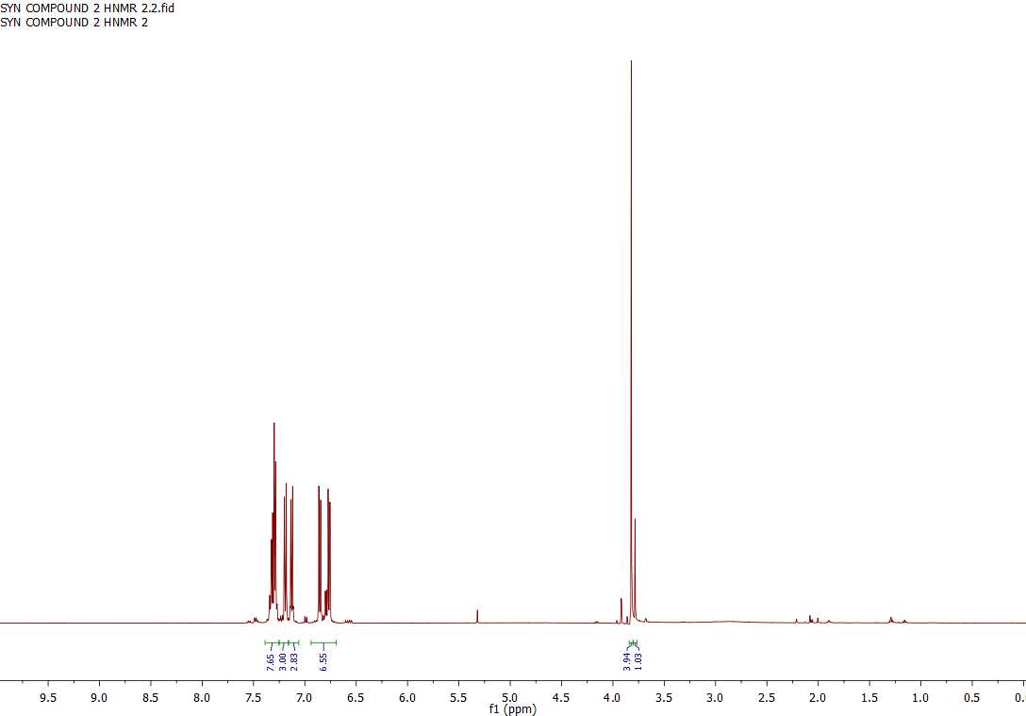

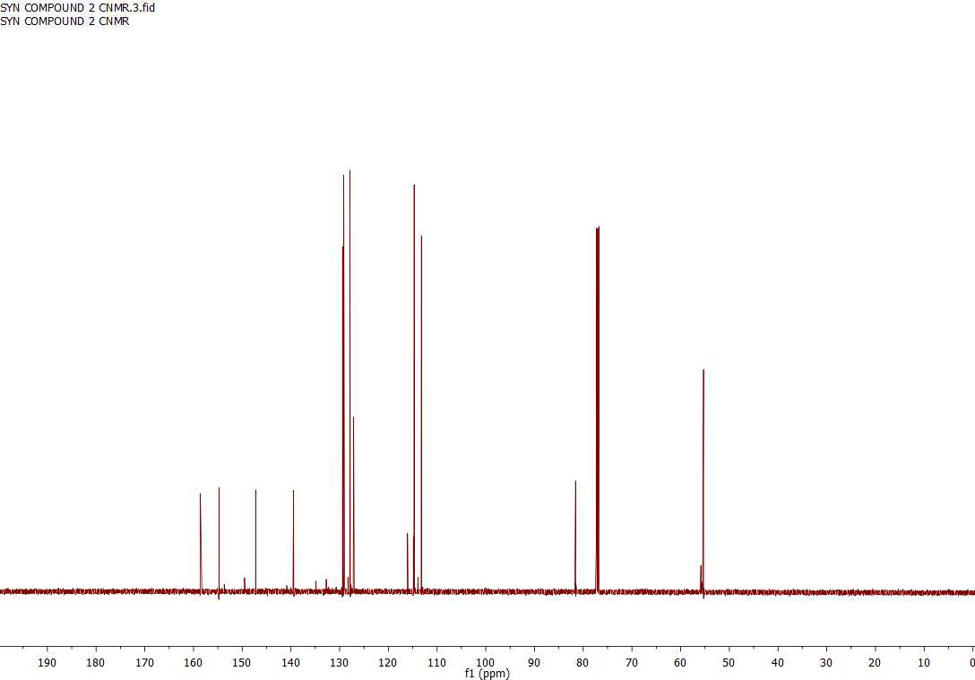



Image of compound **7**.

TLC (SiO2, 3:1 hexanes/EtOAc) for compound **7**. Left lane: **7** after purification by precipitation from DCM with hexanes; middle lane: co-spot of samples on left and right lanes; right lane: authentic **7** purified with chromatography and characterized with NMR.

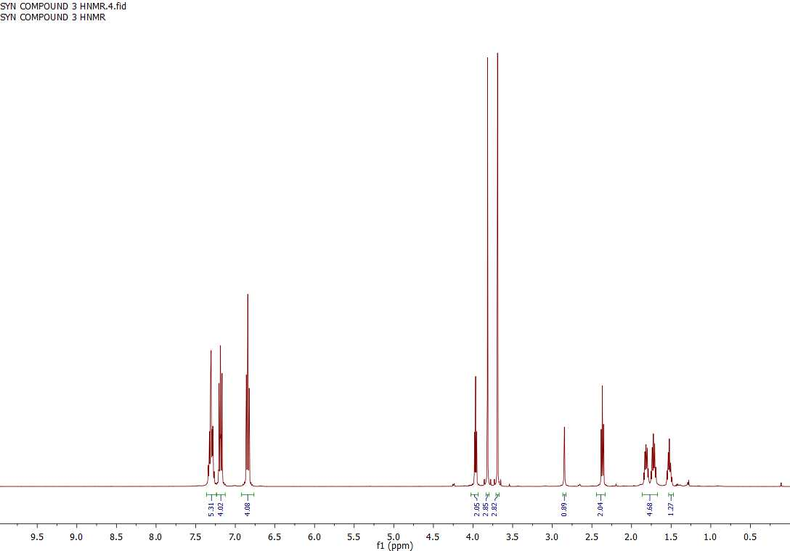

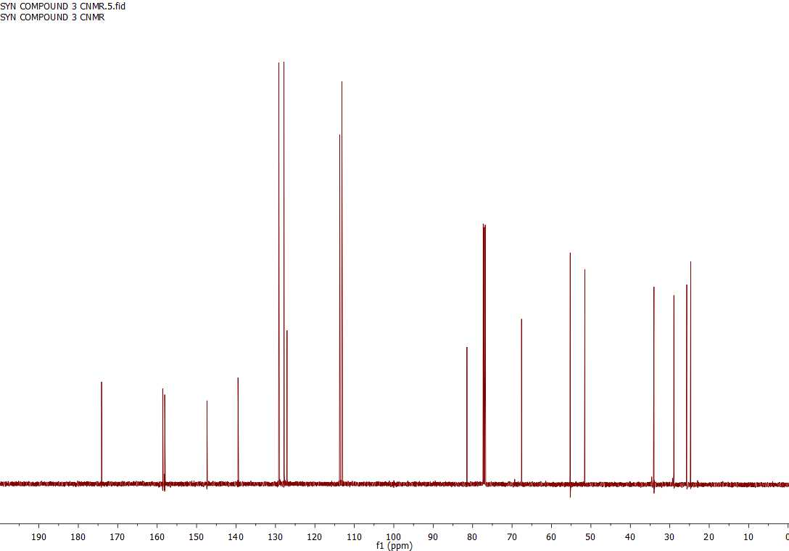



Image of compound **8**.

TLC (SiO2, 5:2:2:1 Et2O/MeCN/MeOH/Et3N) for compound **8**. Left lane: compound **7**; middle lane: co-spot of samples on left and right lanes; right lane: product **8** purified by partition between DCM and water.

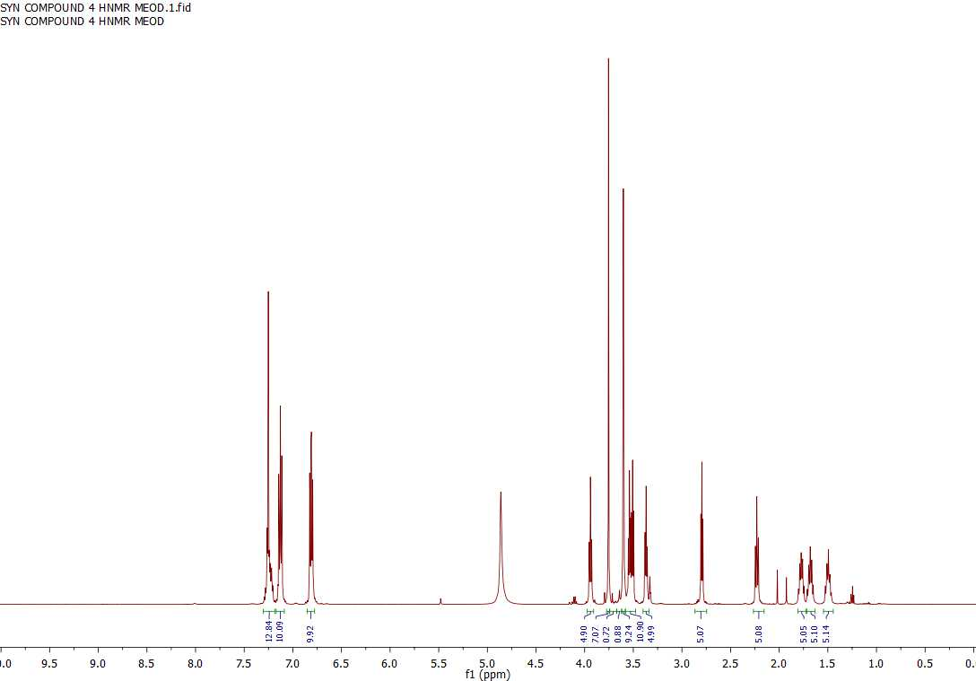

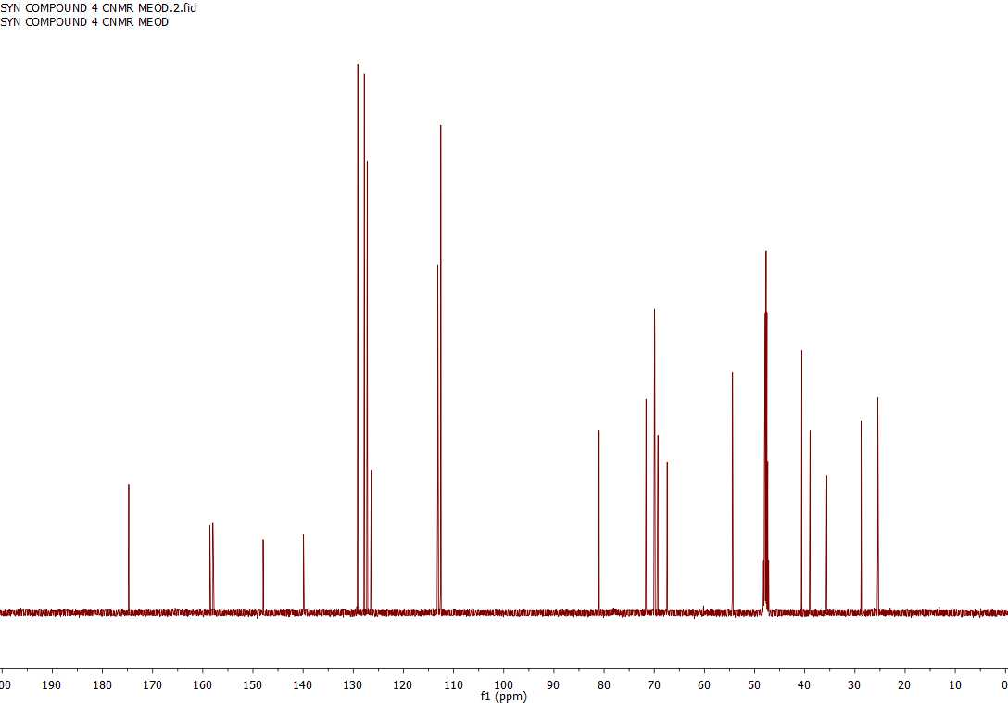



Image of compound **9**.

Left TLC (SiO2, 3:2 acetone/hexanes 5% Et3N) for compound **9**. Left lane: reaction mixture after partition between DCM and K2CO3; middle lane: co-spot of samples on left and right lanes; right lane: authentic **9** purified with chromatography and characterized with NMR.

Right TLC (SiO2, 3:2 acetone/hexanes 5% Et3N) for compound **9**. Left lane: product after purification by partition and precipitation from 1% DIEA in THF with hexanes; middle lane: co-spot of samples on left and right lanes; right lane: authentic **9** purified with chromatography and characterized with NMR.

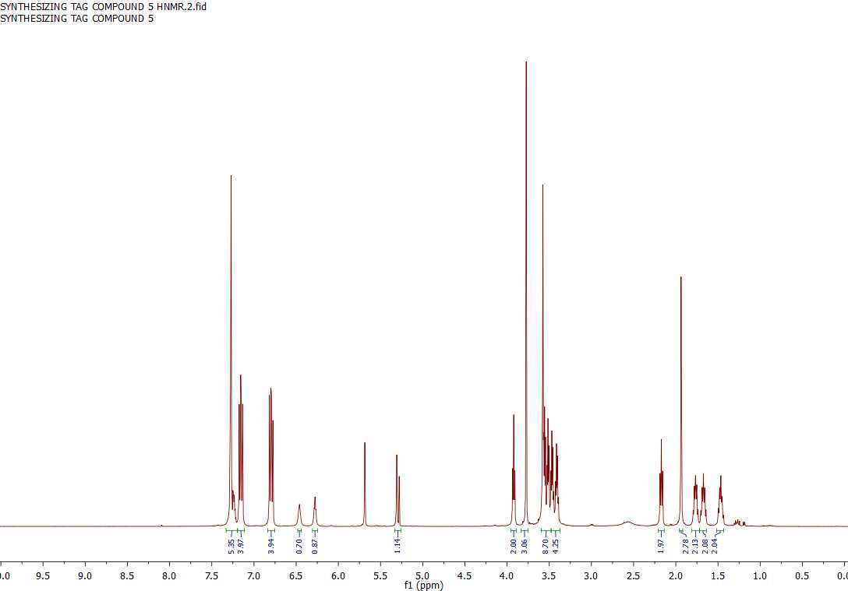

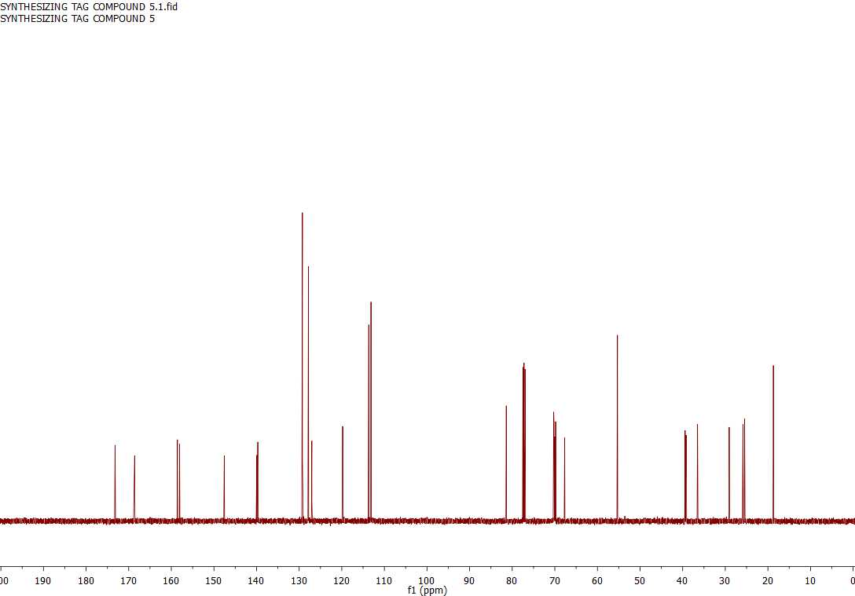



Image of compound **10a**.

Left TLC (SiO2, 3:2 acetone/hexanes 5% Et3N) for compound **10a**. Left lane: compound **9**; middle lane: co-spot of samples on left and right lanes; right lane: crude reaction mixture (upper spot is pyridine, lower spot is the product).

Right TLC (SiO2, 3:2 acetone/hexanes 5% Et3N) for compound **10a**. Left lane: compound **9**; middle lane: co-spot of samples on left and right lanes; right lane: product **10a** after purification by partition and precipitation.

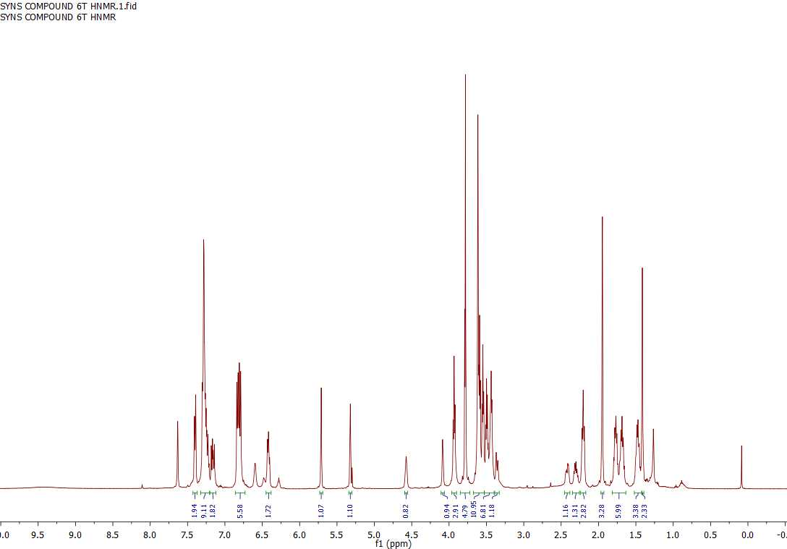

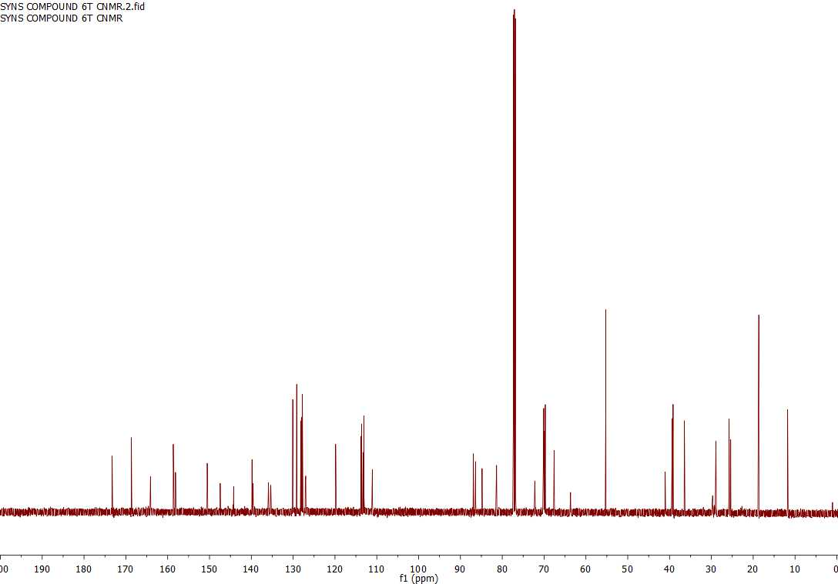





Image of compound **10b**.

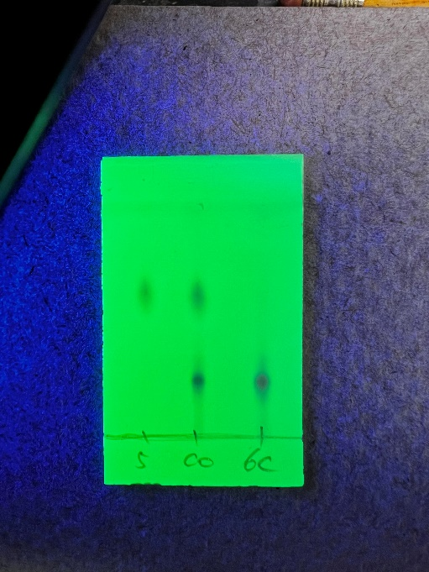

TLC (SiO2, 3:2 acetone/hexanes with 5% Et3N) for compound **10b**. Left lane: compound **9**; middle lane: co-spot of samples on left and right lanes; right lane: product after partition and precipitation.

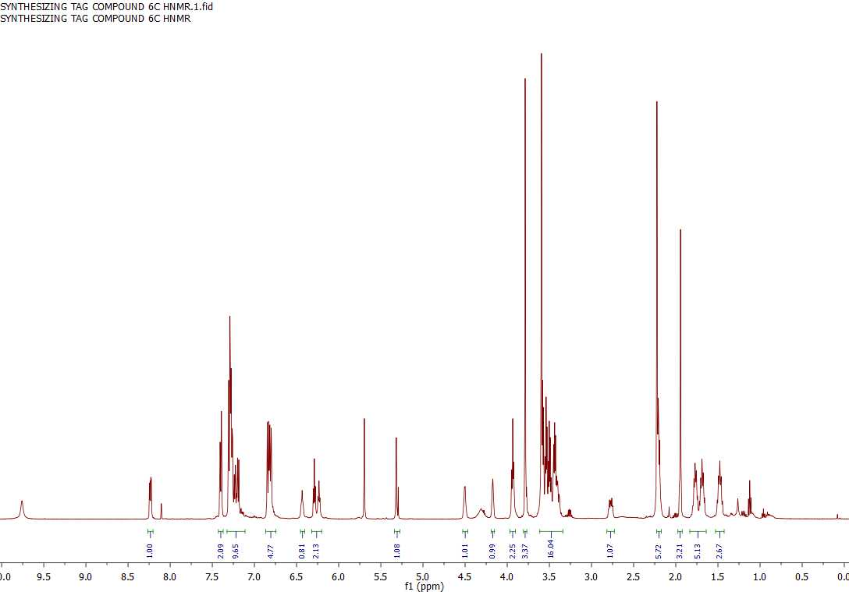

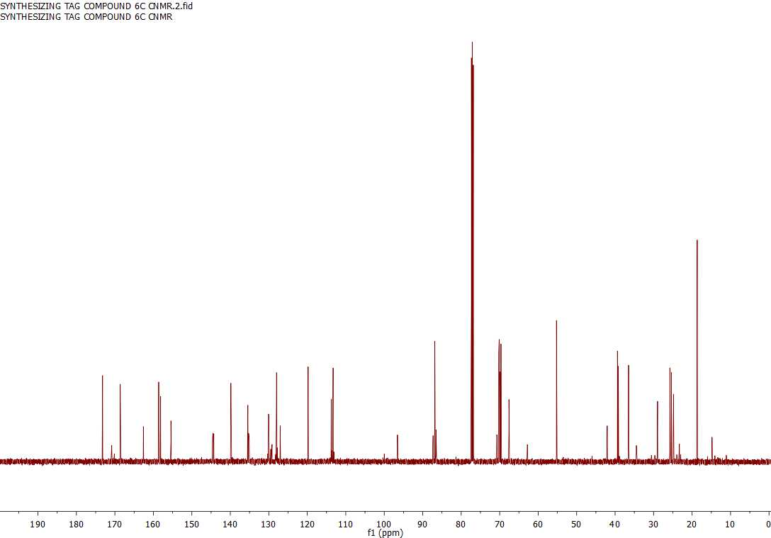





Image of compound **10c**.

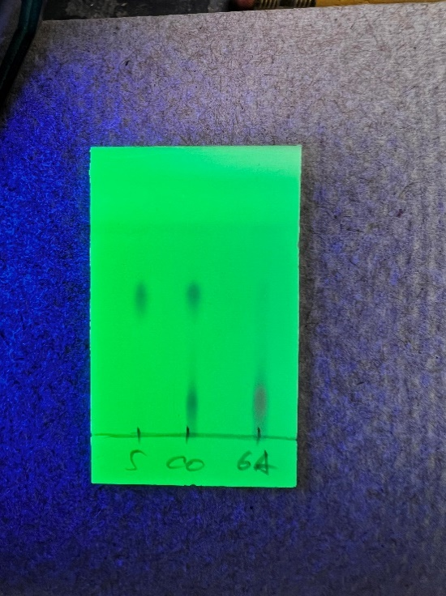

TLC (SiO2, 3:2 acetone/hexanes 5% Et3N) for compound **10c**. Left lane: compound **9**; middle lane: co-spot of samples on left and right lanes; right lane: product after partition and precipitation.

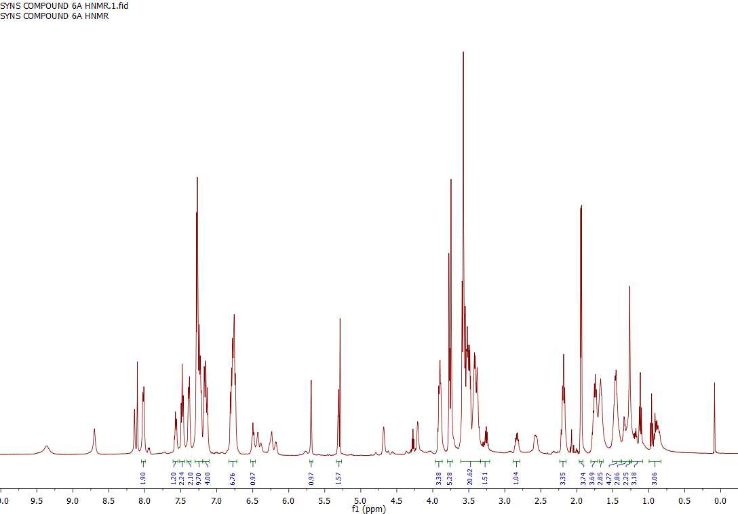

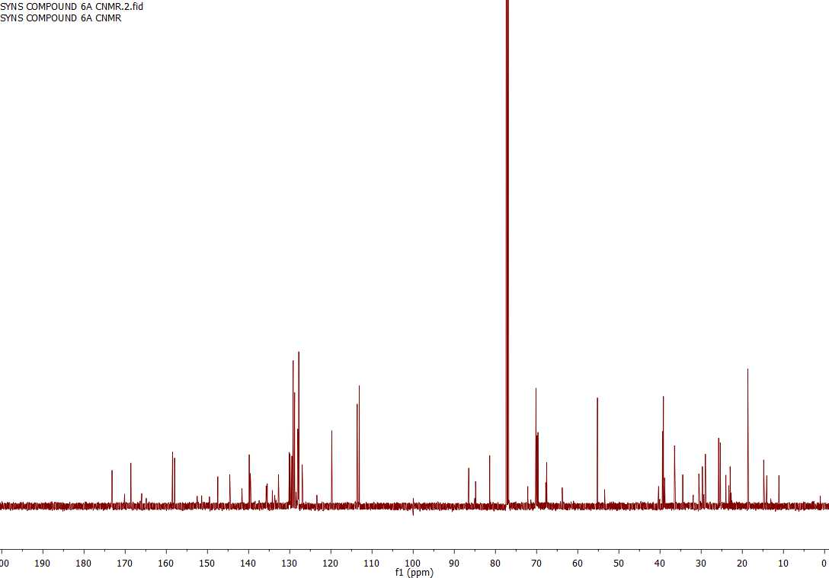





Image of compound **10d**.

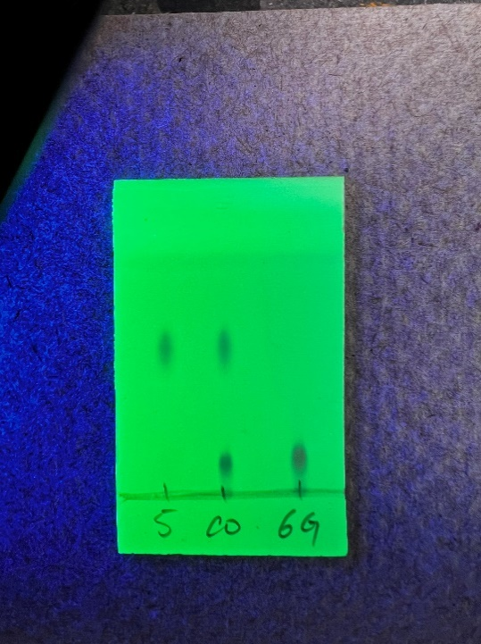

TLC (SiO2, 3:2 acetone/hexanes 5% Et3N) for compound **10d**. Left lane: compound **9**; middle lane: co-spot of samples on left and right lanes; right lane: product after partition and precipitation.

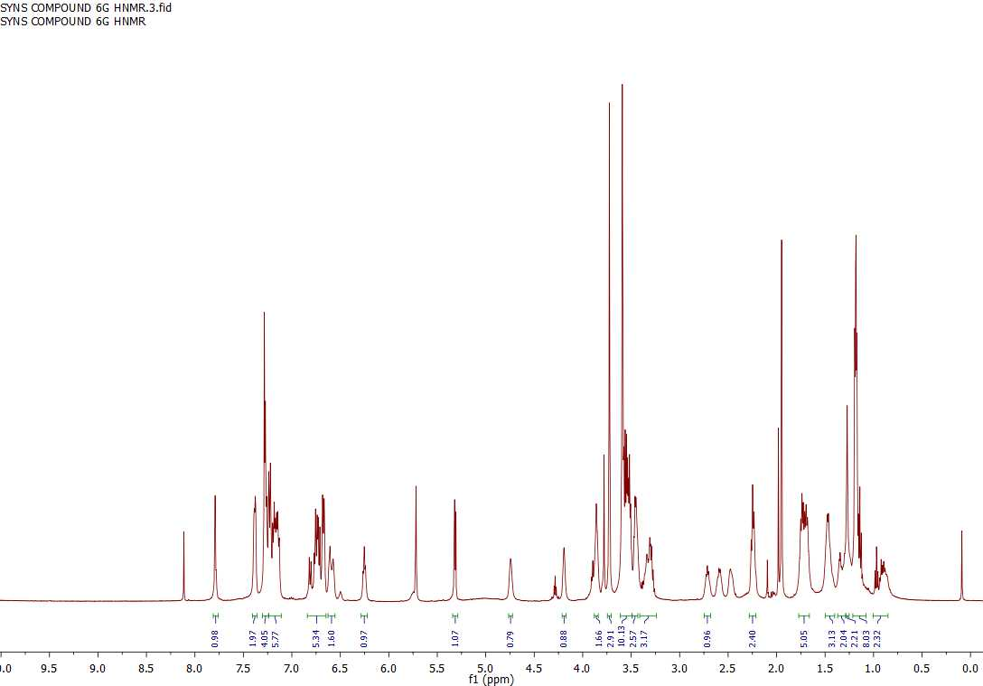

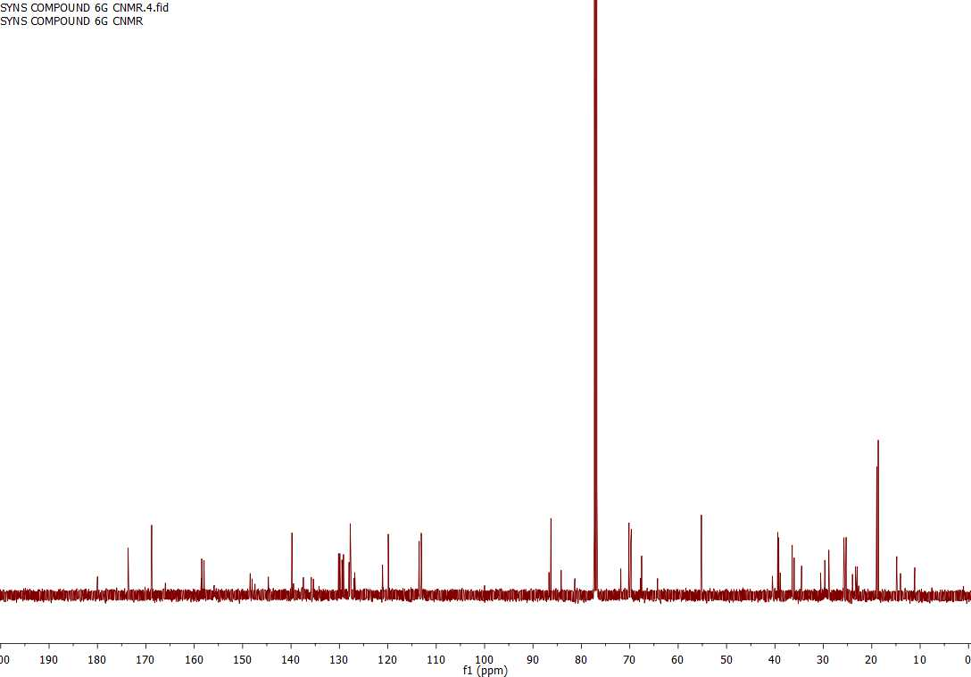





TLC (SiO2, acetone/hexane 3:2, 5% Et3N) for compound **1a**. Left lane: starting material compound **10a**; middle lane: co-spot of samples on left and right lanes; right lane: compound **1a** from reaction mixture.

TLC (SiO2, acetone/hexane 3:2, 5% Et3N) for compound **1a**. Left lane: starting material compound **10a**; middle lane: co-spot of samples on left and right lanes; right lane: compound **1a** purified with chromatography.





