Characters | Value | Image
Dorsal spot polymorphism  (DP) | DP₁ – presence of blue spots  (Kaczmarek, 2015) | 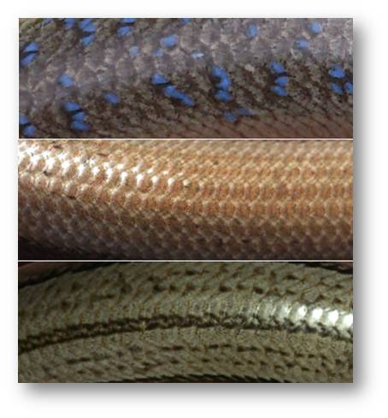
DP₂ – presence of green spots
(Kaczmarek, 2015)
 | DP₃ - no dorsal spots
DP₄ – 4 lines of spots so called „pattern”
(Kaczmarek, 2015)
Dorsal line (CL) and dorsa/lateral border (CT) | CL₁ – No dorsal line  CT₁ – lacking of dorsa/lateral border,  (Kaczmarek, 2015) | 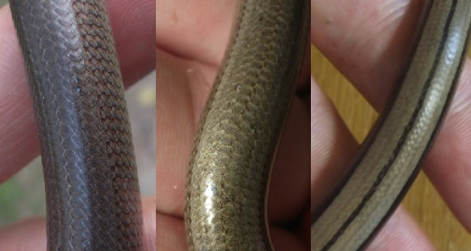
CL₂ – Vanishing dorsal line
CT₂ – intermediate state of dorsa/lateral border,
(Kaczmarek, 2015)
CL₃ – presence of dorsal line
CT₃ – strong dorsa/lateral border,
(Kaczmarek, 2015)
Abdominal coloration (CV) | CV₁ – Black coloration of ventral part of body  (Kaczmarek, 2015) | 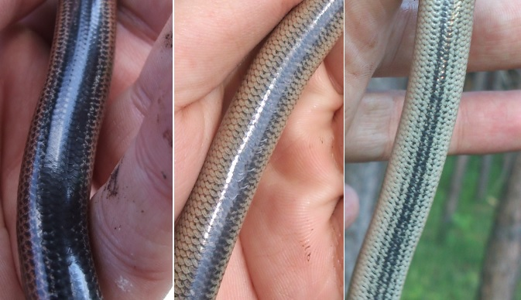
CV₂ – intermediate state of ventral part of body
(Kaczmarek, 2015)
CV₃ – light state of ventral part of body
(Kaczmarek, 2015)
 | CV₄ – Different coloration of ventral part of body (eg. blue) (Kaczmarek et al., 2016) | 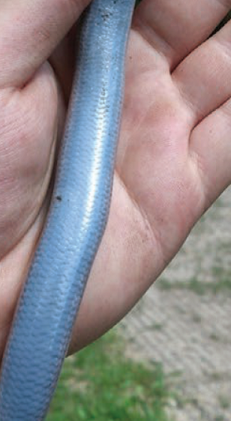
Spots after head (HP) | HP₁ – no brown spots after head  (Kaczmarek, 2015) | 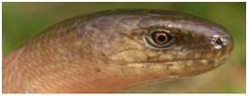
 | HP₂ – Brown spots presence after head.  HP₃ – Spots after head with other color (no image).  (Kaczmarek, 2015) | 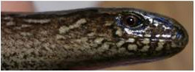
Ear opening (EO) | EO₁ – Ear opening clearly visible on both side  EO_{1*} - Ear opening clearly visible on one side  (Skórzewski, 2017) | 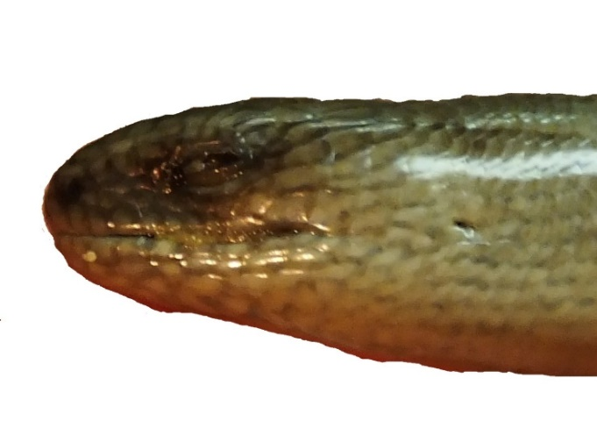
 | EO₂ – no visible ear opening  (Skórzewski, 2017) | 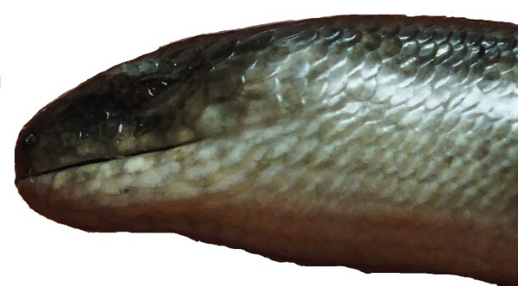
 | EO₃ – Shallow on one or both side of head,  (Skórzewski, 2017) | 