.Supplementary material
Manuscript Title: Insecticides may facilitate the escape of weeds from biological control
Authors: Elizabeth K. Rowen^{a,b}, Kirsten A. Pearsons^{b}, Richard G. Smith^{c}, Kyle Wickings^{d}, John F. Tooker^{b}

Table
Table S1: Planting and field management for each field 2017-2019
Year | Field | Cover crop species | Cover crop planting date | Cover planting rate | Cover termination date  (Herbicide Product) | Crop | Seed variety | Cash crop planting date | Planting rate (seeds/acre) | Seed Coat treatment (product, mg/seed) | IPM treatment | Herbicide application date during crop growth (Product)
2017 | North | Avena sativa | 11-Apr-2017 | 2-3 bu/acre (~ 960K– 1440 K seeds/acre) | 24-May-2017 (Roundup PowerMax [22 fl oz/ac]) | Soy | TS2849R2S (Local Seed Co., Jersey Shore, PA) | 2-Jun-2017 | 180,000 | Trius Elite (imidacloprid, 0.125) |  | 30-June-2017 (Accent)
 | South | Avena sativa | 11-Apr-2017 | 2-3 bu/acre (~ 960K– 1440 K seeds/acre) | 4-Jun-2017 (Impact, Accent, Banvil, and Degree Extra) | Corn | MC5250 (Masters Choice, Anna, IL) | 19-May-2017 | 30,000 | CruiserMaxx® 250 + Vibrance® (thiamethoxam, 0.250) |  | 3-July-2017 (Round-Up)
2018 | North | Secale cereale | 12-Nov-2017 | 50 lbs/acre (~1 million seeds/acre | 21-May-2018 (Roundup PowerMax [22 fl oz/ac]) | Corn | TA477-18 (Local Seed Co. Jersey Shore PA) | 30-May-2018 | 32,000 | CruiserMaxx® 250 (thiamethoxam, 0.250) | In furrow granular application of Force 3G (8 g a.i./ ha) | 26-Jun-2018 (Round-Up PowerMax2)
 | South | Secale cereale | 22-Nov-2017 | 50 lbs/acre (~1 million seeds/acre | 23-May-2018 (Roundup PowerMax ([22 fl oz/ac]) | Soy | TS2849R2S (Local Seed Co. Jersey Shore PA) | 14-June-2018 and 26-June-2018 | 178,000 | Trius Elite™ (imidacloprid, 0.125) |  | 29-Jun-2018 (Round-Up PowerMax)
2019 | North | Avena sativa | 29-Mar-2019 | 2-3 bu/acre (~ 960K– 1440 K seeds/acre) | 4-Jun-2019 (Roundup PowerMax [28 oz/ac]) | Soy | LS2847R2S (Local Seed Co., Jersey Shore, PA) | 22-May-2019 | 180,000 | Radius Premium (thiamethoxam, 0.0756)
 | South | Avena sativa | 29-Mar-2019 | 2-3 bu/acre (~ 960K– 1440 K seeds/acre) | 22-May-2019 (Roundup PowerMax (28 oz/ac), Acuron (3 qt/ac)) | Corn | ZS9725 GT (Local Seed Co., Jersey Shore, PA) | 17-May-2019 | 30,000 | Radius 500 (clothianidin, 0.500)

Figures:
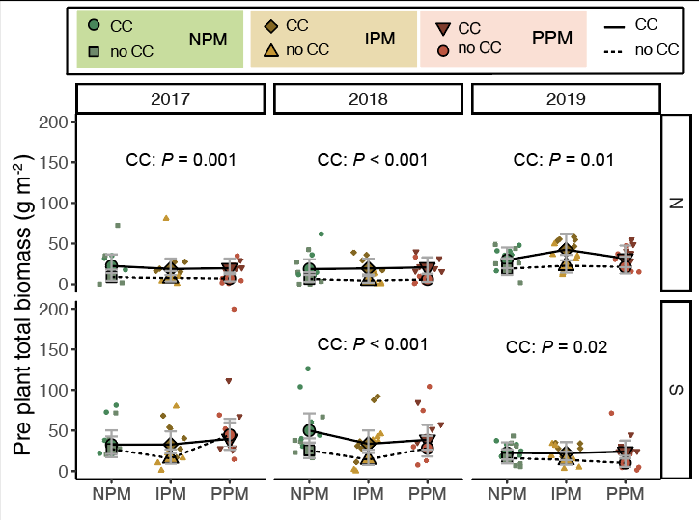
Figure S1: Estimated marginal means (95% confidence intervals [CIs]) of total pre-plant biomass (g m⁻²) before planting in each field and year. GLMM (lognormal distribution), ᙭² = 159, df = 23, P < 0.001, N = 209. Significance of cover crop treatments (CC) included in panels where GLM indicated cover crops had a significant effect by year/field slicing. Means for treatments with cover crops indicated with a solid line, means without cover crop indicated by a dashed line. Raw data shown as open small shapes behind means and CIs.
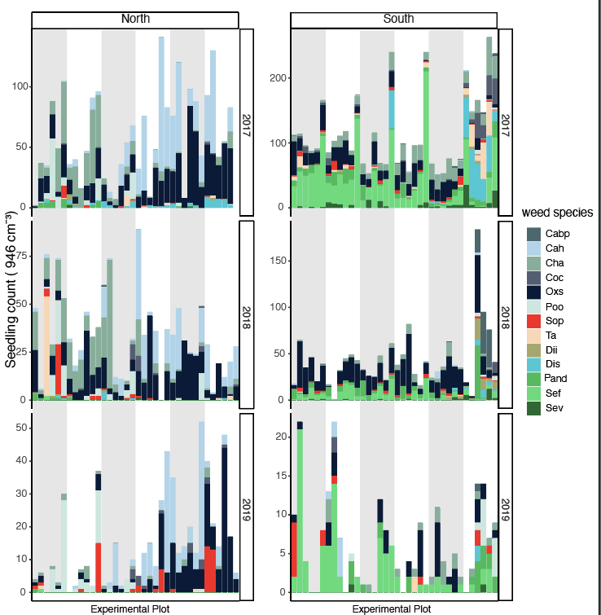
Figure S2: Weed community in the weed seed bank. Stacked bars are colored by weed species with > 20 individuals recovered over three years. Grey stripes show one direction of blocking in Latin-square experimental design. Species abbreviations: Cabo = Capsella bursa-pastoris (Shepard’s purse), Cah = Cardamine hirsuta (hairy bittercress), Cha = Chenopodium album (lambsquarter), Coc = Erigeron canadensis (marestail), Osx = Oxalis stricta (yellow woodsorrel) Poo = Portulaca oleracea (purslane), Sop = Solanum ptychanthum (eastern black nightshade),Ta = Taraxacum spp. (dandelion), Dii = Digitaria ischaemum (smooth crabgrass), Pand = Panicum dichotomiflorum (fall panicum), Sef = Setaria faberi (giant foxtail), Sev = Setaria viridis (green foxtail).

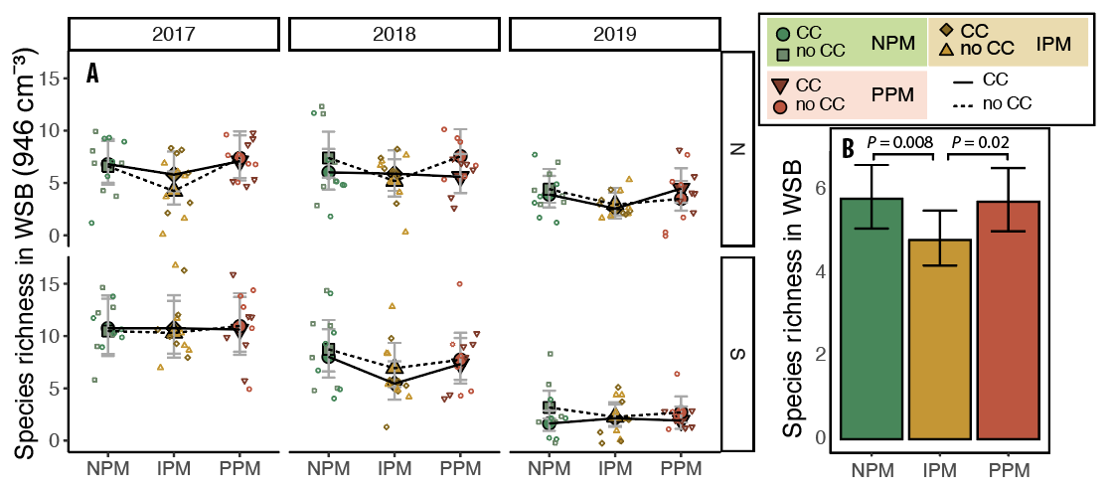
Figure S3: Estimated marginal means (95% confidence intervals [CIs]) of species richness in the weed-seed bank before planting A) in each field and year, and B) for all years and fields combined. In A) means for treatments with cover crops indicated with a solid line, means without cover crop indicated by a dashed line. Raw data shown as open small shapes behind means and CIs. GLMM (Poisson distribution), ᙭² = 217, df = 8, P < 0.0001, N = 216. Significance of PM treatments included in panels where GLMM indicated PM had a significant effect, and the P values for pairwise comparisons are given.
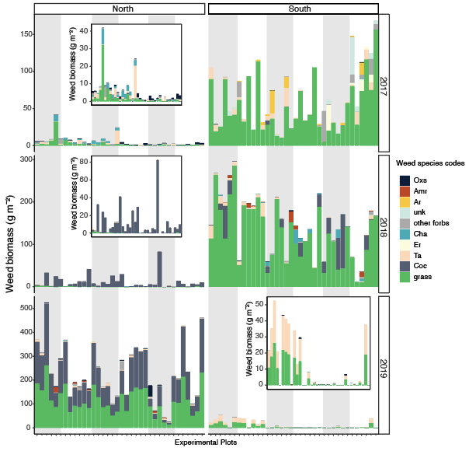
Figure S4: Weed community in August in each experimental plot. Stacked bars are colored by weed species with > 50 g biomass collected over three years. All other weeds are grouped in “other forbs”. Grey stripes show one direction of blocking in Latin-square experimental design. Insets show weed biomass at finer resolution for field years with lower weed biomass. Species abbreviations: Amr = Amaranthus retroflexus (redroot pigweed), Ar = Arcticum spp. (burdock), Cha = Chenopodium album (lambsquarter), Coc = Conyza canadensis (marestail), Er = Erigeron spp., Ta = Taraxacum spp. (dandelion), unk = unknown sp.

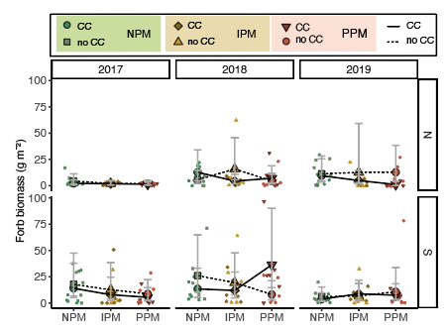
Figure S5: Estimated marginal means (95% confidence intervals [CIs]) of forb biomass in August for each field and year. Model information: GLMM (Poisson distribution), ᙭² = 43, df = 8, P < 0.001, N = 216. Means for treatments with cover crops indicated with a solid line, means without cover crop indicated by a dashed line. Raw data shown as open small shapes behind means and CIs.

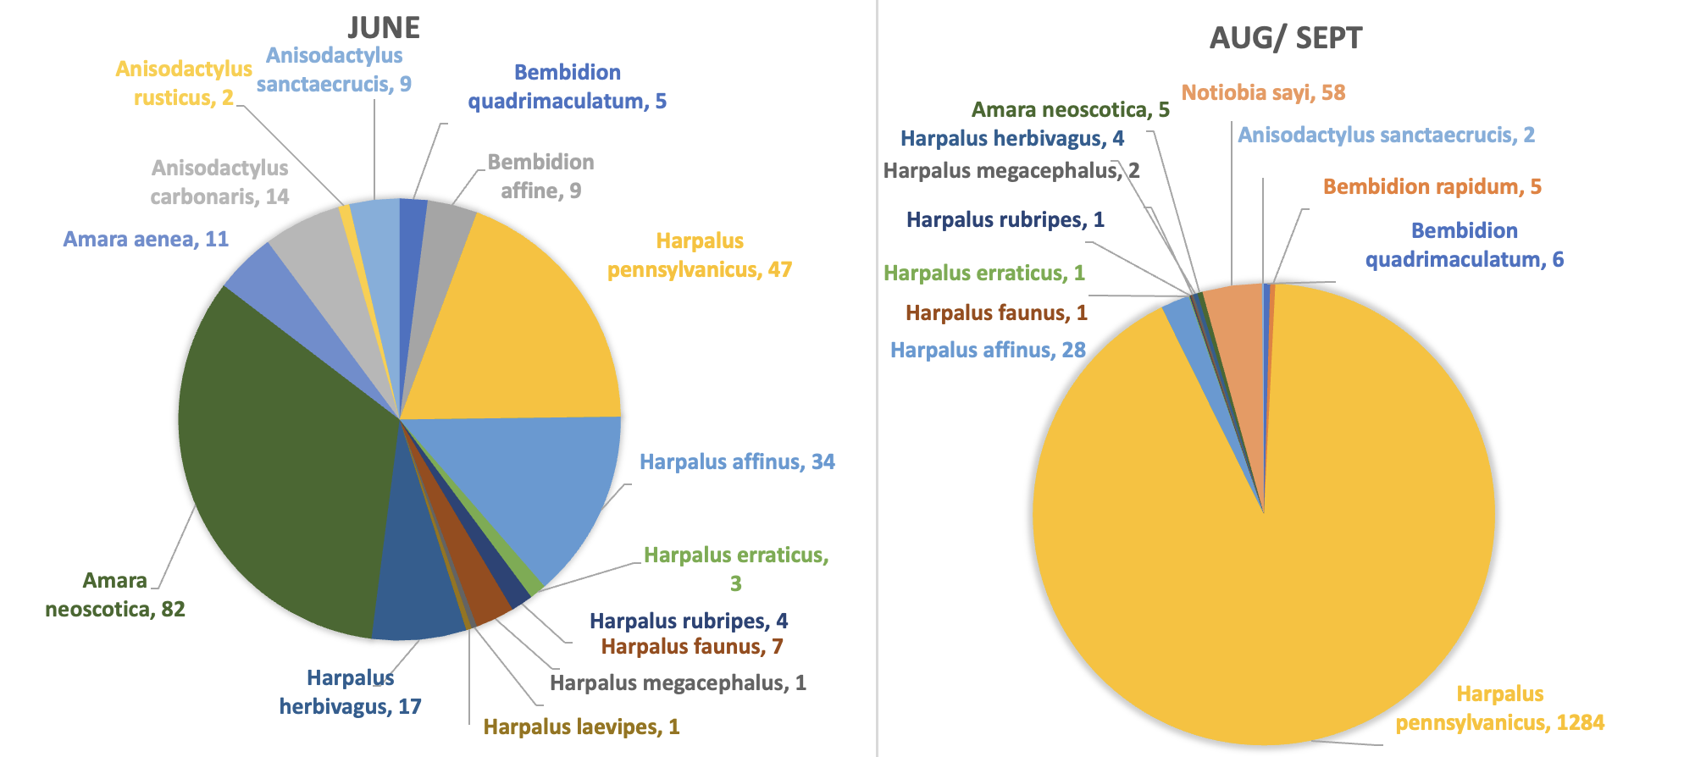
Figure S6: Pie charts of community composition of all granivorous carabids collected across all fields and years in June and August/September. Sums of number of individuals from species are reported with the species name.

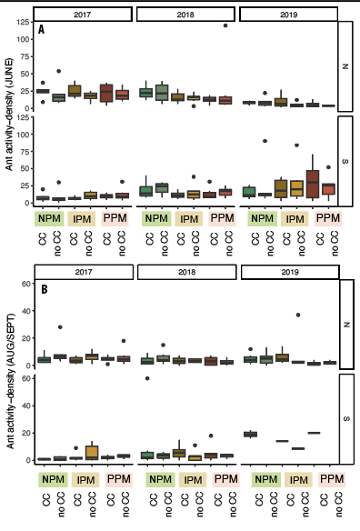
Figure S7: Boxplots of ant activity-density for in A) June/July and B) Aug/Sept for each field and year. Model information: GLMM (negative binomial distribution), ᙭² = 256, df = 11, P < 0.001, N = 395.

