Hawaiian black coral (Antipatharia) complete mitochondrial genomes have limited phylogenetic signal for taxonomic resolution of species

Supplementary Figures

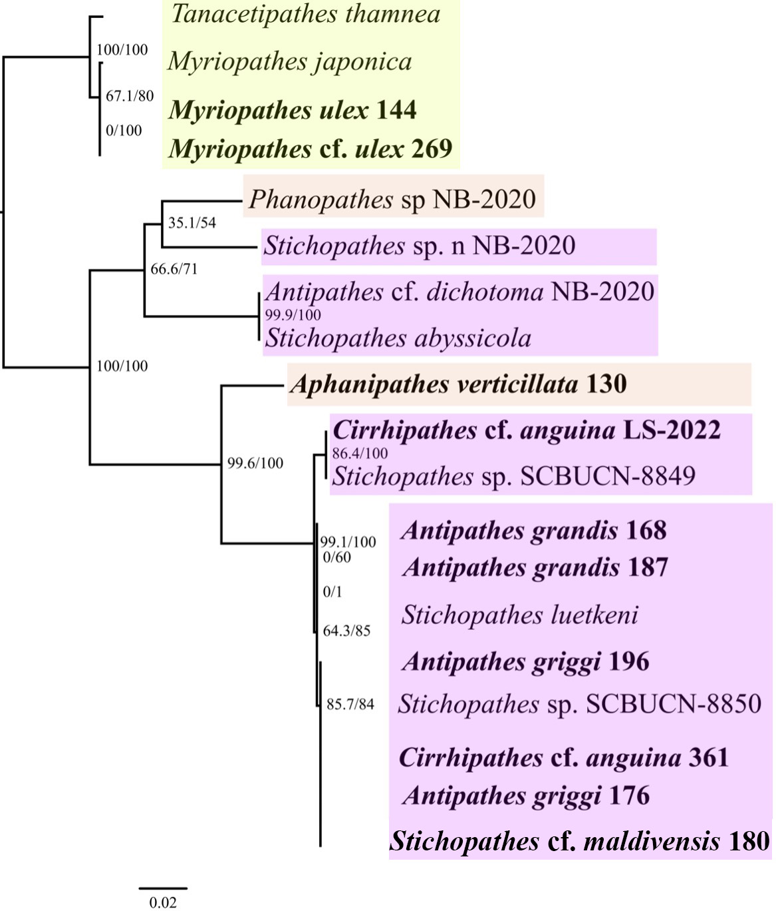
Figure S1. Maximum likelihood phylogeny of 19 antipatharian taxa belonging to three families: Myriopathidae (green), Antipathidae (pink), and Aphanipathidae (brown). The IQ-TREE inferred phylogeny is based on ATP6 (pairwise identity: 92.6%; identical sites: 76.4%). ʻĒkaha kū mona sequenced from Hawaiʻi are bolded. Branch lengths are relative to genetic divergence, and values at each node represent SH-aLRT /ultrafast bootstrap values.

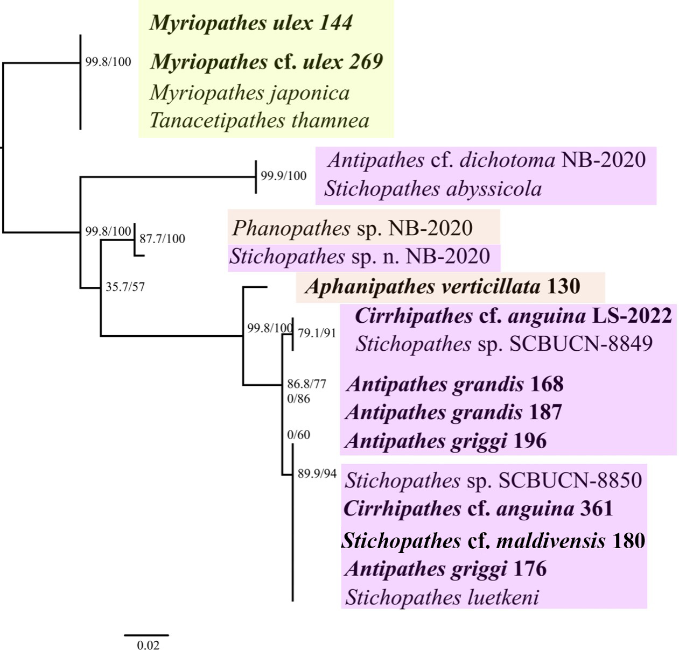
Figure S2. Maximum likelihood phylogeny of 19 antipatharian taxa belonging to three families: Myriopathidae (green), Antipathidae (pink), and Aphanipathidae (brown). The IQ-TREE inferred phylogeny is based on ATP8 (pairwise identity: 91.8%; identical sites: 76.5%). ʻĒkaha kū mona sequenced from Hawaiʻi are bolded. Branch lengths are relative to genetic divergence, and values at each node represent SH-aLRT /ultrafast bootstrap values.

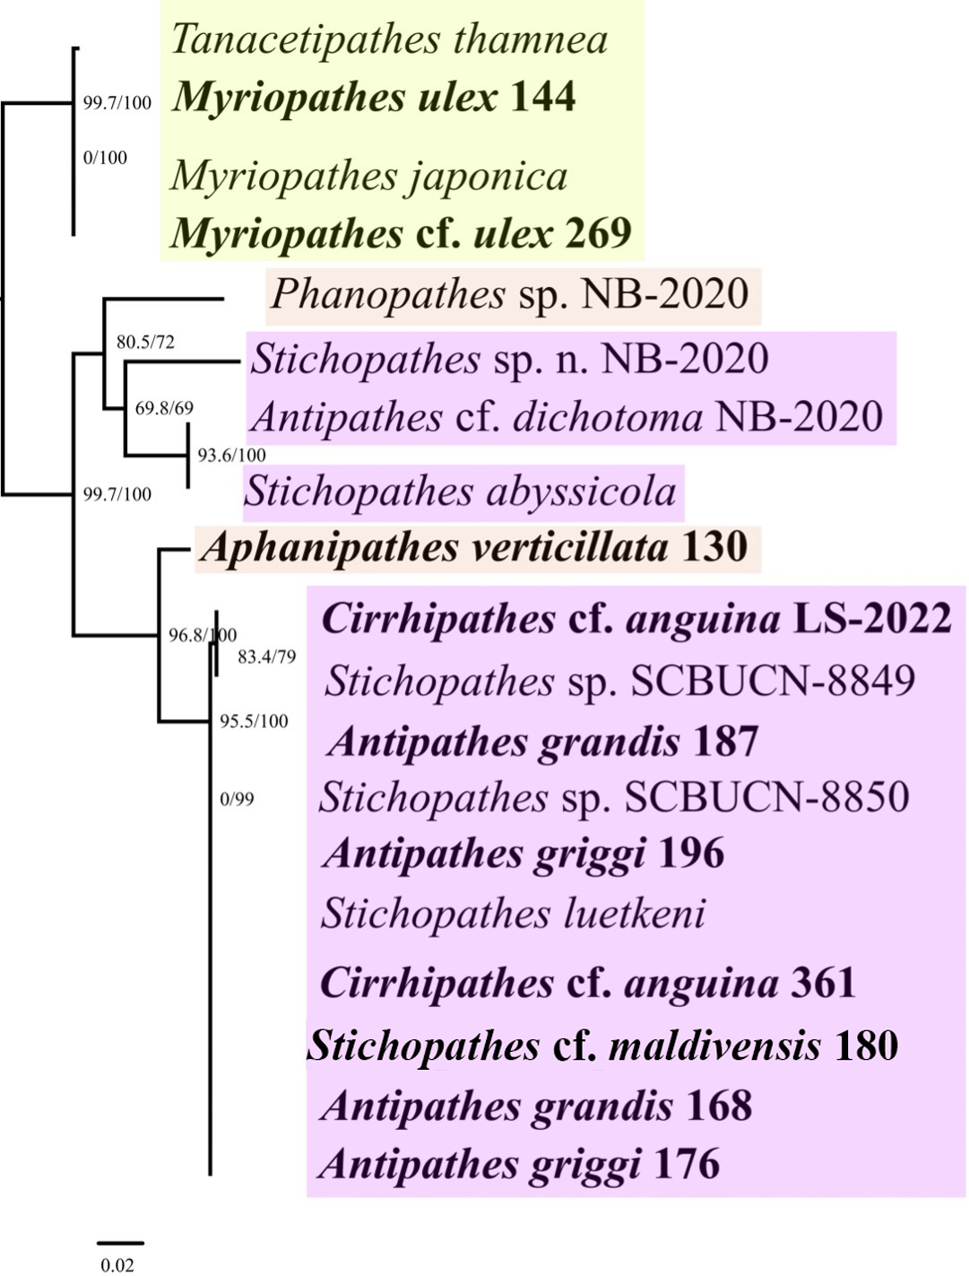
Figure S3. Maximum likelihood phylogeny of 19 antipatharian taxa belonging to three families: Myriopathidae (green), Antipathidae (pink), and Aphanipathidae (brown). This IQ-TREE inferred phylogeny is based on ND3 (pairwise identity: 94.1%; identical sites: 81.2%). ʻĒkaha kū mona sequenced from Hawaiʻi are bolded. Branch lengths are relative to genetic divergence, and values at each node represent SH-aLRT /ultrafast bootstrap values.

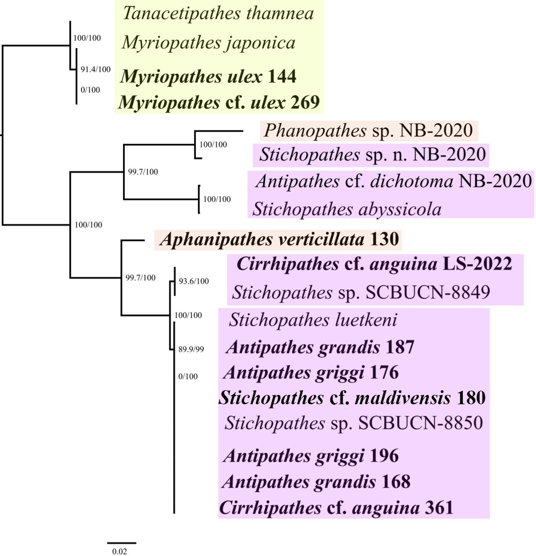
Figure S4. Maximum likelihood phylogeny of 19 antipatharian taxa belonging to three families: Myriopathidae (green), Antipathidae (pink), and Aphanipathidae (brown). That IQ-TREE inferred phylogeny is based on ND4 (pairwise identity: 92.1%; identical sites: 76.4%). ʻĒkaha kū mona sequenced from Hawaiʻi are bolded. Branch lengths are relative to genetic divergence, and values at each node represent SH-aLRT /ultrafast bootstrap values.

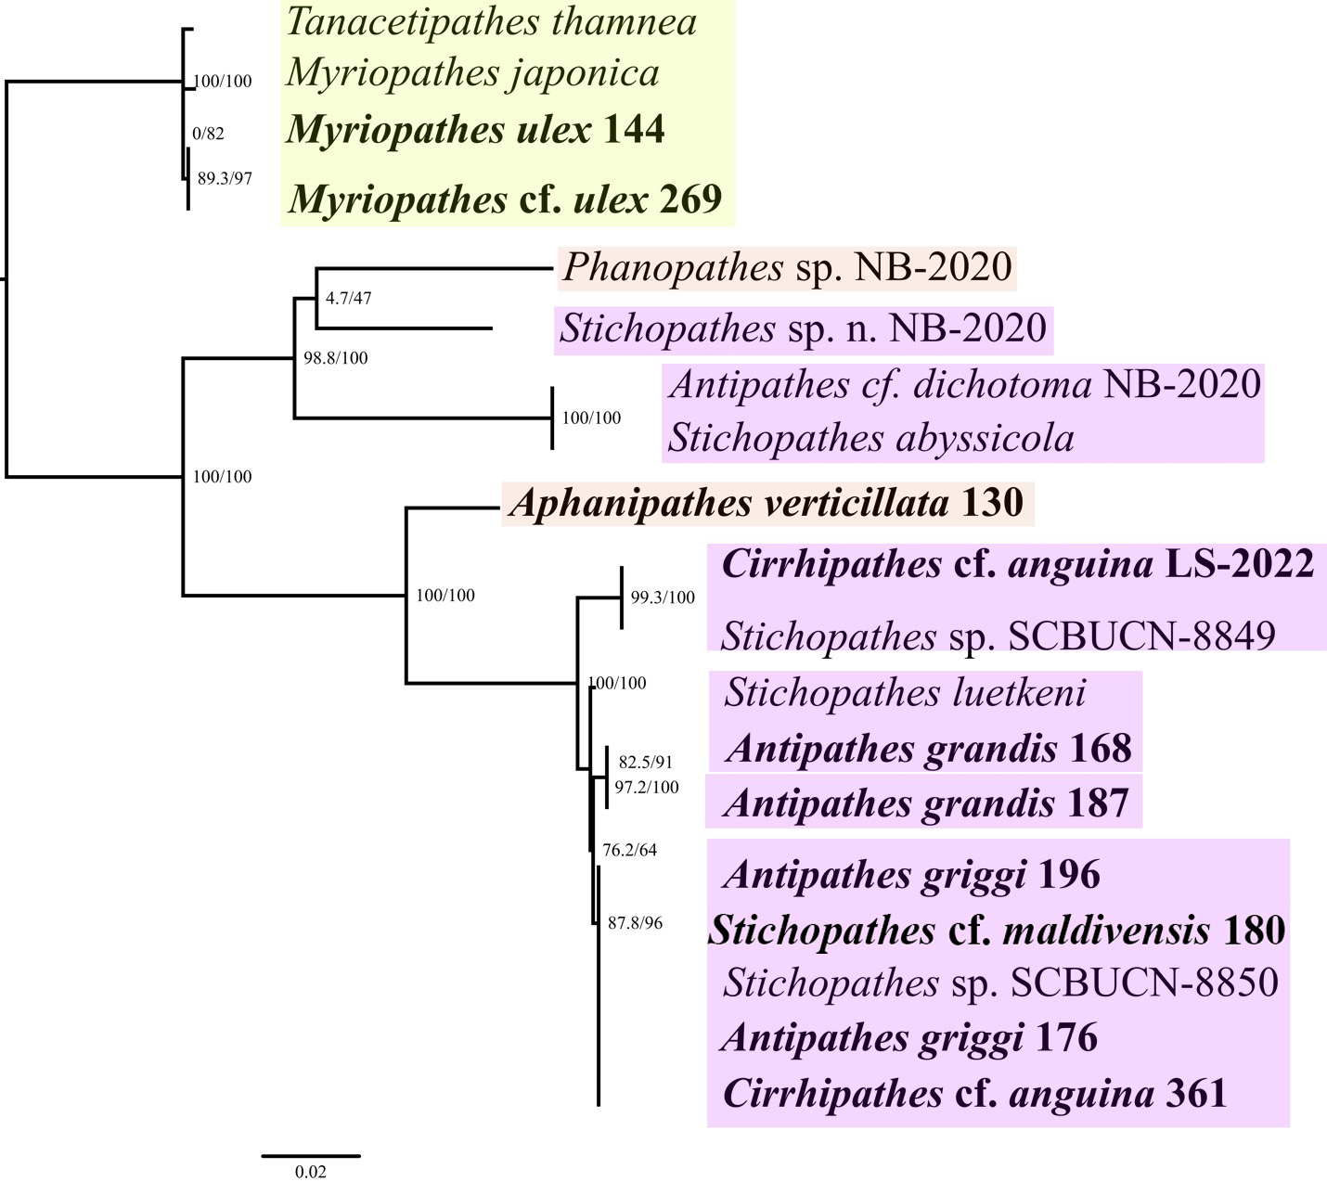
Figure S5. Maximum likelihood phylogeny of 19 antipatharian taxa belonging to three families: Myriopathidae (green), Antipathidae (pink), and Aphanipathidae (brown). The IQ-TREE inferred phylogeny is based on ND5 (pairwise identity: 77.1%; identical sites: 36.1%). ʻĒkaha kū mona sequenced from Hawaiʻi are bolded. Branch lengths are relative to genetic divergence, and values at each node represent SH-aLRT /ultrafast bootstrap values.

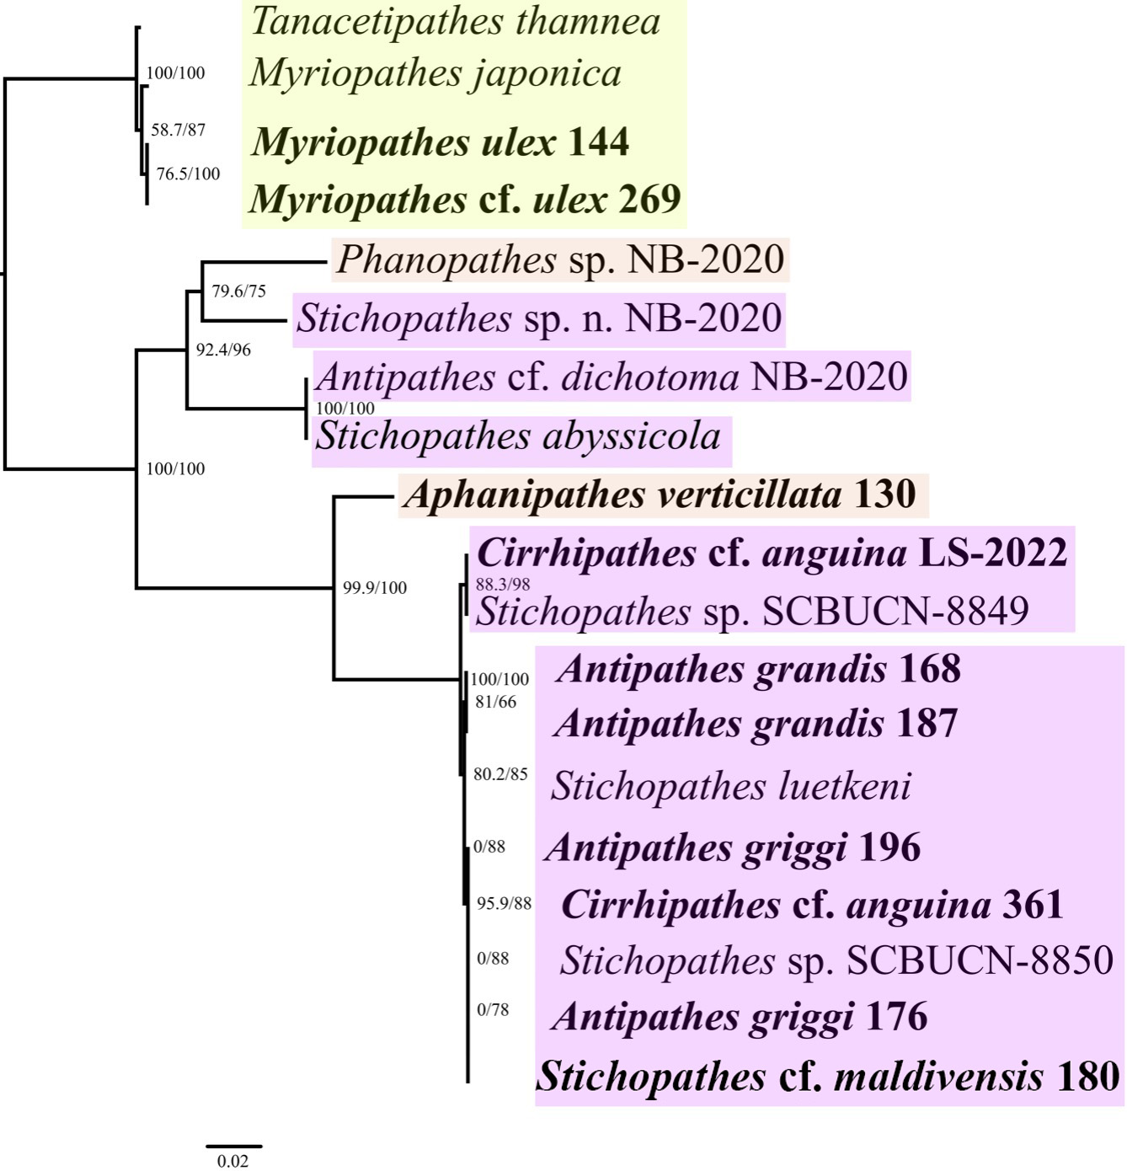
Figure S6. Maximum likelihood phylogeny of 19 antipatharian taxa belonging to three families: Myriopathidae (green), Antipathidae (pink), and Aphanipathidae (brown). This IQ-TREE inferred phylogeny is based on COX1 (pairwise identity: 85.3%; identical sites%: 47.4%). ʻĒkaha kū mona sequenced from Hawaiʻi are bolded. Branch lengths are relative to genetic divergence, and values at each node represent SH-aLRT /ultrafast bootstrap values.

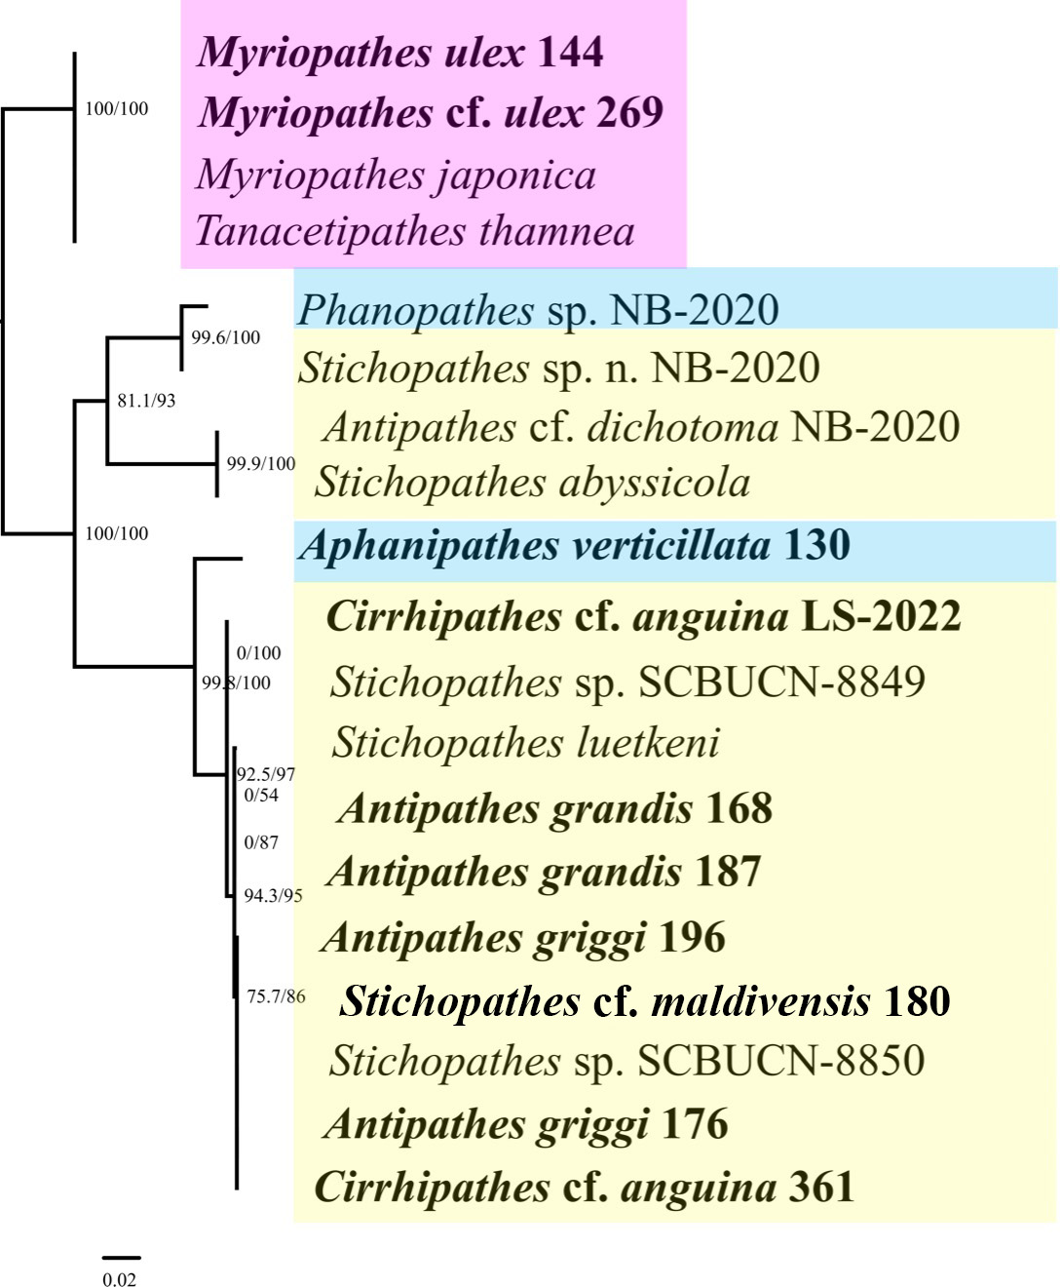
Figure S7. Maximum likelihood phylogeny of 19 antipatharian taxa belonging to three families: Myriopathidae (green), Antipathidae (pink), and Aphanipathidae (brown). This IQ-TREE inferred phylogeny is based on COX2 (pairwise identity: 92.6%; identical sites: 78.7%). ʻĒkaha kū mona sequenced from Hawaiʻi are bolded. Branch lengths are relative to genetic divergence, and values at each node represent SH-aLRT /ultrafast bootstrap values.

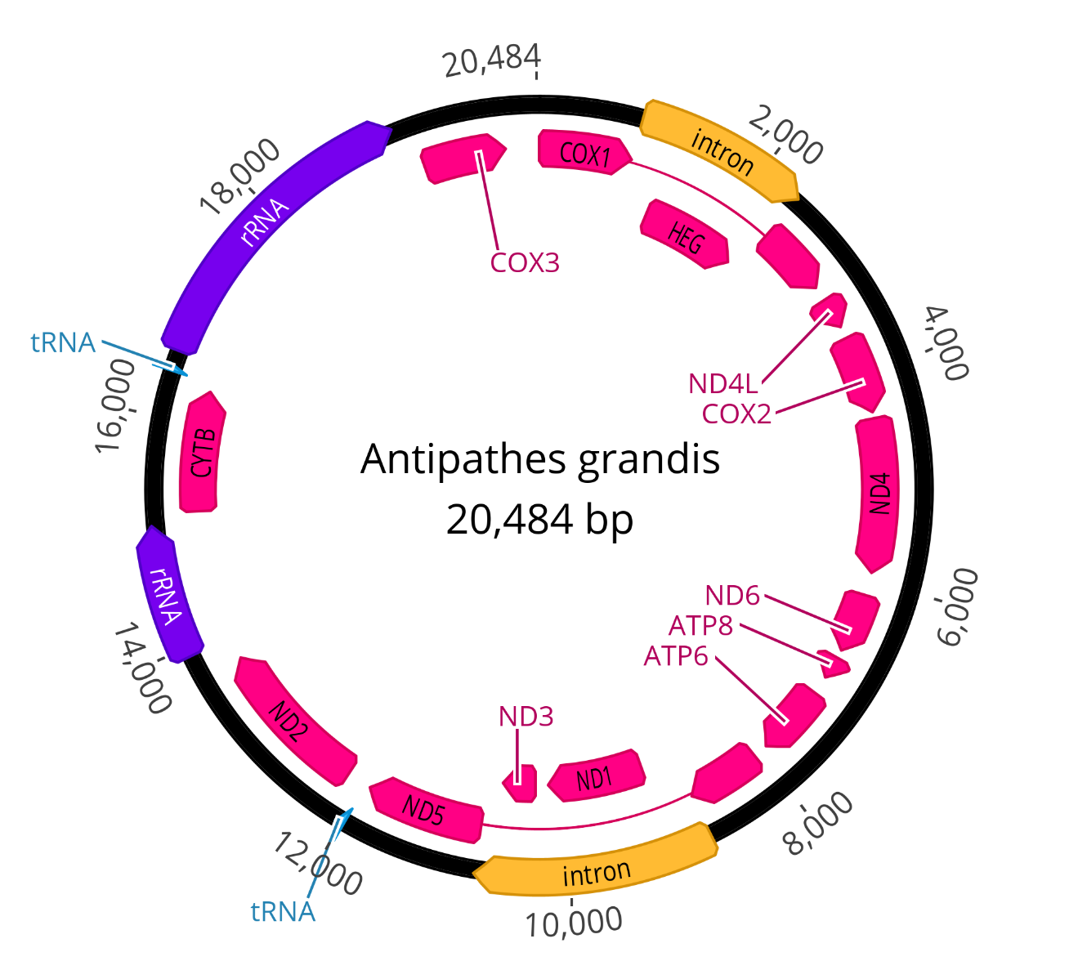
Figure S8. Map of the complete mitochondrial genome of Antipathes grandis (#168), drawn by Geneious Prime version 2023.2.1 (https://www.geneious.com).

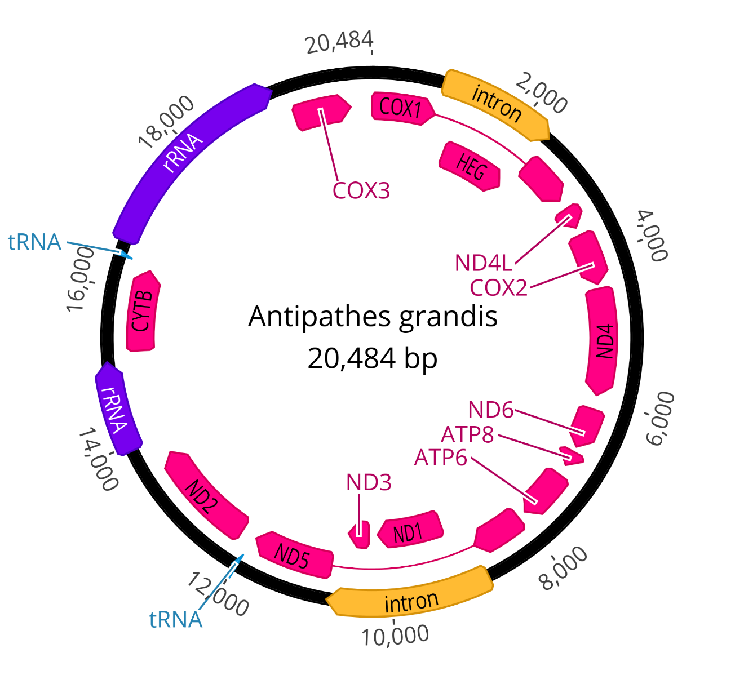
Figure S9. Map of the complete mitochondrial genome of Antipathes grandis (#187), drawn by Geneious Prime version 2023.2.1 (https://www.geneious.com).

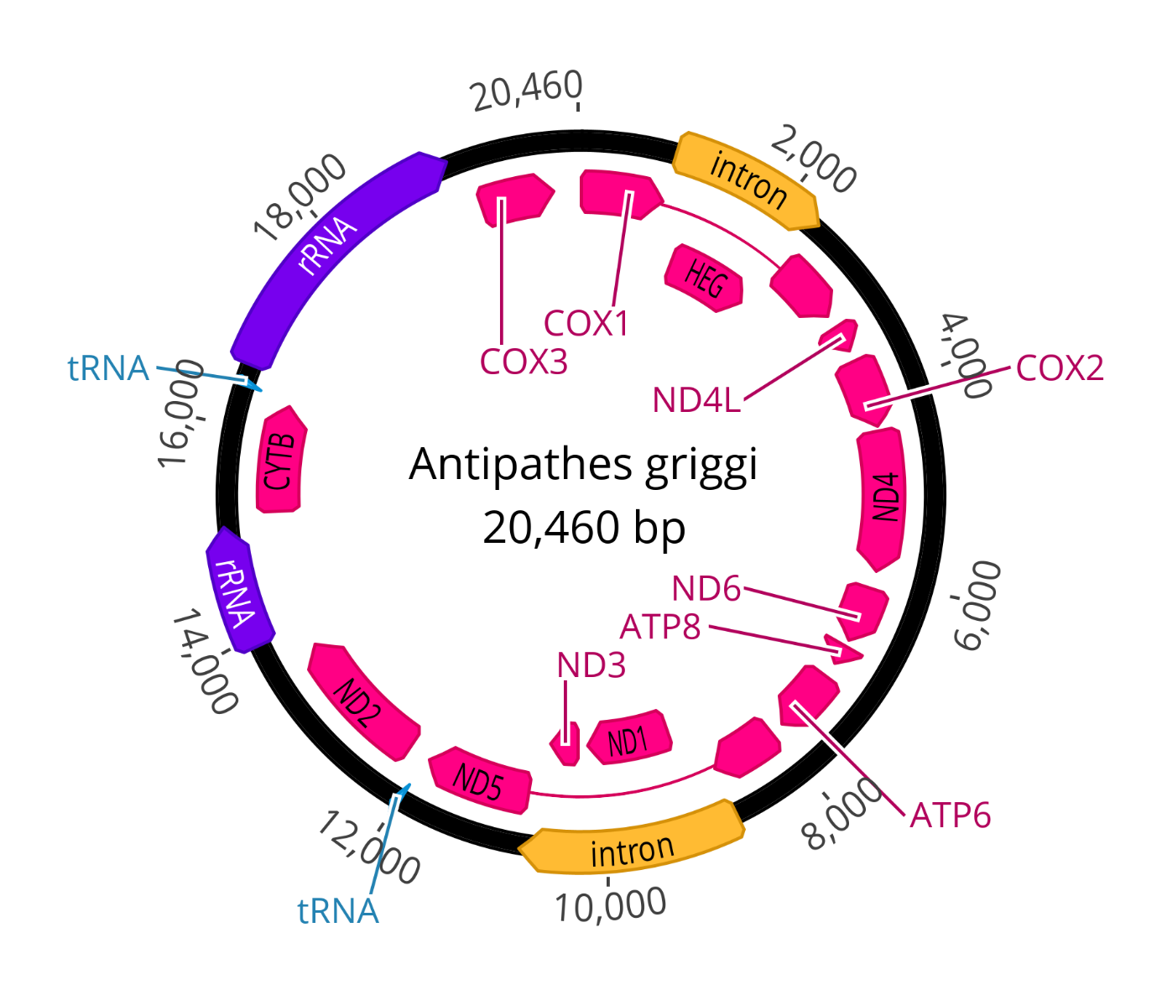
Figure S10. Map of the complete mitochondrial genome of Antipathes griggi (#176), drawn by Geneious Prime version 2023.2.1 (https://www.geneious.com).

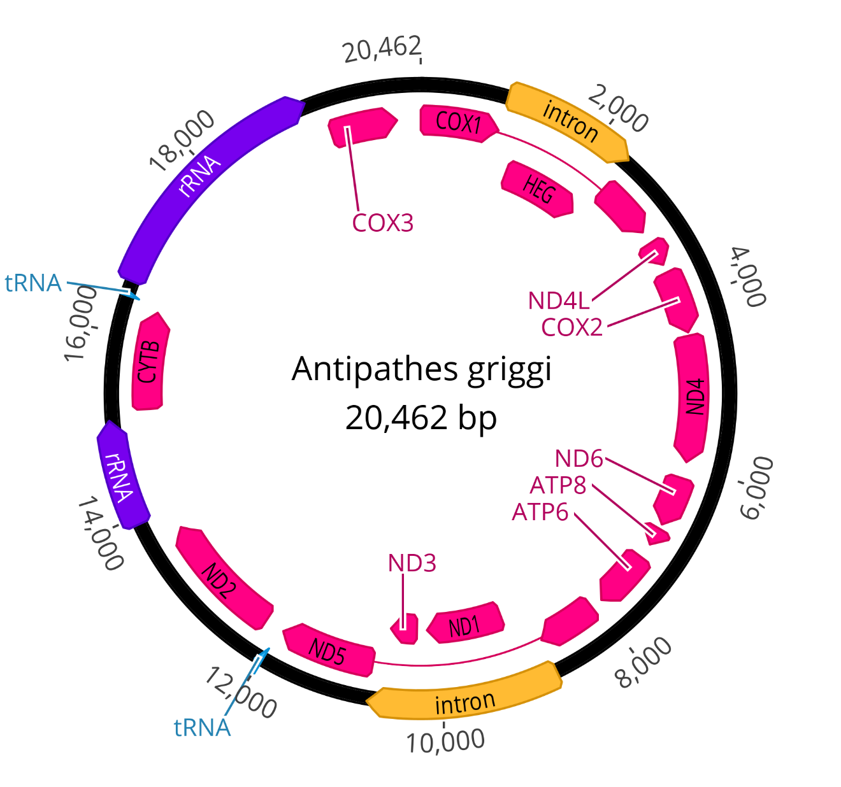
Figure S11. Map of the complete mitochondrial genome of Antipathes griggi (#196), drawn by Geneious Prime version 2023.2.1 (https://www.geneious.com).

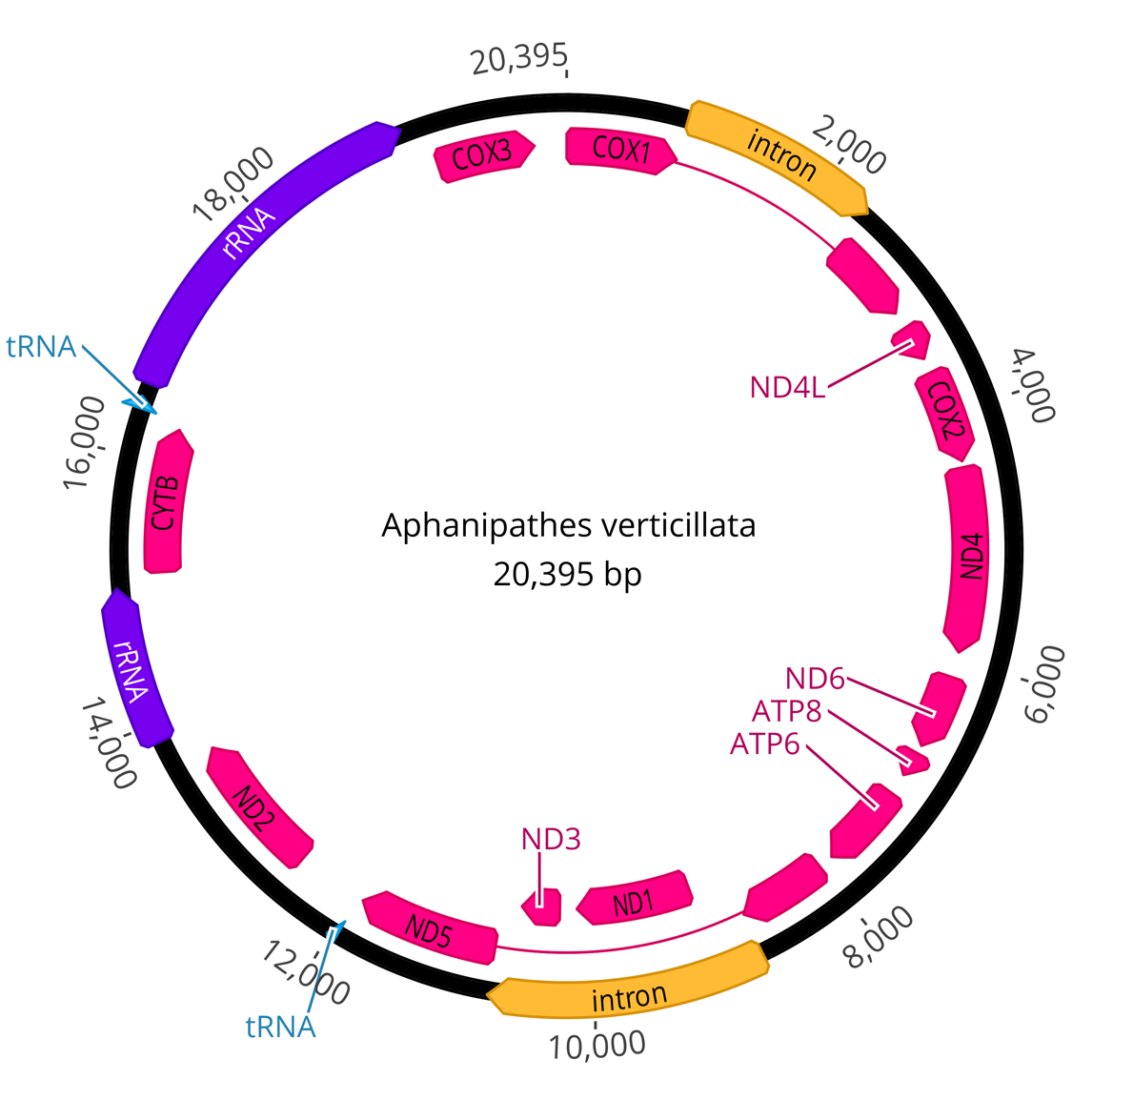
Figure S12. Map of the complete mitochondrial genome of Aphanipathes verticillata (#130), drawn by Geneious Prime version 2023.2.1 (https://www.geneious.com).

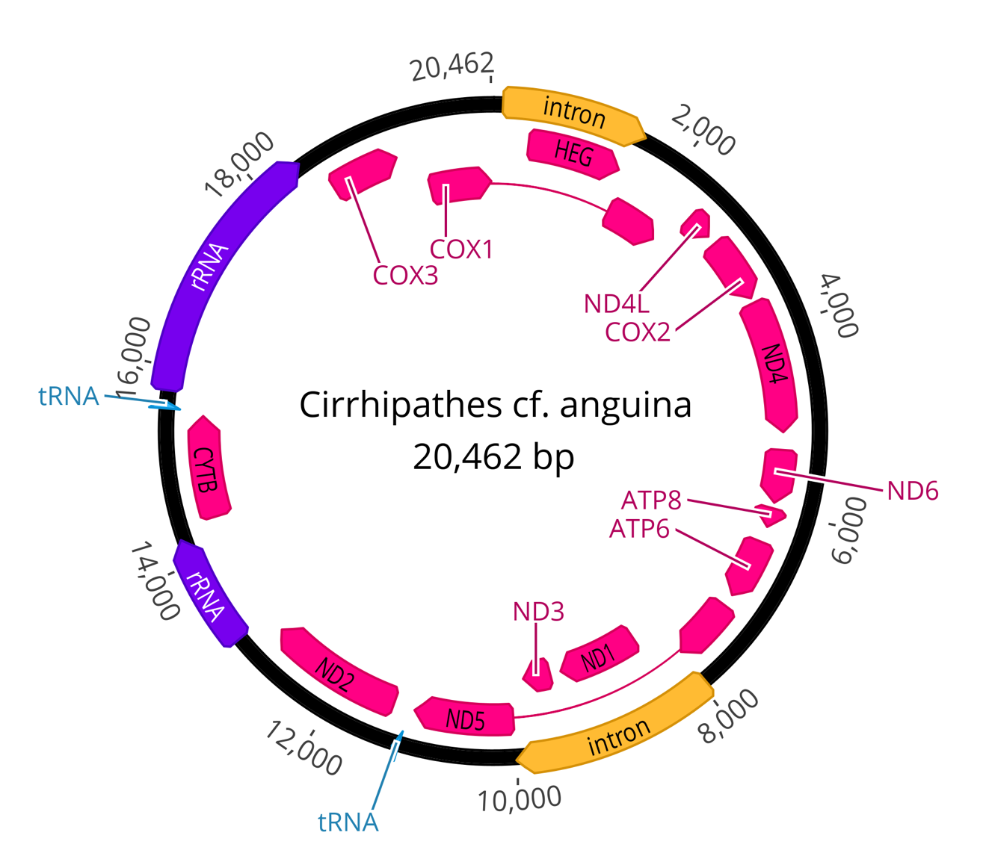
Figure S13. Map of the complete mitochondrial genome of Cirrhipathes cf. anguina (#361), drawn by Geneious Prime version 2023.2.1 (https://www.geneious.com).

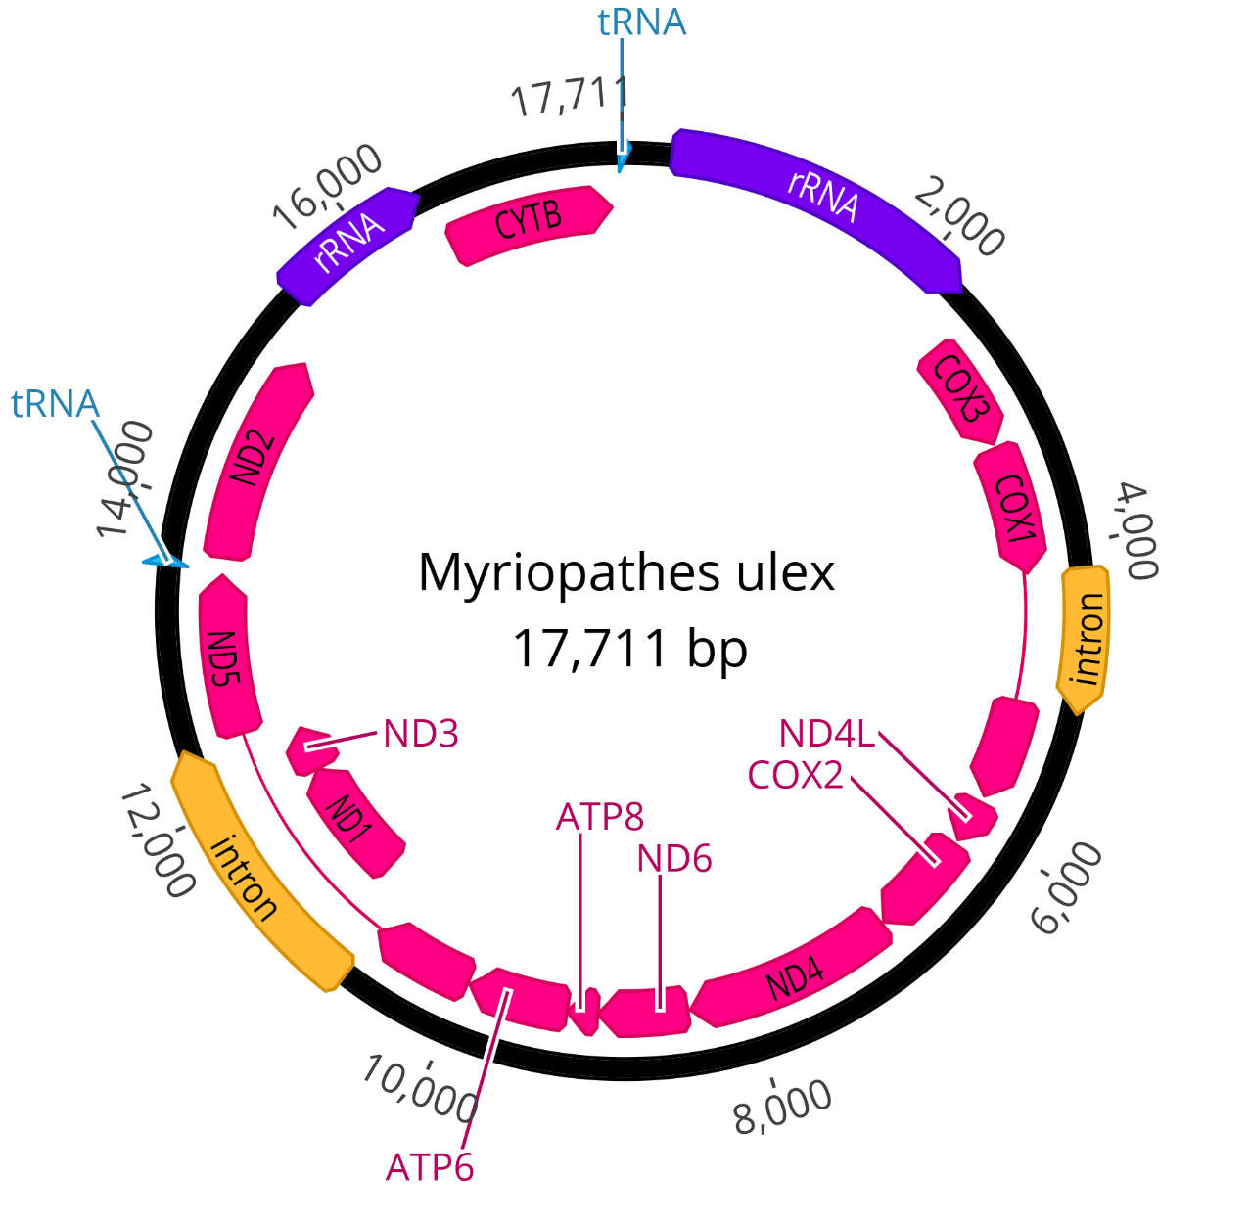
Figure S14. Map of the complete mitochondrial genome of Myriopathes ulex (#144), drawn by Geneious Prime version 2023.2.1 (https://www.geneious.com).

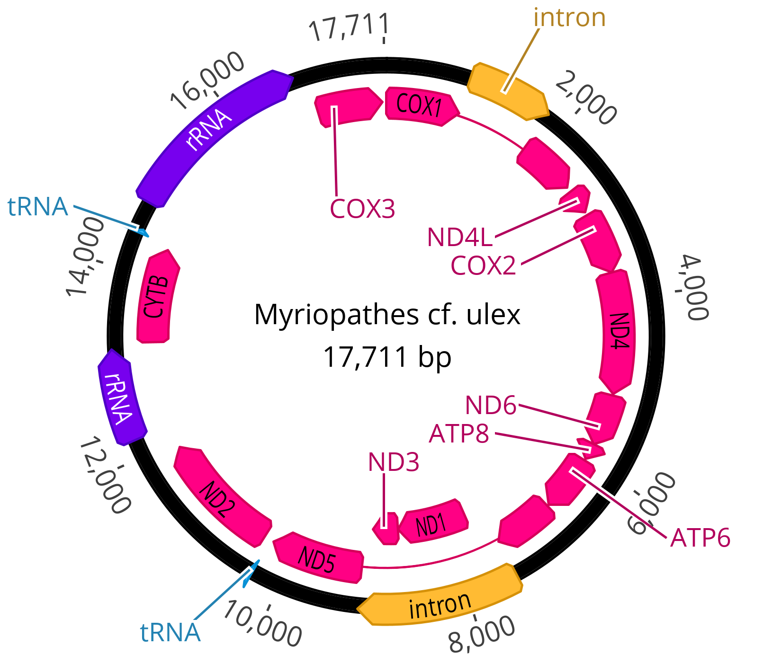
Figure S15. Map of the complete mitochondrial genome of Myriopathes cf. ulex (#269), drawn by Geneious Prime version 2023.2.1 (https://www.geneious.com).

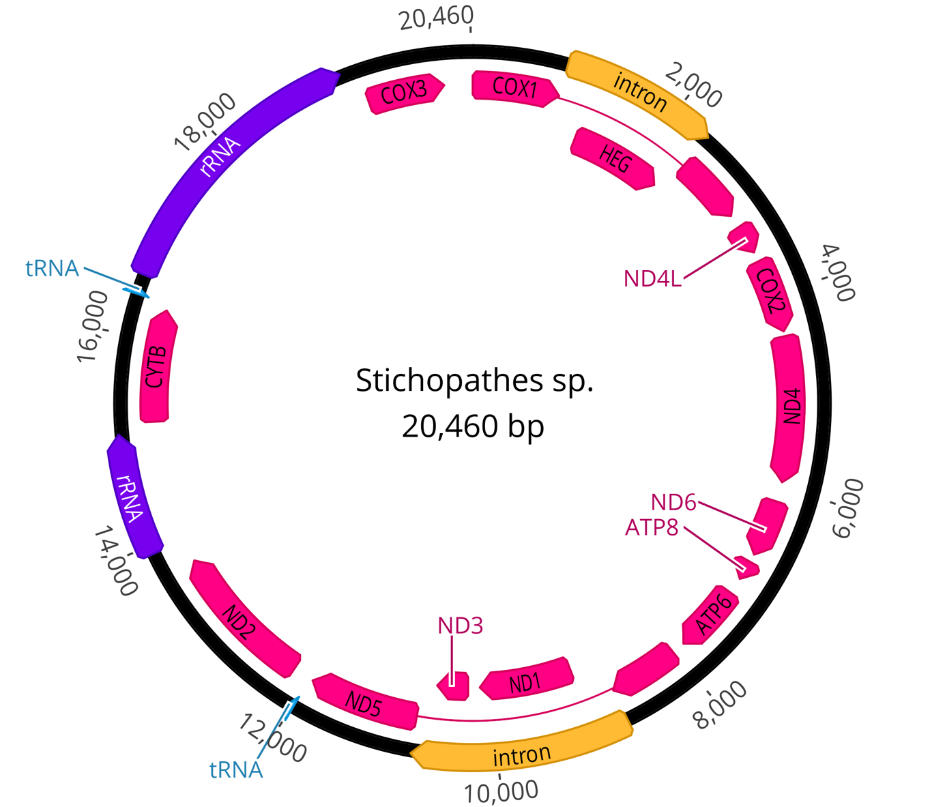
Figure S16. Map of the complete mitochondrial genome of Stichopathes cf. maldivensis (#180), drawn by Geneious Prime version 2023.2.1 (https://www.geneious.com).

