Table S2 A brief overview of morphological characteristics for respective CFUs.
CFUs | Morphology | Characteristics
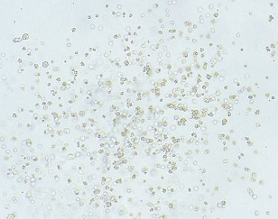  CFU-E |  | CFU-E produces a colony containing 8-200 erythroblasts with 1-2 cells clusters.
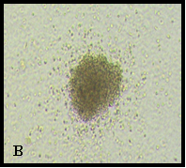  BFU-E |  | BFU-E is more immature erythroid progenitor than CFU-E and produces a colony  containing >200 erythroblasts in a single or multiple clusters.
CFU-GM | 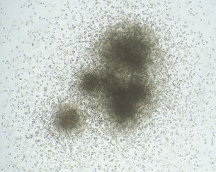 | CFU-GM is more primitive myeloid progenitor than CFU-G and CFU-M and produces a colony with >40 cells of granulocytes and macrophages in a single or multiple clusters.
CFU-M | 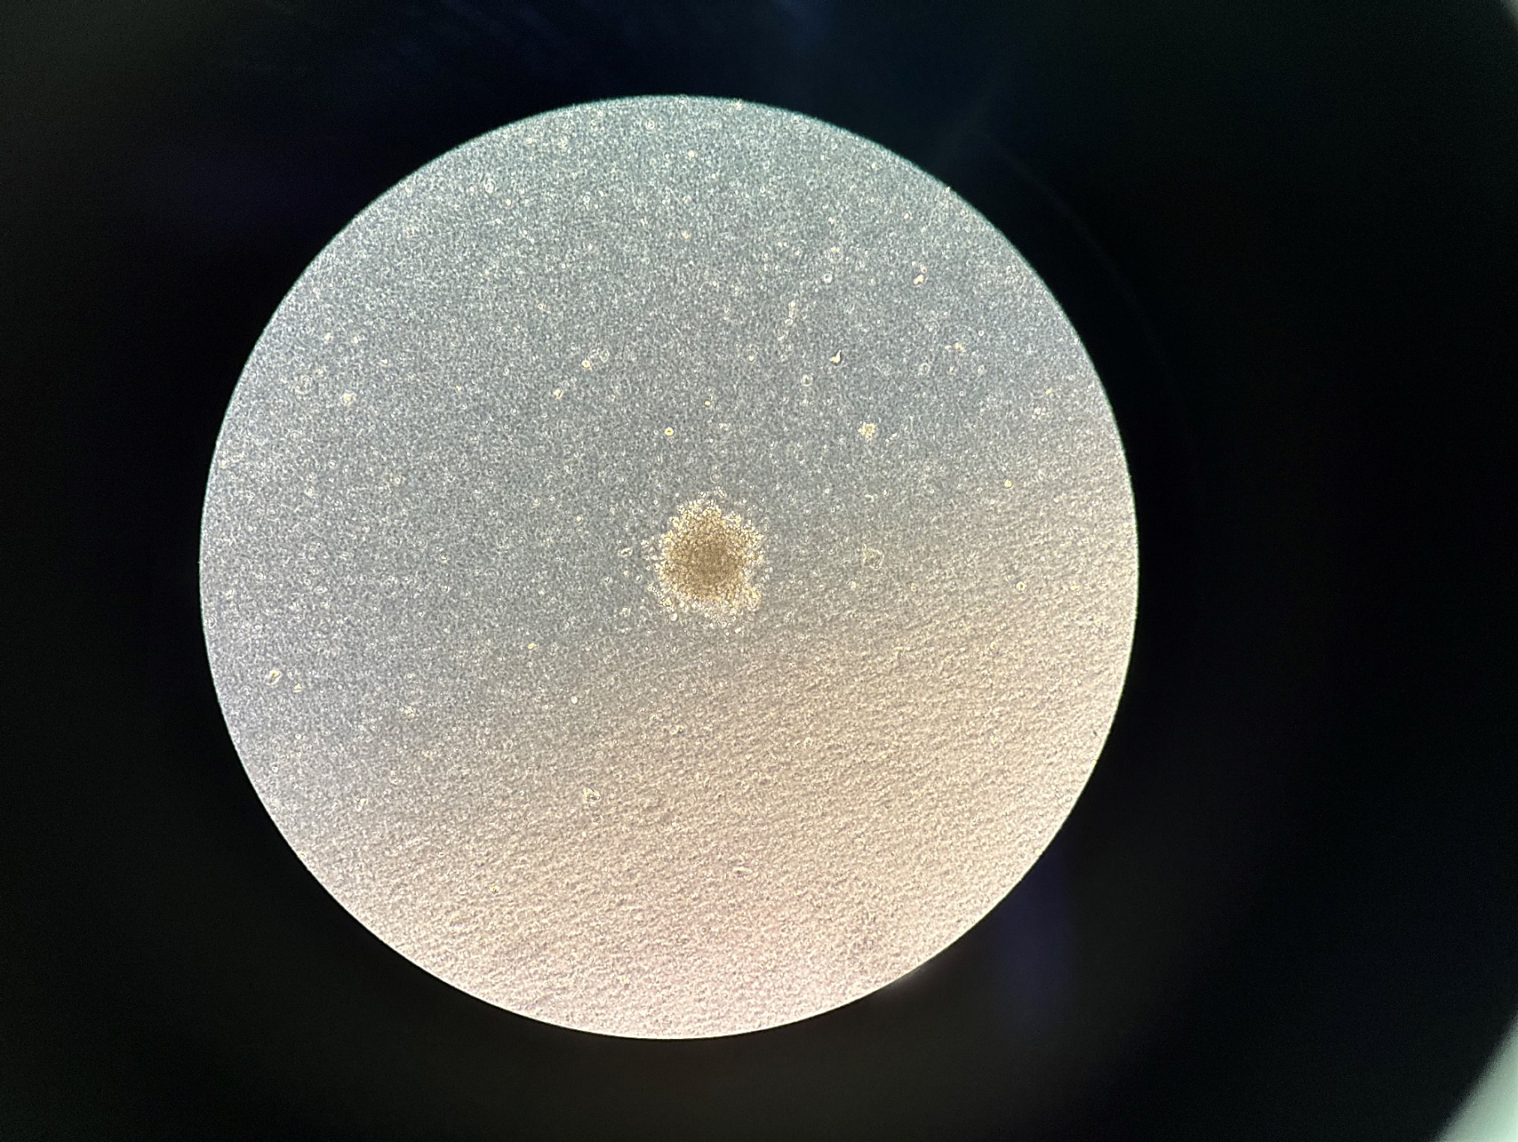  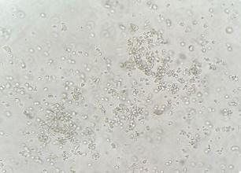 | CFU-M produces a colony containing macrophages with irregular shape and size.
CFU-G |  | CFU-G produces a colony containing round and small granulocytes with denser colony as compared to CFU-M.
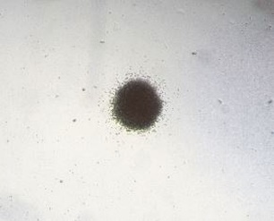  CFU-Pre-B |  | CFU Pre-B produces colonies with variation in size and morphology. Colony consist of tiny, round or oval shaped cells and may appear as compact colonies or diffuse colonies with peripheral cells.
CFU-Mk | 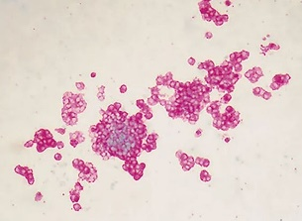 | CFU-Mk produces a colony containing 3 or more megakaryocytic cells. However, the colony requires special staining for megakaryocytes in order to visualize the colony.
CFU-GEMM | 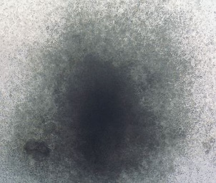 | CFU-GEMM produce large colonies of >500 cells of erythroblasts (at periphery) and lineages (monocytic and granulocytic). Colonies derived from CFU-GEMM have a highly dense core with an indistinct border between the core and peripheral cells. Clusters of large megakaryocytic cells are usually seen.
Source: StemCell Technologies (2017). Abbreviations: CFU-E: colony-forming unit-erythroid; BFU-E: burst-forming unit-erythroid; CFU-GM: colony-forming unit-granulocyte/macrophage; CFU-M: colony-forming unit-macrophage; CFU-G: colony-forming unit- granulocyte; CFU-Pre-B: colony-forming unit-Pre-B; CFU-Mk: colony-forming unit-megakaryocytes; CFU-GEMM: colony-forming unit-granulocyte/erythrocyte/monocyte/megakaryocyte.

