Figure S1. Immunofluorescence showed subcellular localization of GRN using the HPA online tool (https://www.proteinatlas.org/).
Figure S2. GRN expression in different cell types from various normal tissues including adipose, breast, fallopian tube, liver, and lung sing the scRNA-seq datasets from HPA online tool (https://www.proteinatlas.org/).
Figure S3. GRN is selectively expressed by macrophages in the indicated non-cancer tissues and organs using the scRNA-seq datasets from HPA online tool.
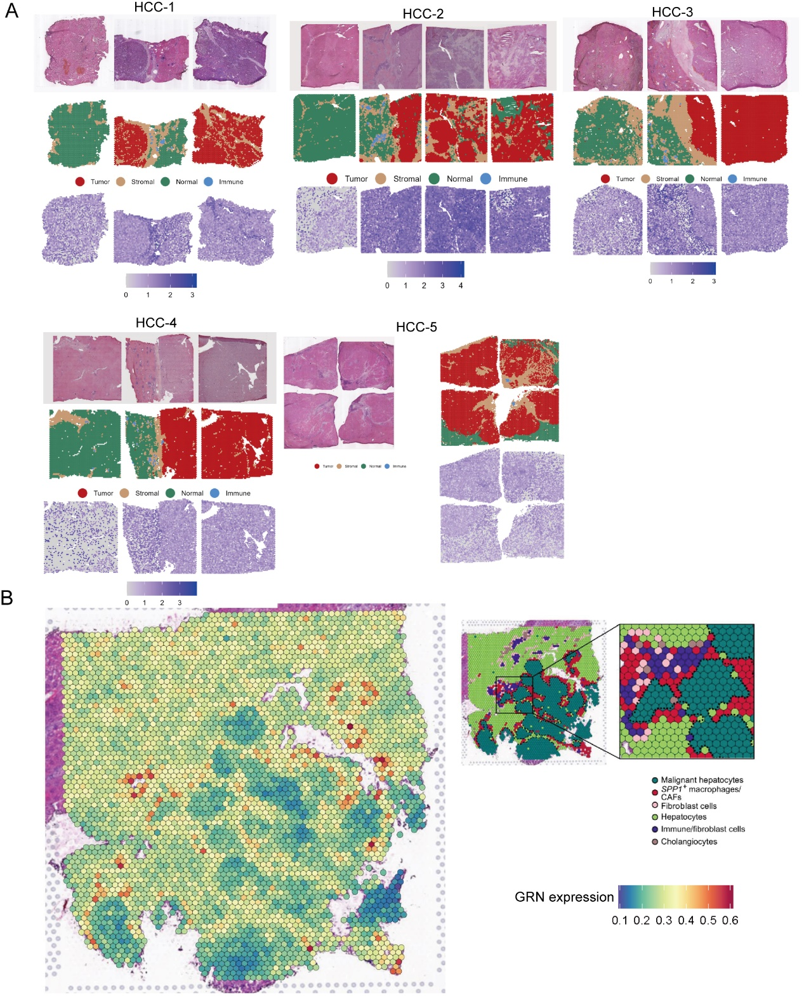
Figure S4. GRN was highly expressed in HCC, particularly in the stroma area between HCC tissues and adjacent non-tumor tissues. A. H&E staining, cell type maps, and gene count maps of different sites in samples from patients with liver cancer (HCC-1, HCC-2, HCC-3, HCC-4, and HCC-5) using spatial transcriptomics from HCCDB online tool (http://lifeome.net:809/#/home). B. Unbiased clustering of spatial transcriptomics spots, definition of cell types of each cluster, and GRN expression among different cell types in ICB-treated non-responders’ tumor tissues.
Figure S5. GRN⁺ macrophages communicate with other immune cell subgroups in HCC. A. t-SNE projection of single cells derived from 25 HCC patients (GSE151530) colored by cell clusters. B. Bubble plot showing the significant ligand–receptor pairs between other cell types and GRN⁺ macrophages calculated by Cellchat using scRNA-seq data (GSE15130).
Figure S6. GRN⁺ Myeloid cells communicate with other immune cell subgroups in HCC and adjacent non-tumor tissues.
A-B. t-SNE projection of single cells derived from 10 HCC patients (GSE149614) colored by tissue origin (A) and cell clusters (B). C. Bubble heatmap depicting the expression levels of cluster-specific marker genes. The dot size indicates the fraction of expressing cells, and dots are colored based on average expression levels. D. The cell–cell interaction numbers between GRN⁺ Myeloid cells and other cell types from non-tumor tissues and HCC tissues. E. The cell–cell interactions between GRN⁺ Myeloid cells and other cell types indicated by the scRNA-seq data.

Figure S7. Tignificant ligand–receptor pairs between GRN⁺ Myeloid cells and other cell types calculated by Cellchat using scRNA-seq data (GSE149614).

Supplementary Table S1
Primer sequence used in this study
Gene | sequence
GRN-F | 5′ CGGCCACTCCTGCATCTTTA 3′
GRN-R | 5′ CCCACGGAGTTGTTACCTGA 3′
CD163-F | 5′ TTTGTCAACTTGAGTCCCTTCAC 3′
CD163-R | 5′ TCCCGCTACACTTGTTTTCAC 3′
TGFB1-F | 5′ CTGTACATTGACTTCCGCAAG 3′
TGFB1-R | 5′ TGTCCAGGCTCCAAATGTAG 3′
IL10-F | 5′ GAGGAGGTGATGCCCCAAGC 3′
IL10-R  ACTB-F  ACTB-R | 5′ GGGAAGAAATCGATGACAGC 3′  5′ GGACTTCGAGCAAGAGATGG 3′  5′AGCACTGTGTTGGCGTACAG 3′

