**SM2. Analysis performed to compute the required sample size**

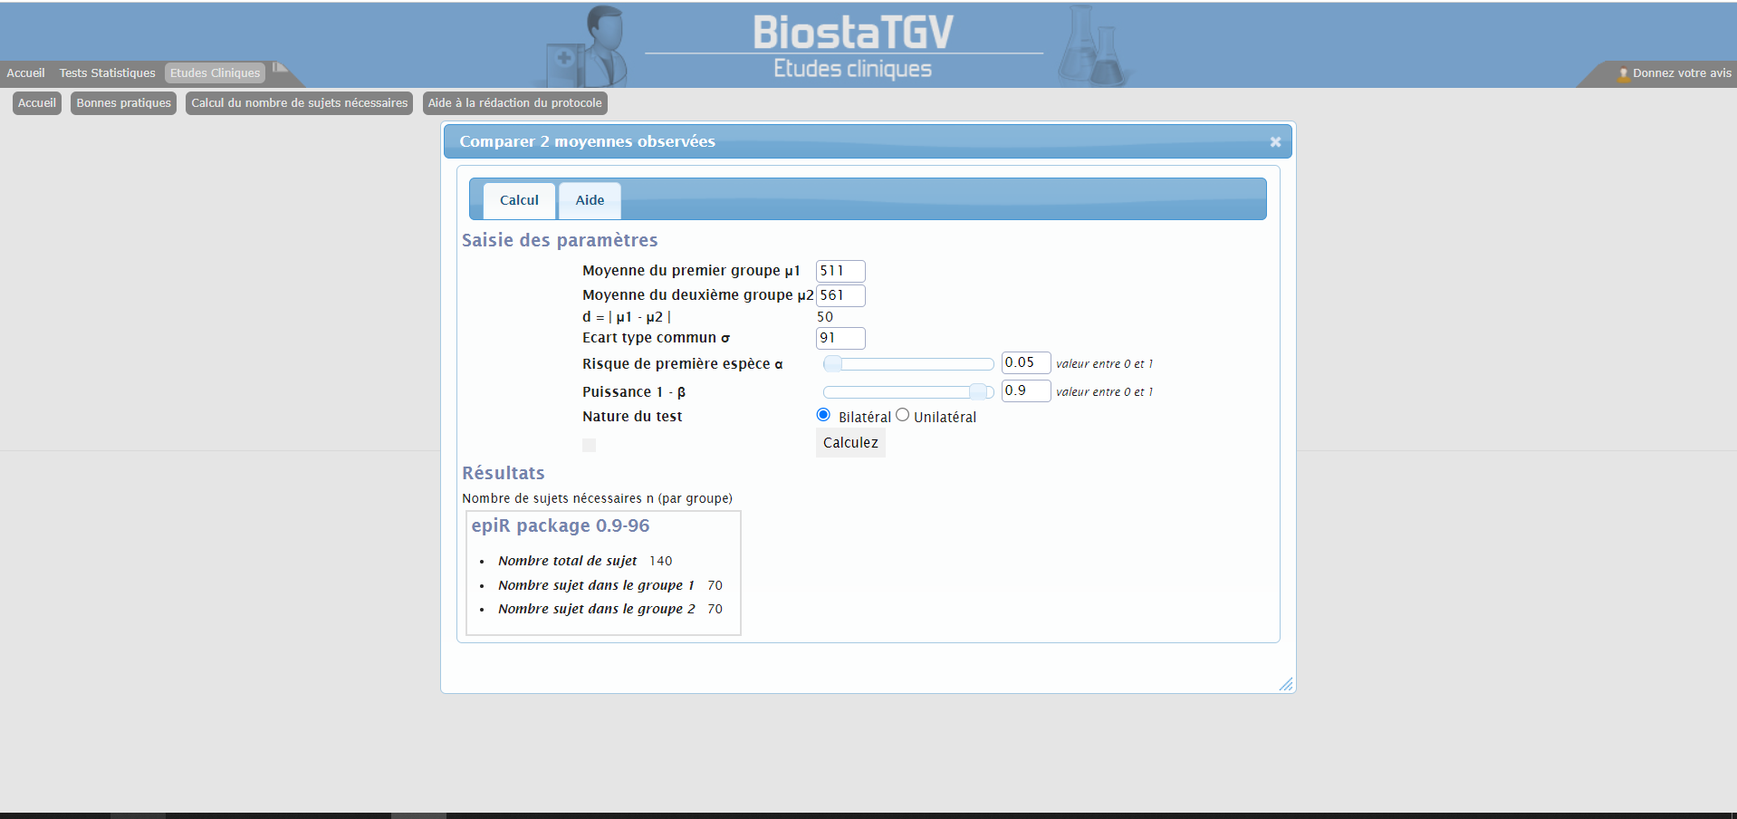

*Note.* The required sample size for the APA&Co study was obtained by dividing the result of the analysis (*N*=140) by 2. Please see the Methods section of the manuscript for the details of the explanations.