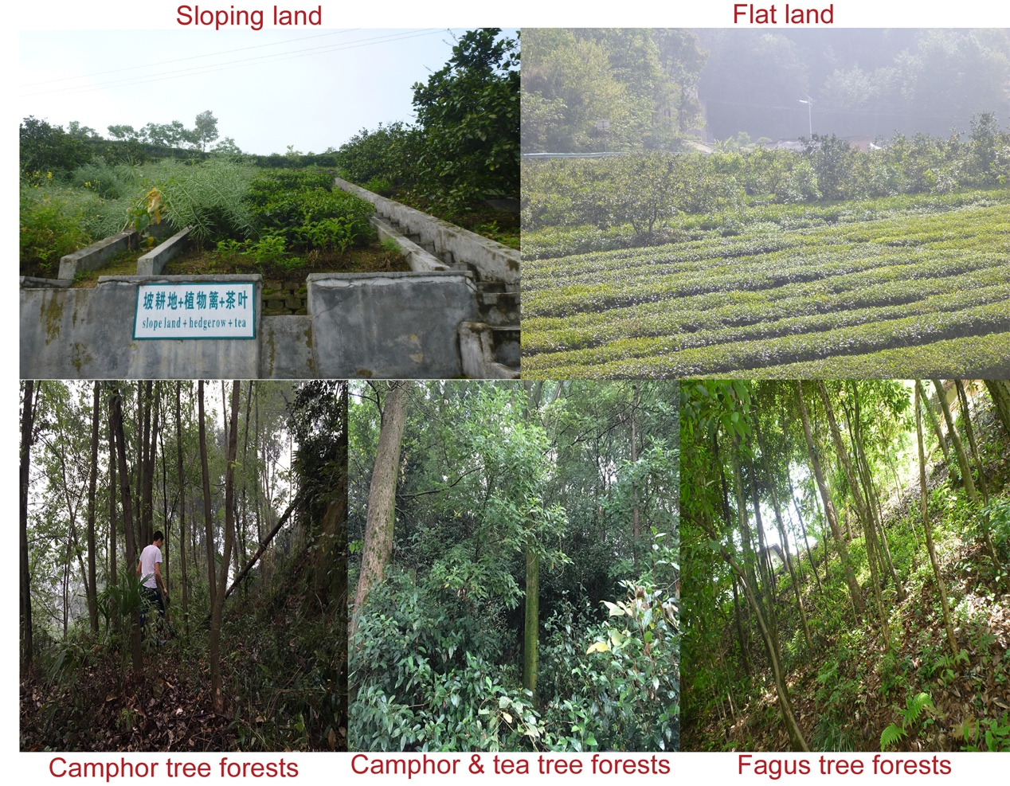

Figure S1. Photographs demonstrating the natural condition of each land use type sampled. The images were taken by Lin Xu and Zhongsai Tian during sampling.

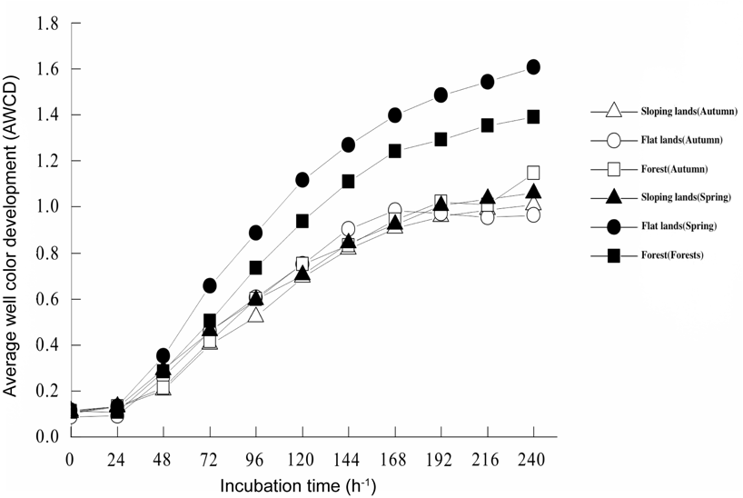
Figure S2. Average well color development dynamics (AWCD) with the incubation of soil microorganisms at different times.
Figure S3. Correlations between soil fertility index and each individual soil fertility. The number in each block indicates significance of the Spearman’s correlation rho: *, P < 0.05; **, P < 0.01; ***, P < 0.001.

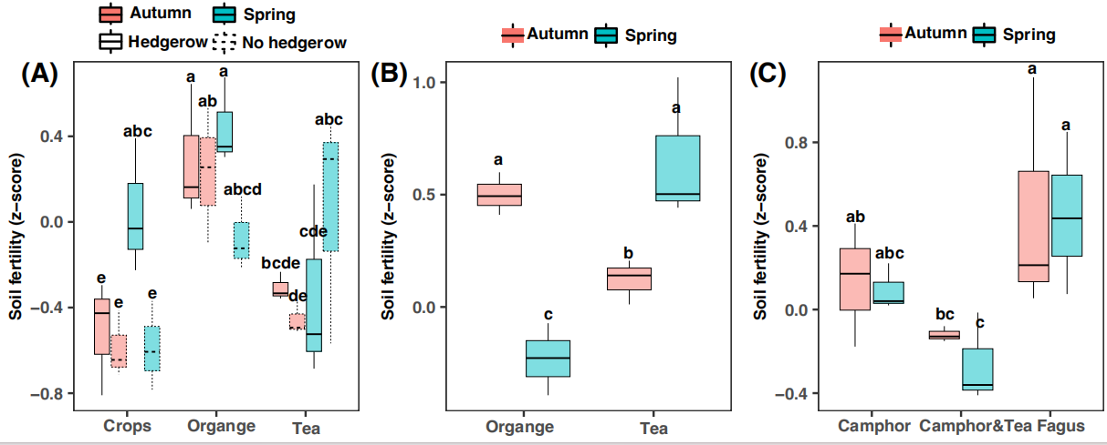

Figure S4. Boxplots of soil fertility varying temporally among plots dominated by different plants and in different land use types (A:sloping land, B: flat land,C:forest). Each boxplot includes three samples (n = 3). Difference lower-case letters indicate significant differences determined by the Kruskal-Wallis test at a significance level of P < 0.05.

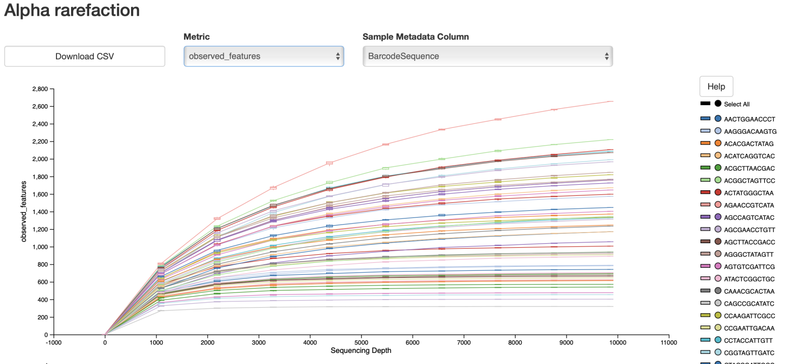

Figure S5. Rarefaction curves showing the relationships between sequencing depth and observed ASVs numbers of soil bacterial communities.

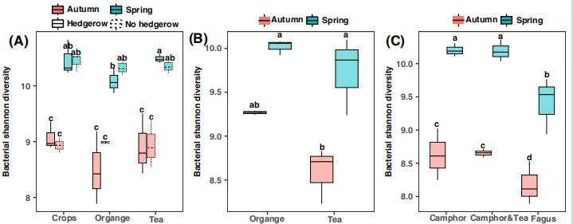

Figure S6. Boxplots of bacterial Shannon diversity varying temporally among plots dominated by different plants and in different land use types (A:sloping land, B: flat land,C:forest). Each boxplot includes three samples (n = 3). Difference lower-case letters indicate significant differences determined by the Kruskal-Wallis test at a significance level of P < 0.05.

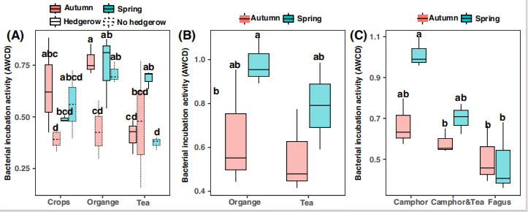
Figure S7. Boxplots of microbial metabolic activity (average well color development, AWCD) varying temporally among plots dominated by different plants and in different land use types (A:sloping land, B: flat land,C:forest). Each boxplot includes three samples (n = 3). Difference lower-case letters indicate significant differences determined by the Kruskal-Wallis test at a significance level of P < 0.05.

Figure S8. Correlations between soil fertility index and relative abundances of key bacterial phyla identified by the random forest modelling. The number in each block indicates significance of the Spearman’s correlation test: *, P < 0.05; **, P < 0.01; ***, P < 0.001.

