**Minimal Inhibitory Concentration of FLC:**

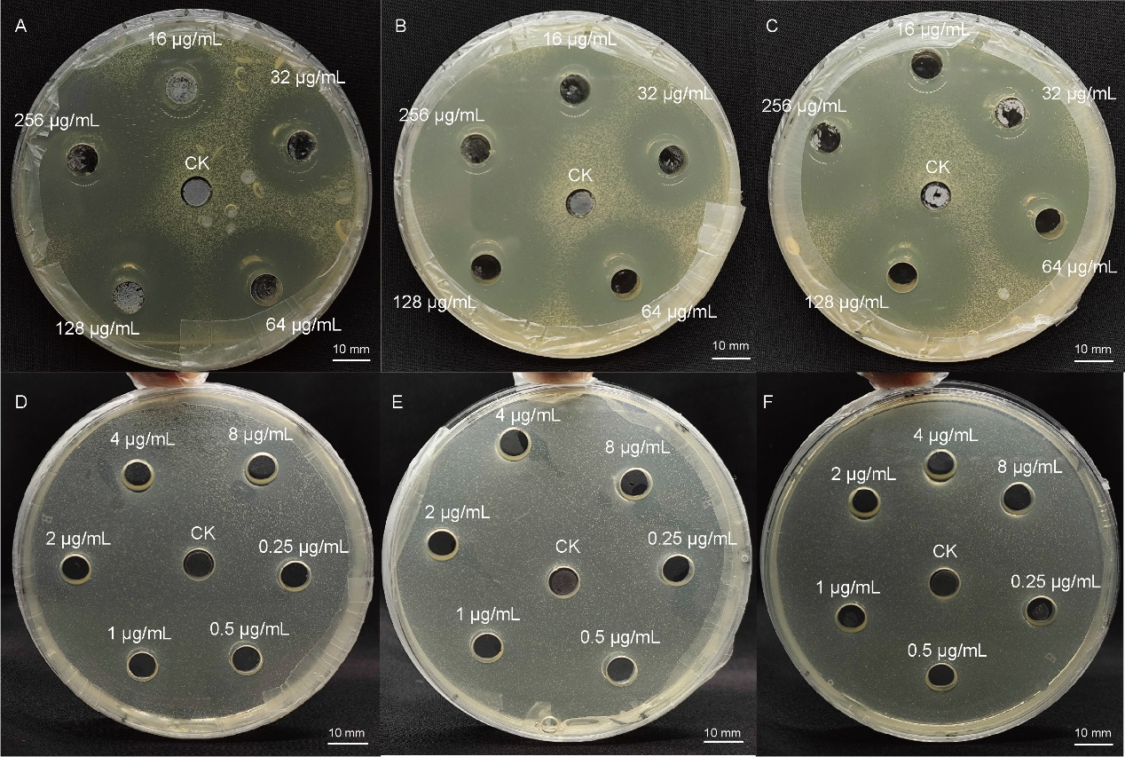

When the FLC concentration is 8 μg/mL, the antifungal effect is not evident. Thus, the MIC of FLC is considered to be 16 μg/mL.

**Minimal Inhibitory Concentration of QAP:**

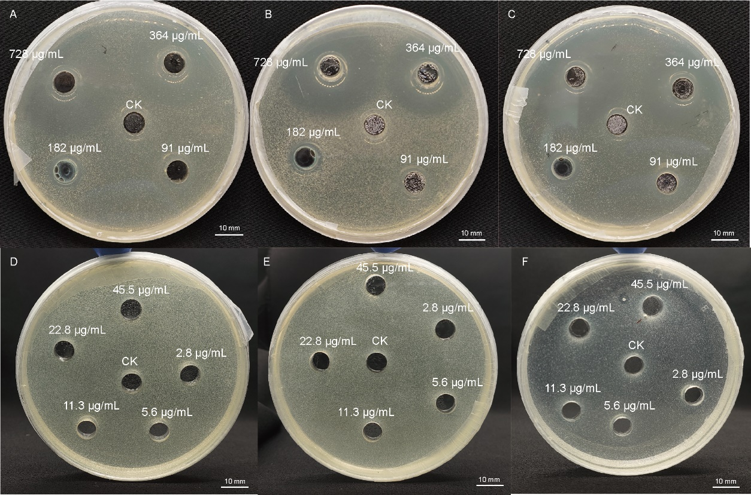

When the QAP concentration is 91 μg/mL, the antifungal effect is not evident. Thus, the MIC of QAP is considered to be 182 μg/mL.