Supporting Information

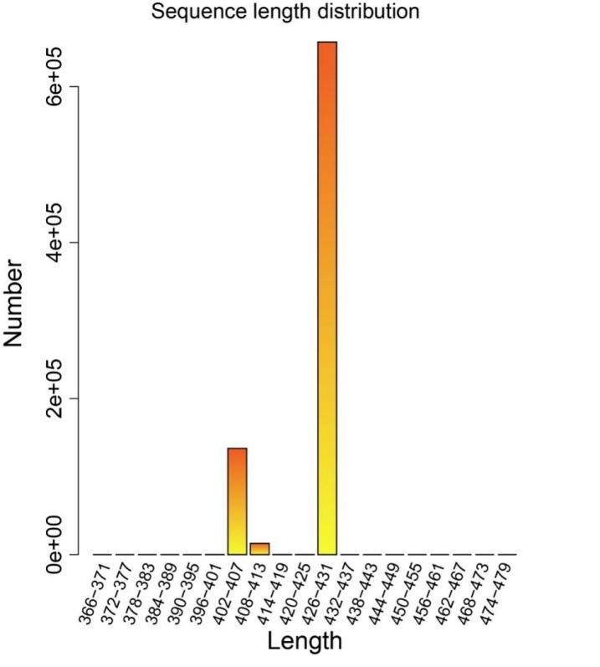
Figure S1. The statistic of ASV sequences in the gut microbiota of B. lantschouensis. The sequence length distribution of ASV sequences in the gut microbiota of B. lantschouensis.

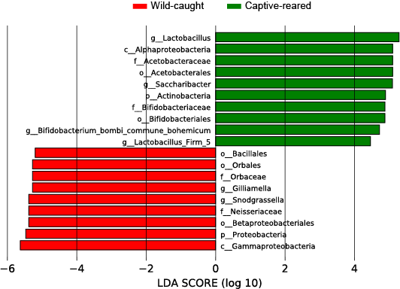
Figure S2. The differentially abundant bacteria among samples with different treatment groups. LDA scores (bacteria that obtain a log LDA score of >4 are ultimately considered) can be interpreted as the degree of consistent difference in relative abundance among two treatments.
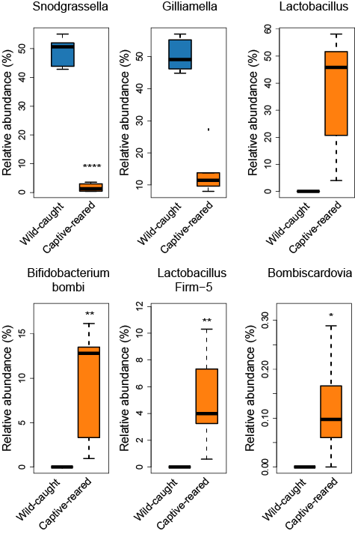
Figure S3. the most significant difference of genera in wild-caught group and captive-reared group of B. lantschouensis at the genus level.
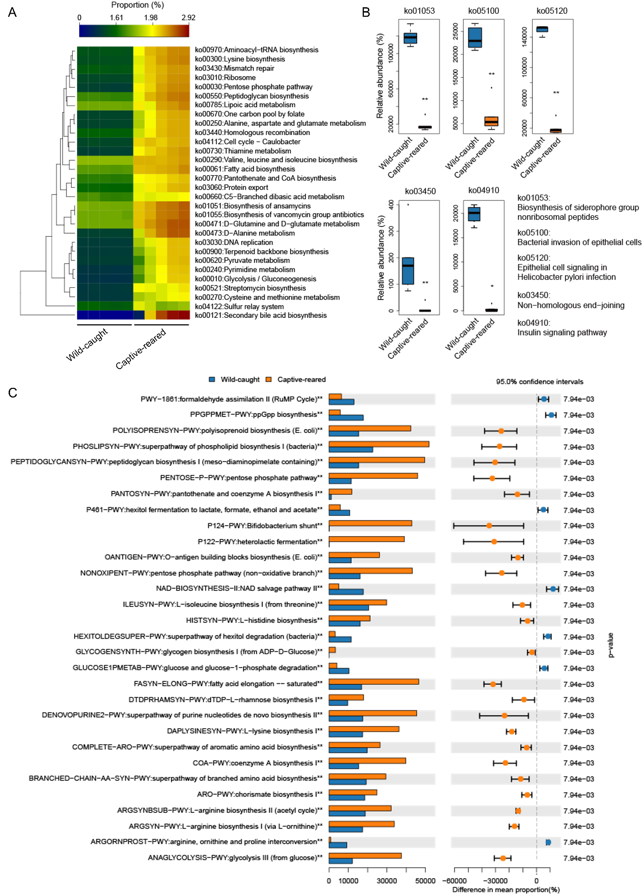
Figure S4. Functional prediction of gut microbiota with Captive-Reared in B. lantschouensis. (A) The Heatmap of KEGG function of gut microbiota in wild-caught group and captive-reared group of B. lantschouensis. (B) The histogram of functional subcategories showed a lower abundance after captive-reared of B. lantschouensis. (C) Histogram of functional subcategories with the top 30 metabolic pathways of gut microbiota by MetaCyc between two groups of B. lantschouensis (p<0.05). Significant differences in relative abundance of functions predicted between two groups.

Table 1. Summary of quality control in 16S rRNA amplicon sequencing of gut microbiota in B. lantschouensis.
Id | Group | Input | Filtered | Percentage of input passed filter | Denoised | Merged | Percentage of input merged | Non-chimeric | Percentage of input non-chimeric
1 | Wild-Caught | 83586 | 76803 | 91.89 | 76647 | 76352 | 91.35 | 69110 | 82.68
2 | Wild-Caught | 81330 | 74475 | 91.57 | 74387 | 74186 | 91.22 | 68051 | 83.67
3 | Wild-Caught | 84237 | 75050 | 89.09 | 74935 | 74706 | 88.69 | 69649 | 82.68
4 | Wild-Caught | 81290 | 74738 | 91.94 | 74619 | 74307 | 91.41 | 68170 | 83.86
5 | Wild-Caught | 77502 | 70531 | 91.01 | 70403 | 70099 | 90.45 | 66138 | 85.34
6 | Captive-Reared | 79229 | 72589 | 91.62 | 72459 | 71891 | 90.74 | 68114 | 85.97
7 | Captive-Reared | 74431 | 69147 | 92.9 | 69022 | 68883 | 92.55 | 66244 | 89
8 | Captive-Reared | 76128 | 70650 | 92.8 | 70494 | 70015 | 91.97 | 66681 | 87.59
9 | Captive-Reared | 76018 | 70852 | 93.2 | 70608 | 70007 | 92.09 | 66512 | 87.5
10 | Captive-Reared | 87345 | 75059 | 85.93 | 74963 | 74405 | 85.19 | 69420 | 79.48

Table 2. The abundance of sequences annotated at the genera level in wild-caught group and captive-reared group of B. lantschouensis.

Genus | Abundance Of Sequences
Genus | Captive-Reared | Wild-Caught
Gilliamella | 8627 | 31054
Snodgrassella | 1091 | 30055
Lactobacillus | 22180 | 16
Saccharibacter | 17345 | 15
Bifidobacterium bombi/commune/bohemicum | 5945 | 1
Lactobacillus Firm-5 | 3313 | 0
Unassigned | 2650 | 122
Gluconobacter | 261 | 0
Staphylococcus | 0 | 227
Bombiscardovia | 79 | 0
Carnimonas | 12 | 0
Phaseolibacter | 0 | 9
Acinetobacter | 0 | 4
Lactobacillus kunkeei | 0 | 3

