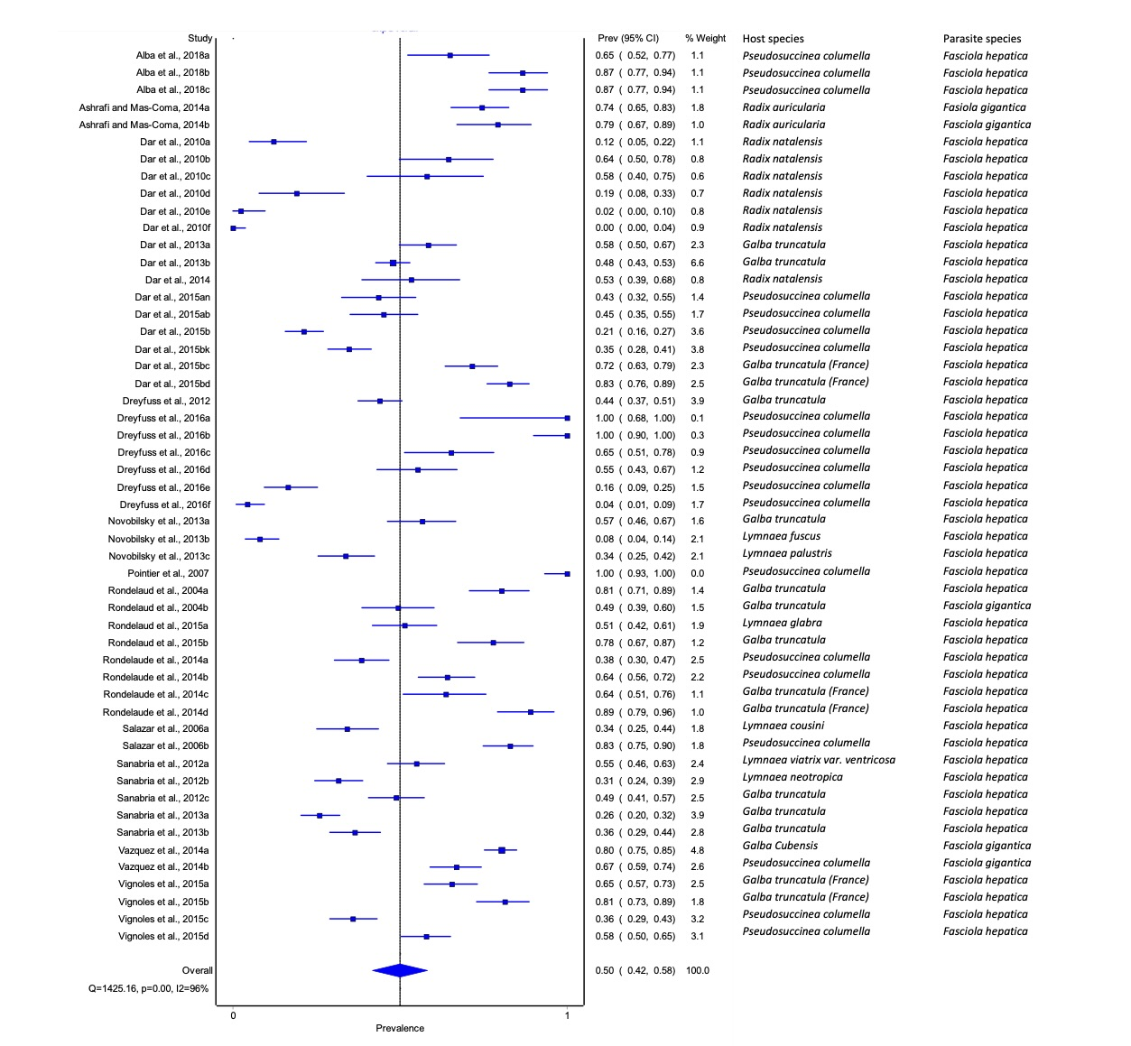

**Figure S1 Forest plot showing the overall experimental infection rates of *Fasciola hepatica* and *F. gigantica* in lymnaeid snails.**

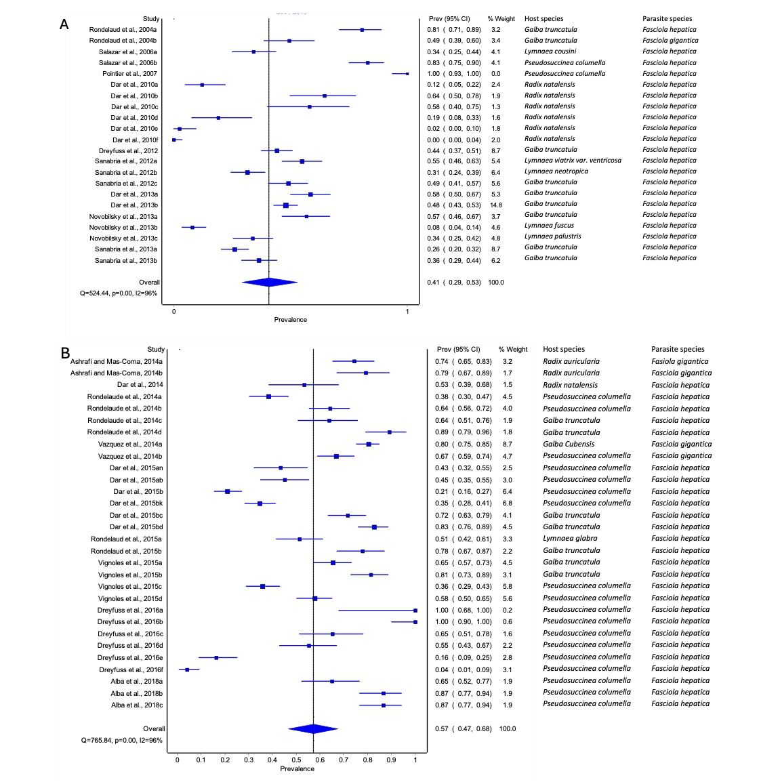

**Figure S2 Forest plots showing experimental infection rate of lymnaeid snails with *Fasciola* species from (A) 2004-2013 and (B) 2014-2023.**

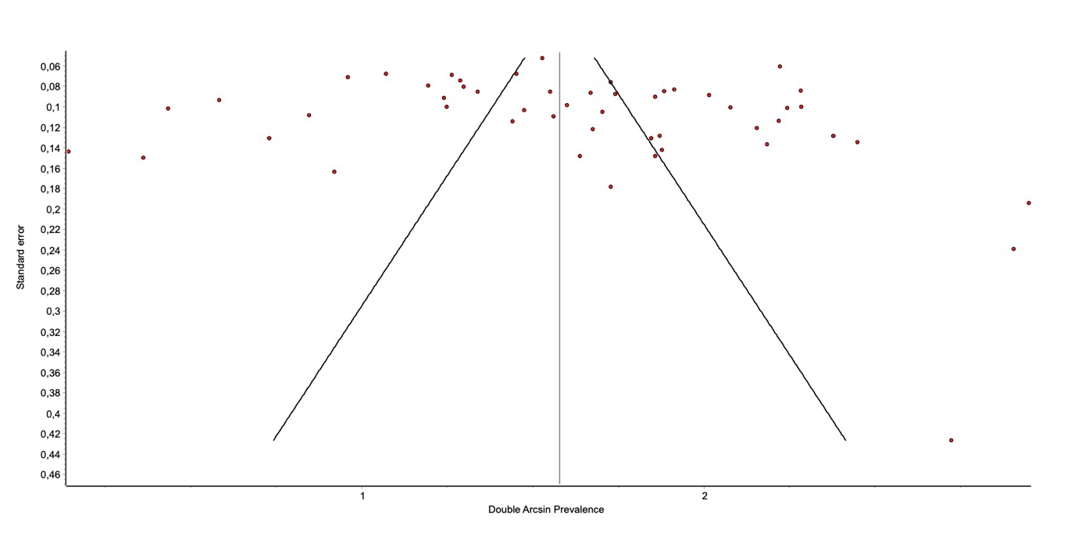

**Figure 3 Funnel plot showing overall publications on experimental infections of *Fasciola* species in their intermediate host snail.**

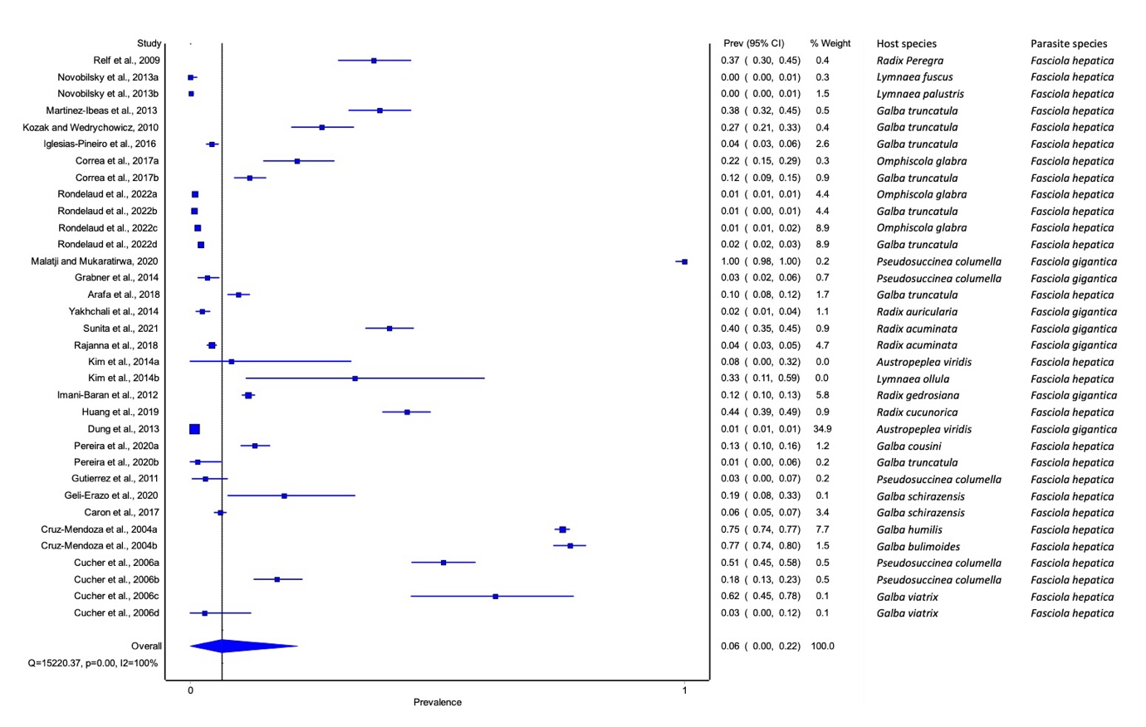

**Figure S4 Forest plot showing the overall rates of natural infections of lymnaeid snails with *Fasciola* spp. worldwide.**

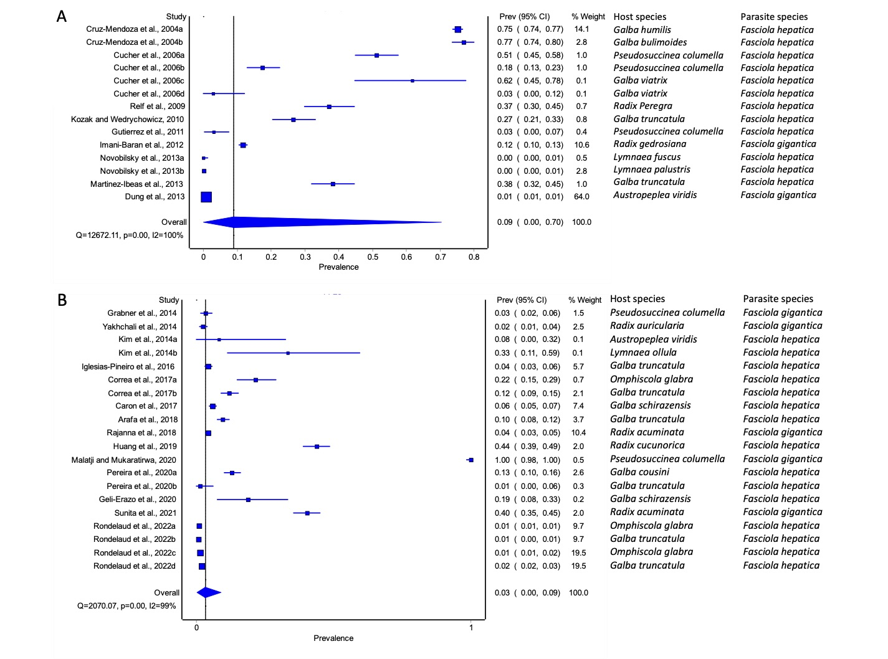

**Figure S5 Forest plots of the rates of infection of lymnaeid snails naturally infected with *Fasciola* species from (A) 2004-2013 and (B) 2014-2023.**

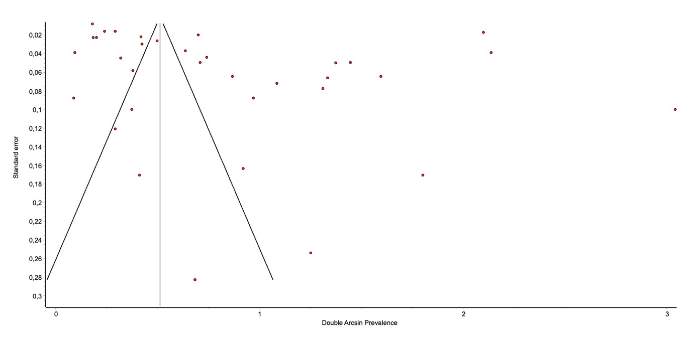

**Figure S6 Funnel plot of overall publications on natural *Fasciola* spp. on their intermediate snail hosts.**