Proposal
一、計畫名稱：
中文: 口服尿毒素吸附劑活性碳及益生菌對於減緩慢性腎臟病進展之前導隨機對照研究
英文: A pilot randomized control Study of oral uremic toxin absorbent and probiotics to retard the progression of chronic kidney
disease
二、研究主題說明：
口服活性碳尿毒素吸附劑活性碳及益生菌是否會改善及減緩慢性腎臟病患者的預後
三、研究目的及背景說明（包括學理根據及有關文獻報告）：
研究目的：
測試以下假說：使用口服竹炭活性碳(activated bamboo charcoal, ABC) + 益生菌可以降低血中尿毒素及減緩慢性腎臟病之進展，包括：
- 血清中尿毒素量改善或減緩上升。
- 腎功能指標減緩下降。
這些指標將在第3個月與基線相比的血清中尿毒素與腎功能變化評估。

背景說明：
In patients with chronic kidney disease (CKD), uremic toxins accumulate when kidney function declines. Those uremic toxins, by definition, have adverse impacts on patients’ outcomes, or biochemical profiles.[1] Uremic toxins may be classified according to their sizes or affinity to plasma protein. Those uremic toxins had a greater affinity to circulating proteins are called “protein bound uremic toxins, PBUT.” Apart from traditional small or middle molecule uremic toxins, the PBUTs can be rarely eliminated using traditional renal replacement therapy, even using high flux dialysis modalities. European Uremic Toxin Work Group (EUTWG) recently updated their list of uremic toxins. PUBTs are provided in Table 1.
Among these molecules identified, indoxyl sulfate (IS), and p-cresol (PC)[2, 3] are mostly studied. Both in vitro and in vivo study, IS is associated with endothelial dysfunction, vascular smooth muscle proliferation, and increased risk for atherosclerosis.[2, 3] In vitro study also demonstrated that p-cresol has a toxic impact on endothelial cells. Circulating p-cresol is also positively associated with CV outcomes. The kidney, specifically the renal tubular cells, is most likely to be the first target of injury caused by retention of IS. IS accelerates the progression of CKD mainly because of its profibrotic and oxidative stress-inducing effects. Renal fibrosis is a common sequelae and contributor for CKD[4, 5]. A profibrotic effect of IS administration has been widely reported on the kidney. Oral administration of IS in 5/6-STNx rats induced renal tubular injury, renal interstitial fibrosis, and glomerular sclerosis, leading to functional impairment, determined by increased serum creatinine and blood urea nitrogen. Glomerular sclerosis in association with renal impairment also has been demonstrated in 5/6-STNx rats receiving indole.
Table 1. Mean and highest concentrations of uremic retention solutes found in uremic population and normal concentration found in the general population: protein-bound molecules.
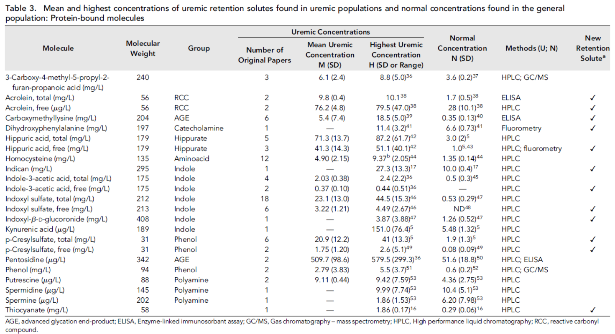
On the other hand, alone or together with IS, p-cresol also induces endothelial damage, inhibits wound repair, blunts cellular response to a given insult, and induces disassembly of gap junctions of cardiomyocytes.[4, 5] In clinical study, serum p-cresol level also predicts adverse outcomes in patients with different stages of CKD. Even carcinogenic effect has been reported in animals. These studies have demonstrated IS and PC’s role in adverse cellular, histological and clinical outcomes in subjects with impaired kidney function and subsequent IS/PC accumulation. But owing to their physical and chemical characteristics, these protein-bound uremic toxins are not readily removed.
The uremic toxins (IS and PC) are originated in the endogenous environment, mainly from the protein metabolism, food intake, or produced by gut microbiota. In fact recent studies have documented the role of gut microbiota as the primary source of several well-known pro-inflammatory/pro-oxidant uremic toxins as well as many as-yet unidentified retained compounds.[6] Dysbiosis[7] denominated an imbalance in the gut microbiota that precipitates changes in the usual activities of gastrointestinal tract, resulting in production of toxins and deleterious effects in the organism. Dysbiosis is frequently found in uremic state, leads to retention of uremic toxins, most of them derived from the unbalanced fermentation of nitrogen compounds in relation to non-digestible carbohydrates, especially IS and PC. Increasing urea concentration during chronic kidney disease (CKD) leads to alterations in the intestinal flora that can increase production of gut-derived toxins and alter the intestinal epithelial barrier. The vicious cycle is noted between dysbiosis, uremic toxins and CKD in published literature. A number of strategies have been proposed to interrupt this pathway of injury in CKD.
Prevention of IS precursors from being absorbed across the intestinal tract has been extensively studied in the renal literature by use of oral adsorbents. In animal models, activated charcoal reduces the serum concentration of creatinine (cre) and may delay CKD progression by alleviating IS overload. An improvement in renal structure and function with activated charcoal treatment has been observed in uremic animal models. [8,9, 10] In addition, treatment with activated charcoal may also improve survival in patients with end stage kidney disease (ESRD). [11] An oral form of non-absorbable surface-modified activated bamboo charcoal (ABC), has been demonstrated to effectively reduce circulating and renal IS levels in animal models. We thus wonder if removal of uremic toxins with ABC would improve outcomes in patients with CKD.
Probiotics refer to the living microorganisms which colonize or implant in the host’s gastrointestinal (GI) environment and exert beneficial health effects.[12,13] Prebiotics are defined as non-digestible food ingredients that induce the growth and/or activity of beneficial microorganisms in the host.[12,13] Synbiotics are a mixture of probiotics and prebiotics. Recently, probiotics, prebiotics or synbiotics have been reported to reduce inflammation, improve kidney function and retard progression of CKD by restoring the symbiosis of gut microflora in patients with CKD. A randomized trial found synbiotics decreased serum PCS without reducing serum IS in non-dialysis CKD.[14] A pilot study suggested probiotic dietary supplements are more effective than placebo in reducing blood urea nitrogen (BUN) and improving the quality of life of patients with stage 3 or 4 CKD.[15] Another study found that synbiotics delayed CKD progression.[16] A systematic review found prebiotic and probiotic therapies reduced IS and PCS in patients with end stage kidney disease (ESKD) on haemodialysis.[17] However, it is unclear whether the results hold true for other patients with CKD.
Based on these previous findings, we will conduct a prospective randomized open blinded end-point (PROBE) study to see if oral uremic toxin absorbent + probiotics could prevent CKD progression.

四、研究方法與程序：
This is a pilot and prospective, randomized study for 3 months. All patients presented to the clinics of participating sites with CKD with eGFR 30< eGFR < 60 ml/min/1.73m² will be screened for eligibility. Patients who fulfill the inclusion/exclusion criteria will be invited to participate in the current study. After the patient provides the written informed consents, detailed demographic data including genders, ages, body weights, body heights, smoking status (never, past, or active), the baseline creatinine (the nadir value in the past three months) and its corresponding eGFR and CKD stages, degrees of proteinuria (Urine albumin creatinine ratio, UACR), will be recorded. Detailed medication list will also be obtained, with the focus on angiotensin receptor blocker or angiotensin converting enzyme inhibitors, statins, and beta-blockers.
Processing urine and blood sample
After being processed, urine and serum samples will be stored in -80°C for further examinations. The names and chart numbers of the participants will be masked to provide adequate privacy. The coding book connecting codes and individual patients will be filed separately in order to protect patients’ privacy.
Serum and urine biomarker
In addition to serum BUN and creatinine, urine albumin and creatinine will be also assessed. The concentrations of indoxyl sulfate (IS) and p-cresol (p-CS) levels will be determined by liquid chromatography. The serum trimethylamine N-oxide (TMAO) concentration will be determined by LC-MS/MS.
End Points
The primary endpoint is the % change of UACR, serum IS, p-CS, TMAO, Cre, and eGFR from baseline at 3M.

五、受試者選擇標準（Patient eligibility）
The inclusion criteria include:
- Age ≥ 20 years old on the day of screening.
- CKD patients with eGFR 30 < eGFR < 60 ml/min/1.73m² and in a stable status with creatinine elevated less than 0.3 mg/dL in at least 30 days before enrollment.
The patients with the following conditions will be excluded:
- Baseline estimated glomerular filtration rates (eGFR) < 30 ml/min/1.73m² according to MDRD equation.
- Patients in severe malnutrition status, albumin less than 2.0 g/dL
- Patients in severe anemia or active gastrointestinal bleeding with hemoglobulin < 8 g/dL.
- Peptic ulcer, esophageal varices, ileus or under fasting status
- Previous gastrointestinal operation.
- Chronic constipation, as defined with less than 3 bowel movements per week, straining, hard stools, incomplete evacuation and inability to pass stool. If usage of oral laxatives can achieve bowel movement, this patient will not be excluded.
- Patients with major hemorrhage, as defined with acute hemorrhage and requirement of blood transfusion during index admission.
- Patients with a biopsy proved or clinically diagnosed advanced liver cirrhosis, Child classification B or C.
- Solid organ or hematological transplantation recipients.
- Patients with oliguric kidney injury, as defined with less than 500 cc/day.
- Evidence of obstructive kidney injury or polycystic kidney disease.
- Antibiotics or probiotics treatment within the last 2 weeks before enrollment and during follow-up period.
- Presence or history of malignant neoplasms within the past 5 years prior to the day of screening.

六、受試者招募方式
During this 3 months’ trial, eligible 48 patients with eGFR 30 < eGFR < 60 ml/min/1.73m² will be enrolled and randomized into 4 groups. The patients in group 1 will receive CharXenPlus 4g (with ABC 2g) thrice daily + CharXprob 0.8 g once daily in the 3 months. Group 2 will receive CharXenPlus 4g thrice daily. Group 3 will receive CharXprob 0.8 g once daily. Group 4 will be the control patients. The detailed flow chart is provided in Figure 1.
Figure 1. Flow chart of Study.
Randomization
N=48
3 months
CharXenPlus 4g thrice daily
+ CharXprob 0.8 g once daily
Group 3
(N=30)
Group 4
(N=30)
Group 1
(N=30)
Group 2
(N=30)
CharXenPlus 4g thrice daily
CharXprob 0.8 g once daily

七、研究期限與進度：自倫委會通過後兩年
八、研究人力及相關設備需求
研究助理一名。不須特殊相關設備。
九、資料之蒐集處理評估及統計分析方法:
All data are described as the mean ± standard errors (SE) or percentages as appropriate. To compare continuous variables, we used a two-sample t test or Mann-Whitney rank sum test, and to compare categorical variables we used the χ² or Fisher’s exact test, as indicated. Analysis of variance ANOVA will be used to test the differences among the experimental groups. If there are differences, Duncan’s multiple range test will be used for further analysis. The statistics will be carried out using SAS 9.2 (2012 SAS Institute Inc., SAS Campus Drive, Cary, North Carolina).

【參考資料】
- Centers for Disease C, Prevention. Hospitalization discharge diagnoses for kidney disease--united states, 1980-2005. MMWR. Morbidity and mortality weekly report. 2008;57:309-312
- Chronopoulos A, Rosner MH, Cruz DN, Ronco C. Acute kidney injury in elderly intensive care patients: A review. Intensive care medicine. 2010;36:1454-1464
- Hoste EA, Kellum JA, Katz NM, Rosner MH, Haase M, Ronco C. Epidemiology of acute kidney injury. Contributions to nephrology. 2010;165:1-8
- Eckardt KU, Kasiske BL. Kidney disease: Improving global outcomes. Nature reviews. Nephrology. 2009;5:650-657
- Duranton F, Cohen G, De Smet R, Rodriguez M, Jankowski J, Vanholder R, Argiles A, European Uremic Toxin Work G. Normal and pathologic concentrations of uremic toxins. Journal of the American Society of Nephrology : JASN. 2012;23:1258-1270
- Aoyama I, Niwa T. An oral adsorbent ameliorates renal overload of indoxyl sulfate and progression of renal failure in diabetic rats. American Journal of Kidney Diseases. 2001;37:S7-S12
- Takayama F, Taki K, Niwa T. Bifidobacterium in gastro-resistant seamless capsule reduces serum levels of indoxyl sulfate in patients on hemodialysis. American Journal of Kidney Diseases. 2003;41:S142-S145
- Nakagawa N, Hasebe N, Sumitomo K, Fujino T, Fukuzawa J, Hirayama T, Kikuchi K. An oral adsorbent, A900, suppresses oxidative stress in uremic rats. American journal of nephrology. 2006;26:455-461
- Niwa T, Ise M, Miyazaki T. Progression of glomerular sclerosis in experimental uremic rats by administration of indole, a precursor of indoxyl sulfate. American journal of nephrology. 1994;14:207-212
- Owada S, Goto S, Bannai K, Hayashi H, Nishijima F, Niwa T. Indoxyl sulfate reduces superoxide scavenging activity in the kidneys of normal and uremic rats. American journal of nephrology. 2008;28:446-454
- Taki K, Tsuruta Y, Niwa T. Indoxyl sulfate and atherosclerotic risk factors in hemodialysis patients. American journal of nephrology. 2007;27:30-35
- Jürgen Schrezenmeir and Michael de Vrese. Probiotics, prebiotics, and synbiotics – approaching a definition. Am J Clin Nutr 2001;73:361S–4.
- Bo L, Li J, Tao T, et al. Probiotics for preventing ventilator-associated pneumonia. Cochrane Database Syst Rev 2014;10:CD009066.
- Rossi M, Johnson DW, Morrison M, et al. Synbiotics easing renal failure by improving gut microbiology (SYNERGY): a randomized trial. Clin J Am Soc Nephrol 2016;11:223–31.
- Ranganathan N, Ranganathan P, Friedman EA, et al. Pilot study of probiotic dietary supplementation for promoting healthy kidney function in patients with chronic kidney disease. Adv Ther 2010;27:634–47.
- Guida B, Germanò R, Trio R, et al. Effect of short-term synbiotic treatment on plasma p-cresol levels in patients with chronic renal failure: a randomized clinical trial. Nutr Metab Cardiovasc Dis 2014;24:1043–9.
- Rossi M, Klein K, Johnson DW, et al. Pre-, pro-, and synbiotics: do they have a role in reducing uremic toxins? A systematic review and meta-analysis. Int J Nephrol 2012;2012:1–20.

