Supplementary table 1. Sampling information.

Site | Coordenates |  | Ecosystem | Samples (morphological) | Samples (molecular) |  | GenBank accession No. |  | Haplotype | Leaf tip
Site | Lat | Long | Ecosystem | Samples (morphological) | ITS | rbcL | ITS | rbcL | Haplotype | Leaf tip
Pedra do Sal (PS) | -2.81359722 | -41.72624722 | Beach | 10 | 5 | 5 | OR284886 | OR345359 | Hap_1
Praia de Macapá (MAC) | -2.91486944 | -41.45075278 | Estuary | 10 | 5 | 4 | OR284887 | OR345360 | Hap_2
Timonha-Ubatuba (SETU) | -2.96099444 | -41.32233611 | Estuary | 10 | 4 | 5 | OR284885 | OR345358 | Hap_1
Praia de Manguinhos (PM) | -22.76953333 | -41.91093333 | Coastal lagoon | 10 | 10 | 10 | OR284889 | OR345362 | Hap_2 | 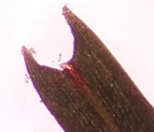
Lagoa da Conceição (LC) | -27.59112778 | -48.43615556 | Beach | 10 | 6 | 6 | OR284888 | OR345361 | Hap_2 | 